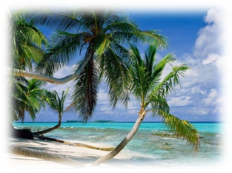
Додаток 1 до уроку №2
______________________________
______________________________
______________________________
__________________________________________________________
__________________________________________________________
__________________________________________________________
__________________________________________________________
__________________________________________________________
__________________________________________________________
__________________________________________________________
__________________________________________________________
__________________________________________________________






