Фотоальбоми

**[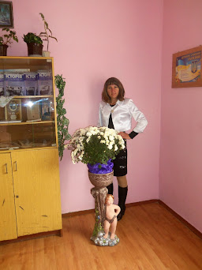](https://blogger.googleusercontent.com/img/b/R29vZ2xl/AVvXsEgDhtDwtHxdWhOgF1CNRQnzXLmkJstGv5MOSFntEjZf10I15ArZ2ANybypvMdv_EcWI-ZTdawCkTF23L1o2q40jZyMrUbuLh7scY0q_RAmeh_m1s5pAdp9fmatsKqQtSP1JmKYpgpN9narK/s2048/100_2904.JPG)**

**[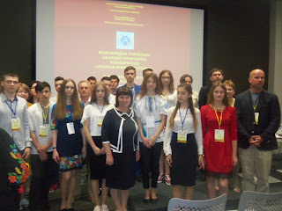](https://blogger.googleusercontent.com/img/b/R29vZ2xl/AVvXsEhlAtKFb-3WDeOJj88XzLfiP5EYiOk2unkNCg5jDjDFuCTCYDn6rvcH-FxAM6Cpt1DIcaksprgmXvtPHGx75-NN3RAvknVtDmzyi3PwXCZSOFG5fjMX8jWbnS-M4DIEeMYCRcrFsmN-HbnR/s2048/100_8091.JPG)**

**[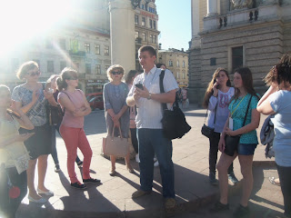](https://blogger.googleusercontent.com/img/b/R29vZ2xl/AVvXsEgMA5XUqnJp2n07PO0LNstgekiNKYA7iQWUv4zBJapqzVP0D2dKTE4ndFRBfm1bi57jwnNClXD1BA0ON73bF95mX82U6L5A_NecFOj8y1ItR74T9rVh1E6ciZT_Ftpk4sbVLckMJbzgbXIP/s2048/100_8090.JPG)**

**[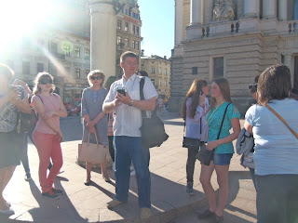](https://blogger.googleusercontent.com/img/b/R29vZ2xl/AVvXsEhQwSabfprBh3IqzWL2asgToHd6dFn3nAbwzGNkr84W4_PDV2gjOeo13thsVasVfP-jvmYY3r-76wM9fVXoTpWtlN6UadozLw1O54n-U40XET5eH7GY3gQp1PuOzb2Zf2Zw-z4EnKdcOity/s2048/100_8089.JPG)**

**[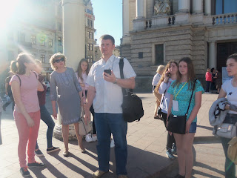](https://blogger.googleusercontent.com/img/b/R29vZ2xl/AVvXsEgzgrEqc8kmaixBiD5QvOrcHcWRI6jUt7vC9O8UIhfKCz03USuM0-ztDadDM1t6NMY87TlenPUMc-6B9o0g7ElQNg4Ittg2GoWLuzBtvBf-zg4UBuNKnXN2S2teh-ECnayxKbcayjfoA4FE/s2048/100_8088.JPG)**

**[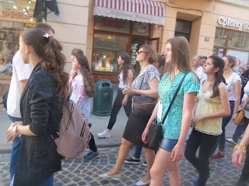](https://blogger.googleusercontent.com/img/b/R29vZ2xl/AVvXsEg4LvwNKr64M0LzUsDl_b8B3x_hW5oHygXhrygnSpmvSLEimhY3s7GjPbBaJeUmugQcZuFTIlGVDjBIXCImXI5VnvXPWpnOT4vk_UWAkzvCwb0-OQriDud_NAcP23kf__QFwYhEhQcDPKbR/s2048/100_8087.JPG)**

**[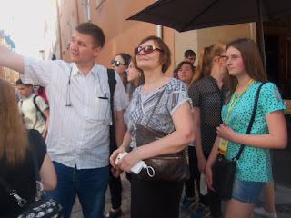](https://blogger.googleusercontent.com/img/b/R29vZ2xl/AVvXsEjDQsCx6BkSk66e9XaIU9MDA1637YUae4KdMvbGarkjz6cLd8Qpb2RATwcjDPZlHHKFkkZPyMo5FHRinbkVH-6tdHSc1tE8r5yr4F-MUVPlrudLS4VBKU23MswmxiDAgU9q3OT-qCqElcem/s2048/100_8084.JPG)**

**[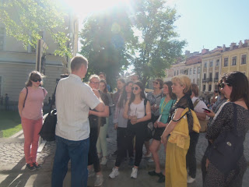](https://blogger.googleusercontent.com/img/b/R29vZ2xl/AVvXsEgDqq_Vw0n1Z3zG-DNIntKVYjN9Othh3weYknOGjm3GiEyepMZxRVjANMMAlBut2Izb2_W-D2TpOJDHYGxC1roPCFU1_4ClriYiWZx1zxJxW27KZxPny6AjMdFQeQH2TU-OMFquRVRxI0-D/s2048/100_8083.JPG)**

**[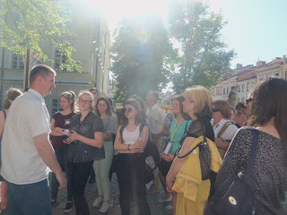](https://blogger.googleusercontent.com/img/b/R29vZ2xl/AVvXsEjJWbcbyYpci3JZc5nKGbtPRgCahAReHwLYPSiKBatAkE621r41sCNYYVUmNQW4j8h5L-DZutHLlJMUgnR8khTHdInf7IoqcxgON7uwMW9G8IOE9iXvmZYkGvyTJIq79rpFYZPGz3yUZ4-z/s2048/100_8082.JPG)**

**[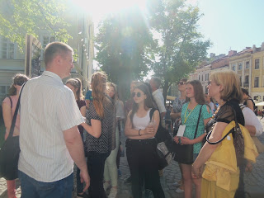](https://blogger.googleusercontent.com/img/b/R29vZ2xl/AVvXsEgT4wCQLtDXGf2pkbd7PVJI3NU6-xJZ2m44iBOtSz-281iEs7FOIFl3OCNYM19-KkZFYZKsCX6MegdWBxwCe0M3GHqoja6ff7pVLFtML7Ro-oMSPTT_jPJ6Hv8JO5RwrkAJKexqHEX74LZK/s2048/100_8081.JPG)**

**[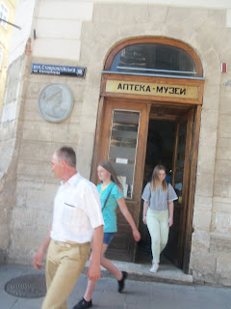](https://blogger.googleusercontent.com/img/b/R29vZ2xl/AVvXsEgZVrUOOKr6mtYKA2SZR4Ei9BLnZN54P5d_nHGfpZZogaGttJ3R1LGCJfo9waaT0hUuQUoRCv-nXpZZxPU-aZelBZr1a8paIvSkW0DR4mFZS0hDFwf8OEOHD562bzI1mvUFGGeNTAAvcJqR/s2048/100_8079.JPG)**

**[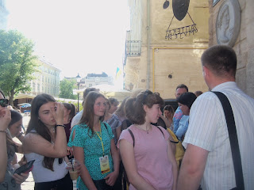](https://blogger.googleusercontent.com/img/b/R29vZ2xl/AVvXsEhEeb_lI62XDXUbSO8upCKHqXWP179zdi0PqRAwnJo2jhD4N6rwO0mqbY-FQBt_bOYg10t-apHKSzlOW6TlfXzZmd6pcGi7KK7oyOfcIHx1FSRYEdS9mjU7G1Ula4OHjhOOj8UxguQM2Ybl/s2048/100_8077.JPG)**

**[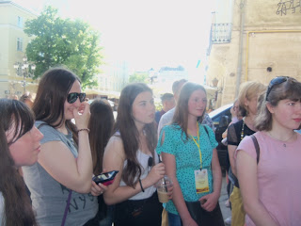](https://blogger.googleusercontent.com/img/b/R29vZ2xl/AVvXsEhw_ewda0X2wXrGab0gbHByn6cCf2nhbB88TsntRwcYjX4baWz72CvzQ7wAEB1k1Ni3bdSWrDrkcRV020TPZq9VtElrgxu_UKHDWdNqgxmgbggmMpjhXfip-SysEQP8k2ScZQgdRKTbp343/s2048/100_8076.JPG)**

**[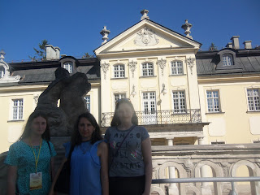](https://blogger.googleusercontent.com/img/b/R29vZ2xl/AVvXsEi29zP1Mqr1ufyU7YP35Ib9PC07VVlWrVyGPaNTzTnwtMxi4UxN2tkjx8e2XmcoDDBWMrW9TC8ORVJjsW2nVmMtxZ1VRsG0HDkXBMSaOEfdsIc-iSSzwUVsM9AhzGzg7Oq627P0ZEQlktzV/s2048/100_8075.JPG)**

**[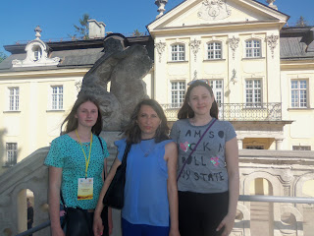](https://blogger.googleusercontent.com/img/b/R29vZ2xl/AVvXsEjyTtkluvyiL5K7Rg87rcUS0Af8R39pkxdOuL5L9IF6e3CeJJqTNOr4nXIdX5uSFbkkepvJBCV3mwWDBreoiGS5c0oeabH_EWicgq5sv5dGzssTZYbdmF-QGA9M8Hem5kFL_SZzu1fsUgSu/s2048/100_8074.JPG)**

**[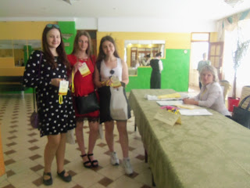](https://blogger.googleusercontent.com/img/b/R29vZ2xl/AVvXsEjJuaSp2VRl0wW5iRe2a8OxbiRS-itUo_nTBVboP8-L-R1P866L89mbBUTLlgfJBx8KBET908L17Bqh-0klCmSJb7nuIq5zpopXC-bEsh3fur85MsKo3RYgsIyypGRjCGly3RRgpmhtiXCP/s2048/100_8072.JPG)**

**[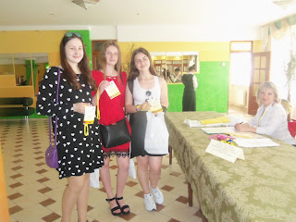](https://blogger.googleusercontent.com/img/b/R29vZ2xl/AVvXsEiDueU_OBh-HQegAoOTdUp-cxoq6PllQcYBE83KlYnwqRNYQo6O43AYuB2FCf9l_sYWdd8JcYS7oLAfuD1o55UzQE4E043oM3A7NnaDLWt9Arko8mfpY0uH98cDUAaENFSvPpbZncbrCTNA/s2048/100_8071.JPG)**

**[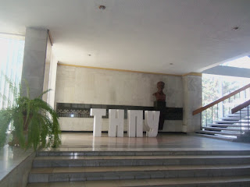](https://blogger.googleusercontent.com/img/b/R29vZ2xl/AVvXsEgaru0G6v4gI9f9qNludu5UPHahfNOW8HKJUfRCeF9YTCpZMprcPWkVcZ_jYJ4SEGKxy-r-kHnfDb9E4Z7nBnYIsWRpNJozknNy9FyeWCOrEo1KQlBvqVGO3n0SGzyfG7IXnMuvQyJR1nCn/s2048/100_8070.JPG)**

**[](https://blogger.googleusercontent.com/img/b/R29vZ2xl/AVvXsEjwsab5fm5NnlzZlUn5sIXEeRbn6nWngMHVluw_yCz0lbzgHlmvy6aKve5yjhVB1THKRcgsw4YZ6lFbxiu-moCoBB1aLBoRFx8zFoI5slpNRAJ55AFAow4Yy38YS-2-fL_NJ4FQIBZXoqrh/s2048/100_8069.JPG)**

**[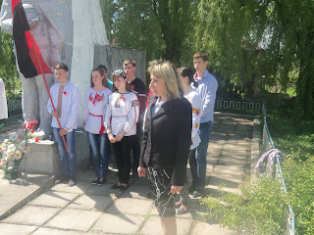](https://blogger.googleusercontent.com/img/b/R29vZ2xl/AVvXsEivzvglC3CTuBf_UJb-FwGDFDxkVVhAHRkyKznspcvKAQgg7qjRDgwnqldTTOebp1-OqR1g2T9yWh7pEZUcM6d_Qmw0ibm41jy75pALmLMidcM_Yrm9pkEwjAaSxiQiHMFv7xAr8eGoH0up/s2048/100_6777.JPG)**

**[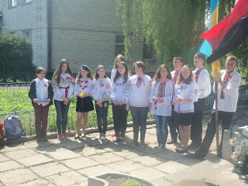](https://blogger.googleusercontent.com/img/b/R29vZ2xl/AVvXsEgWW5Mis_7xLyQN0BIVl-BKhTBppBu39uKdzOOUlUyVpajwoSCNSTQ12hFSUA3mq9PoJXVHJZyeFFr4wFkQhZbwf-6yXoJ1e_uLjWLibCF4HfaSzcbgakOrKxOQoGgVgfl9ix8OumPLkr7C/s2048/100_6776.JPG)**

**[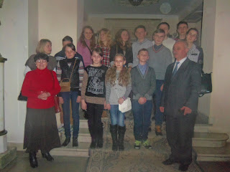](https://blogger.googleusercontent.com/img/b/R29vZ2xl/AVvXsEh_YOFBh3qMeQsIjYkdgMdeYQa2oQsxc-GzM55Bjsjg2m40x8RZIQA0ooR0Gwk_Ci6yjbxX3-eUYvvHGt97CY1RHsoxbQPHvzjYdC9xzPk7_uVsKVyNFyrfZ3fz_zcXzGqDgzdZRpVq6Ksw/s2048/100_6714.JPG)**

**[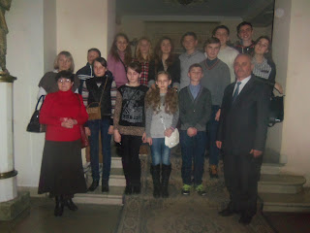](https://blogger.googleusercontent.com/img/b/R29vZ2xl/AVvXsEiEArWAH312xCL43USAfDLB5qUsGhqJj7V9PE_L6thkETpGl1aBmNMHzYjIbDt45p_q-u6AGEQ9E1qgnfztptU0_o-iZHsIdfmwMWz9BxIo-u_nEp6UANaTRB0Trw2zkvPr9U8hVtbhMYWX/s2048/100_6711.JPG)**

**[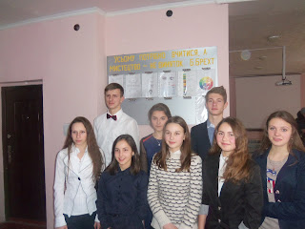](https://blogger.googleusercontent.com/img/b/R29vZ2xl/AVvXsEgBNH7sLRHzsh56n9YxV5-Z0jD2tPg8exffGeaB4bRAXG4T6Ps5pottlF0zKNheWCqlZ9ze9jAvk0NwG-TxPJ7rzgqqa0qD40R-5b_J0YmgNsXJLK0NPaUFvwRuCUMVe4cKUkYsszKELeso/s2048/100_6660.JPG)**

**[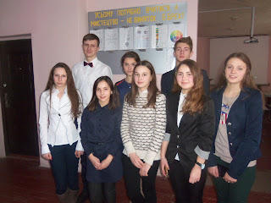](https://blogger.googleusercontent.com/img/b/R29vZ2xl/AVvXsEjx1_-XYqqPnCTdzAUEBk7EKZyYYIUnOHlY3LqkWP-hjs503VD4Dx1egeUj108VisJZ3MVktyPm15eKQGum2Lr5o7weWGkdGIYb5iDQHltge8U_uFUYUREkal9rnsfcK_Q22dMt2uZwAiYH/s2048/100_6659.JPG)**

**[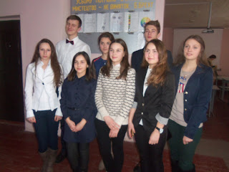](https://blogger.googleusercontent.com/img/b/R29vZ2xl/AVvXsEibgL6jyGBqbnX2YBUkyM2VAvBhKdVhuaSgJ0agUnqKbbgsjombe013wQpwljYB3L0njTasFZOVTBhpDaGS3aE890QwPfWkOxatr5Ryk8VBqi4UZwHIzIlhGXmoIEguNaHkb9qIMp7hA1u6/s2048/100_6656.JPG)**

**[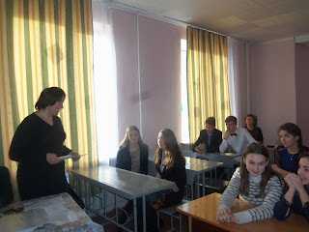](https://blogger.googleusercontent.com/img/b/R29vZ2xl/AVvXsEiij9ZXFJ0weaSU5ur1gu8zRBOZKOFFoUBrDXJ4GpNrwAPjn7P3pN78-_7_dc7tPazmjdgC-bckBH0xPH1WTvH8K9OxdlDcn1oslZItlGDmsCBzzyBIPvUqUYucjmyUEgKLYeeVYfFq3EmD/s2048/100_6652.JPG)**

**[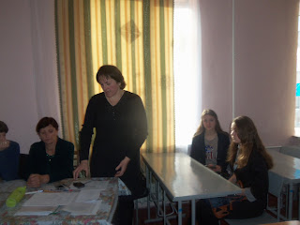](https://blogger.googleusercontent.com/img/b/R29vZ2xl/AVvXsEhn1kWbx9869wfhkvY1McidZKmfyHxe1iR9N23dVgq8I3-18TCQkrwjrgDWkF_WxUIlRp2pbPd3Eckoh8X6XF7XH9_pgYli9KRZGWlSQM3IOBKAxo-6zHVtXmzNtk1c-cXLOjRVogUHCiFb/s2048/100_6649.JPG)**

**[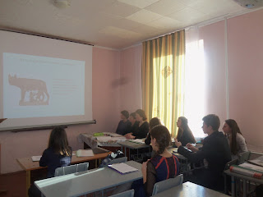](https://blogger.googleusercontent.com/img/b/R29vZ2xl/AVvXsEiyC2y2FDrAihgR9LRo26eA7daqezToktnNKDViY1AiQ7DfbMXQ0IBMWJnyvVq51_OROa8Rq4_PZk5uLdSkNV-jmHe8mq6DzWHEFWTP7kN9BDujdl1PkC1dOA_M7uLYO-HotbC1cu_9yc1A/s2048/100_6647.JPG)**

**[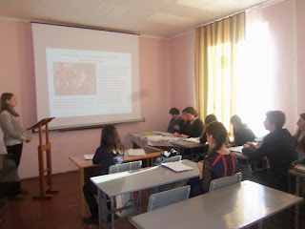](https://blogger.googleusercontent.com/img/b/R29vZ2xl/AVvXsEijymoN1aNq3z1pE_NpipK2fTEUgPiXpsuUhETOkBm-8nRJJ1YKMrcaXkrkdtWB-3IPToOl-ycLOAAF3yU7O5UMK-oCT74mSnwj6ehQb7DRwxgPSGleHxTLnTP1MRkhI0NrKD8_Tcjip8Jc/s2048/100_6646.JPG)**

**[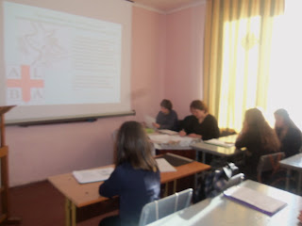](https://blogger.googleusercontent.com/img/b/R29vZ2xl/AVvXsEio0f1YyBt9SqpH8ragt2d962h7aBC3qKbLOZfyXY2UjdwmEe5pBkmOPg3jnnhDT_4IQjUIcgUjzt2qUDX3nHEkyVDRhCLoxWntPk3ObEpE7anBRrsQXISOPeIFLdbQhYNBmgiuhilucJy3/s2048/100_6645.JPG)**

**[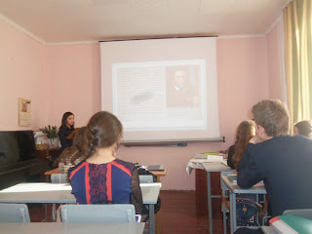](https://blogger.googleusercontent.com/img/b/R29vZ2xl/AVvXsEhqHieR252Tw96uH6LiSr-CUb1mEzqgnta_cOdcSzEgUHUFctFnhIRrR9QYeXwyBLZxC9clIDb82dDGFQ76kEZ2PXpwvHvNBTgt-cRBA0wDDzsfQWjty8oJeHJV1W3CmQk9_J476CLr1JLz/s2048/100_6642.JPG)**

**[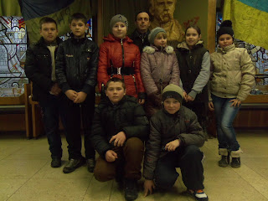](https://blogger.googleusercontent.com/img/b/R29vZ2xl/AVvXsEi_ETx9zfzpJfFgbpHsEnAObtzIaAmclK3sIw0bTJ7wCKmm35bL3fnS4mIYjsGaF_u_c46jn4_-S9K9RjPYWqt8LfchhNt_eDysfcBzK1z8M_56sQ2yq2bB83m8bw2ZnjJapOQoO8ZOcjcx/s2048/100_5765.JPG)**

**[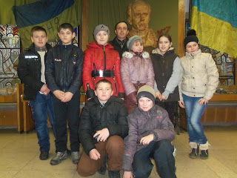](https://blogger.googleusercontent.com/img/b/R29vZ2xl/AVvXsEjQGOH-9wAXybXVgXzqRftUqO-KluG8mXh8uaSi4XzMK4Hcy2ulq0F5-5tcw14G7PaZBayPWyIW61oiA_QCRi8Sx3RJ1IfnylmbAyyi6KOvHp6u40CwYM7BnJt34qfEf3c5pbv-9gf1PwSI/s2048/100_5764.JPG)**

**[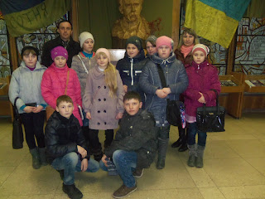](https://blogger.googleusercontent.com/img/b/R29vZ2xl/AVvXsEj7JcxNHC1OkBVDzHlYe5a5JP29KaYRk5b640OvJ1BSZv2tNPskISsPnD4lxiM44B5GSkjY9yOksV3mMUU6dJ2WOHKXDl4cvhxWo8vOBPDDyRZfN4N9-PKx_kmDAVm3hEowZSgRMkIZRfMH/s2048/100_5763.JPG)**

**[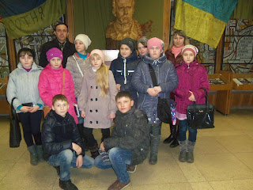](https://blogger.googleusercontent.com/img/b/R29vZ2xl/AVvXsEj_H_yI5yZ076-9QrhIWb0GgT0vHrRn6D367cjO-MalP1IZSsFN736xc5JiGLGbk1_tDkVPBKKCMQXK-wbAmdJhmIuVYJPmn3dDF-h8k50G2v0K_K7yyKqQKz3lfOxkreVkCTJR-VYKwIHB/s2048/100_5762.JPG)**

**[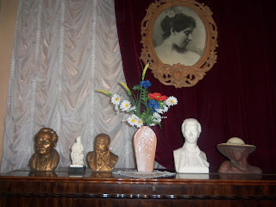](https://blogger.googleusercontent.com/img/b/R29vZ2xl/AVvXsEjhqClw31JsQ-LGTT584hx54t5aNKTDg4wYA3pA67CB8XgagkFTKWxVxY9C3ShOnTH2IVrlbuyEUfAhOrHB-FJuNApRv2WzoOzLtOhwT3Gj1Qa2Et5Nh7Xk7wyCRaJ2YMuZeDPuOBofBBZR/s2048/100_5760.JPG)**

**[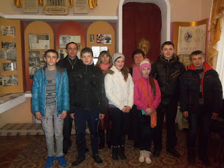](https://blogger.googleusercontent.com/img/b/R29vZ2xl/AVvXsEjb0EHAsOrAa1Jbn-qtntKE-dhSVcgsStbcBTshyphenhyphen3RZzz5K_yCfc-QpZO4lmG9AxPeRSiM3t7V2ZAC6iOmG4V2YQRLtarjn0COYnOrkFTKzBlxY65g41zlHwJDVNpwc7zn0UY31HItYUxta/s2048/100_5759.JPG)**

**[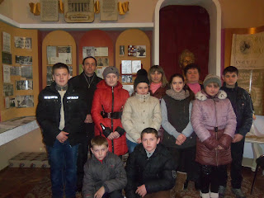](https://blogger.googleusercontent.com/img/b/R29vZ2xl/AVvXsEi7UvOpTdK6soFT9IbjIqgOjPlGfBCVZFWDGGGc1Apl8DtoTGacEQWg3Cjicrvh-NloAhDiF8hg4E73xuaLbmAbF2kiXT3q6lF5_pdi9wDoORfB3hQnhIMnVuCrXamJrzhV9WUpstonkv-q/s2048/100_5757.JPG)**

**[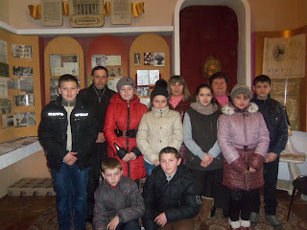](https://blogger.googleusercontent.com/img/b/R29vZ2xl/AVvXsEjNFn08llkct6NDOF8e14Hr0xk5DdS0wQAawkesDjLixfwCoT8j0uOcBXfa-FRs6bpmtKHW6AOzmBAgGyer44A0xO_6k-FeHoFFTM0syK5XLW2urslqyCneQfQ4lVFt01obiUvMORopdl27/s2048/100_5756.JPG)**

**[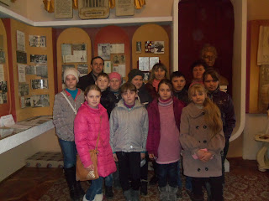](https://blogger.googleusercontent.com/img/b/R29vZ2xl/AVvXsEhy9LOGg2Pn_wv6hRnKV9yvMrX_kzHAtU3kWa51nnWKawaF0oSUH5TDFchSNZWZTVGsYTQCn-kX_LM1ZLG5174uZsyUOZWIjuEzSufo_BkeqPdt0msVxUPr8QxPNdVuPyyuOqxLgiK9h_ax/s2048/100_5755.JPG)**

**[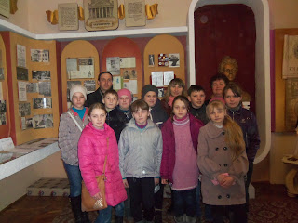](https://blogger.googleusercontent.com/img/b/R29vZ2xl/AVvXsEhpdyNxl8ajCvkxaE8lV3mpTOFB3Ry8mXgl0Zqmj54ekjKbEmTThV0TQ0f6V834a0j4LG9vt45O_EtDXY7O4zFKVUW9juvHXzi3iYq7HEDPoUyRhr3oEhmlQpInVaARPD-ydO2S6Rxq47cY/s2048/100_5754.JPG)**

**[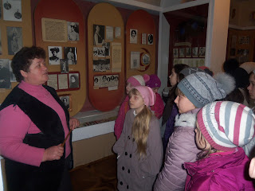](https://blogger.googleusercontent.com/img/b/R29vZ2xl/AVvXsEjez5JODcXHAz-9TN-9t7iFSylEPn_7F6iFKLMeoWB8OxxSj6pRCc-mOOe6YYS8zXySQLmi7JqE1wfGbVE9LKawWkayXA91jc3Y-f95zpuBLLp0I2vx_FJaQnYp2VsqWT3VHd0Aa1WAfMwv/s2048/100_5753.JPG)**

**[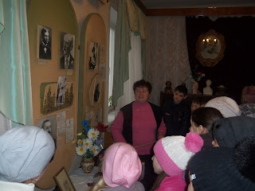](https://blogger.googleusercontent.com/img/b/R29vZ2xl/AVvXsEgjcOmY4TBOKrl7RJWRThbP9ZlA5RsA71w1C7GAe7OX_q_tcmN923cY9GY5Idg4AecZA3HqhLX-5Rx82v3uNbSShMgMSD3O9qeSpsARgUzqQ6ba_pXebJpqyzZcALRdC5BX8BQPyMUGBFRp/s2048/100_5752.JPG)**

**[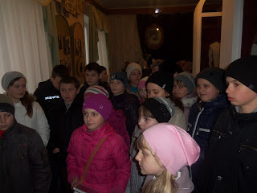](https://blogger.googleusercontent.com/img/b/R29vZ2xl/AVvXsEjEokK5MtmaNKbp3FQqOSgA-DqXWqBVcaa8fGXewO7zqUOm7luBhRWYzjjMqaWPtVYlXjBQPTFvcg5mu_JlyMiBKk485GBQwYa_lZFB9uhSN1N_z7ILMr2zze8zXriQk0xwommBdqzc0dg2/s2048/100_5751.JPG)**

**[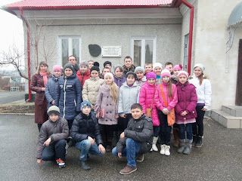](https://blogger.googleusercontent.com/img/b/R29vZ2xl/AVvXsEjuNm-m1GjkzmvAdNbTzL0NQCER8Te5jF1Yb3393GBJhKOL2mu9C3gsf83Mdxm4gI0r3TePveZL2Ixv85tljPDMdKOdD-4NripgxGAcyL8kSjXAnK42pD-mzUSuKmPGCjAeo8iinMMkiQJ5/s2048/100_5750.JPG)**

**[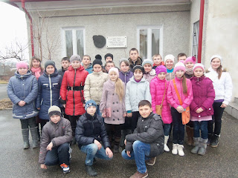](https://blogger.googleusercontent.com/img/b/R29vZ2xl/AVvXsEjfoZbPMC-CVxrr_IGEOSuKVrtjpKpLMlY7Mt6AvKbyiIkXNAwO6-ZFL6mt7ahNlO8-QTlKRkNkNsWGZzKTHOICQNDMSqGCDQG1RSknYEcid8jjN0i6DkFsXmm8-L23_dcvpQJAeYjI5DkU/s2048/100_5748.JPG)**

**[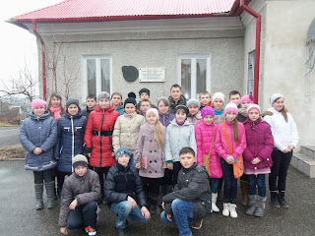](https://blogger.googleusercontent.com/img/b/R29vZ2xl/AVvXsEj8zQv29V5GFwahm9Ri-_mcxZPiefJAiknm5PqNEJCHnwgnQqN3UOvEFWr7YYE1lw3Oj_QM8aSxeN82QtjQRPPam5pV4jzLCKpnc6NGY8gMeT2pxs3aUfMcqxKewEw31k8Hw3mtumPteOxh/s2048/100_5747.JPG)**

**[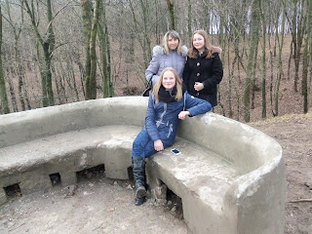](https://blogger.googleusercontent.com/img/b/R29vZ2xl/AVvXsEgkKmyPWkwbGxygEy_c7Jv9WeGoC5er-68qnbPDzcSAvTYhv38CoL80ZNFdR6FJ_rFvxgE4g8CuTH8qzonZo66I4jCJUsaRoOHkvTzMsnv_0sxmEXOk_TozV0GiCLmQwQ9FlgnQndNSL5bM/s2048/100_5745.JPG)**

**[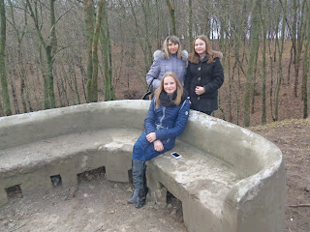](https://blogger.googleusercontent.com/img/b/R29vZ2xl/AVvXsEgS31kjPcs7il4pMTniq579CLeMigzXq81WdkP7BFYG0-trsncQhnMcoT6aLxy_YWEfB1bFVyXHbgh6su-IyICMYIKJBA_9JIqLb1me9U92nbiCv36vxOaDTqfIRof0-mukFFiaEh9AREPV/s2048/100_5744.JPG)**

**[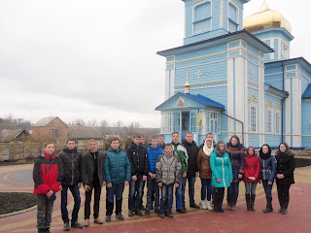](https://blogger.googleusercontent.com/img/b/R29vZ2xl/AVvXsEjChyphenhyphenjOwDhyphenhyphen6NdAh-FfzW-DE6qLqDIeRpzYZLIRFgOvCeM1C_wffJ6zmHQCx7WfHApxvuaVlzZoOaoYrQBJyPaeKrfcys2VzCWo1dvq_BKNBVgqJZgZSZvUe0M1bCAWgEKpvfqql_tV0hLF/s2048/100_5694.JPG)**

**[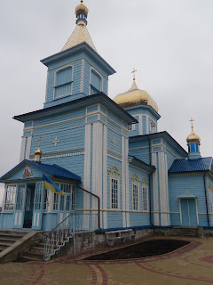](https://blogger.googleusercontent.com/img/b/R29vZ2xl/AVvXsEguYb3zuTioFDhyphenhyphenjftw2fE03fP0nW0cYsOkzZOzLMevvHy1b2szX6ar_YDzlLphqLFrhY-8Rd5xPDOqhcRHYhnPC_t1U2f4nSp-D9xlw9DhVPMg1iWV1ydY2CMOJ_wN9YA9Q0GTLQ00IY8B/s2048/100_5693.JPG)**

**[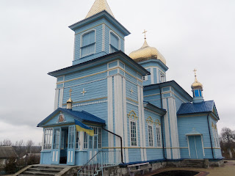](https://blogger.googleusercontent.com/img/b/R29vZ2xl/AVvXsEjaKte-Vqa1GIiC2WdMuidfx-9MlLPdqCJEUTCbMy9Qu1V2QKCNCuVCVXyEEtETEvZbF_8k36F5KCeglqf864KdN-KWmZkBO3Pa1CIpxXQIOpSk3W3hd5adWo7fIFi4wIjktFT_ajmUzsKR/s2048/100_5692.JPG)**

**[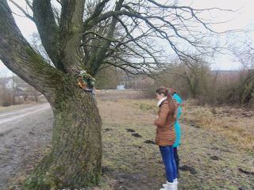](https://blogger.googleusercontent.com/img/b/R29vZ2xl/AVvXsEi8Sw7Pl4TLjMlhd42rbj1LVy5ltk3TJK78HFXKPnwIl5RfltQAF71Knv3rqvQp1nPvFIfPm79qneSO8lrByGHwAp0F8QRPVVy6LxU5ZzDogDWAYkVtIB8ywZGxyoXRA0NWV92cuYv_7FbW/s2048/100_5691.JPG)**

**[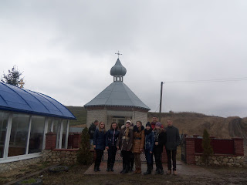](https://blogger.googleusercontent.com/img/b/R29vZ2xl/AVvXsEhBSiy62yqmT1EHYVpUe1EcVni1lYkldod4G1lRa5YXGOcEIsNtTsTXcHbqMYfAqcqnrcdZjox9nkCIR9lUc1AHBvEacrSTimWcg8J6PlIo9RLSvaOpvT-Q_tsncqVqqJNKobwqzvYYvOS5/s2048/100_5690.JPG)**

**[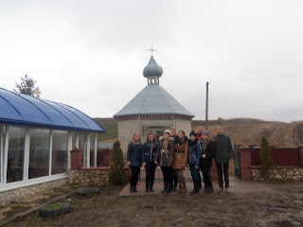](https://blogger.googleusercontent.com/img/b/R29vZ2xl/AVvXsEicgDwUHcbBXiq5WpoXkE5oeaLtdnzy8WR__PmDE1wGLfYqeLOIvrMvMaEqj-kIRreQGFlcd0Zm_iJ7__PTXtdmtT03fuf2Ye2YfLLn5JbGW4ZmiYOawdx2vsgeqcikYgQ62kfwS3ChyVen/s2048/100_5689.JPG)**

**[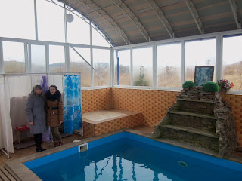](https://blogger.googleusercontent.com/img/b/R29vZ2xl/AVvXsEhhJxnA2t2awHM5xfKI2mVQAf6opx9mysGLQcNiRiWUvKwe8FMIwsyv5avX9ndfxLewEgpl9YU2dwn3eBFiQvE7XHrO8SZrkjDW8MXjbsUPSp7z3dfXcNkOxu8WJyJfAoWsBBlo3G3znYq7/s2048/100_5688.JPG)**

**[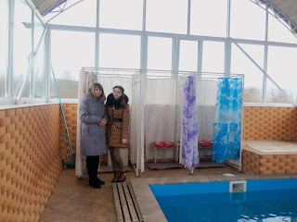](https://blogger.googleusercontent.com/img/b/R29vZ2xl/AVvXsEj7vqnn2ul8ezN5DkstFUTB3LTXVP3axvNizyH5ikWqTYNrt2bl8hI97cQuBei6R1KVzVllvTx6kcJ3xtkU1LxeEqTOaJ9vqSOOpiv-sAnxeUeFfZkurmcQn5syN-iH4IdD0_f_pWOp03Np/s2048/100_5686.JPG)**

**[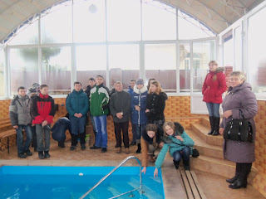](https://blogger.googleusercontent.com/img/b/R29vZ2xl/AVvXsEh_ELkw23fDell-Do8V-eEMfs69aQCcEZJe1ma1oiNHu_NV41AnDHTLRkISAxmA419bmrmYX6IUGGM9eAgX92FMKaQkajRO_hN6SGF8hSdiqS7m3oX2CF3xuAzBgj2ypNmlA6lRYN6XFVWb/s2048/100_5685.JPG)**

**[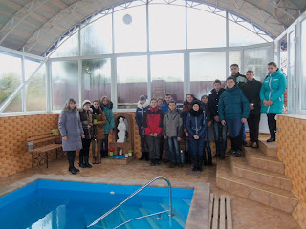](https://blogger.googleusercontent.com/img/b/R29vZ2xl/AVvXsEhGYLiJ0B24fQFvDEhAdlbY0QQHQhGr5FkHQVPtnuSW06YgplhJaWeRpRxx7JEMsboY-hKl_LQbVw_P3keSdxD4kj3N8DogWSlZtciD4ea21Umds1F-A5daTnHxfMdZO-IgZHNT_tRRwfHe/s2048/100_5684.JPG)**

**[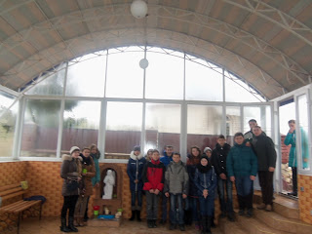](https://blogger.googleusercontent.com/img/b/R29vZ2xl/AVvXsEhIgIO0VkWXmde44Ki58EPUNpx_bLDoiOERTr7h5OMO0uPrKxNxKR9687P4yjNyYGO-HuQyxF-q2YnVnINn3t9N1NKxECRrSPr0pNM9mUqnqTWECm95h4g6dsWUd4T0-Pl4fUgpuqQBQU1-/s2048/100_5683.JPG)**

**[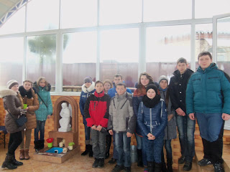](https://blogger.googleusercontent.com/img/b/R29vZ2xl/AVvXsEgyY2U2W-ZfBEpMwHoeDIYQMi02rffp2ficjmyMbtlTe4oSRxWPURGYfTWTVITd_t9aiUWcTGdg-MUfblsxcqfc8FSWeOnYqbLcjteqpknLOadHz_RODtg2qLYSlNRAEXzWHl4sinun-eVg/s2048/100_5682.JPG)**

**[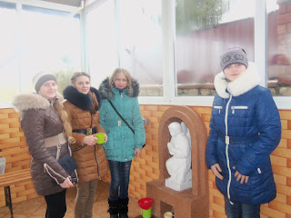](https://blogger.googleusercontent.com/img/b/R29vZ2xl/AVvXsEgFT_KOnxt5hC3_UfTfACQfwTPwYDU6lpp4JU6MORxCBPwW5Pv6awuiSGyagWTEiSAM7tOnWeyPbxUbnvjYb3y4hTTmTtAcBf-fCapzwg22dvzPPeEGplFCVKHsLsYMcypS_5LSzgdE2KQE/s2048/100_5681.JPG)**

**[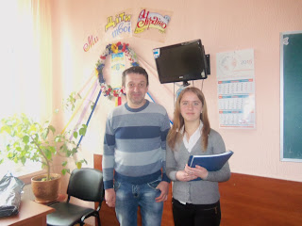](https://blogger.googleusercontent.com/img/b/R29vZ2xl/AVvXsEjTf9Y4gU14gNVunLzoHXxWaT1asUDqhWB37DgsNm-QxjO6Ok2-8iJu9CYcvNLjDWu4Kp1Uv9lv524iGsm_6gyfOr_0GPBz-C6S5Nn2yeAhmSvFbqzuYf_yS2ySOhv49z5hhd3vWsUqdJEM/s2048/100_5680.JPG)**

**[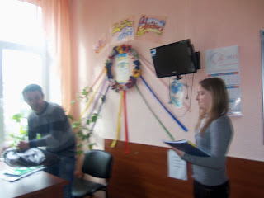](https://blogger.googleusercontent.com/img/b/R29vZ2xl/AVvXsEgfIOsFmXy1r6dDdATxIxSiv0qk7CgnwiIw4lRxv2_zf8tLzW3CqE3eT_eM7ZNK7K-I1ZaHnczMXoySy1c5zQxXKLqR4xMKy2oaYMx0CW67kj1oUKFfSIcKR6QfUhlaZJjni9xZ3AZkkrAV/s2048/100_5679.JPG)**

**[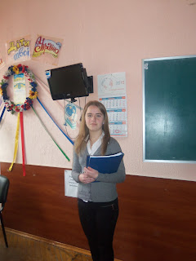](https://blogger.googleusercontent.com/img/b/R29vZ2xl/AVvXsEgvlMonp0tdn_iAHb8Ck0maHOpou7Il_m6vng7EQoWdxp0AbunQ2S3Q8HcriyWRkTQG_Z1v2K4mSKudJpJxuk0BBIiLcBLWc8GNfzyBkB-S8dHFmzy3HGMtkPRztDsiH9CF-qfVwZSihTgM/s2048/100_5678.JPG)**

**[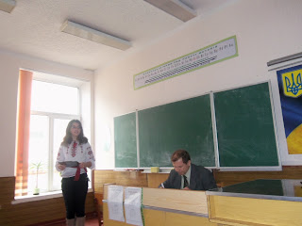](https://blogger.googleusercontent.com/img/b/R29vZ2xl/AVvXsEgfaTNSANRcFFoExEjGDiJy7_OehMy44j8aVws-0KtCw7oBC16-bApdHPBcWbe1bMT40EnOEj01ql0oijEa-Bs1IiXRyICHJ3ub0lfJ60bCFS-lCXifKrIIezRS7wo9mwchzn8LFE9h69Z6/s2048/100_5677.JPG)**

**[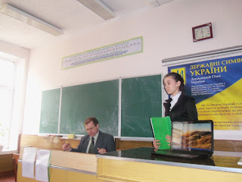](https://blogger.googleusercontent.com/img/b/R29vZ2xl/AVvXsEintHXPtn7PULWP0Up0Dndfk4QRB83vhUI9_cov8QwFlDkZhLAHmr7jxxDay5AvMzWQqVkJOv-MmbtwtdhzmGQa0LascUYkr8NqibuIrGLmBGdu7tsqCFE2UVuJB8FGXbw7tlVU2QPuUGwA/s2048/100_5676.JPG)**

**[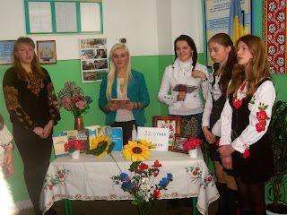](https://blogger.googleusercontent.com/img/b/R29vZ2xl/AVvXsEhk79kCukB96iY87EWwlssr-AgNEmPcs0dMku4HAeJ1FtW-I2c0qheLJz0w5ynjOrb_s1NB1Z287clnQ5lkZNLOYDiDkOlOKTa4ggRcI3g-hWgpX5RpoOXu1Wq2Bv2D0V3dyEPOhDWpV5Xk/s2048/100_4016.JPG)**

**[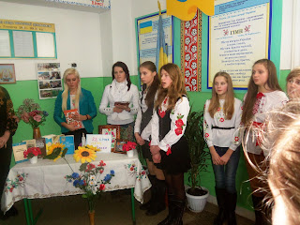](https://blogger.googleusercontent.com/img/b/R29vZ2xl/AVvXsEj4WjxNmecmXGOyYNJyTyHpABosUxgVDxd7ZHrzFtXX40ZJo-p8e9Vde0NmiEL1ojWKVbdS3W05rBLhI_GudClnspNXJSj5AjktxdpsOJve5QX8JQbvoEDDjFluLTnh08pE_d3RvcvxTgE2/s2048/100_4015.JPG)**

**[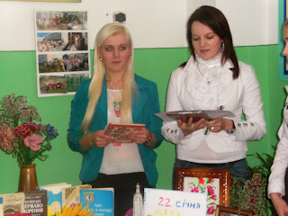](https://blogger.googleusercontent.com/img/b/R29vZ2xl/AVvXsEgKmQWiLt4nYXoRJrppnjOwhdIzLHtTlfH19c0Wah3Vsy8OO4SDnhPPAOR8OBvpknLwI7miQ7Kzupo5lUDFEuWJAU8hj8uhQcA63CAYnyd86Z5U-VI-Wxd8rSIjq6-ssN1igmPyjci5WXjT/s2048/100_4008.JPG)**

**[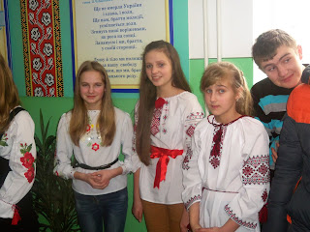](https://blogger.googleusercontent.com/img/b/R29vZ2xl/AVvXsEgTddDa7tR689XjHIbUmVS2NlAQabotP9azKfq8TkthQ1ntFjso9LmUfy9jlgWPRZ4dV57k-BpJEokr-GM41UmWOfUQG6oCa7L2mtHHtTffW4A-WQW4u7uKPvR-bLmod6PHnHjV6Hs68PWk/s2048/100_4006.JPG)**

**[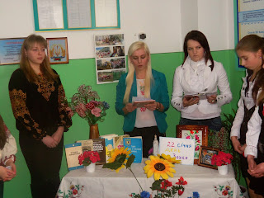](https://blogger.googleusercontent.com/img/b/R29vZ2xl/AVvXsEi6_cP56WVQUbkUHQL-2A057Wm3CFsklw_FSHezAGxmhfieJyAFiw2q5q_EXMF4BhSm2TyXLQY01K3U8nfGcNWFHeafO7-cYX0oI-i4p-yToXoHmOeaDUlOmEPe7RwhRLLA_yqYrLbK-84R/s2048/100_4004.JPG)**

**[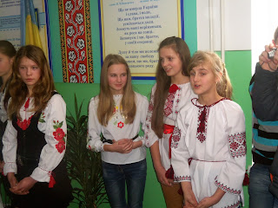](https://blogger.googleusercontent.com/img/b/R29vZ2xl/AVvXsEj0AFWQyDFgZaNMyGe1lbr4aqTK54xKVZkxGVlS610GI9DJEY8bUs_2DV4SKZXta3lRtDA5Ivi9n7dreajn_h7DQXJuFUvfkhjvOvLxxBlniysAnRFw9MvUMWgIBgV8sgLZ3ow5gpIpbYjn/s2048/100_4001.JPG)**

**[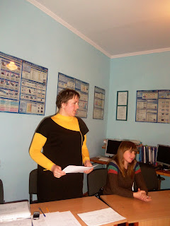](https://blogger.googleusercontent.com/img/b/R29vZ2xl/AVvXsEjroONy7l-jcWM16qGuGraL6PAR1Mwp6VUr4NJ336beEsSUwil29nOcJLVmzgdZO7h5PoONUAQL275wb7lx6BaVjRpV4jvp65pOKisCqUpK-Dr7y9nhAkhdBSD0BvcjlH-X-kv9xmh6FUjW/s2048/100_3978.JPG)**

**[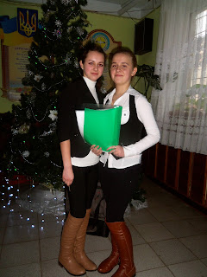](https://blogger.googleusercontent.com/img/b/R29vZ2xl/AVvXsEj0HXXSUmwRdnQMC_C87gR39qQmdSkxR8JqF2-tIV5ibQhyJrCwCjelmAM0DYGXQcvr2r7cOd0El0UPA-VSrvo3-oDw4e62aUIw0bkD_9NBUBQ7BEUv5xduSrhgYD5axhHG79BEvnoEmXQY/s2048/100_3977.JPG)**

**[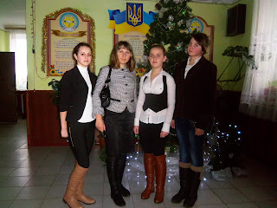](https://blogger.googleusercontent.com/img/b/R29vZ2xl/AVvXsEjtS2qESkMjtVGmlcrcRnMUVfCjut_tjURzrKS6FxoiQlMz8HJNTUxF4MQd9X5MdDbrBRICVOookTk6ons88DYhyphenhyphen6giNHHOoDRsDQuKl3Le3KV3LzeIEgnz-bJoTl4jAWBre-G0qaWe6pGm/s2048/100_3976.JPG)**

**[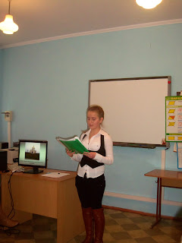](https://blogger.googleusercontent.com/img/b/R29vZ2xl/AVvXsEi-PbBDfOhfWuFge2wDjwrs0V0rPYYLtOgZn639kOD0QXdBdUg6XjgzTKwXOIzBX4wjxYPCVloB0pNR4ydXk-dL-HhMyTe_nI8HEIm_g626Dn6Nba4CrQT0niolhyphenhyphen86Wn4yKVa5dtEti-nF/s2048/100_3972.JPG)**

**[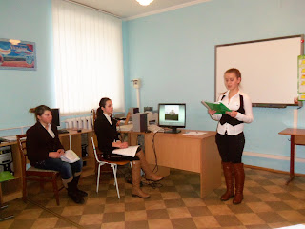](https://blogger.googleusercontent.com/img/b/R29vZ2xl/AVvXsEj-ODeLp__St5Wq4f8LEQJF5j72KgQMJ9HyyCj3mSP26mPoNbDH6LimZT4hcFwQpu4WVMYuG6smUCDqFdJ30Z4iAU9paEzW3xlotPeR_GsbzQcV_NiIOXXJL0MEfRl-QJLG9gUnD2r11ek3/s2048/100_3969.JPG)**

**[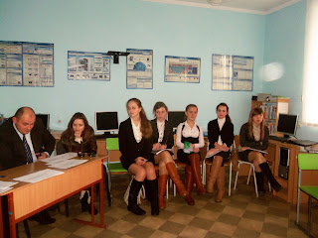](https://blogger.googleusercontent.com/img/b/R29vZ2xl/AVvXsEjKDoGPchN5tn5k4liA3a-qsbh-roW5kzdTZq_ei_xG5yYoRIBtRrjosWQ-1nidRN1Cbs8MMH9e325Rx93kzvA_2rPti_gYwR3gP3Uw9B7VA7dwDGhFytkTZ3s3BwJSYQLa3i2HSRVOyqqG/s2048/100_3966.JPG)**

**[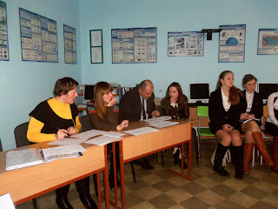](https://blogger.googleusercontent.com/img/b/R29vZ2xl/AVvXsEjso7rjSPSSyPwdhegcV9Dqz83uoA0Fpk9y6KR9HJVg63CofMlSDk5ebm0LjsyMqKUQKv8XZFMB0DkBfGvhFl37WnQ3KniFMpXI-omLmIlH05ETaYwSbMsxYsGU-u9dIZUBq16fzFSMppN1/s2048/100_3965.JPG)**

**[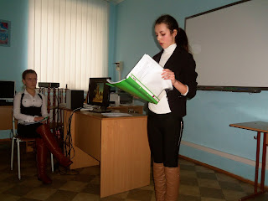](https://blogger.googleusercontent.com/img/b/R29vZ2xl/AVvXsEjyOXHG3N1T21F87FAcAOgojASDI4IGai8_LAFaFdcwG9_LPtqMjwk3SyX-s9jpLk76kqluL-CU70DM8jAFlzL1WsPEaCrigFzexTXqzQWLqsgYnB1erVBfx0sk8mhHtHUBjuL1xAxEQmCi/s2048/100_3964.JPG)**

**[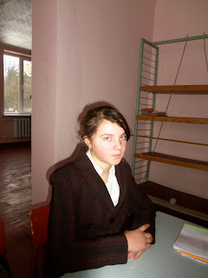](https://blogger.googleusercontent.com/img/b/R29vZ2xl/AVvXsEjItR9anooKb_ZxBPh8m6naQpfndlWJHz7IwaQ0KvSFi0bUoX2sk85sNoqZ87LYgmVi_-zxpAryQNkr9kauS8z7uPPBBPBrHEqnkQpRmXylHThf2IG6dqStxK2rGv_mtJcKPYCJhNycmaDH/s2048/100_3949.JPG)**

**[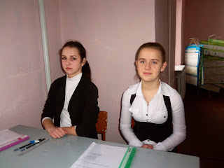](https://blogger.googleusercontent.com/img/b/R29vZ2xl/AVvXsEh4O-5ZJInDHFPNfcF_5JGgzfnBclhS9ryuE5Rm7vQZ5rCqZxuCJMbfsSbsTdzoq4aiueQ7uha68xifeUbTo9__AGwIowaHwLJvcmgipueR1s9JQ-PcC0x71beNuM-yxSjVmvX0Ie7b8Y07/s2048/100_3947.JPG)**

**[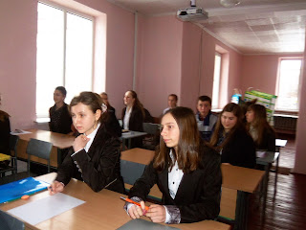](https://blogger.googleusercontent.com/img/b/R29vZ2xl/AVvXsEiaBBTe6MJkX6-i2YDyvg0EUpeialK5AojLxSLfqk7H7_5RoB0cGrzVxfjfyYT494hlS2ZK7T_OjIw4HfbCjgNjUCALbWpRhCCIPyZB6b6U82sywB0M7hGzYTGEgfGQofLgJD4OezQywbcp/s2048/100_3944.JPG)**

**[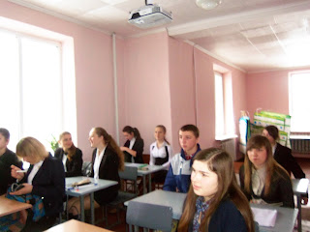](https://blogger.googleusercontent.com/img/b/R29vZ2xl/AVvXsEir2ChMswpRJRORCYphtE9RMuOlPIwjD1WQAVTvZYfPg5Vfx9hux1ArUQuCefrzJ-9n6RlhzzZGNsX2lTNJoQ9_upeyhDwrpkLwhuZME5ESDAv5Lg8gKSfEj3VRbORByqir-sFY9ctfcnYi/s2048/100_3943.JPG)**

**[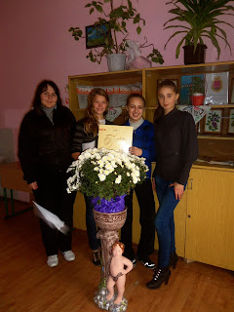](https://blogger.googleusercontent.com/img/b/R29vZ2xl/AVvXsEg013lqTFwueOblV9UgFEYElwt-qdst-JuWSFpZH2FG9QPsM_0D6qG4H2B_J3TLRUzGxML34jqOpKSPDrZnglck5z_4v8K_Sq4w0Nwy08umz2FJ0GwmjUTdpVkAm-NbiqhYGjWSkRCgy1Zu/s2048/100_2897.JPG)**

**[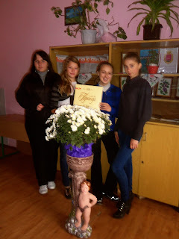](https://blogger.googleusercontent.com/img/b/R29vZ2xl/AVvXsEhqROZlCtkxrqfRoFNY_6vhTYahDXhA4z1LXjvZfUZ0-ZhOmTpEgSokenxrUDBsjr38f-J1PGRBnr8UHwE1DhaUU56KYVinYBCBq3x6E_n_f5sz-qCapT4IlDsnLLGgFr1vcRTG0y5HZj7f/s2048/100_2894.JPG)**

**[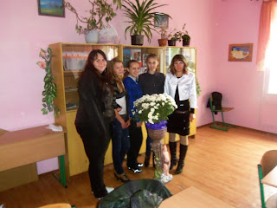](https://blogger.googleusercontent.com/img/b/R29vZ2xl/AVvXsEiNPtT1QGUh_gujwv78OtO19eJ8c85ChJ1MZxYFonQ4VC4gYJB-OQ5cCB2pmbrqFaVVpRXrcu6QmKUSqwDQsyTFtNbBKG-VNFMnwR6SCqswzWWrFy5-oid5XIOXKQ6NyRXy55z39Hf54HIQ/s2048/100_2892.JPG)**

**[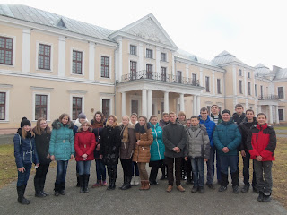](https://blogger.googleusercontent.com/img/b/R29vZ2xl/AVvXsEg0xB7tdjV4pJD9Js4zDJLDlKQQ5jL34jF8yxBHTHss8etDqqe_eoXY0Yiz7G3FXqlYLpMJoCUhf-IQ4y5gV9_OnftTmMykLtK6bmxeLP5VphtpBfFc3RBlHBKhZtDYExNjD4irTNdYWfzm/s1600/100_5700.JPG)**

**[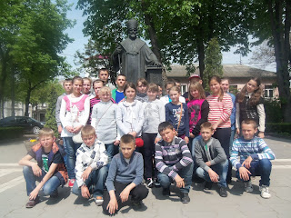](https://blogger.googleusercontent.com/img/b/R29vZ2xl/AVvXsEhY7N1vhgAGNoqR9jpN1U5vcEqNvVkxm8luB7gyUOroAAhRy8Dp7LsAxAPLMbAeHjsbEKSnPWyqe_5LRkkp2AAFXSNRj1kc5q8DDWfrJ8S1CWmDa6JXQ4h-XWIdMEW9yqWkbkvKWa3wjmOF/s1600/100_5838.JPG)**

**[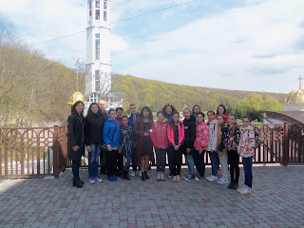](https://blogger.googleusercontent.com/img/b/R29vZ2xl/AVvXsEjZT7tcIbyGT41Nv4pTqA02XCjYXyT2ckNCOMrcmbDwSjb3HK-ArgvE3clH_ZyCqwWr5cQa2P3LeGovh-37RP0Ai1geRvPxH8NmdbXzrSHVamDp2m13RN2HOn1TqOJ3laEXMRMr1Xpiwfrz/s1600/100_7218.JPG)**

**[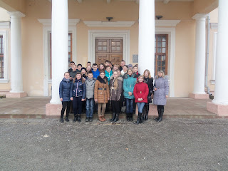](https://blogger.googleusercontent.com/img/b/R29vZ2xl/AVvXsEiqF0fwXGS3CY0jY19BOqxpDu7CDWo4xwkxTdFk2568ZHRv4SrBEv9y9rNq3y7KK4gDa7Cp2VJU3QpKwLN7HT_pmzCkh6MSA39kSx9lerlGNxExM3Pz6Fb4v-3cMAZ0dWYJJQZS150svmg2/s1600/100_5714.JPG)**

**[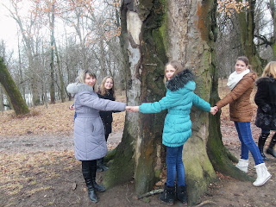](https://blogger.googleusercontent.com/img/b/R29vZ2xl/AVvXsEiR2lgh2Dpo54m3PevXZTk0lbCAmkoZij5MxZJ3HEL-05pv2Vx1o4koesy4ZdftATLOnya_J2phPS-L_K9-W06d2MBWa1wZ1oclQWFydwPMX5-cMyqSOzcBb-lp57NfvdCRPUo8WWEqCLJg/s1600/100_5741.JPG)**

**[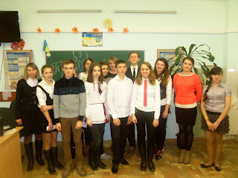](https://blogger.googleusercontent.com/img/b/R29vZ2xl/AVvXsEhNh1Wz_cmKnILv4Q3t1YQfnVVq1_Zsj8QkYIUMnuDWrqAuww0DNNQRkQhuMgGXbPUKJWvPWJRdD-omwJ1PZxCCOZhtU0Fnzy44qzSj8u9K_w4TgWmuZeJ_oYpRmIxOHT7gT5VZNvns-b_C/s1600/100_5548.JPG)**

**[](https://blogger.googleusercontent.com/img/b/R29vZ2xl/AVvXsEjNW22yVQ72c51ylzIBL_AEF_wdqIcReqQb7G2Z3hgjQiVLMBeLU-NdMrhmwh2G6D1nYgIhBxYI6UdwCx6d5p3_lQJOAo7g8_jU75QAVHA-9i5F8bdIiCvsYm4PpjQ5G4Z2KUJpVK8fsEzC/s1600/100_5750.JPG)**

**[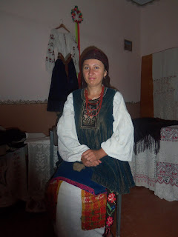](https://blogger.googleusercontent.com/img/b/R29vZ2xl/AVvXsEh0ECdmV9CVrsKLJL6Kd9KRW1d_KoM09L134TBkqowMetJEPSg0tZzggWll3CgXokMxOJOcsl2WPewx88Xv-s2zJcRkzfBv_CJkAIfeMn7prVl0rxWIuy649yMod7GQYi3rkfeNMLjKDwmU/s1600/100_7778.JPG)**

**https://brataschykmariya.blogspot.com/p/blog-page_48.html**