Unit 14 Date __________________Name and Surname_____________________________
LISTENING
Listen to two people Paul and Holly. For statements 1-5 choose T or F and 6-10 choose the best option a, b or c.
 | T | F
- Paul works in the centre of his town.
- Paul usually uses his scooter to get to work.
- Paul can drive a car.
- He goes to work by taxi when the weather is bad.
- To other cities Paul travels by trams.
- Holly gets to college and cafes by___
- 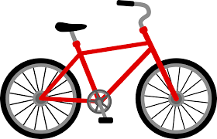 b) c)
- Holly uses a_____to go shopping.
- b) c)
- The girl travels by_____when she visits her friends in other cities
- 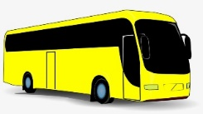 b) c) 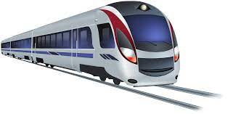
- Holly never travels by___
- b) c)
- Taxis are very_____for the girl.
- cheap b) slow c) expensive
VOCABULARY AND READING
Match the sentences halves
A but it`s very expensive.
B with her best friend Liz.
C and have a family picnic.
D because they are the fastest.
11. ____Planes are the best for business trips
12. ____Let`s go to the park on Saturday
13. ____I want to buy a new laptop
14. ____Kitty often goes out

Read the adverts and for questions (15-20) choose the correct advert (A-F).
In which advert___
15. can you see two professional sports teams? ___
16. must you register online? ____
17. must you pay to visit the event? ____
18. can you see the latest Hollywood movie? ____
19. can you see actors and actresses performing on stage? ____
20. can you learn about the culture and traditions of people many years ago? ___
GRAMMAR
Circle the correct option Let`s or Shall we (21-25).
- Frank, 21. let`s/shall we go to a museum on Friday afternoon.
- Sorry, I can`t. I`ve got a meeting at 12 o`clock.
- 22. Let`s/Shall we go after your meeting?
- Yes, that`s a good idea. 23. Let`s/Shall we meet in a café next to the museum.
- OK. 24. Let`s/Shall we have a snack there first?
- That would be nice. I`m always hungry after meetings. So, 25. let`s/shall we have a snack at 1 pm at a café and then go to museum.
Complete the sentences (26-30) with and, or, because, but.
26. I want to go to the seaside ____________________ to the mountains on summer holidays.
27. Lots of people like travelling by train _______________________ it`s not very expensive.
28. We want to watch this movie on a large screen ________ there isn`t a cinema in our town.
29. Going by Underground is fast __________________________________________ cheap.
30. Ted often goes swimming ________________________________ it`s good for his health.

Your mark________________

