Unit 12 Date_______________ Name and Surname________________________________
LISTENING
Listen to a letter from Sue to her new pan-friend Emily. For statements 1-10 choose the best option a, b or c.
- Sue studies at the_____form.
- sixth b) seventh c) eighth
- Sue wants to become a(n)___
- b) c) 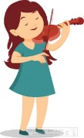
- Sue`s mom is a___
- b) c)
- Now mom is at (in) the___
- hospital b) garden c) cafe
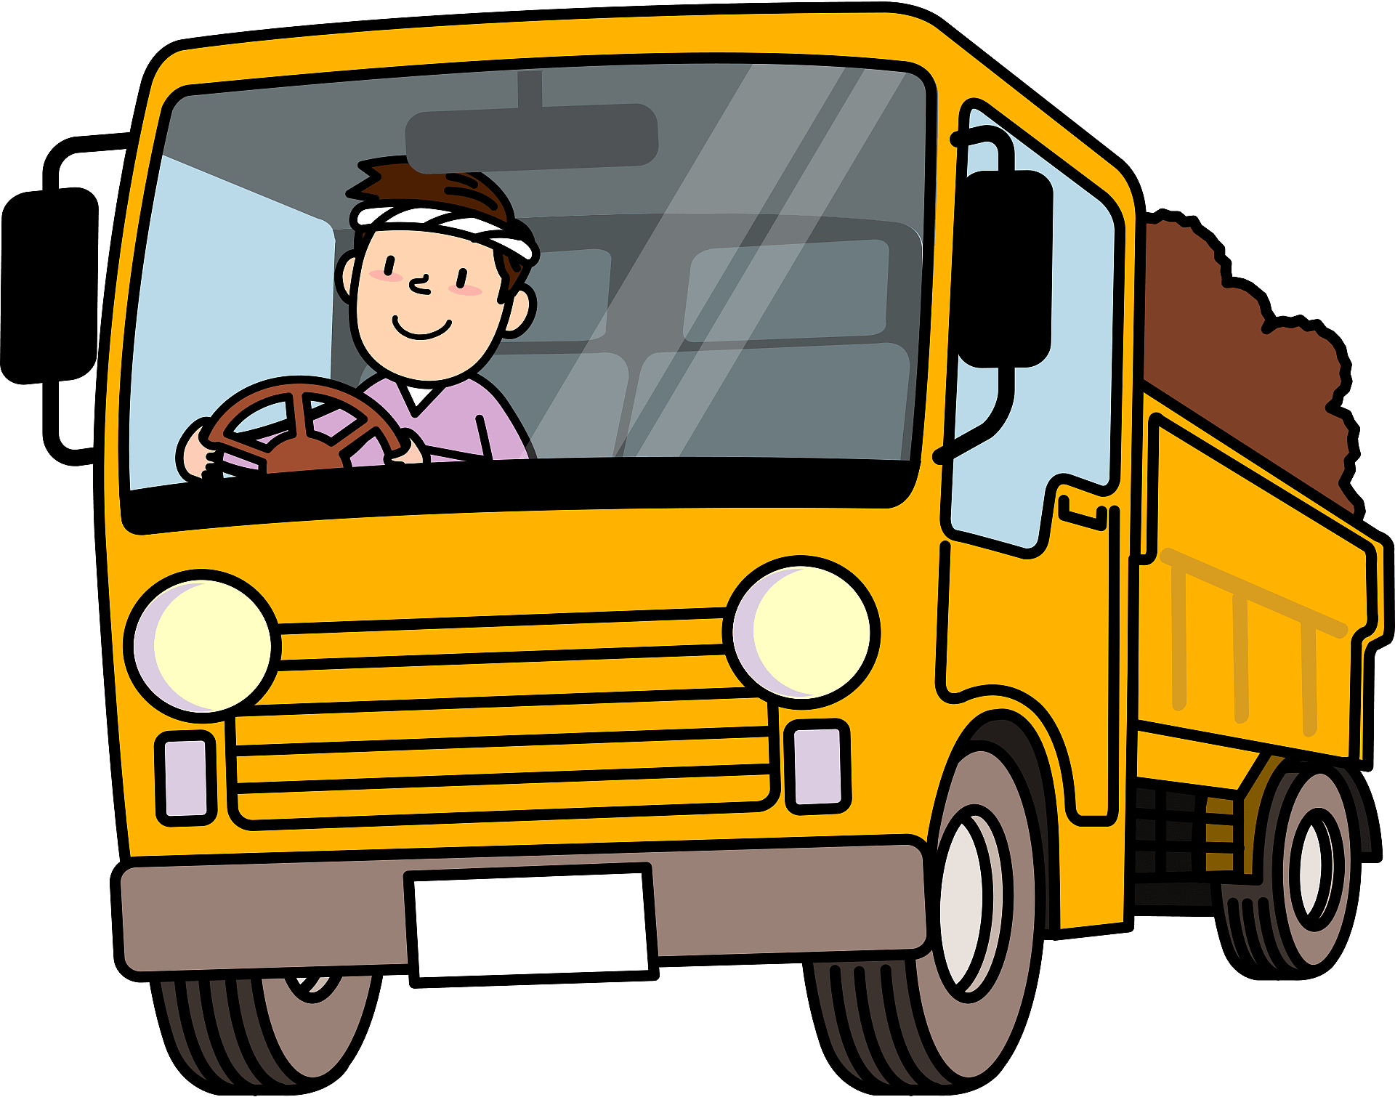
- Sue`s dad is a____

- b) c)
- They see each other____
- not often b) very often c) every day
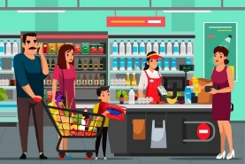
- Sue`s sister works at (a)____

- b) c)
- Julie works______days a week.
- four b) five c) six
- Now Julie is___
- painting pictures b) drawing pictures c) taking pictures
- Julie wants to become a___
- b) c)
VOCABULARY AND READING
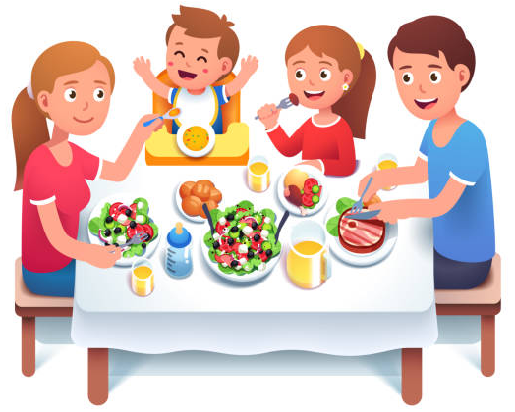
Look at the picture and complete the text (11-20) with the words starting with the given letters.
Look at the photo of my family at a dinner table. There`s a big 11. b_______________ of salad in the middle. My dad is eating meat with a 12. f____________ and a 13. k__________. My mom is feeding Tommy, my younger brother, from a 14. s______________. There are two 15. g_________________ with orange juice. We often drink it for dinner. There is some water for Tommy in the 16. b____________. I`ve got some meat and tomatoes on my 17. p__________. We don`t like spicy food, so there isn`t any 18. s______ or 19. p_______ on the table. We also don`t drink sweet drinks. Do you see any 20. s________ on the table?
GRAMMAR
Complete the sentences (21-25) with Present Simple or Present Copntinuous form of the verbs in brackets.
21.Ted is a farmer. He _____________________________________________ (grow) food.
22. It`s very early. Jim______________________________________________(sleep) now.
23. Children usually are very busy and they ___________________________(not help) their mom with the housework.
24. Look! It`s warm and sunny. My sisters_____________________________(play) outside.
25. Our father is a doctor. He __________________________________(not work) at school.
Complete the requests (26-30) with Can I or Can you and with the words in the box
me to school my question your bedroom your tablet a cup of tea

26. _________________use_________________________________________, Jane?
27. _________________drive________________________________________, please?
28. _________________answer_______________________________________, please?
29. _________________have_________________________________________, mom?
30. _________________clean_________________________________________, please?

Your mark__________

