Unit 11
Date_____________________ Name and Surname________________________________
LISTENING
Listen to the dialogue twice. Put numbers 1-8 next to the names of the teens according to the information in the dialogue as for the things they have got. Then complete the sentences 9-13 with the proper answers a, b or c
Lucy_____________
Ron_____________
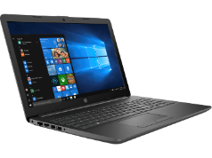
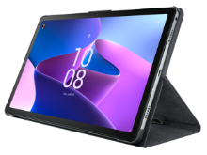
5
7
1
3
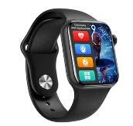
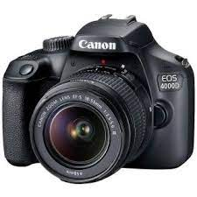
6
4
2
8

9. Lucy`s digital camera is…
a) old b) new c) pink
10. Lucy takes photos with her…
a) tablet b) digital camera c) smartphone
11. Lucy watches movies or does school projects on her…
a) lap top b) smartphone c) tablet
12. When Lucy listens to music she uses her…
a) headphones b) smart speaker c) flash drive
13. Lucy`s smartphone is…
a) pink b) blue c) purple
VOCABULARY AND READING
Read the text about a famous blogger. For statements 14-20 choose T or F
Hello! I`m Rebecca from Canada. I`m a famous blogger and I often get e-mails or messages from my followers and fans with lots of different questions. Today I am going to answer some of them. As for my favourite TV shows, I haven`t got any because I never watch TV. I usually watch some interesting videos or movies in the Internet on my tablet. I love listening to music on my smartphone. I always listen to music when I play tennis with my friends at the weekends. Also, I listen to music when I do some work around the house or even when I study. My favourite band is BTS. It`s a great Korean band and the boys are famous all over the world now. I usually go to all their concerts. In my free time I enjoy cooking but I never show it in my blog. It`s my secret hobby. I can make perfect sweet things like cakes, biscuits and other delicious desserts.
 | T | F
14. Rebecca is American.
15. The girl sometimes watches TV.
16. Rebecca watches movies on her laptop.
17. She enjoys listening to music on her smartphone.
18. She plays tennis on weekdays.
19. Rebecca`s favourite band is from China.
20. The girl loves making desserts.
GRAMMAR
Write the sentences in Present Simple using proper adverbs of frequency
Helen
Jim and Liz
My brother
Children

21._______________________________________________________________________
22._______________________________________________________________________
23._______________________________________________________________________
24._______________________________________________________________________
Complete the questions with how much/how many
25.____________________________________________movies do you watch every week?
26. ___________________________________________________apple juice have you got?
27. ______________________________________money does your sister spend every day?
28. ______________________________________________________songs can they sing?
29. _______________________________________________concerts do you want to visit?
30. __________________________________________________meat is there in the fridge?

Your mark____________

