Unit 20 Date __________________Name and Surname_____________________________
LISTENING
Listen to an advert about the zoo. For statements 1-8 choose T or F.
 | T | F
- The Park Zoo is open seven days a week.
- The zoo is open until five o`clock on Sundays.
- You can`t stay at the zoo after it closes.
- You can`t get to the zoo by train.
- You can see the elephants after the 3d of May.
- You can buy a T-shirt at the zoo shop.
- Children need to pay £5 for the ticket.
- A family ticket to the zoo costs ten pounds.

VOCABULARY AND READING
Do the animal crossword (9-14)
Read the adverts and for questions (15-18) choose the correct advert (A-F).
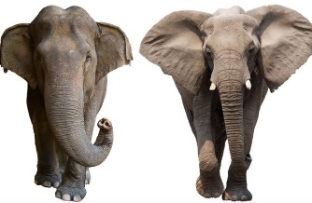
Most people know that there are two types of elephant, the African and Asian elephant. But what`s the difference between them? Well, African elephants are bigger and havier than Asian elephants. African elephants have also got huge ears which they use not to feel hot. They live in hot countries and use their ears to stay cool. African and Asian elephants can hear things that people can`t hear, but they can`t see further than 20 metres.
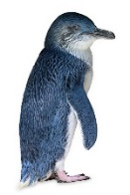
There`re around 18 types of penguin in the world. Emperor penguins are taller and havier than other penguins. They can swim faster and dive deeper than any other bird and they can stay under water for 20 minutes. Penguins are usually black and white, but there`re little blue penguins. They live in Australia and New Zealand. They are smaller and slower than emperor penguins. There are not more than a million of these penguins in the world.
17. Emperor penguins_____
A swim faster than other animals
B stay under water for a long time
C swim for about 20 minutes
18. Little blue penguins____
A are faster than emperor penguins
B are black and white
C live in two countries
15. African elephants___
A are smaller than Asian elephants
B use their ears when they`re hot
C can see better than people
16. Asian elephants___
A are smaller than African elephants
B have bigger ears
C can`t hear well
GRAMMAR
Complete the sentences (19-24) with the verbs in brackets. Use Past Simple.
19. My brother _______________________________________(visit) our local zoo yesterday.
20. Her mom _______________________________________(cook) a tasty dinner last night.
21. We______________________________________(live) in the countryside two years ago.
22. They ___________________________________________(wait) for a bus for a long time.
23. Fanny _________________________ (carry) home two heavy bags from the supermarket.
24. Jim ___________________________________________(study) not very hard last month.
Write negative sentences about yesterday (25-30) in the Past Simple.
25. I - _______________________________________________________
26. she - _______________________________________________________
27. my mom - __________________________________________________
28. we - ______________________________________________________
29. Julie - _______________________________________________________
30. Tim - ______________________________________________________

Your mark________________

