Unit 19 Date __________________Name and Surname_____________________________
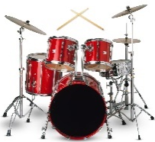
LISTENING
Listen to the dialogue and for options (1-10) choose a, b or c.
drums
- Helen______in Nick`s band.
- dances b) sings c) plays the drums
- Nick plays the____.
- b) 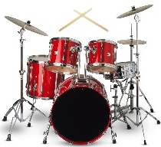 c) 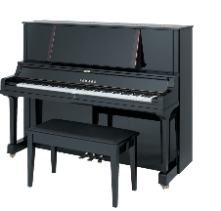
- Nick`s band needs a person who can play the____.
- b) c)
4. Sam agrees to play the guitar for Nick on_____.
a) Wednesday b) Thursday c) Friday
5. First Sam needs to come to Helen`s flat at_____.
a) 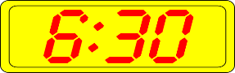 b) c) 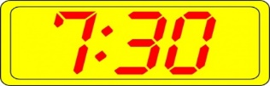
6. Nick`s band meets_____.
a) in a garage b) at Helen`s flat c) in Nick`s bedroom
7. Sam needs to bring____.
a) b) c) 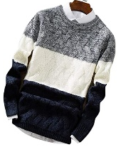
8. The band`s next concert is_____.
a) at a party b) at a club c) at a college
9. How much money does the band get for a night?
a) £10 b) £25 c) £110
10. How much does Helen get per night in a band?
a) £10 b) £25 c) £110
VOCABULARY AND READING
Write the adjectives (11-16) describing the pictures.
11. s___________________ 12. l____________________
13.s_____________________ 14. f_______________________
15.d___________________ 16. h___________________________
Complete the sentences (17-22) with the given words.
late excited brilliant easy friendly heavy

17. We are very ______________________________ about going on a school trip next week.
18. My brother is a very _________________________________ boy. Everybody loves him.
19. If you don`t want to be ___________________________________________, catch a taxi!
20. This test is ______________________________________________________. I can do it.
21. I can`t carry this bag, it`s very _______________________________________________.
22. Our teacher has always got _____________________________________________ ideas.
GRAMMAR
Complete the sentences (23-30) with was/were or wasn`t/weren`t.
Hi, Sandra!
How are you? How 23. ____________ your weekend? I 24. __________ at home on Saturday because it 25. ____________ rainy and windy. I 26. _______________ happy, because I don`t like bad weather. My little sister 27. __________ also at home and that 28. _________________ a problem because she`s very noisy and loud. I always need to look after her when my parents aren`t at home and on Saturday mom and dad 29. ____________________ at work until 3 pm. So, Saturday 30. __________________ a good day for me.
See you soon,
Kate.
Complete the questions (31-34) with question words How, What, Where, When and write your answers.
31. ____________were you yesterday?
___________________________________________________________________________
32. ____________do you like eating for lunch?
___________________________________________________________________________
33. ____________does you mom go to work?
___________________________________________________________________________
34. ____________old were you in 2020?
___________________________________________________________________________

Your mark________________

