Unit 17 Date__________________ Name and Surname______________________________
LISTENING
Listen to a boy and a girl speaking online. For statements 1-6 choose T/F, complete the sentences 7-12 with the best option a, b or c.
 | T | F
- The girl is at the beach now.
- She goes swimming every evening.
- She is in Italy.
- The girl is staying at a hotel.
- There`s a swimming pool and a café at a hotel.
- The girl goes to the centre of the city every afternoon.
- The boy is in the _____now
- b) c)
- Jim is____than his brother.
- younger b) older c) bigger
- The boy is visiting his____
- aunt b) uncle c) cousin
- They are having a birthday picnic near the_____.
- b) c)
- Jim`s aunt is ____.
- attractive b) unusual c) amazing
- She`s_____ today.
- 45 b) 53 c) 35
VOCABULARY AND READING
Look at the picture and complete the text (13-20) with the words starting with the given letters.
My name is Jason. I live in a beautiful 13. 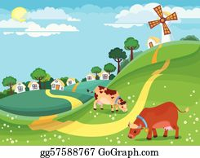___________________ with my parents. It`s a great place for a quiet life and a 14. p___________ place for lots of tourists who enjoy eco-tourism. There`s a large 15. ______________ with tall 16. _________ nearby. There isn`t a 17._____________, but we can swim in a clean 18.__________ in summer. We`ve got a 19. f____________ 20. 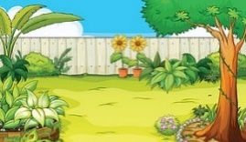___________ with 21. am______________ bright 22. ______________ and green soft 23.________ behind the house. Also, there are some 24. un_______________ bushes here. Gardening is my mom`s hobby.
GRAMMAR
Look at the information about Kyiv and Lviv. Write sentences with the words (24-29) to compare the cities.
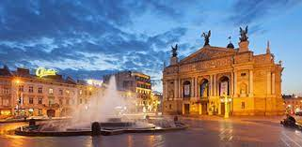 Lviv | 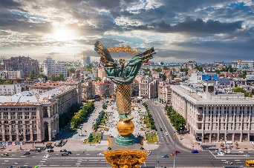 Kyiv
Area: 149 km²  Age: more than 760 years old  Average high temperature: 19,6⁰C | Area: 839 km²  Age: more than 1540 years old  Average high temperature: 19⁰C

24.(old)____________________________________________________________________.
25. (big)____________________________________________________________________.
26. (hot)____________________________________________________________________.
27. (small)__________________________________________________________________.
28. (young)__________________________________________________________________.
29. (cold)___________________________________________________________________.
Write sentences (30-35) using comparatives
30. My car/expensive/your bike - ________________________________________________
___________________________________________________________________________
31. Playing games/exciting/doing homework - ______________________________________
___________________________________________________________________________
32. English/popular/French - ____________________________________________________
___________________________________________________________________________
33. Lions/dangerous/cats - ______________________________________________________
___________________________________________________________________________
34. London/famous/York - ______________________________________________________
___________________________________________________________________________
35. Cakes/delicious/biscuits - ____________________________________________________
___________________________________________________________________________

Your mark_____________

