Unit 15 Date __________________Name and Surname_____________________________
LISTENING
Sandra is describing what people are wearing. Listen and write the correct letter (A-H) next to each person’s name (1-8). pants (US) = trousers (UK)
Listen to Emma speaking about her housemates. Write the numbers (9-12) next to the names.
Robert_____ Jason____
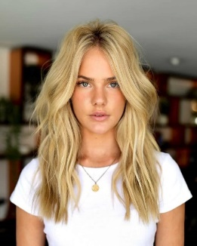
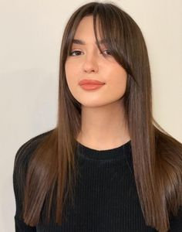
Sarah______ Charlotte_____

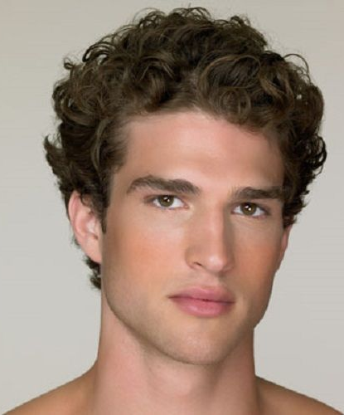

9. 10.

11. 12.
VOCABULARY AND READING
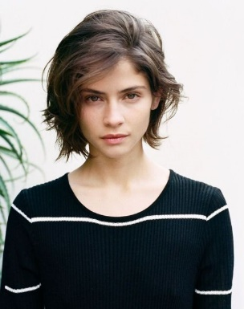
Match the descriptions (13-16) to the photos (A-D).

D_____
C_____
B_____
A_____
13. This is a new girl in my class. Her name is Ann. She is about 20. She is very tall. She`s got short curly hair and she wears glasses.
14. Daniel is 17. He isn`t tall. He`s got curly blonde hair and he is really good looking.
15. This is Paul`s cousin. She is pretty. She`s got dark brown hair and she is an actress.
16. This is Tony`s girlfriend. Her name is Ella. She is tall and has got long brown hair.
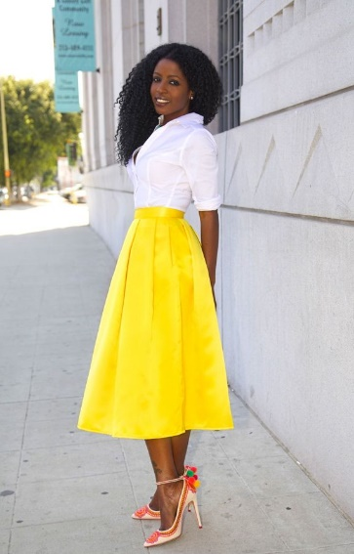
Complete the text (17-24) with the suitable words.
This is my aunt Joe. She isn`t old. She is 17._________________ and beautiful. My aunt isn`t short. She is 18.______________and she is also not fat. She is very 19.________. She`s got long curly black 20. ________ and beautiful big dark 21.___________. Aunt Joe is wearing a long yellow 22. _____________ and a nice white 23. ______________. She has got new modern 24._____________ on her feet.
GRAMMAR
Complete the sentences (25-30) with the plural form of the words in the box.
country T-shirt bus dress baby eye

25. I`ve got lots of long __________________________________________ in my wardrobe.
26. We like travelling to different _____________________________________ of the world.
27. My mom has got beautiful green ________________________________ and a nice smile.
28. There aren`t many ________________________ in the streets of my town so late at night.
29. She`s got two twin brothers. They`re still ______________________________________.
30. Alex prefers wearing _____________________________________ with jeans in summer.
Complete the sentences (31-36) with is/are, have/has got, is/are wearing.
31. Look! Jessica _________________________ a beautiful white silk scarf around her neck.
32. Her children ___________________________________________ short wavy blond hair.
33. Emily ________________________________________________________ tall and slim.
34. Her grandfather ______________________________________ a big house in the village.
35. Students at this class _____________________________________ very clever and polite.
36. The boys _____________________________ yellow and blue uniforms here in the photo.

Your mark________________

