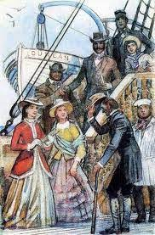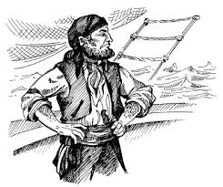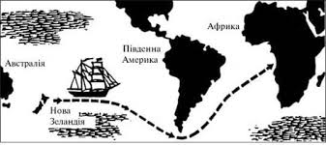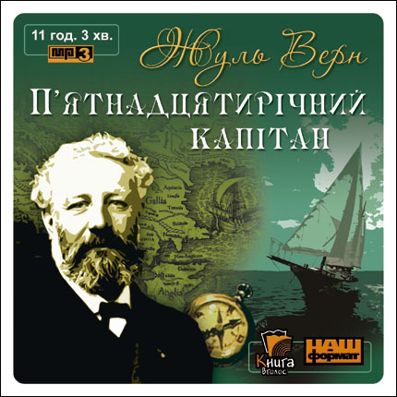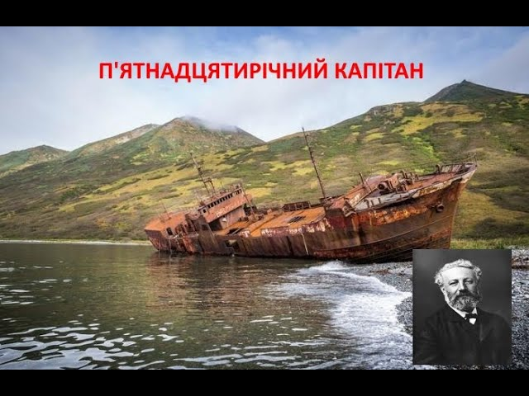

Вороги

Друзі

Герої роману

ПАСПОРТ ТВОРУ__________________________________________________________________________________________________________________________________________________________________________________________________________________________________________________________________________________________________________________________________________________________________________________________________________________________