Матеріали
з досвіду роботи учителя англійської мови загальноосвітньої школи І-ІІІ ступенів села Клювинці
Качуровської Марії Петрівни
Конспект уроку англійської мови
( як другої іноземної мови) у 5 класі
Let's Go To The Country!
Підготувала учитель англійської мови
загальноосвітньої школи І-ІІІ ступенів с.Клювинці
фахівець вищої кваліфікаційної категорії
М.П.Качуровська
Мета уроку
Освітня: вчити учнів вживати лексику, пов’язану з сільським життям; Практикувати у вживанні Present Simple тa Present Continuous Tenses; Активізувати вживання питальних та заперечних речень у Present Continuous.
Мовна: Спонукати учнів до вільного мовлення у мовленнєвих ситуаціях, наближених до реальних.
Практична: Тренувати у запитуванні інформації та передаванні отриманої інформації.
Розвивальна: Розвивати комунікативні вміння учнів; заохочувати до спілкування та співпраці в групі, в парі; формувати вміння бачити позитив у світі довкола.
Обладнання: Smart Board, додатки до уроку, комп’ютер, диски із записом текстів для аудіювання, дитячі долоні, вирізані з кольорового паперу, постер, маркери, квіти, виготовлені з паперу із завданнями для пантоміми.

Хід уроку
І. Початок уроку
I. Greeting
-Good Morning to you!
What a fine morning!
I’m glad to see you!
-Good Morning to you!
It’s a fine morning!
We are glad to see you too!

Teacher: Dear pupils! Let me introduce our guests. They are English teachers of our region. Let’s greet them!
Today we continue our topic “let’s go to the country!”.
We’ll do a lot of various activities which will develop your speaking, listening, reading and writing skills.
I want to start our English lesson with a surprise! The matter is, we have got an invitation from the village of Wiltshire!!! Bob and Kath invite us to visit them in Wiltshire. So, we are going to the country! Are we ready for the trip?
Let’s check it!
--
II-Фонетична вправа
Listen to the sounds and say if it is a country sound or a town sound.
Sounds, CD2, Tr.45
ІІ. основна частина уроку
1. warming-up
- Assoсiations
T: and now, what do you associate the word “Kluvyntsi” with?
P: make associations
T: You know we must be ready for our trip to the village of Wiltshire. What do you expect to see there?
P: name the words
- I-CAN-DO-GAME
T: I’m sure; there are a lot of activities we can do in the country. So what can we do here, in our village?
Try to complete the puzzles and you will be able to answer this question.
Ps. make puzzles and answer: I can…
T: And what do you think, can the children do in the village of Wiltshire?
-They can…
- Writing
Pupils get cut-up hands
Write on each finger the main activities you like doing in the country.
I like going fishing.
I like picking flowers.

Ps: make the poster “My favourite activities”
(Go fishing, pick flowers, feed animals, have fun, swim in the river, work no the fun, eat apples, play football, help in the shed, ride a bike skate, draw a picture… )
- Singing
T: Now I see you are really ready for the trip! Let’s go to the village of Wiltshire!
Ps: sing a song “Leaving town “CD-2 ,Tr.48
2. Listening and Speaking (CD-2 Tr.41)
- Pre-listening-activity
Role Play: phone call
T: speaks on the mobile
T: we have excellent news: the Jacksons are going to the village of Wiltshire too. So your friends Lisa, Emma, Terry and Sam will be there too. I wonder, are they ready for the trip? We will check it. Listen to the story and complete the table.
- Listening to the text ( CD-2 Tr.41)
Під час слухання учні заповнюють табличку в парах в межах групи.
 | Tiger | Emma | Lisa | Sam | Terry | Mr.  Jackson | Mrs.  Jackson
closing
the door
opening
the window
feeding Tiger

sitting
on the wall
sending messages
saying goodbye

T: Are you ready? Let’s check it.
Завдання для груп:
- 1) Are the Jacksons ready for the trip? P. make sentences.
- 2) Oops, sorry, but my table is not completed. Can you help me, please! What is Sam doing?
Sam is feeding tiger. ….
- 3) I would like to compare our results! Is Sam sitting on the wall?
-No, he isn’t…..
- Chinese Whispers
T: Our next activity is the game Chinese Whispers. You know this game, don’t you? So, we need 3 volunteers. I’m sorry, but you have to go out, please.
The class listens to the story and completes the table.
P1. Tells the story to the pupil 2.
P2. Tells the story to the pupil 3.
T: Listen to Ivan’s story attentively and count how many differences are there in their stories.
P3. Tells the story to the class.
T: Let’s compare what is different at Ivan’s story and at Halia’s story.
PPP: Sam isn’t playing computer. He is working in the farm.
3. Speaking and Practicing Grammar
- Watching video
T: Our next activity is pantomime (dumb show). We’ll guess what somebody is doing.
But first you‘ll watch the video and learn how to ask about it.
P: watch video
- Pantomime-Play
T: We have such magic flowers in our classroom! Now choose a flower for yourself. Read the task and make the dumb show. Pupils must guess what you are doing now.
-Are you helping in the shed? -Yes, I’m./ no, I’m not.
Один учень демонструє гру на клас, дальше продовжують гру в групах.
4. Reading and Writing
- Pre-reading task
T: we have got the E-mails here but they were confused. I think, you are the right people to complete them.
- Reading
Each group gets an E-mail and completes it.
T: read your E-mails aloud please to make sure everything works
Groups read their texts.
- Writing
Teacher: I think it would be great to answer your E-mails. You have got e-mails and now you must complete them. Use the Present Continuous. Work in groups, please!
Групи отримують текст з пропусками і продовжують його.
T: put your e-mails into the mail-box and I’ll check them later.

ІІІ. Закінчення уроку
- Your hometask for the next lesson is to write your own e-mail to your friend about your life in the country. Open your daybooks please, and write for tomorrow. Send your messages on my e-mail: kamari40@meta.ua, please. You can see the address on the Smart Board.
- Pupils get their notes.
  - Summing – up
- Speaking in a form of relaxation
Web-net “We want to be happy “
T: stand up in a cycle, please. I held up a ball of string in my hand. We’ll throw it and share with the group what we are doing to feel happy in this wonderful world.
So, we have created a giant web. This web represents our happiness here at school, at home, in our village, in our country Ukraine, on our planet the Earth. Everyone and everything within it is interconnected. And we’ll be happy when the others feel happy too.
P1,P2,P3 let go of your string. What happens to the Web? What happens to us? How do you feel?( Sad, bad,unhappy, disgusting, awful )
Remember, dear pupils,: When someone is unhappy , the others we’ll be unhappy too.
Thank you for your active work, positive mood and I wish you just to be happy!

Resources:

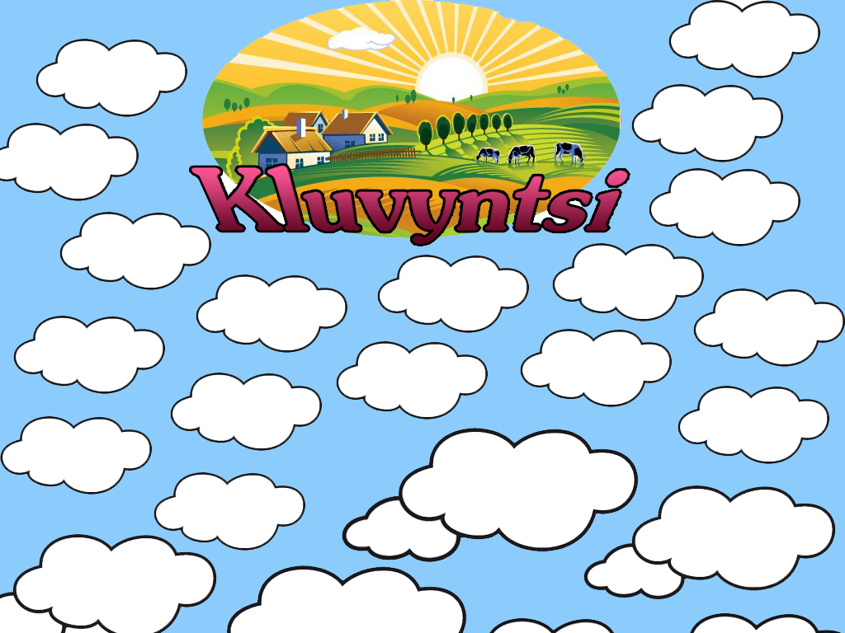

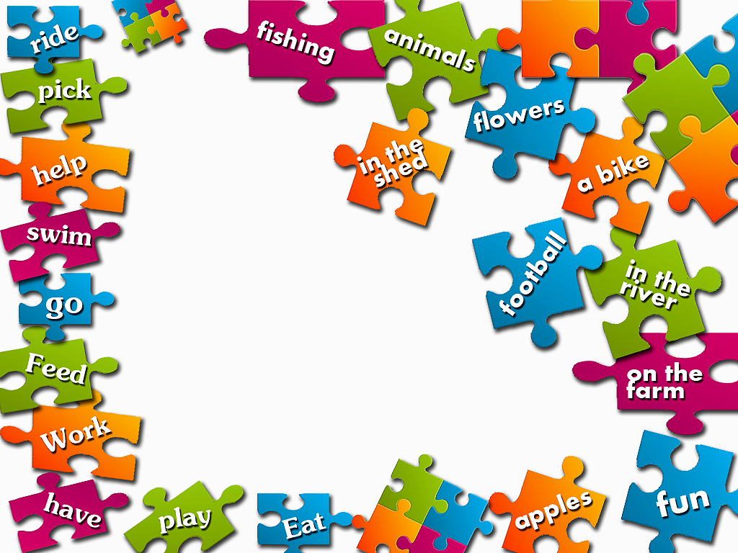

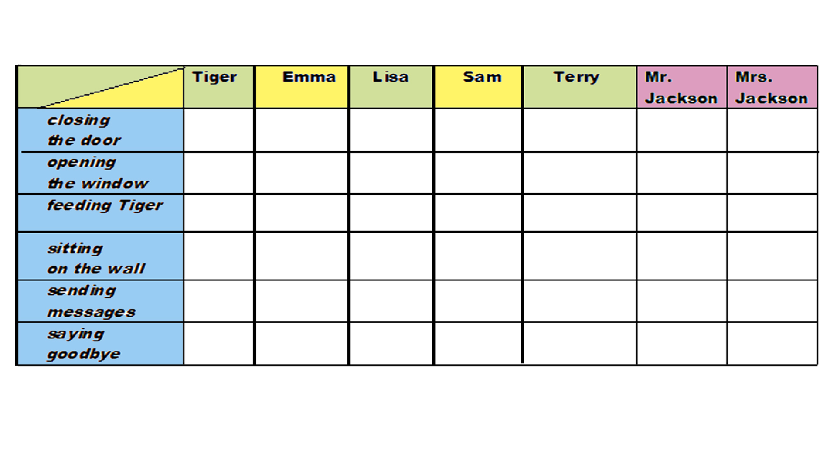
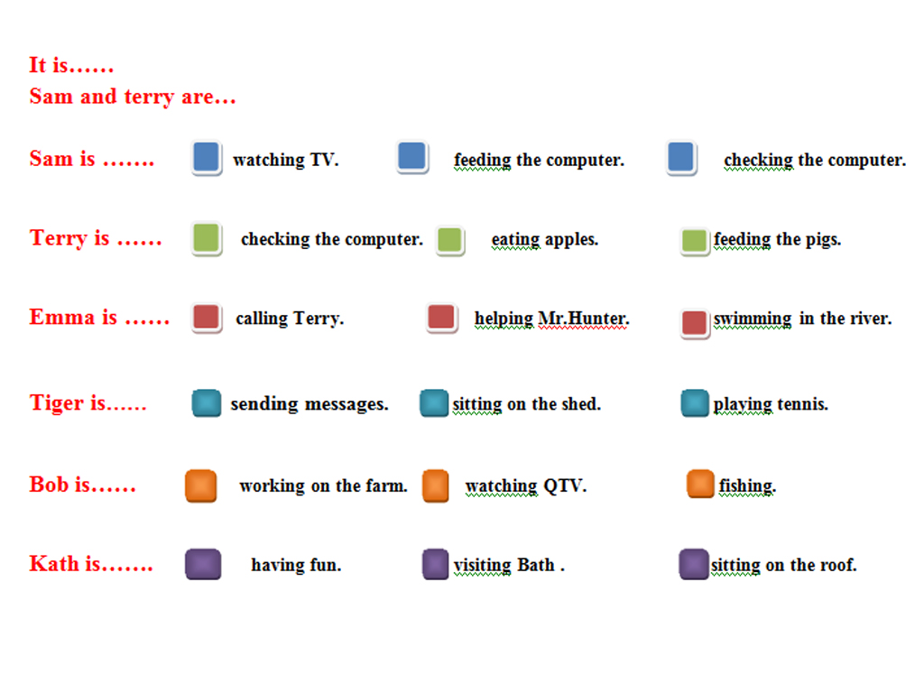
Hi, Yulya!
How are you? We hope you are having fun. What are you doing? Are you fishing or are you watching QTV with Terry? I hope you aren’t spending your time in front of the TV.
Grandma hopes you aren’t making work for the Jacksons. And she hopes you are helping in the house.
Bye, Dad

Hi Taras,
How are you? We hope you are having fun in Wiltshire. Aren’t you? What are you doing? Are you playing football with Vitalik? What is Alina doing?
Is she helping on the farm or she skating? We hope you are going fishing and helping Mr. Jackson.
Bye, Mum & Dad

Hi Mykola,
How are you? We hope you are OK! What are you doing in the country? Are you helping in the shed or are you working on the farm?
Dad hopes you aren’t watching QTV but feeding pigs, cows and sheep on the farm. I hope you are eating a lot of apples and having fun.
Bye, Mum

