План-конспект виховного заходу
«Spring is coming»
Підготував: Гнедько А.М.

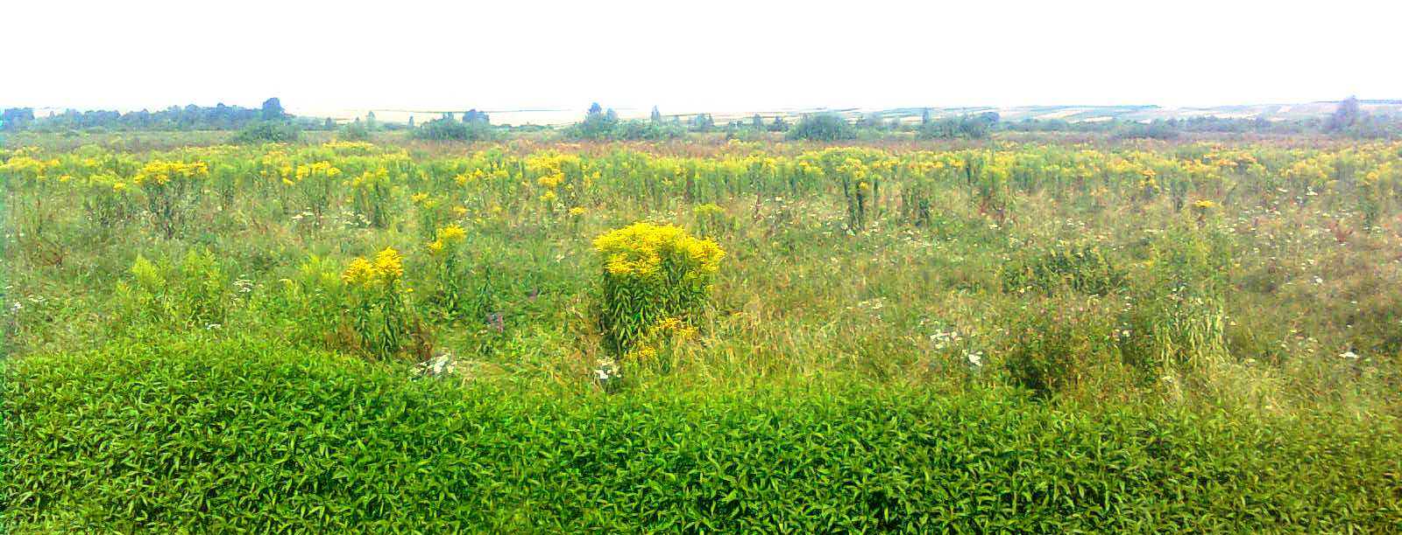

Передмірка 2010

Тема: SPRING IS COMING
Мета: узагальнити знання учнів про весну, весняні місяці, весняні явища,
найпоширеніші весняні свята в Україні та англомовних країнах;
розвивати артистичні вміння учнів, навички виразного читання віршів,
танцювальні здібності;
прищеплювати любов до прекрасного, виховувати зацікавленість до
вивчення англійської мови

Обладнання: весняно прикрашений зал; учасники у костюмах квітів, весняних
місяців, весни, птахів, кролика; портрети Шекспіра, Шевченка; букети
вербових котиків; аудіотехніка, CD із записами мелодій, комп’ютер

Хід виховного заходу

In the spring
In the spring
Sweet and fresh is everything.
Winter winds are no more blowing,
In the fields all is growing.
In the spring,
In the spring,
Sweet and fresh is everything. (Melody __01__)

Dear ladies and gentlemen! Welcome to our bright and merry party “Spring is coming” where there will be a lot of fun for everyone!

It is spring now. Nature awakes from its long sleep. We are the witnesses of a great miracle. It brings new hopes, new dreams and new life.

Winter sleep is over, |
Spring then comes. |
With brooks and flowers |
And young green grass. |

Nature is awaking, |
Birds are singing. |
The sun is shining, |
The bright day is ringing. |

Pass the happy news along, | (Melody____02__)
Listen to the birds’ sweet songs: |
Spring is coming, winter’s gone! |
Pass the happy news along. |

Spring is coming, spring is here! |
Flowers are coming too. |
Pansies, lilies, daffodils, |
Now are coming through. |

Spring is coming, spring is coming! |
Birdies, build your nests, |
Weave together straw and feather, |
Doing each your best. |

I’m happy! I’m happy! |
I sing all day, |
It’s spring, it’s spring again. |

A special guest will come to us today.

A girl (Spring) comes into the hall followed by children-“flowers” and dancing round the girl. (Melody __03__)

I am Spring. Spring – the season of delight.
Apple blossom –pink and white!
Welcome spring with all your joys
For merry girls and merry boys!
People call me the season of hope and happiness. When I came, flowers begin to grow, green leaves appear on the trees. Birds come back from the south. Children and grown-ups plant trees, bushes, flowers and vegetables. My first rains wash the Earth and everything looks so bright.
The flowers are blooming everywhere,
On every hill and dale,
And ah! How beautiful they are,
How sweetly they smell!

In early spring the sun shines warmly. Bright sun-rays begin to melt snow. I’m wearing a white dress. I’m Snowdrop, the first spring flower.

I come a little later. My name is Violet. I am very nice, as you see.

I am a little flower in a nice yellow dress. I like the sun, I like warmth. My name is Buttercup.

I am blue like the sky and my dress is like a bell. I like the sun too. I am Bluebell.

I am Forget-Me-Not. My blooms are blue as heaven; my leaves are fresh and green.

It’s time to call my sons. This is the month of the last frost, of melting snow, of the first buds, of the earliest spring flowers, of the migratory birds. It’s March. Come in, please. ( A boy, dressed as March comes in.)
(Melody __04__)

I bring breezes long and shrill
To stir the dancing daffodil.
Grey winter’s gone away,
The world looks new and gay.

This is the month of heavy spring rains, of the return of birds, of new grass and new leaves, of spring flowers. It’s April. Welcome!
( A boy, dressed as April comes in.)

I bring the primrose sweet
You see daisies at your feet.
April weather, rain and sunshine both together.

April is rich in rain that gives power to nature to renew and grow.
(A girl-rain appears.) (Melody__05__)

Rain, rain, rain, April rain,
You are feeding seed and grain,
You are raising plants and crops
With your gaily sparkling drops.

This is the month of blossoming of fruit trees, of late flowers, of spring birds. Welcome, welcome, dear May! ( A boy, dressed as May comes in.)

I bring flowers, joy and grass,
And many sunny days for us.
In the merry month of May
All the little birds are gay,
All the little flowers smell,
Children are happy, they laugh, sing and say:
“Welcome, welcome, merry May!”

Thank you, my sons. You have worked a lot. Look, how beautiful is everywhere!

Spring brings us some bright holidays too.

On the 8th of March we celebrate Women’s Day greeting our mothers, sisters, grannies, and girl-friends.

On the 2nd Sunday of March Mother’s Day is celebrated. We all love our mothers very much and a lot of poems, songs were dedicated to them.

Poem “Only one Mother” (by G. Gooper) (Melody _06___
Hundreds of stars in the pretty sky; _______________________)
Hundreds of shells on the shore together;
Hundreds of birds that go singing by;
Hundreds of bees in the sunny weather.
Hundreds of lambs in the purple clover;
Hundreds of butterflies on the lawn,
But only one mother the wide world over.

Poem “A Wonderful Mother!” (by Pat O’Reilly) (Melody _07___
God made a wonderful mother, ____________________)
A mother who never grow old;
He made her smile of the sunshine,
And He molded her heart of pure gold;
In her eyes He placed bright shining stars,
In her cheeks, fair roses you see;
God made a wonderful mother,
And He gave that dear mother to me.

Also in March the great Ukrainian poet Taras Shevchenko was born. He wrote a lot of poems about splendid nature of our Motherland.

(Melody _08__)

The Sun sets, the mountains darken,
A bird grows quiet, the field grows mute,
People rejoice that they will rest,
And I look… And with my heart I rush forth
To a dark tiny orchard to Ukraine.
I think a thought, I ponder it,
And it’s as though my heart is resting.

Сонце заходить, гори чорніють,
Пташечка тихне, поле німіє,
Радіють люди, що одпочинуть,
А я дивлюся …. І серцем лину
В темний садок на Україну
Лину я, лину, думу гадаю,
І ніби серце одпочиває.

April starts with a merry holiday – April Fool’s Day. However people make tricks but they stays friends.

(Dance. Song. BeFour “How do you do?”)

We celebrate Easter – the greatest religious holiday. It’s a feast of Christ’s resurrection. It’s the feast for children and grown-ups, the feast of joy and happiness.

Easter begins with High mass and the Easter matins, during which paskas, pysankas, cheese, sausage, smoked meat, horse-radish, butter are blessed in churches.

It’s a very happy day. Flowers, chickens’ eggs are the signs of Easter. They are sings of a new life. In England rabbits are signs of Easter too.

Little children believe in the Easter Bunny. It has many baskets with Easter presents in them, coloured eggs and sweets.

(3 girls, boy and Bunny come in. )(Melody_09_)

This is the Bunny,
That hops so funny,
And this is his hole in the ground.
When a noise he hears,
He pricks up his ears,
And jumps in the hole in the ground.

Here comes a rabbit,
Hip, hip, hip,
See his long ears,
Flip, flip, flip,
See how his nose goes,
Twink, twink, twink,
Strike his coat;
Soft and furry, hip, hip,
He is off in a hurry.

Ding-a-ding, make a ring.
“Easter, Easter!” children sing.
Yellow chicks and Easter Bunny,
Look at them! They are so funny!

I have a basket, it’s for Easter,
What’s in the basket, please, tell me.
Paska, babka, cheese and butter,
Ham, horse-radish and kovbaska.
With some onions and beet radish,
A pilled egg and coloured ones,
And an Easter egg.
We are going to light a candle,
Go to church and have it blessed.
And together we’ll all sing out:
“Christ has risen!”

“Indeed, He has risen!”(together)

On the 23rd of April the world-famous playwright and poet William Shakespeare was born. He wrote a lot of sonnets and plays. “Romeo and Juliet” is a sad story of real love.

Sonnet # 66 (Melody ___10__)

In April in Britain and America people celebrate Birds’ Day.(26/04)
(Children-birds come in and dance) (Melody __11___)

Birds, birds all around!
Some birds are small,
And some live on a wall.
Some birds are big
And some eat a fig.
Some birds eat less,
And some made a mess.
Some birds are fat,
And they live on a mat.
But they are favourite friends of mine,
Like the jewels in the sky.

In May we celebrate May Day and Victory Day. May peace be on our land, on our planet and no war!

And finishing our party let us listen to these words:
(Melody_12___)

Spring! Spring! Spring!
Everything around is so green!
I enjoy the blue sky
Where beautiful birds fly.
The spring sun is shining,
Happy children are running;
The weather is warm –
It’s the time when first flowers are born!

And we greet you with coming of spring!
(All the guests are given bunches of willow branches)
(Melody_13__)

