План-конспект позакласного заходу

Підготував Гнедько А.М.
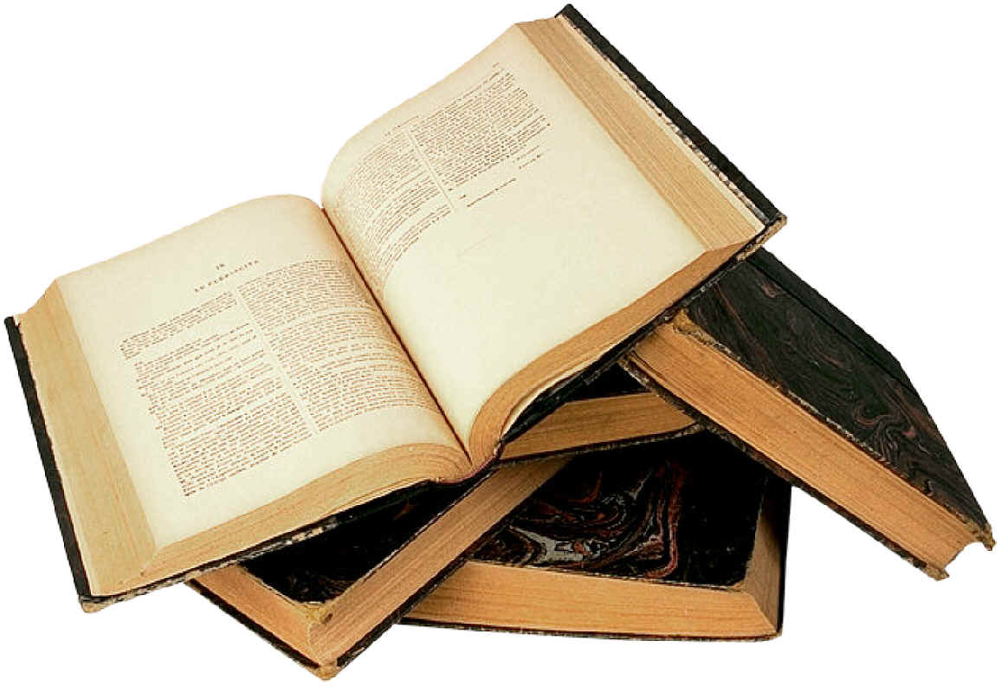

2009
Тема заходу: П о е т и ч н и й т у р н і р

Мета: ознайомити дітей з світом англійської поезії; розвивати вміння учнів
декламувати вірші англійською мовою; прищеплювати любов учнів до
поезії, до прекрасного

Обладнання: святково прикрашений зал; портрети англійських поетів; записи
мелодій; аудіоапаратура; грамоти переможців

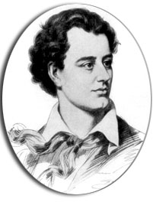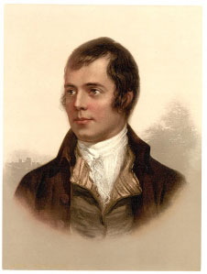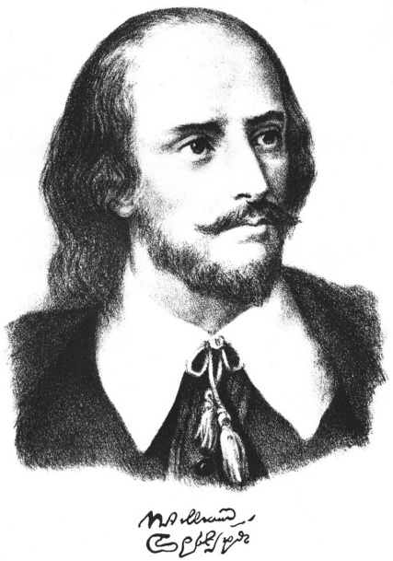

Хід заходу

Ведучий(Вед.) 1: Dear guests, we are glad to welcome you at our tournament!

Вед.2: Yes, we are going to listen to a lot of English poems written by English and American poets. English poetry is really amazing!

Вед. 1: For our poetry contest four pupils of forms 9, 8, 7, 6. Also we will have our jury. (Ведучий представляє членів журі).

Вед.2: Now we are going to listen to the pupils of form 6.

Pupil 1: A Birthday
(by Ch. Rossetti)

My heart is like a singing bird
Whose nest is on a watered shoot,
My heart is like an apple-tree
Whose boughs are bent with thick-set fruit;
My heart is like a rainbow shell
That paddles in a halcyon sea;
My heart is gladder than all these
Because my love is coming to me. (Melody 01)

Pupil 2: The Seasons
This is the season when fruit is sweet,
This is the season when school friends meet,
When noisy and gay, and brown in the sun
With their books and bags to school they run.
This is the season when mornings are dark,
And birds do not sing in forests and parks.
This is the season when children ski,
And Father Frost brings the New Year’s tree.
This is the season when snowdrops bloom
When nobody likes to be in his room.
This is the season when birds make their nests,
This is the season we all like the best.
This is the season when nights are short,
When children are full of fun and sport,
Playing, swimming all the day,
With a happy song on a sunny day. (Melody 02)

Pupil 3: May Song
(Country rhyme)

Spring is coming, spring is coming
Birdies, build your nests
Weave together straw and feather,
Doing each your best.
Spring is coming, spring is coming
Flowers are coming too.
Pansies, lilies, daffodils
Now are coming through.
Spring is coming, spring is coming
All around is fair.
Shimmer and quiver on the river
Joy is everywhere.
We wish you a happy May!(Melody 03)

Pupil 4: One Thing at a Time
(by Edith Segal)
Work while you work,
Play while you play.
That is the way
To be happy and gay.
All that you do,
Do with your might,
Things done by halves
Are never done right.
One thing at a time,
And that done well,

As a very good rule
As many can tell.(Melody 04)

Вед.1: Thanks, our smallest reciters.

Вед.2: Well, and now we are going to listen to form 7.
Pupil 1: Walt Whitman
О Captain! my Captain! our fearful trip is done,
The ship has weather'd every rack, the prize we sought is won,
The port is near, the bells I hear, the people all exulting,
While follow eyes the steady keel, the vessel grim and daring;
But О heart! heart! heart!
O the bleeding drops of red,
Where on the deck my Captain lies,
Fallen cold and dead.(Melody 05)
Pupil 2: О Captain! my Captain! rise up and hear the bells;
Rise up-for you the flag is flung-for you the bugle trills,
For you bouquets and ribbon'd wreaths-for you the shores
a-crowding,
For you they call, the swaying mass, their eager faces turning;
Here Captain! dear father!
This arm beneath your head!
It is some dream that on the deck,
You've fallen cold and dead. (Melody 06)
Pupil 3: My Captain does not answer, his lips are pale and still,
My father does not feel my arm, he has no pulse nor will,
The ship is anchor'd safe and sound, its voyage closed and done,
From fearful trip the victor ship comes in with object won;
Exult О shores, and ring О bells!
But I with mournful tread,
Walk the deck my Captain lies,
Fallen cold and dead. (Melody 07)
Pupil 4: Dreamland by Lewis Carroll
When midnight mists are creeping,
And all the land is sleeping,
Around me tread the mighty dead,
And slowly pass away.
Lo, warriors, saints, and sages,
From out the vanished ages,
With solemn pace and reverend face
Appear and pass away.
The blaze of noonday splendour,
The twilight soft and tender,
May charm the eye: yet they shall die,
Shall die and pass away.
But here, in Dreamland's centre,
No spoiler's hand may enter,
These visions fair, this radiance rare,
Shall never pass away.
I see the shadows falling,
The forms of old recalling;
Around me tread the mighty dead,
And slowly pass away. (Melody 08)

Вед.1: And now it is time for our eight-formers to recite their poems:

Pupil 1: In Flander's Fields
In Flanders fields the poppies blow
Between the crosses, row on row,
That mark our place; and in the sky
The larks, still bravely singing, fly
Scarce heard amid the guns below.
We are Dead. Short days ago
We lived, felt dawn, saw sunset glow,
Loved, and were loved, and now we lie
In Flanders fields.
Take up your quarrel with the foe;
To you from falling hands we throw
The torch; be yours to hold it high.
If ye break faith with us who die
We shall not sleep, though poppies grow
In Flanders fields.
(written by Liet.-Col. John McCrae, a Canadian serving at Ypres)
(Melody 09)

Pupil 2: We have prepared poems by Robert Frost
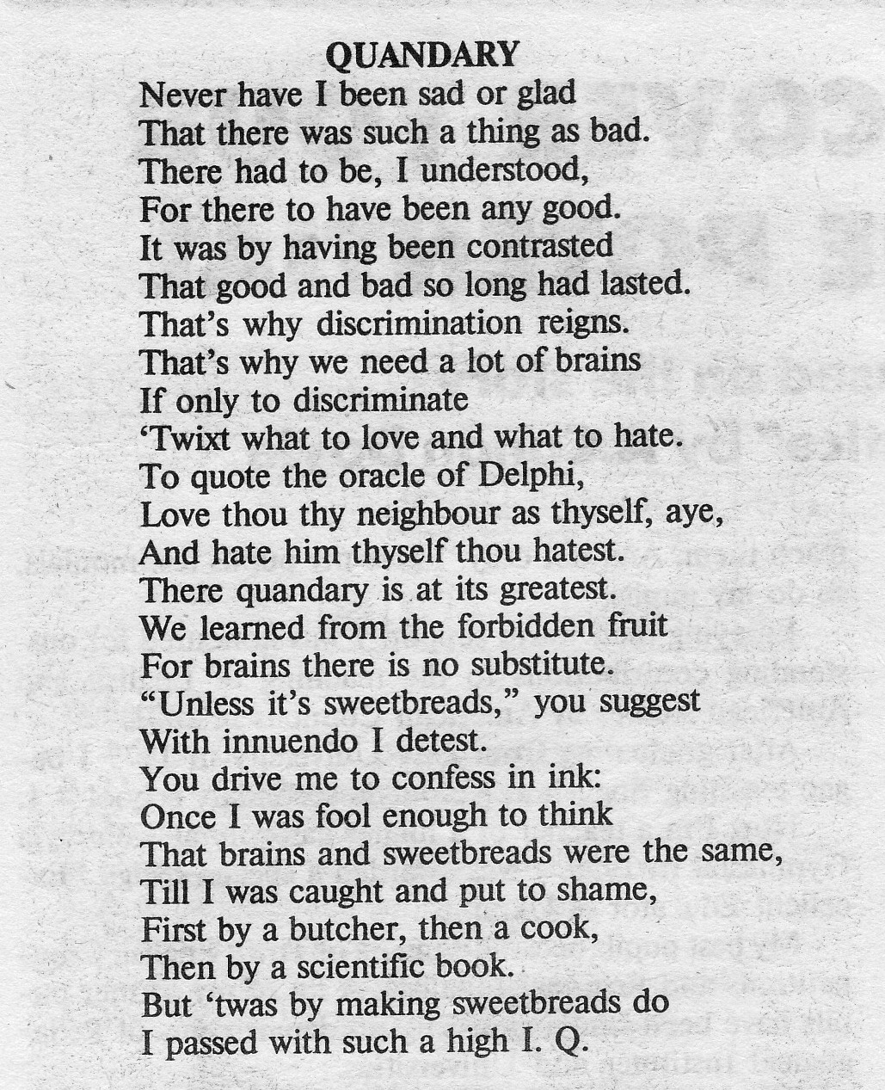 Melody10

Pupil 3:
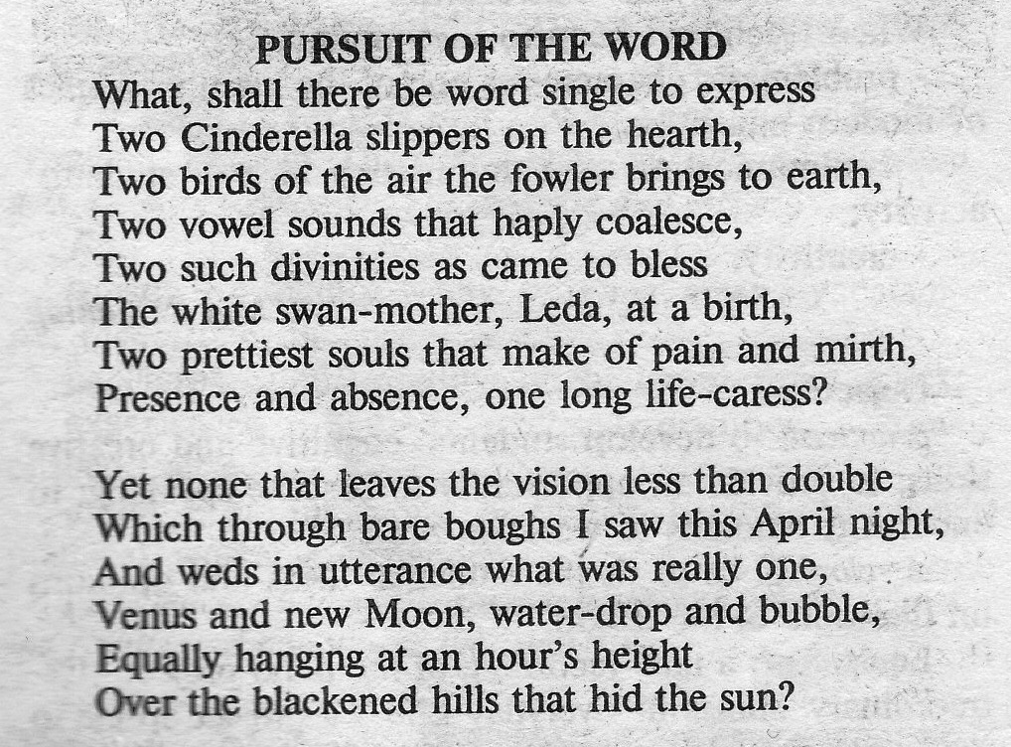Melody 11
Pupil 4:
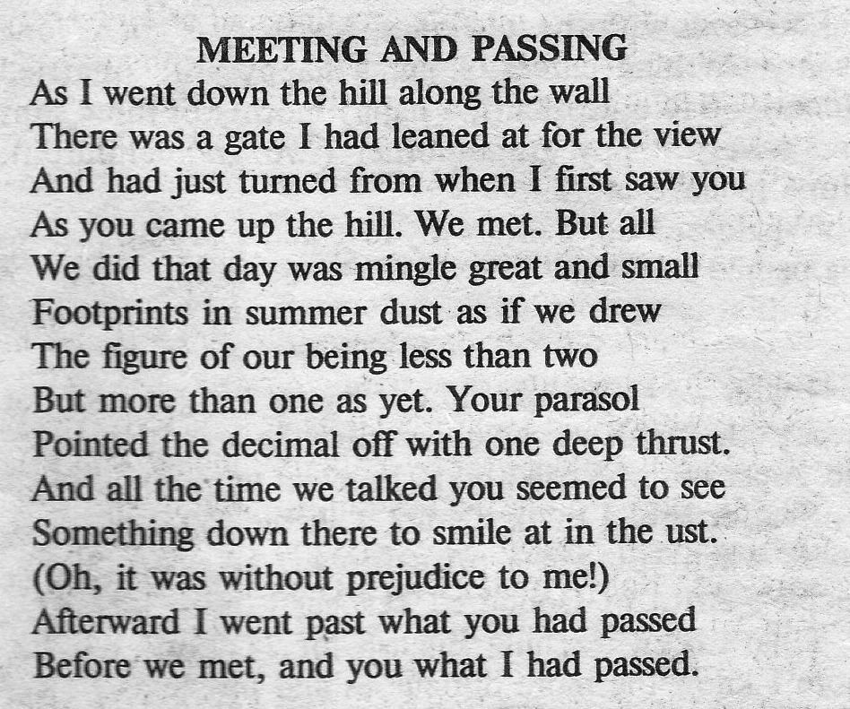 Melody 12

Вед.2: Thanks, and now we are going to listen to our nine-formers.

Pupil 1:
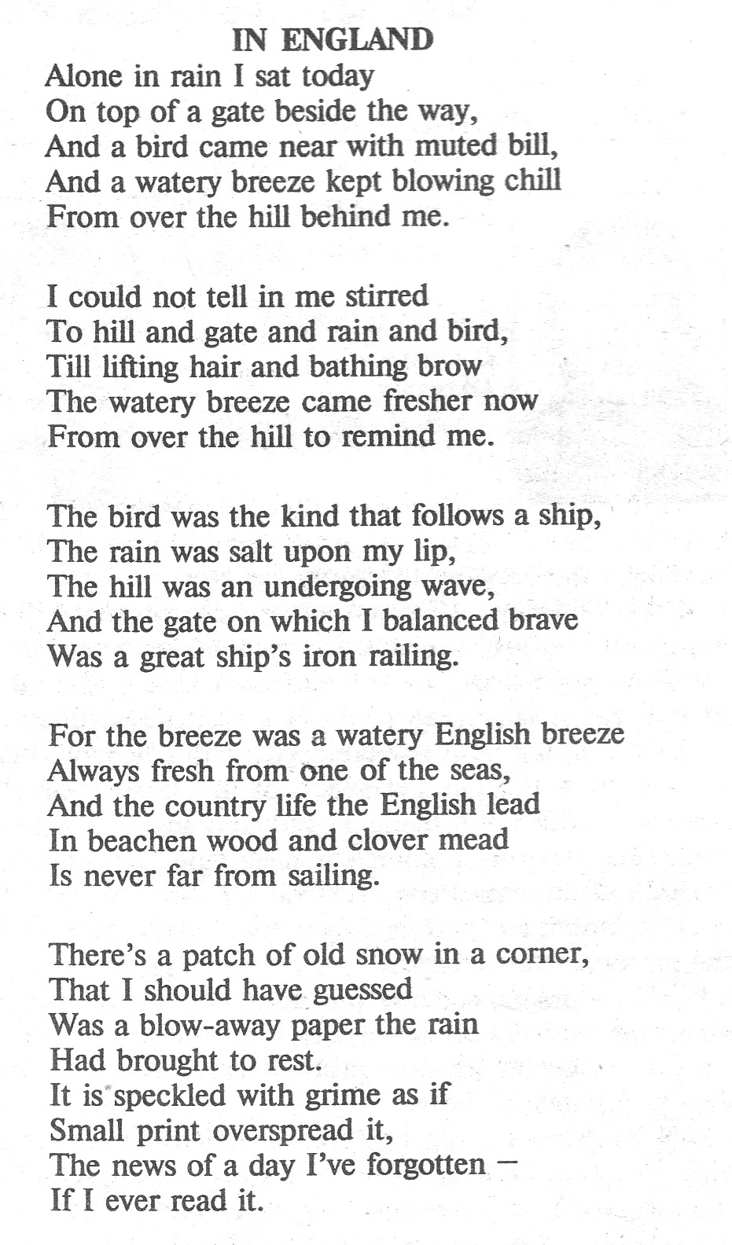Melody
Melody 13

Pupil 2:
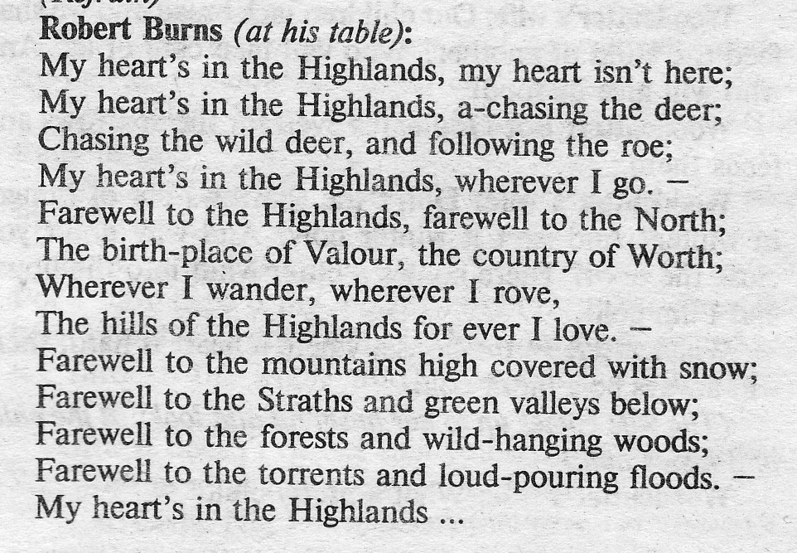M 14

Pupil 3:
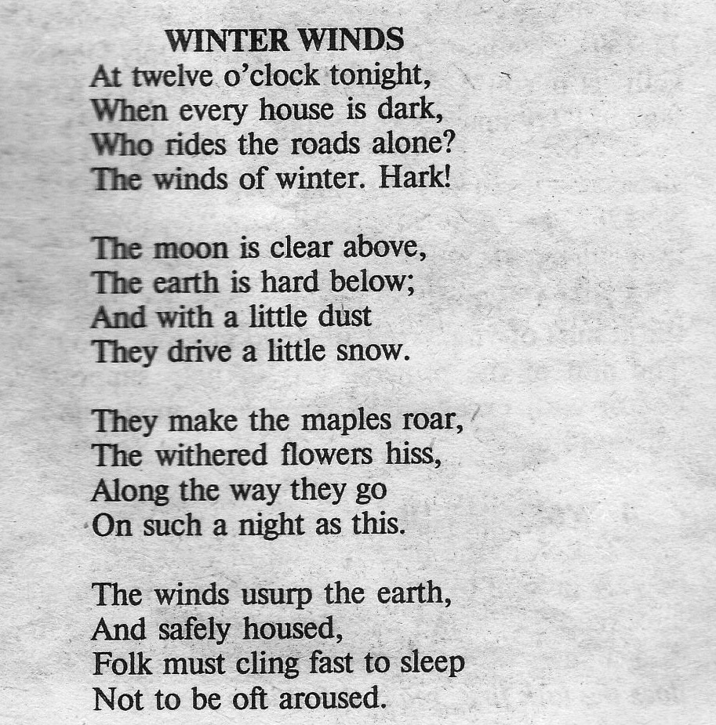 M 15

Pupil 4:
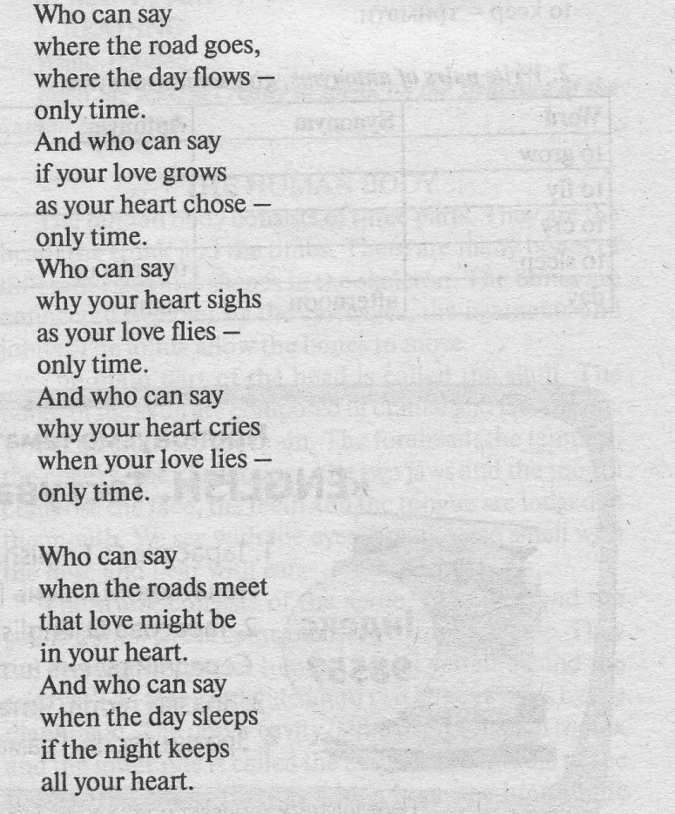 melody 16

Вед.1: Thanks, thanks, very much. We could listen to your declamation. So, let us listen to our jury.
(Журі підбиває підсумки і нагороджує переможців конкурсу грамотами).

Вед. 2: And now we must tell you «Good bye!” We hope to meet you next time!

