Theme: In the cafe. Table manners.

Objectives:
- to generalize and enlarge the knowledge about meals and certain rules in the cafe;
- to improve the communicative language skills;
- to teach pupils to respect the points of view of other people.

Outcomes:
- to develop the ability to express thoughts, to share opinions on the given topic;
- to learn how to order food and understand the café menu;
- to work in groups in the process of the lesson;

Equipment: cards with the task, menu, pictures, posters, a white board, the textbook “Enterprise 4”

PROCEDURE
- Introduction.
Good morning, dear pupils. Today we have a very unusual lesson because we will cook and have an imaginary trip to your favourite café or restaurant. We’ll learn how to behave appropriately at the table, i.e. about table manners.

- Brainstorming.
Now I propose you to think a little and say in turn what associations come to your minds when you hear the word “food”.
P1: When I hear this word I think of vitamins – fruit and vegetables.
P2: As for me, it means hunger, because I’m always hungry.
P3: And I think of fast food restaurants, for example, McDonald’s.
P4: For me the word “food” means pleasure.

- Warming-up.
Very good! Now let’s answer the questions:
1) Do you like cooking?
2) What is your favourite dish?
3) What ingredients is borsch made with?
4) Are the British people tea drinkers?
5) What favourite dishes made of flour do you know?
6) Do you go shopping every day?
7) Who usually buys food in your family?
8) Where do you have your Sunday lunch?

- Main part.
1.Vocabulary drill. a)Find the hidden words:

C | O | R | M | C | E | B | U | T | T
S | U | N | I | I | S | A | L | T | E
M | G | F | L | U | C | M | H | C | R
A | A | L | K | J | H | E | S | A | T
R | R | A | K | E | E | A | I | K | E
M | A | L | A | B | E | T | F | E | A
S | O | P | D | R | S | E | E | B | H
C | U | O | E | E | A | D | G | A | A
O | P | R | R | I | G | E | A | C | M
F | F | E | E | S | A | U | S | O | N

b)Now we’ll do the following task. You see the table on the white board. Your task is to find phrases and then make up sentences with them.
clean | buy | table | food
wash | eat | dish | pizza
boil | count | soup | money
fry | taste | potatoes | meat
pay | go | bill | market
have | make | dinner | cake

2.Unfinished sentences. Continue each sentence:
- I eat soup; (I eat soup every day; I eat soup every day in the morning; at half past seven; delicious soup with bread; before school; a plate of soup)
- She drinks tea (green tea; with sugar; with lemon; a cup of tea; in the afternoon; every day; at school)

3.Group work (students work in 3 groups):
A) Now we’ll show how to lay the table for breakfast, dinner and supper. Do you remember which things are necessary on the table?
Let’s remember and watch the video - https://www.youtube.com/watch?v=p9mzBckf3G4
We have 3 groups. Pupils from one group will show us how to lay the table for breakfast and pupils from another group will show us to lay the table for dinner, and pupils from the other group - for supper.
Group1: We have to put the plate on the napkin. The knife must be to the right hand of your plate, the fork – to the left hand of it. The table spoon for porridge must be near the knife. The cup with the tea spoon is from the right side but the glass for juice is from the left side. The plate for bread is in the middle of the table.

Group 2: Put a nice napkin and two plates: a dinner plate and soup plate. The fork is from the left side, the knife and the spoon for soup – from the right side. Put down butter, salt and pepper in the middle of the table.

Group 3: We lay the table the same as for breakfast. We have to put the plate on the napkin. The knife must be to the right hand of your plate, the fork – to the left hand of it. The table spoon for porridge must be near the knife. The cup with the tea spoon is from the right side but the glass for juice is from the left side. The plate for bread is in the middle of the table.

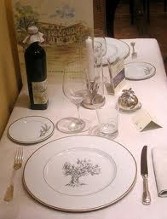

B) Now you will have the following task – to make the proverbs, i.e. to match two halves of the proverbs.

1)Good health is | a)drink with measure.
2)Eat at pleasure, | b)differ.
3)After dinner sit a while, | c)lessen your meal.
4)The way to a man’s heart is | d)above wealth.
5)To lengthen your life, | e)with eating.
6)An apple a day | f)after supper walk a mile.
7)Taste | g)through his stomach.
8)Appetite comes | h)keeps the doctor away.
(Keys: 1-d, 2-a, 3-f, 4-g, 5-c, 6-h, 7-b, 8-e)

C) It’s great! But do you know that we can’t speak and laugh at the table. You have to know table manners. Let’s remember them.

4.Pair work: listen to the dialogue (ex.11 p.72) and then in pairs act out a similar dialogue using the examples below:
1)Waiter: Good afternoon! Have you a reservation?
P1: Yes, we have. We booked a table by phone.
W: Oh, yes. You are by yourself?
P1: No, I am with my classmates.
W: Would you like this table by the window?
P2: Fine, thank you.
W: Here is the menu.
P3: Let’s choose tasty dishes.
W: What would you like to start with?
P3: I think we’ll have mushroom soup.
W: Yes, and what would you like to follow? I’d recommend the roast beef.
P4: That sounds very nice. Yes, fish, a mutton chop, water.
P2: Oh, fruit, please.
W: Would you like roast potatoes?
P2: No, thank you.
W: What would you like for dessert?
P3: No dessert, just coffee, please.
P2: But I want to have dessert. An ice cream, please and coffee, biscuits with raisins, oranges, sweets…
P1: Are you so hungry?
P2: Oh, no. I am not hungry; you see, I don’t eat much
P1: I see!!!
P3: Waiter, will you bring me the bill at once?
W: Certainly.

2)W: Good morning, madam. Good morning, sir. Are you ready to order?
M: Oh, yes. We would like English breakfast. We’ll begin with porridge.
W: Sorry. We have no porridge today. I can recommend cornflakes.
S: All right. Then cornflakes, bacon and eggs, marmalade, butter, toasts, juice and tea.
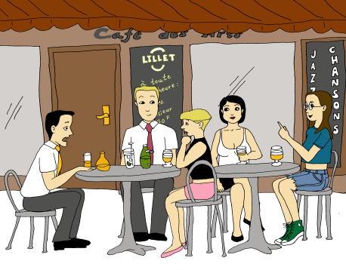
W: What kind of juice?
M: Apple juice for me, please.
W: How do you want your tea?
S: Much sugar and a slice of lemon.
W: Very good. (Serves their breakfast) Here you are. Bon appetite! Here is your check, please.
S: Here you are.
W: Thank you very much.

- Summary. Reflection.
So you have learnt much new information about table manners, i.e. how to behave yourselves at the restaurants or in the cafes, how to lay the table. And I think you’ll succeed in it.
The exercise “Microphone”:
- At the lesson I learnt …
- It was interesting to …
- I enjoyed …
- This knowledge I will use …
- Home assignment.
Write down the shopping list and the recipe of your favourite dish.

