Lesson plan 3
Topic Impersonal /Personal passive structures. The
Causative
Objectives
- To develop students’ grammar skills
- to introduce new grammar theme
- To develop critical thinking skills writing
- To encourage students to use grammar structures when speaking
- To train writing skills
Outcomes
By the end of the lesson pupils will be able use passive structures, will improve speaking skills, increase vocabulary, and more learning skills

Age group 9 form 13-14
Level Intermediate
Time 45 minutes
Materials Worksheet, Role card A, Role card B
Procedure
1.Greeting (5 minutes)
You will need one copy per student of the exercises, one teacher’s copy of
answer key and the poster.
2 . Warmer (5 minutes)
Bingo game
3.Checking home assignment
Fill in: specialise, use, identify, represent, supervise, present.
1 Mr Nash will …………………………… Paul in court – he’s been the family lawyer for years.
2 The guards …………………………… the prisoners during the day and make sure they behave themselves.
3 In this forensic department, we …………………………… in fibres and blood analysis. For fingerprint specialists, go to the 5th floor.
4 Amy has to go to court tomorrow to …………………………… evidence in the trial because she witnessed the attack.
5 Forensic scientists have special equipment to …………………………… chemicals found at the crime scene.
6 The police …………………………… scientific techniques, such as DNA analysis, to catch criminals.

4. Grammar presentation

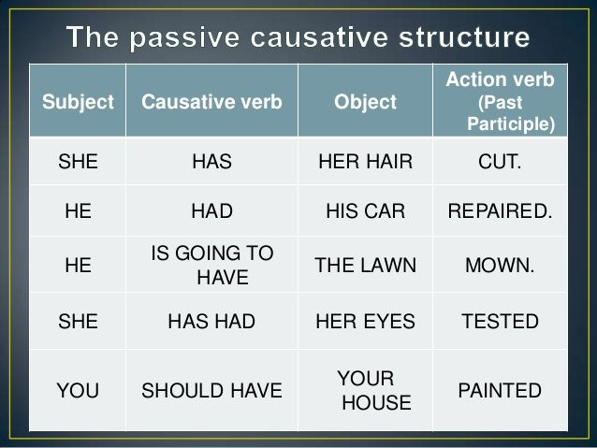
Grammar practice
Rewrite the sentences in the passive personal and impersonal construction, as in the example.

1 People say that he has the most beautiful garden in the neighbourhood.
It is said that he has the most beautiful garden in the neighbourhood.
He is said to have the most beautiful garden in the neighbourhood.
2 People think that the car has been stolen.
It
The
3 They know that the thief was wearing a red T-shirt.
It
The thief
4 People say that he escaped from prison yesterday.
It
He
5 People expect that the President will win the Nobel Peace Prize this year.
It
The President
6 They believed that she had stolen the money before she resigned.
It
She

The causative

D Write the sentences in the causative form.

1 The hairdresser dyes Linda’s hair.

2 Mike has installed some new programs on my computer.

3 Did someone clean your pool?

4 A cook will prepare a meal for them.

5 They stole my brother’s bike last night.

6 A beautician is painting Charlotte’s nails.

7 A travel agent had organised their trip.

8 They were decorating Tom’s house.

5.Developing listening skills

Listening

You will hear five people talking about their communities. Listen and match the speakers (1-5) to the statements (A-F). Use each statement once. There is one extra statement.

A The speaker often sees crimes taking place. | Speaker 1
B The speaker is happy about something that’s happened in their community. | Speaker 2
C The speaker feels afraid of something. | Speaker 3
D The speaker has started a community programme. | Speaker 4
E The speaker wants to move out of their area. | Speaker 5
F The speaker is fighting to keep something.

- Feedback, evaluation, home assignment
Ex9p.101 SB
p.6b WB

