Відділ освіти, молоді і спорту Бережанської міської ради
Семінар вчителів англійської мови

Методичний вісник
Teaching listening skills at school
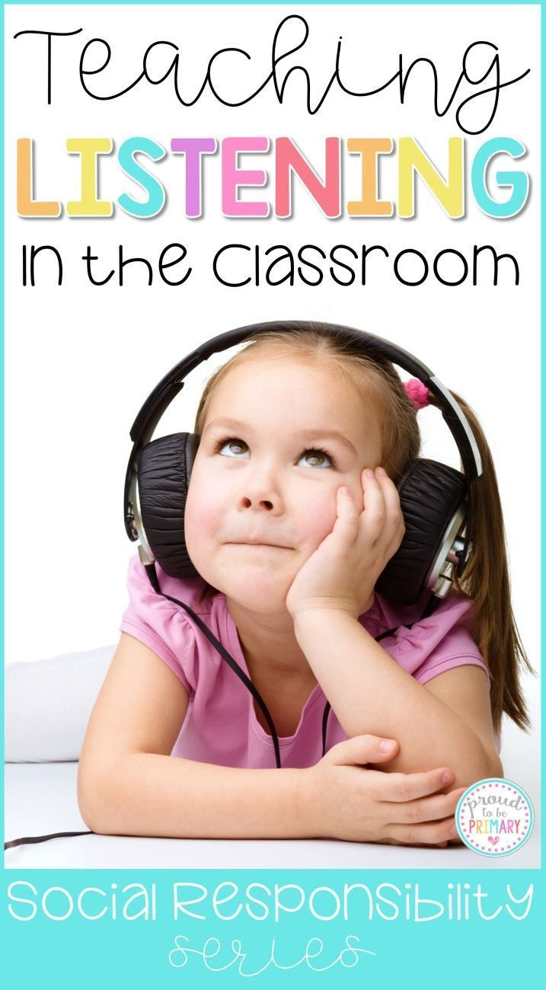

Бережани 2017

Аудіювання є одним з найскладніших видів мовної діяльності. Оволодіння аудіюванням дає можливість реалізувати виховні, освітні і розвиваючі цілі. Воно дозволяє вчити учнів уважно вслухатися в звукову мову, формувати вміння передбачати значеннєве зміст висловлювання і таким чином, виховувати культуру слухання не тільки іноземною, але і рідною мовою.
Даний методичний вісник містить інформацію про основні стратегії навчання аудіювання, принципи навчання та рекомендації з підбору матеріалу для аудіювання. Подано зразки вправ та технологій перевірки навичок аудіювання.

Упорядник: Галещук О.В.,
вчитель англійської мови Бережанської школи-
гімназії ім.Б.Лепкого

Затверджено на засіданні методоб’єднання вчителів іноземних мов Бережанської школи-гімназії ім. Б. Лепкого
INTRODUCTION
The importance of teaching listening
Listening comprehension is an important language skill to develop. Language learners want to understand target language of the speakers. Listening is not an easy skill to acquire because it requires listeners to make meaning from the oral input by drawing upon their background knowledge and produce information in their long term memory and make their own interpretations of the spoken passages .In other words, listeners need to be active processors of information.
How do you really know that someone understood you correctly without asking after every sentence “Do you understand?” (And students are often programmed to respond “yes” even when they didn’t.) This problem may also apply to reading, the other “receptive” language skill, in that its focus is largely on the comprehension of another speaker’s production; however, while the teacher has some understanding of how to teach someone to read in English by teaching context clues, for example, to help students comprehend text, how do you really teach someone to listen better (especially when even many native speakers of English often have difficulties with this)? However, while teaching listening may seem ambiguous, there are actually a number of principles that apply in teaching listening skills in English.

Principles for Good Listening
Following are a number of listening skills, most of which not only benefit the student but also the native speaker.
Basics: Pay Attention
Even native speakers need help with this. Focus on the speaker. Look at him or her because facial expressions and body language can communicate as much as language. For example, there will usually be more engagement with the listener in making eye contact and use of hand gestures if what the speaker is saying is of importance to him or her. In addition, it’s easy to mistake what someone actually said if you are not focusing on him or her and are engaged in some other task.
Practice Active Listening
Ask the speaker to slow down or repeat when you don’t understand or just want to be certain about what you heard. Repeat back what you think you heard him or her say, as there can often be a gap between what we thought we heard and what the speaker intended. This gap can be addressed by letting the speaker know what you heard: for example, “So what I’m hearing from you is that you would like more quiet and fewer distractions after 9 p.m. so that you can study.” This is called “active listening,” in which the listening portion of a conversation becomes as active as the speaking part in communicating a message, and not only helps the listener in understanding what the speaker is saying, but also can help the speaker in organizing his thoughts and clarify what he wants to communicate: e.g., the speaker may be spluttering something about the late hour and her test tomorrow, and may not consciously know what she is trying to ask for—or is too reticent—until the listener clarifies.
Pay Attention to Structure
In a formal lecture or speech, the speaker will usually let you know ahead of time the organization of the discourse: “Today we will discuss the two types of diabetes, Type One and Type Two, although as we will see, there is some overlap—” and then what will follow is a description of Types One and Two, with the overlap probably addressed at the end. These devices, called “discourse markers,” actually help the listener in organizing and understanding the lecture. Even in less formal conversation, speakers will often structure their discourse, especially if they want to make certain they are understood: “Okay, there are a few issues I need to raise with you….” With this informal marker of “there are a few—” and the use of the word “issues,” the speaker signals the importance of what follows. “A few,” it may be noted, is a vague expression, and what follows may be anywhere from two to five or six issues. The listener may clarify when the “issues” are covered by asking “Is there anything else?” when the speaker pauses.
Listen for Key Words
What words does the speaker emphasize? Usually the speaker will let you know by stressing the main point: “Let’s talk about the TIME we will meet tomorrow….” The stressed word “time” signals that the time of tomorrow’s appointment is the main point, as does the marker “Let’s talk about—”
In addition, certain words signal importance by themselves, such as “issues,” as seen above: whatever follows “issues” is of importance. Other key words signaling importance are “concerns” and “points.”
Key Phrases or Markers
In formal lectures the speaker usually also “marks” main points with key phrases: “The main point is…” or “On the other hand, some people take an opposing viewpoint….” But even in everyday conversation the speaker often uses less formal markers: for example, “I guess what I’m trying to say is—” is often used before a main point.

Teaching Principles of Listening
Make it Explicit
Even native speakers, who actually use markers or key vocabulary, may not have consciously thought about these devices. Introducing some key markers and vocabulary is often welcome it makes explicit how to understand and manage conversations, which may have been something a mystery (such as why a friend reacts with anger at your student ignoring a raised “issue”). In addition, key terms such as “active listening” and “discourse marker” should be introduced and exemplified.
Model
For new concepts, such as active listening, a model is needed. This can be provided by traditional print example dialogues as well as film clips, and teacher modeling with volunteer students: e.g., the teacher might say, “Gina, tell me something of importance to you, and I’ll listen actively. The rest of the class, pay attention, and then let’s discuss what goes into active listening.”
Practice
This might be especially important in active listening, which few people, native or nonnative speakers, really know how to do, as we are used to either sitting quietly while a speaker finishes his speech (or diatribe, if he or she is angry), or interrupting, when we think he or she is wrong, or sitting and planning what we will say in response, etc. Active listening takes practice, but is worth it in terms of improved listening skills and relationships.
Teaching good listening skills is difficult as it is so difficult to define and exemplify, and few of us, even native speakers of English, really do it well.
But by making explicit the qualities of good listening and then practicing it, our ESL students can become good listeners in English, and often better than their native speaker peers.
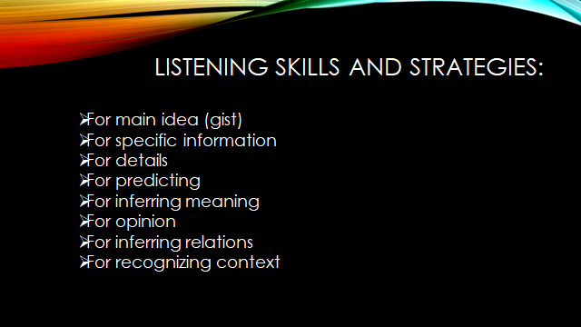

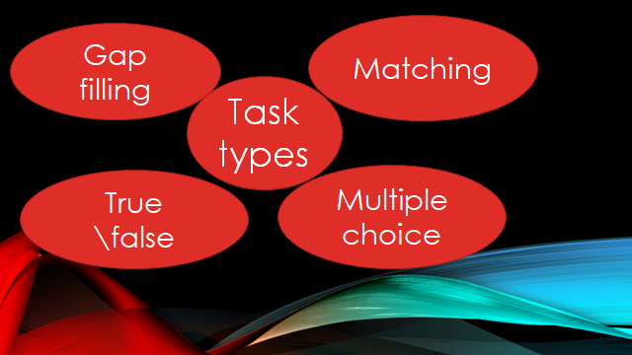

Learning Outcomes
In this workshop, we will:
*identify and explain the reasons behind teaching listening .
*discuss the strategies that good listeners use.
*recognize the appropriate sequence for teaching listening.
*provide some listening skills and activities.
Strategies good listeners
Teaching listening skills presents a series of challenges. It is perhaps the most ephemeral of language skills, hard to understand, teach, and assess.
Good listeners use many strategies concurrently and in accordance with the task. They may listen regularly to a radio broadcast (metacognitive), take notes on the key points (cognitive) and then meet fellow students and tell them all about what they just listened to (socio-affective)
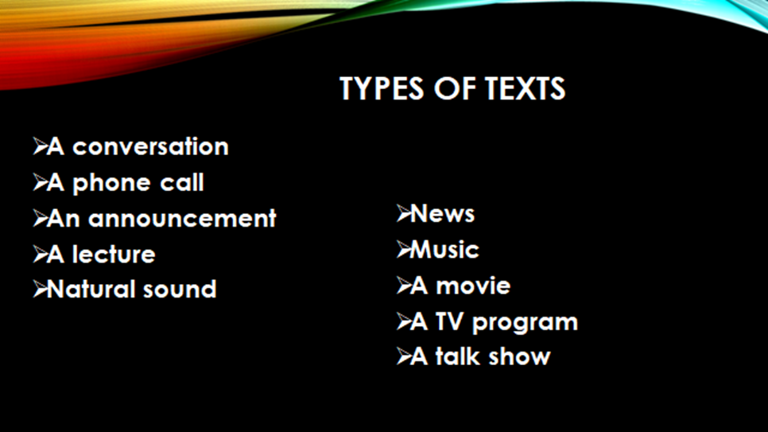

Cognitive strategies
Cognitive strategies are those that we use in order to complete an immediate task. For example, a student may find out about the topic before listening, in order to predict content.
Metacognitive strategies
Metacognitive strategies are related to learning in general and often have long-term benefits. For example, students might choose to tune in to a BBC recording once a week as a strategy for improving their listening.
Socio-affective strategies
Socio-affective strategies are concerned with the learners’ interaction with other speakers and their attitude towards learning. For example, they may choose to rehearse a telephone conversation with another student in order to develop confidence

Pre-listening skills and activities
The pre-listening stage helps our students to prepare for what they are going to hear, and this gives them a greater chance of success in any given task. The first stage of pre-listening usually involves activating *schemata in order to help students to predict the content of the listening passage. The second stage is setting up a reason to listen through setting questions beforehand “signposting questions”
Four practical ways to activate the schemata (activating the listener’s prior knowledge )
1-Brainstorming Poster display:
This activity involves students in groups making a poster based on a given topic then they will stick them on the wall. The teacher and students wander around the
classroom looking at the posters. The listening passage will touch on many of the
words/ideas in the posters. ( word webs)are excellent for posters.
2-Visuals ( pictures – videos – diagrams )
Four practical ways to activate the schemata (activating the listener’s
prior knowledge)
3-Realia ( magazines – menus – calenders – maps – brochures)
4-Opinions and ideas
KWL chart :
Students are given a topic and a chart with a K column, a W column and an L column. K stands for Know. In this column the students write what they already know about the topic. W stands for Want to know. Students write questions here that they would like answers to. L stands for Learnt. After hearing the recording, the students write what they have learnt about the topic.
The students hear the input once, probably listening for gist, although of course there may be occasions when they need to listen for specific information or listen in details. They check their answers in pairs or groups. This is to give them confidence and to open up any areas of doubt. They then listen a second time, either in order to check or to answer more detailed questions. It is important that the students should be required to do different tasks every time they listen.
While-listening skills and activities
The students hear the input once, probably listening for gist, although of course there may be occasions when they need to listen for specific information or listen in details. They check their answers in pairs or groups. This is to give them confidence and to open up any areas of doubt. They then listen a second time, either in order to check or to answer more detailed questions. It is important that the students should be required to do different tasks every time they listen.
Listening for gist
On their first encounter with a passage in the classroom, students usually listen for gist - the main idea. Here are some examples of typical gist questions:
What problems are they discussing?
What does the speaker think of the topic?
Look at the pictures. Who are the speakers talking about?
A simple gist exercise is to ask for basic information under the headings What? Who?Why? When? Table, This works for most listening passages.
Listening for details = selective listening.
Bingo: in this activity, which is particularly enjoyable for young learners, the teacher writes a list of words on the board, all of which occur during the listening passage. These should be content words - nouns and some verbs, The students, working alone, choose and write down seven of these words. They then listen to the passage.Whenever their words come up, they tick them. They shout Bingo! when they have ticked all seven.
Spot the difference: the students look at a picture and listen to a description of it. The oral description contains a number of differences from the picture. The students listen for these differences, and mark them on the page.
Note-taking
Guided note-taking: instead of starting with a blank piece of paper, the students are given subheadings, numbers or unfinished notes to guide them. Here are some examples.
Hidden picture: the students each have one picture of a person, which they keep hidden from their classmates. They describe the picture and their classmates take notes. Each set of notes describing an individual picture is numbered by the students. Afterwards, all the pictures are stuck on the board and the students have to match their notes to the pictures.
Listen and do
Stand up if ...: this is a very simple listening activity that can energise a class. The teacher simply says imperatives beginning with Stand up if you . . . . For example, Stand up if you are wearing blue/like potatoes/own a dog/have been to the cinema in the last month, etc,
Grab the word: choose about fifteen key words from the listening passage and write them on individual cards. Stick the cards on the wall or board, or if there are a lot of students, place the cards on the desks after making duplicate copies. The students listen and grab the words when they hear them. The winner is the person who grabbed the largest number of cards.

Post-listening skills and activities
The whole class checks answers, discusses difficulties such as unknown vocabulary, and responds to the content of the passage, usually orally, sometimes in writing. This may be done as a whole class, pairs or groups. The post-listening stage is where students can reflect on their listening experience without the pressure of having to process real-time speech or do a task.
Discussion
Personalise: ask if the situation is the same for the students. How is it different? In multilingual classes particularly, teachers can ask if the situation is the same in the students’ various countries. Cross-cultural discussions of this nature are often very fruitful and motivating as many students enjoy learning about their classmates’ culture.
Questions: the teacher can devise a number of questions based on the topic of the listening passage.( Ex: Ss answer some questions after implementing the whilelistening tasks as : Have you ever …….? / Is there any member of your family who……)
Statements: the teacher can devise a number of statements based on the listening passage. The students discuss whether they agree or disagree.
Creative responses
Genre transfer: one way to engage students in a deeper processing of a listening passage is to ask them to re-fashion the text, for example by transferring it to a different genre. This might involve turning a spoken text into a written version. A piece of conversation can be transformed into a news article. We can listen to a person chatting about their daily life and then write their diary entry.
Write on: the students listen to a story and then write a continuation. In order to do this, they must be aware of the main ideas and key features of the original input: its tone, style, characters and story line.
Illustrate: this activity is particularly enjoyed by children. The students listen - it might be to a situation, story or description - and then draw an image
that represents the passage. They then explain their illustration in terms of its
significance, and how it reflects what they heard.
Problem-solving
Listing Example rubric: List all the ways to ... (get from A to B/save the whale/get fit).
Sorting Example rubric: Put... (the words/food types/people) into groups.
Sorting demands that students see connections between different items and is good for vocabulary acquisition, in particular.
Ranking Example rubric: Say which is the best, the second best, the worst, etc. Ranking typically has no correct answer. Students need to justify their ideas, and the potential conflict may lead to good discussions.

CONCLUSIONS

So, by developing their ability to listen well we develop our students' ability to become more independent learners, as by hearing accurately they are much more likely to be able to reproduce accurately, refine their understanding of grammar and develop their own vocabulary. Within this article I have tried to describe a framework for listening development that could be applied to any listening text. This isn't the only way to develop our students listening or to structure a listening lesson, but it is a way that I have found to be effective and motivating for my students. These methodological recommendations can be applied by teachers of foreign languages.

LITERATURE
- Cooper, L. O. (1997). Listening competency in the workplace: A model for training. Business Communication Quarterly, 60, 75-84. doi:10.1177/108056999706000405
- Cooper, L., & Husband, R. L. (1993). Developing a model of organizational listening competency. International Journal of Listening 7, 6-34. doi:10.1080/10904018.1993.10499112
- Edwards, R. (2011). Listening and message interpretation. International Journal of Listening, 25, 47-65. doi:10.1080/10904018.2011.536471
- Jones, S. M. (2011). Supportive listening. International Journal of Listening, 25, 85-103.doi:10.1080/10904018.2011.536475
- Lundsteen, S. W. (1966). Teaching and testing critical listening: An experiment.Elementary School Journal, 66, 311-315. Stable URL:http://www.jstor.org/stable/41385715
- McClendon, P. I. (1958). An experimental study of the relationship between the notetaking practices and listening comprehension of college freshmen during 16 expository lectures∗. Speech Monographs, 25, 222-228.doi:10.1080/03637755809375236

