Thanksgiving Day
Lyudmyla Marchyshak
a teacher of English,
Specialized School of Vasylkivtsi,
Ukraine
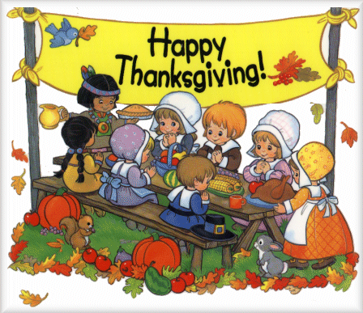
- Introduction
Good afternoon dear guest! We are glad to see you here. The fourth Thursday of November is the Thanksgiving Day. There are several traditions, connected with this day and we want to show you some of them. Welcome to our party!
2. Main part
1. Students are on the stage. 10-11 кл (play)
Students sing and demonstrate the activities. The sit at one big table with lots of food, hold hands and sing.
- It’s Thanksgiving in our house
And I’m sitting here too.
- I’m cooking in a kitchen
It’s what I always have to do.
- I’m raising crazy kids
And feel I’m twice my age.
- I’m reading a paper.
It’s how I disengage.
- I’m brand new to this family
And I’m not all that well-known.
- I really wish everyone put down all their phones.
- Hey guys, could you all put down your phones and say “HI” to Eric, please.
- Hey guy, since this wedding. I’m really grateful to be a part of this family.
- I really like football but not so much people.
- I’ve stress about this day because we are dysfunctional.
- There’s nothing more to do. So I guess we have to talk.
- So where’s the Gravy?
- There’s no Gravy this year
- Why not?
- Oh! This is Thanksgiving day! We thank God for family.
- I think she’s right what do we fight.
- I feel at home because my family’s got them too.
- So on this day!
We thank our king for family
And a happy Thanksgiving!
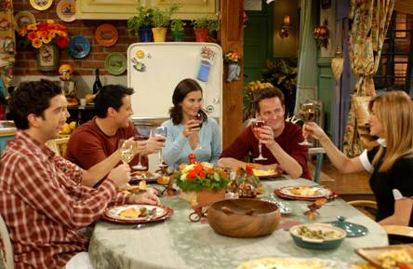
2. Student 1
Thanksgiving – time to carve up a turkey, unbutton your pants, and watch football with the family. While families may have their own rituals, many Turkey Day customs have deep roots in American history.
From turkey pardoning to the first feast, here are the origins of seven of the holiday’s most iconic traditions.
3. The song “One little, two little Indians”
One little, two little, three little Indians,
Four little, five little, six little Indians,
Seven little eight little, nine little Indians,
All came out to play with-

One little, two little three little pilgrims,
Four little, five little six little pilgrims,
Seven little eight little, nine little pilgrims,
On Thanksgiving day.

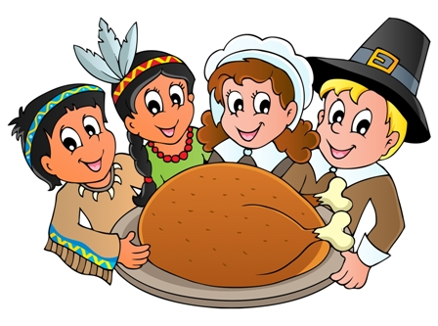
4. Thank you God for the world so sweet
Thank you God for the food we eat.
Thank you God for the birds that sing
Thank you God for everything!
5. 4 кл. (2 кл. стає в три ряди)
6. The song “Thanksgiving Turkey Swing song”
https://www.youtube.com/watch?v=B1HYYhsxyOg
What does a turkey say on Thanksgiving day?
Gobble (4) He says!!! Gobble (4)
His head goes wobble when he says Gobble!
Gobble (4) Say it again! Gobble (4)
He has two brown eyes that are just the same size.
Gobble (4) Say it again! Gobble (4)
Turkey looks great when it’s sitting on my plate!
Gobble (4) Say it again! Gobble (4)
Show me what you do when a turkey looks like you?
Gobble (4) Say it again! Gobble (4)
- Student 2 First feast
Most have heard the story: Pilgrims arrive at Plymouth Rock in 1621, nearly starve, are taught to farm by the locals, and after the first harvest, everyone has a gratitude-filled meal to celebrate. But settlers may have celebrated the first Thanksgiving farther south — at least if Texans have their say. Residents of San Elizario, Texas, claim the first Thanksgiving feast was celebrated in 1598 by Spanish explorer Juan de Oñate. After he and 500 fellow travelers survived a treacherous crossing through the Chihuahuan Desert in Mexico, the thirsty travelers gulped down water from the Rio Grande and devoured a Thanksgiving feast of fish and wild game to celebrate. America's first Thanksgiving feast may have even older roots still: Spanish admiral Pedro Menendes de Aviles is said to have celebrated the first Thanksgiving feast with 500 soldiers and hundreds of the local Timucuan Indians in 1565 in St. Augustine, Fla.
- Thanksgiving turkey sandwich recipe from Little Chefs
Chef 1 Hello my dear women! I’m Ihor and this is your favourite TV program
“Little Chefs”. Today we’re going to make a Traditional Turkey Sandwiches. Doesn’t that sound great?
Chef 2 We’re going to use some pate, butter, toasts and some parsley.
Chef 1 First of all take a toast. Then spread some butter to make it tastier. And now spread some pate on the toast. If you want you can buy a tin of pate in the supermarket or make it by yourself.
Chef 2 I want my toasts look delicious that’s why I’ll use some parsley.
Chef 1 Before using it, wash twice in the bowl.
Chef 2 As I have my leaves washed I remove green leaves from the stem.
Chef 1 Don’t chop the parsley. Only use leaves like this.
Chef 2 The turkey sandwiches are ready!!!! Bon appétit!
- The Song “Mr. Turkey run away”
https://www.youtube.com/watch?v=GPSUF-I9MmE
Mr. Turkey
Mr. Turkey
Run away! (2)
If you don’t be careful,
You will be a mouthful
On Thanksgiving Day! (2)
- The song “Mr. Turkey”
https://www.youtube.com/watch?v=NSvuBV42Vzc
- Mr. Turkey
- Yes!
- Send us a wing. Make up the tastiest we’ve ever seen.
We’d love deep fried, or oven roasted.
Or on the sandwich that is lightly toasted.
Turkey!
- Yes!
- Don’t run away. You’ve been invited to Thanksgiving Day.
Join us the dinner, cause we’re starving.
And you’re here just in time to start the carving.
- The song “Turkey in the straw”
https://www.youtube.com/watch?v=7sXDb4emjT4
Turkey in the Straw
There is a country dance at the only hall town
and everyone come from all around
They want to hear waggle, at the starching of the ground
They come far away to hear the turkey sound
Turkey in the Straw,
(Straw, Straw, Straw)
Turkey in the hay
(Hay, Hay, Hay)
And the old folks dance with the mother in low
As they dance to a tune we call turkey in the straw.
They dance to left, they dance to the right
They dance to the shoe all through the night
And a sheet and gust become such a fine
A turkey dance with it while a wonderful sight

- Student 3
- We all sit down and show we're glad,
Each brother, sister, mom and dad.
We give our thanks for fruits and meats,
For vegetables and special treats.
We thank the world for nature's joys,
For sunny skies and friends and toys.
We all sit down, our thanks to say,
And celebrate Thanksgiving day.
Everybody, shout hooray!
Let's make every day Thanksgiving day.
Friends and family, school and fun,
Let's all give thanks now, everyone.
Thanks!

- One morning farmer Francis set out to feed his turkeys however one of the turkeys was as fat as a pancake.

Gobble! Gobble! Gobble! Gobble!
How can he possibly have the turkey ready in time for Thanksgiving?
So Farmer Francis takes him to the zoo, the grocery store, a pumpkin pie eating contest and gym…
But that doesn’t work either …so farmer Francis gives up
Gobble! Gobble! Gobble! Gobble!
But soon enough, while making a new friend farmer Francis learns the true meaning behind Thanksgiving…
Albuquerque is a turkey
And he's feathered and he's fine
And he wobbles and he gobbles
And he's absolutely mine.
Gobble, gobble, gobble, gobble, gobble, gobble, gobble get.
And he wobbles and he gobbles,
And he's absolutely mine.
He's the best pet that you can get...
Better than a dog or cat.
He's my Albuquerque turkey
And I'm awfully proud of that.
Gobble, gobble, gobble, gobble, gobble, gobble, gobble get.
He's my Albuquerque turkey,
and I'm awfully proud of that.
He once told me, very frankly
He preferred to be my pet,
Not the main course at my dinner,
And I told him not to fret.
Gobble, gobble, gobble, gobble, gobble, gobble, gobble get.
Not the main course at my dinner, And I told him not to fret.
Now my Albuquerque turkey
Is so happy in his bed,
'Cause for our Thanksgiving dinner...
We had mac and cheese instead.
Gobble, gobble, gobble, gobble, gobble, gobble, gobble get.
'Cause for our Thanksgiving dinner,
We had mac and cheese instead.
We had mac and cheese instead. We had mac and cheese instead.
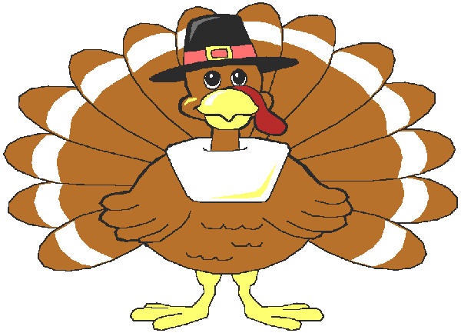
- Pupil
Turkey pardon
Every year, the president frees one lucky turkey while millions of its brethren are consigned to the dinner table. Though turkey farmers have been sending presidents the choicest birds since the 1800s, President John F. Kennedy was the first one on record to spare a turkey. In 1963, he sent back a turkey mailed by the National Turkey Federation, saying, "We'll just let this one grow." President Richard Nixon sent turkeys to a Washington, D.C., petting farm but didn't officially pardon them, according to the White House Blog. President George H.W. Bush gave the first official pardon to a turkey in 1989. The survivor lived out its days at a Virginia petting zoo called Frying Pan Park.

- The song “Turkey tango”
The Turkey Tango

I taught my turkey how to tango. His name is Fred he's from Durango. In a tux he looks so chic, with a rose held in his beak. And he does a nice fandango.
Now Freddie teaches how to tango to all his buddies from Durango. Peter Panda, Betty Bear- They all think he's Fred Astaire- even Al Orangitango.
He's suave and graceful. He would never trip or hobble. He's got that polish like a diamond or a bauble. He's fine and clever and his feathers never wobble. Though it is true that, when he dances he will gobble.
He'll teach the tango and he'll always so perky. But he won't teach to anyone who is being quirky.
From San Francisco to New York and Albuquerque. He'll teach the tango, just remember he's a turkey.
- Cha Cha Cha
- Pupil
Official holiday
While Thanksgiving festivals were informally celebrated throughout the 1600s, they didn't become an annual event until the 1700s, when each state set aside a different day for the holiday. By 1775, George Washington, then commander-in-chief of the Continental Army, declared the first national celebration of Thanksgiving, and he issued a Thanksgiving Day proclamation in 1789. But the holiday didn't get a fixed date until 1863, when President Abraham Lincoln set aside the last Thursday in November for the day of thanks.

- The song “Hip Hop Turkey”
https://www.youtube.com/watch?v=5ptVBuYiQWA
There’s a turkey named T livin’ on a farm.
He changed his name ‘cause he used to be Tom.
He’s got friends and they all like to move.
But their favourite thing is a Hip Hop groove.
They’re more than feathers.
They’re more than gooble.
They’re more than just some birds,
Who have that funny wattle.
They move their beaks and tails.
They move their drumsticks.
These turkeys like it when they’re movin’ to their own mix.
Gobble (5). Yo.
Gobble (5) .Yo.
Gobble (5). Yo.
Gobble (5) .Yo.
Put your drumsticks together like this(2).

- “U can” 8кл
- Загальна пісня. Всі на сцену
The song “THANKSGIVING SONG “
https://www.youtube.com/watch?v=AFI5egZfDqk
Thank-you, thank-you, thank-you
Let's all say thank-you.
We will all say thank-you
On this special day.
Thank-you, thank --you, thank-you
Let's all say thank-you
On Thanksgiving Day!
Many, many years ago
When pilgrims first arrived.
Crops were small, this made it all
A challenge to survive.
In honour of their hard work
They all gathered 'round and dined,
And gave their thanks at harvest time.
We celebrate this holiday
With friends and family.
And thank the Lord for all our gifts
This joyful jubilee.
There's turkey, stuffing, pumpkin pie
Enough for everyone.
Let's eat and drink and have some fun.

