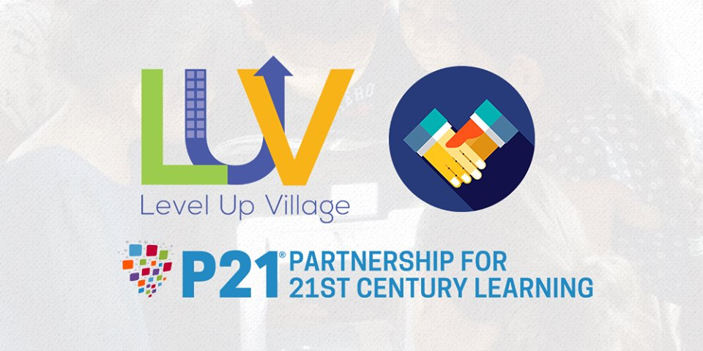
In October, 2017 Buchach lyceum joined Level Up Village (LUV), a socially conscious company whose mission is to motivate and inspire today’s children and to harness the power of global connection and facilitate seamless collaboration between students from around the world via pioneering Global STEAM (STEM + Arts) enrichment courses.
They offer STEAM courses for students. Schools run their courses to students in-school, after school and during the summer. In each course, students connect with peers in other countries – students exchange video letters with their global partner students and collaborate on projects.
We have been enrolled in two courses: Global Doctors DNA (7,8 grades) and Global Inventors (10 grade). Our students have just started these courses!
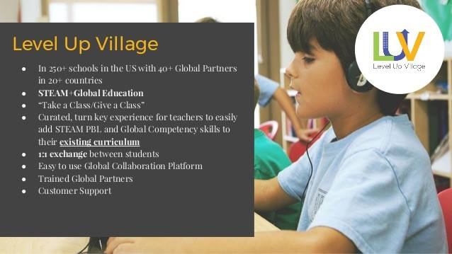
The first lessons in The Global Doctors DNA have been held in Buchach lyceum.
The Global Doctors DNA course provides opportunities for students to explore the intersection between genetics, environment and their own health and discover what they can do to become healthier, happier individuals.
Our students have already learned about the structure of DNA and made models, extracted and observed their own DNA.
They also understood how genes determine appearance, used a basic Punnett square to predict probability of genotypes. The children learned the causes of genetic mutations during the second lesson.
The videos provided by LUV are very useful and easy for explaining. The students are interested in this course and they are looking forward for new lessons and video exchange with their partners from the USA.
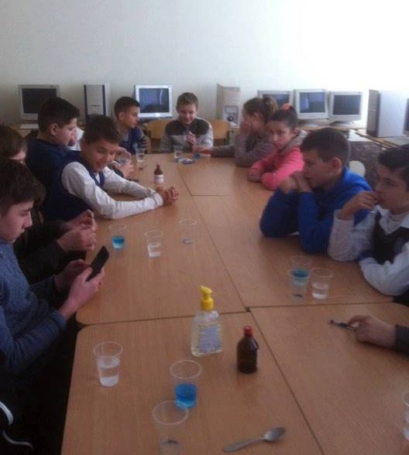
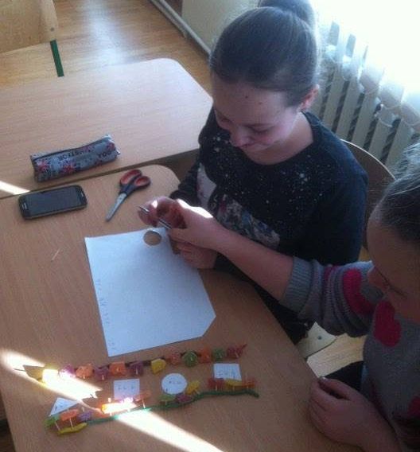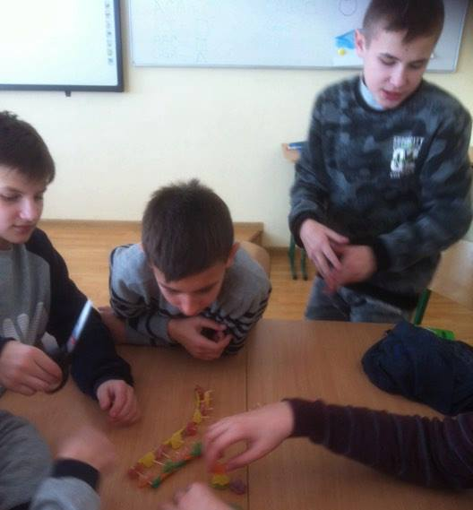

Buchach Lyceum in LUV again!
This year the students of the 8th, 9th and 10th forms are participating in The Global Water Crisis course.
This course provides opportunities for students to learn about the water issues affecting communities around the globe. This is done through understanding how water is managed locally and collaborating with their partner on sustainable solutions to effectively manage the world’s limited water supply.
This LUV Course was arranged to be taught over 8 weeks. The first 4 weeks of the class introduced our students to the course’s Essential Question “How do we access clean water around the world?”, the STEAM foundation work that helped them begin to answer that question, and the LUV Platform used to share ideas and answers to the question. From week 5-8, our students completed weekly activities to connect with their partners and made their own models of water filters using 3D design in Tinkercad program. This week is the last one in our course and we are looking forward to our prize – 3D printer!
