Zhuk Svitlana Dmytrivna, 01.03.1964, ChortkivGymnasium, teacher, tel.:0355221615, email address: maridisguised@ukr.net

Name of activity 1: Listening Skills

Materials used: the Internet photos and information (<https://www.google.com.ua/url?sa=t&rct=j&q=&esrc=s&source=web&cd=1&cad=rja&uact=8&ved=0ahUKEwjn-fbj-NDKAhUC9HIKHQx9DzMQFggjMAA&url=Legendary-Creatures-in-Ukrainian-Folklore.aspx&usg=AFQjCNECjgPimvXcxCYMzcWGo0EhIvaulw&sig2=FeKnn0c-Dh6Ra8gdeZd_AA>)

Note: teachers will have to translate the information from Ukrainian and make it concise.

Objectives: developing listening for specific information skills

Subject: Legendary Creatures in Ukrainian Folklore

Age: 14-15

Level: B1

Vocabulary focus: keep peace, chores, a spirit, drown ,destroy, a dam, a log, kidnap, slave, comb,translucent,damp, male, pale, piercing, mischievous, anaxe,tickle

Description of activity:

1.Students look at pictures of legendary creatures in Ukrainian folklore.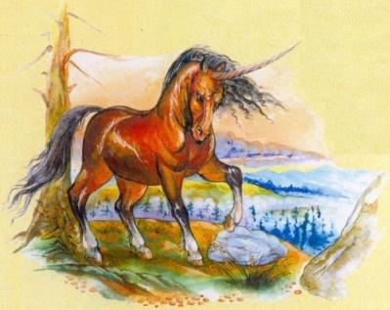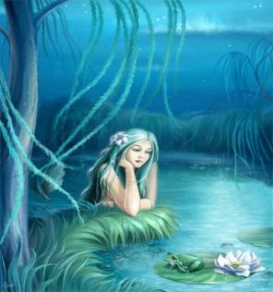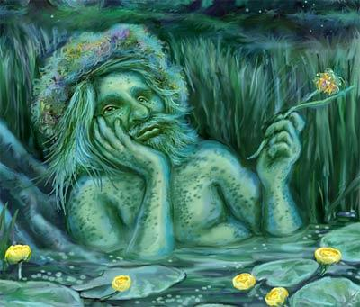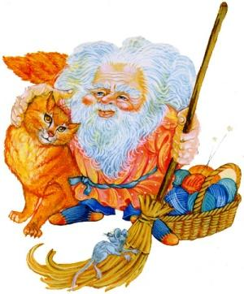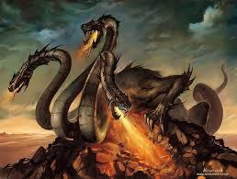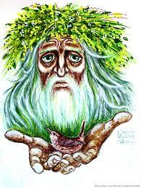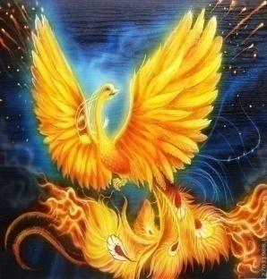

They try to identify them: Indryk, Rusalka, Vodianyk, Domovyk, Zmii, Lisovyk, Zhar-Ptytsia.

2.Students are introduced to the new vocabulary used in the text which describes the seven legendary creatures in Ukrainian folklore.

3.Students split into two teams and read through the comprehension questions.

e.g.: Which creature can have an appearance of a cat?

Who destroys dams?

Who travels on a log?

Who can return as a rusalka according to legend?

Whose heads can grow back?

4.Students listen tothe text and try to answer these questions in their teams.

5.Game: students choose captains of their teams who will compete now in answering the comprehension questions. Purpose: getting more points.

6.The captains sit at a table opposite each other in front of the teams and compete in answering the questions which the teacher reads aloud. In the middle of the table there must be a safe object like an apple . The captains listen to the question. If theydecide they know the answer, they try to grab the apple quicker than their rival. If they do, they get a permission to give the answer to the question. The game goes on until all the comprehension questions have been answered. Each correct answer of the captain brings 1 point to the team.

Name of activity 2 : Oral Interaction/Writing Skills

Materials used: photos and concise information from the Internet resources

Objectives: developing speaking/writing skills

Subject: Colours of the Ukrainian State Flag

Age: 16-17

Level: B2

Vocabulary focus: colour psychology, mind, intellect, trust, peace, loyalty, integrity

Description of activity:

1.Pupils look at the pictures and decide what they have in common.

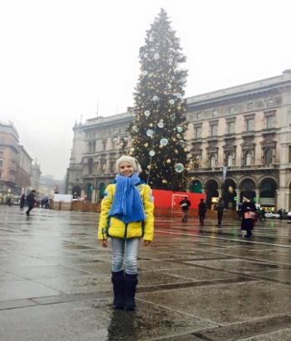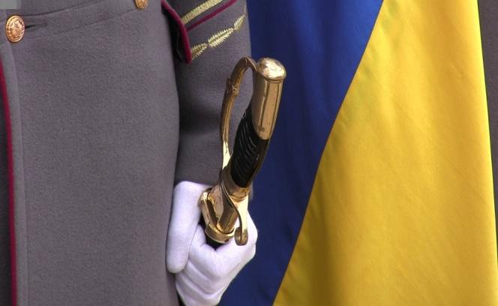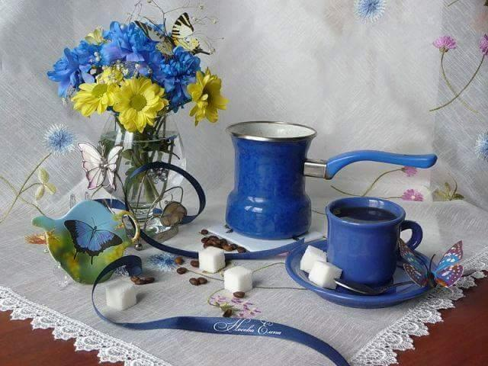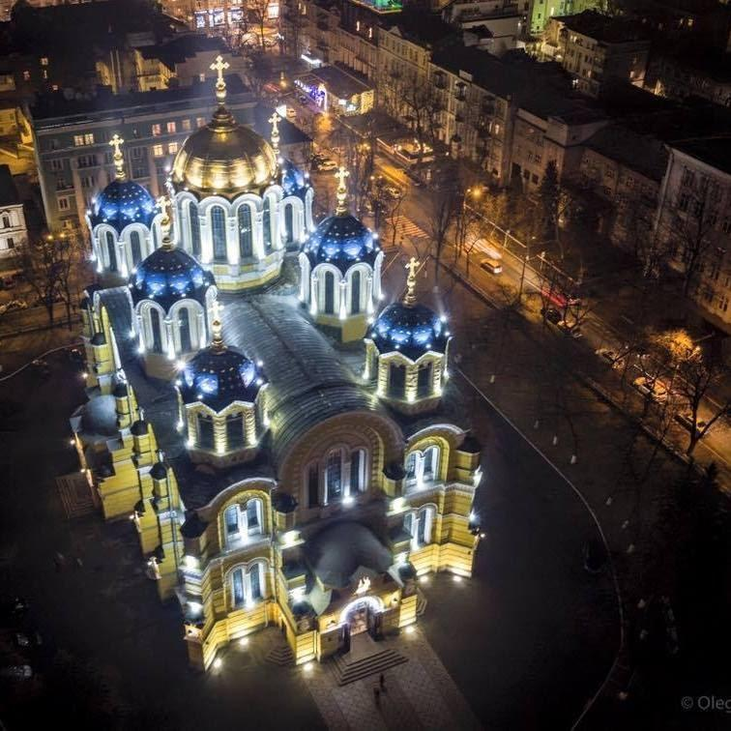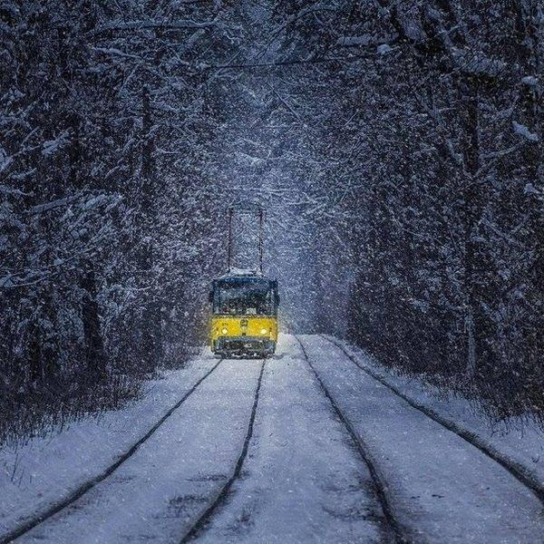

(All the pictures contain yellow and blue colours)

2.Speaking: via Interactive «Think. Pair. Share.» activity. Pupils must explain what the colours of the State Ukrainian Flag stand for(eliciting).

3. Listening/Reading: «The meaning of blue and red colours in non-verbal communication ».

In colour psychology yellow is the colour of the mind and intellect. It is optimistic and cheerful. Blue is the colour of trust and peace, of loyalty and integrity.

4.Speaking: Pupils in pairs comment on the information in relation to the Ukrainian State Flag colours’ symbolic meaning and the national character traits, justifying their opinions and then share their ideas with the class.

5.Writing: In three minutes pupils have to explain what they associate the yellow and blue colours with at the moment and why (e.g.: a happy sunny day, the blue peaceful sky etc.).

Name of activity 3: Reading/Speaking Skills

Materials used: handouts with a text and a dialogue with the missing cues

Objectives: reading, practicing oral interaction skills

Subject: The Climate of Ukraine

Age:13-14

Level: A2

Vocabulary focus: climate, temperately continental, subtropical, the South, the North, the Crimea, average yearly temperature, mild, severe frosts, chiefly, rather hot, dry, favourable for, development of agriculture

Description of activity:

1.Students memorize the new vocabulary by choral and individual repetition, translating it from Ukrainian into English and vice versa.

2.The teacher gives out handouts with a short text about the climate of Ukraine and an incomplete dialogue to check comprehension :

A: Do you know the geography of our country well?

B: I think I do.

A: OK, let’s check. Can you tell me what climate Ukraine has got?

B:---------------------------------------.

A: What climate has the South of the Crimea got?

B:---------------------------------------.

A: What is the average yealy temperature in Ukraine in winter and summer?

B: --------------------------------------.

A: What is winter usually like?

B: --------------------------------------.

A: What is summer usually like?

B: --------------------------------------.

3.First students read the text about the climate in pairs.

4.Students write their answers to the questions in the dialogue in their handouts.

5.Students check answers as a class, memorize the dialogue and act it out .

