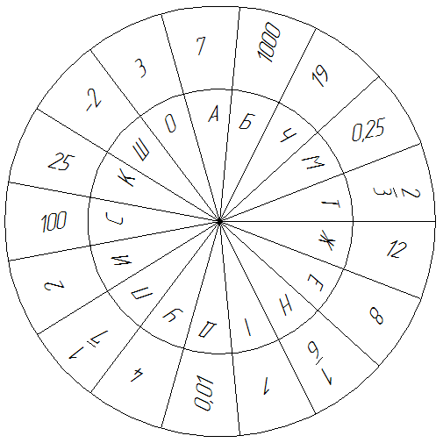
а) Знайти значення виразу:
1. ${\text{log}}_{3}\text{81}$ (9; 26; 28; 46; 48)
2. ${\text{log}}_{\text{64}}2$ (1; 6; 23; 33; 38)
3. ${\text{log}}_{9}\sqrt{3}$ (3; 12; 16; 22; 45)
4. ${\text{log}}_{0,5}4$ (49)
5. ${\text{log}}_{x}\text{49}$ (7; 13; 17; 36)
6. $5{\text{log}}_{5}\text{12}$ (5)
7. $\text{lg}\text{300}−\text{lg}3$ (11; 19; 30)
8. ${\text{log}}_{\text{15}}3+{\text{log}}_{\text{15}}5$ (50)
9. $9{\text{log}}_{3}5$ (20)
10. ${\text{10}}^{1−\text{lg}\text{15}}$ (10; 14; 18; 43)

б) Розв’язати рівняння
1. ${\text{log}}_{2}x=3$ (2; 15; 24; 42)
2. $\text{lg}x=3$ (8; 25)
3. ${\text{log}}_{x}\text{81}=4$ (4; 21; 31; 34; 39; 41; 44)
4. $\text{lg}x=−2$ (27; 32; 47)
5. ${\text{log}}_{x}\text{343}=−3$ (40)
6. $\text{lg}x^{2}=4$ (37)
7. ${\text{log}}_{2}\left(x−3\right)=4$ (29; 35)

1 | 2 |  | 3 | 4 | 5 | 6 | 7 |  | 8 | 9 | 10 | 11 |  | 12 | 13 | 14 | 15 | 16 | 17 | 18 | 19 | 20 | 21 | 22

23 | 24 |  | 25 | 26 | 27 | 28 | 29 | 30 |  | 31 | 32 | 33 | 34 | 35 | 36 | 37 | 38 | 39

40 | 41 | 42 | 43 | 44 | 45 |  | 46 |  | 47 | 48 | 49 | 50

