Self-Evaluation Checklist
 | YES | NO | SOMETIMES
I worked well today
I listened to my classmates
I find this lesson interesting
I can do my homework easily
Name one thing you liked about the lesson
Name one thing you didn’t like about the lesson

STUDENT SELF EVALUATION

I listened to my teacher and my classmates attentively | 
I asked for help when I didn’t understand
I raised my hand to answer the questions
I participated all the activities
I was polite and respectful to students and the teacher

GROUP SELF EVALUATION FORM
 | YES | NO
We finished our work on time, and we did a good job!
We encouraged each other and we cooperated with each other.
We spoke quietly in our group.
We each shared our ideas and then listened and valued each other’s ideas
We did best at…
Next time we’ll improve in…

PEER ASSESSMENT FORM
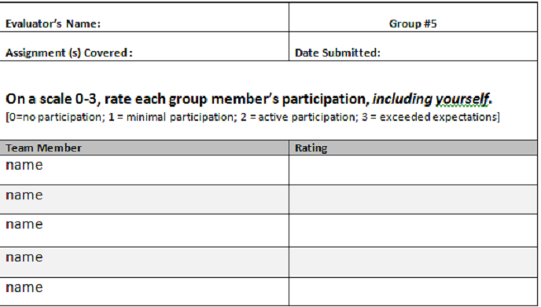
PEER ASSESSMENT FORM
Name | Name | Name
He/She was active today
He/She was tactful
He/she helped other students in the class
He/she knows the vocabulary to the topic
He/she was ready with his/her homework

