Теребовлянська спеціалізована школа І-ІІІ ст. № 3
з поглибленим вивченням іноземних мов

КОНСПЕКТ УРОКУ
на тему
« SEASONS AND WEATHER»


Підготувала
вчитель англійської мови
Ямелинець Л.В.

Objectives:
- to extend pupil's knowledge about seasons and weather in different countries;
- to activate pupils speaking habits;
- to develop listening skills and understanding of English;
- to develop reading activities;
- to develop pupils writing habits and skills;
- to reinforce grammar skills through using in their speech the Indefinite Pronouns;
- to exploit the motivation created by giving and receiving personal feedback.

Equipment: a laptop, a projector, a screen, a pictures, PPT “ What’s the weather like today?”, some handouts, maps of Ukraine, Australia, Great Britain.
PROCEDURE:
- Introduction
-Greeting
Motivation
Vocabulary Drill
Students watch the presentation and name the weather.
- Main Part
Speaking

The students’ task is to take a strip of paper, to say when they can do this activity and stich the strip under the necessary picture.

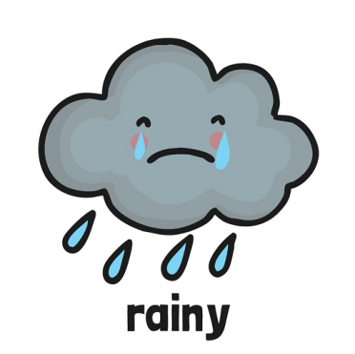

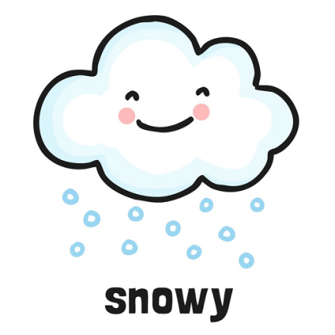
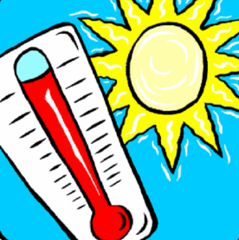

Go to the park
Play football
Sunbathe
Swim
Play snowballs
Make a snowman
Watch TV
Fly a kite

Wear sun hats
Wear coats
Take an umbrella
Go outside

Pre-reading task
Teacher’s questions
-How many seasons are there in a year?
-What are they?
-What’s the weather like in spring?
-What’s the weather like in summer?
-What’s the weather like in autumn?
-What’s the weather like in winter?
Reading
TEXT “SEASONS IN BRITAIN”

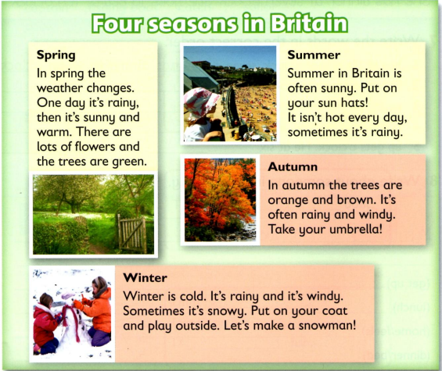

After-reading task

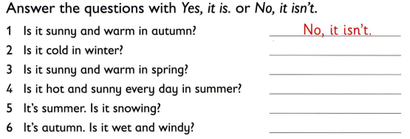
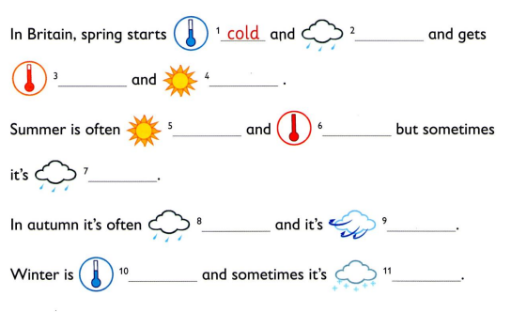

A song
Students sing the song and move .
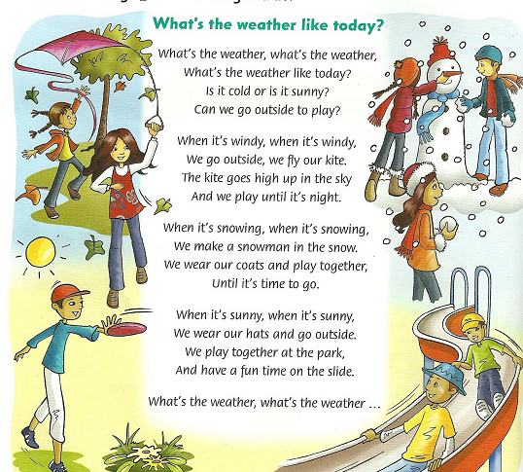
Writing

Students read the text about the seasins in Thailand and write about the seasons in their own country.
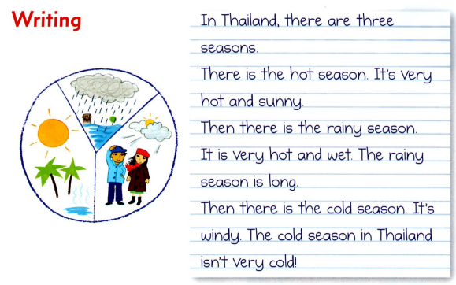
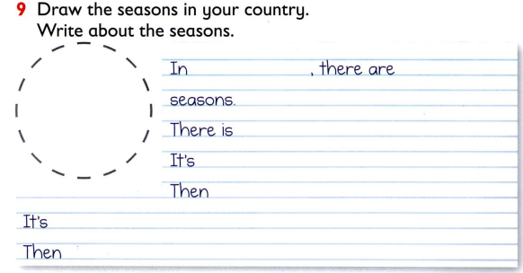

Listening
Ex 1, p 63
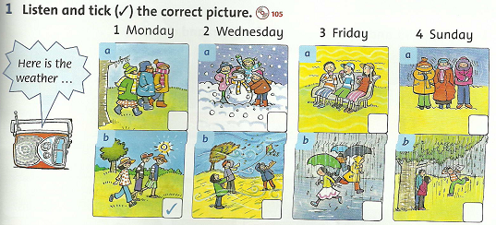
T

Project “WEATHER NEWS”
Students read the information about the weather in one of the countries, draw the signs on the map and then tell the weather forecast in this country.
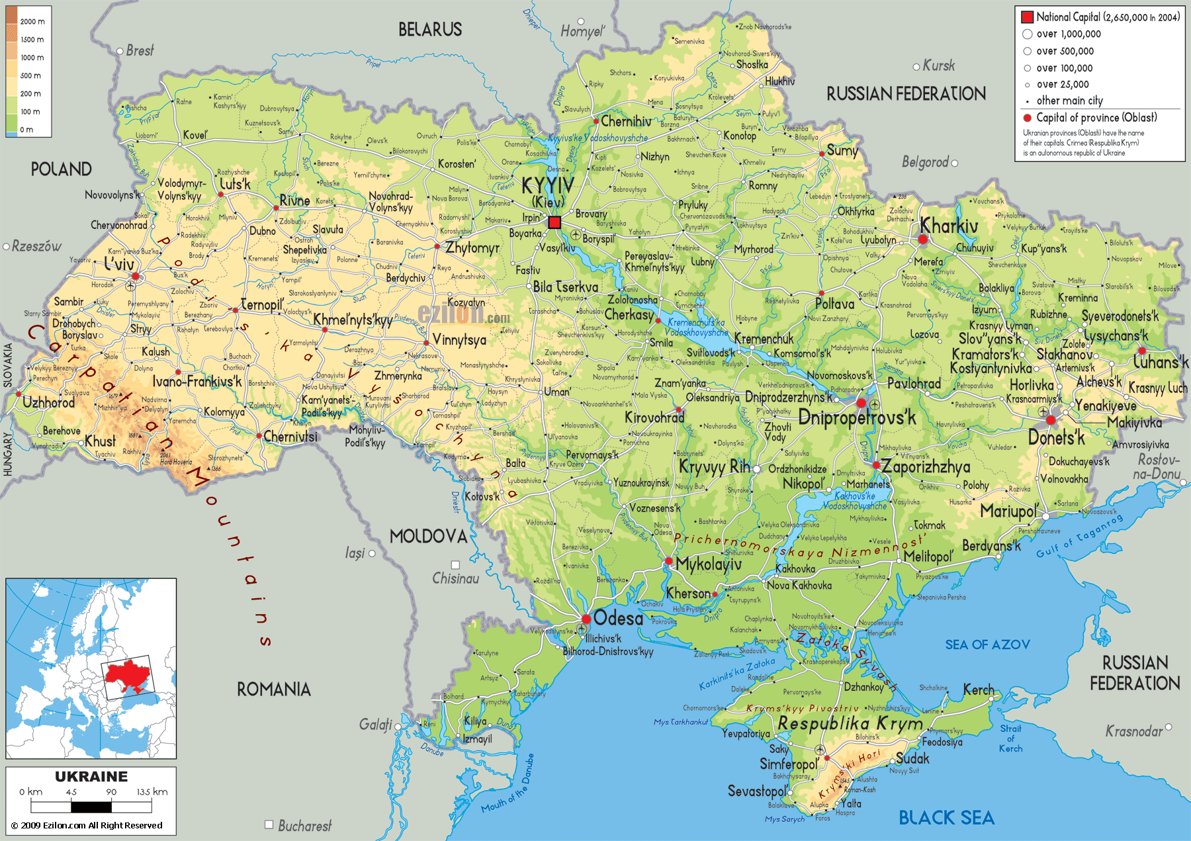

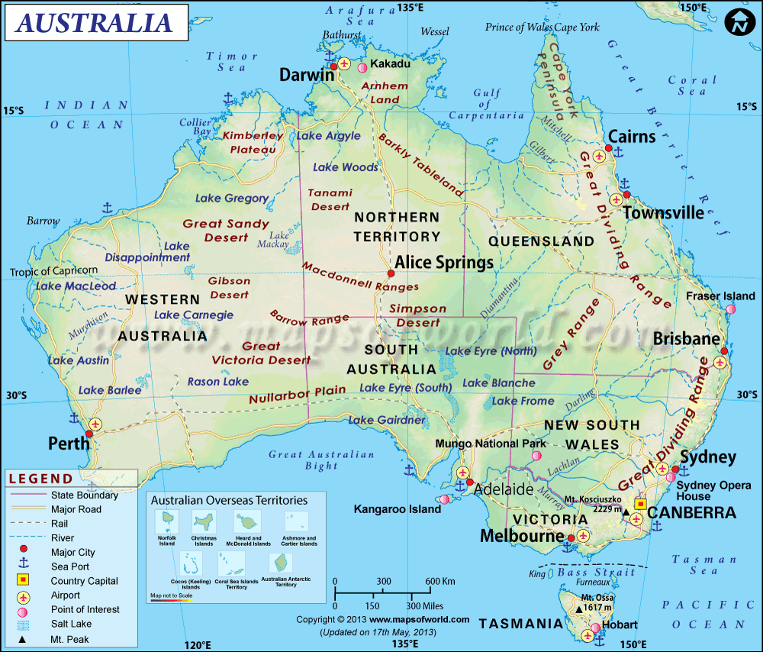

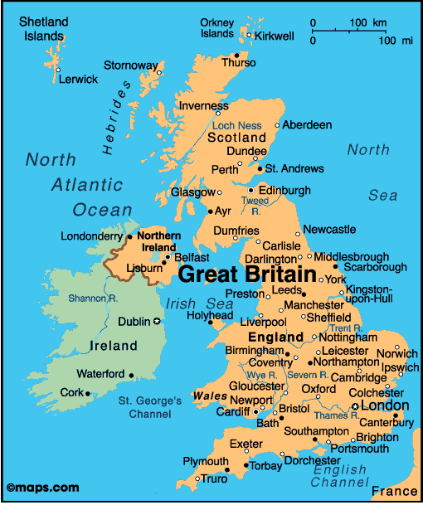

Here is the weather news. It is cold in Ternopil today. It is cloudy.The temperature is 5 degrees below zero.
It is cold in Kyiv. It is snowy. The temperature is 10 below zero.
It is cold in Kharkiv. It is snowy. It is slippery. The temperature is 12 degrees below zero.

Here is the weather news. In London it is chilly. It is cloudy and rainy. The temperature is 12 degrees above zero.
In Glasgow it is chilly. It is foggy and rainy. The temperature is 10 degrees above zero.

Here is the weather news. In Darwin it is hot. It is sunny. The temperature is 25 degrees above zero.
In Canberra it is hot. It is stuffy. The weather is 30 degrees above zero.

