Теребовлянська спеціалізована школа І-ІІІ ст. № 3
з поглибленим вивченням іноземних мов

КОНСПЕКТ
уроку в 2 класі
на тему
PROFESSIONS



Підготувала
вчитель англійської мови
ЯМЕЛИНЕЦЬ Л.В.

Теребовля 2015
Topic: The world of professions
Subject Matter: Professions
Objectives:
-To practice the usage of the vocabulary on the topic;
- To develop speaking skills;
- To present the new grammar material (He’s/She’s)
- To practice the grammar material;
- To involve students into interactive activities;
Materials: class-books, video, jobs posters, pictures, CD
PROCEDURE:
I.INTRODUCTION
- Greeting
Good morning, good morning,
Good morning to you,
Good morning, good morning,
I’m glad to see you.
-Motivation
A Game “ PRESENTS ”
Teacher: I want you to play a game. Come to the board, take a present and do the task.
Correct the mistake
Ticher
Translate the sentence
Він є фермер
Name the profession
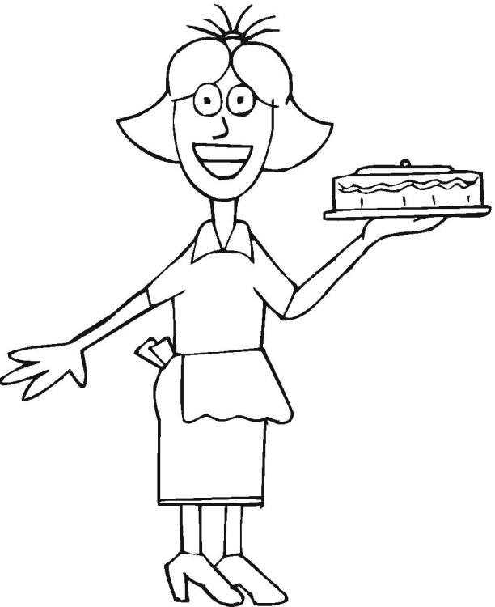

Correct the mistake
nurs
Name the profession
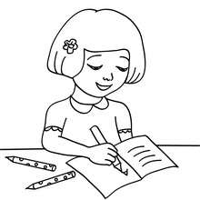
Correct the mistake
He’s a doctor
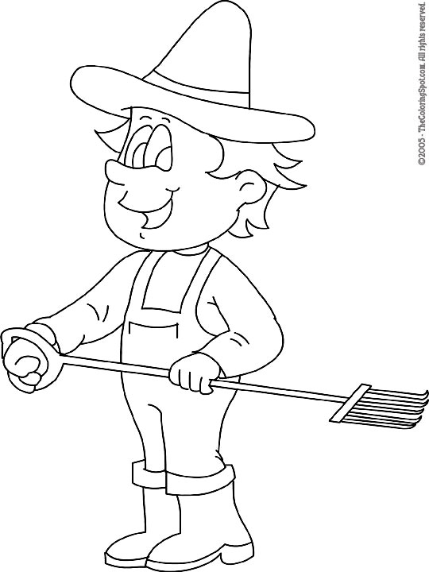

Translate the sentence
Вона є медсестра
Correct the mistake
pailot
Name the profession
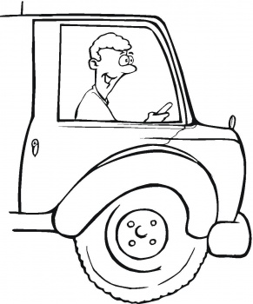

II. MAIN PART
Vocabulary Drill
Teacher: You can see the jobs flashcards on the board. I’m going to give you the pictures and your task will be to match the job and the picture it is connected to.



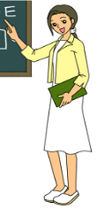

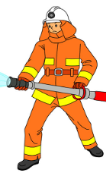
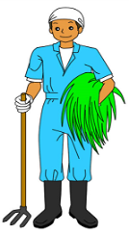







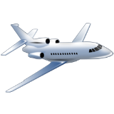

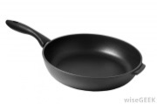

Checking the homework
Teacher: Last lesson we spoke about your favourite professions. And today I want you to imagine you’re adult and tell us about your professions.
Pupils’ predictable answers:
Pupil 1: My name is…. I’m a teacher. I work at school. I teach pupils to read and to write. I love my job.
Pupil 2: My name is…. I’m a doctor. I work in the hospital. I treat my patients. I love my job.
Pupil 3: My name is….I’m a builder. I work on a site. I build houses. I love my job.
Pupil 4: My name is….I’m a chef. I work in the kitchen. I cook food. I love my job.
Pupil 5: My name is….I’m an artist. I work in the studio. I draw pictures. I love my job.
Pupil 6: My name is….I’m a singer. I work on a stage. I sing songs. I love my job.
Pupil 7: My name is….I’m a policeman. I work in a police department. I keep people safe. I love my job.
Pupil 8: My name is….I’m a waitress. I work in the café. I bring food and drinks. I love my job.
Pupil 8: My name is….I’m a barber. I work in a barber’s shop. I cut hair. I like my job.
Pupil 8: My name is….I’m a farmer. I work on the farm. I take care of cows, chicks and goats. I like my job.
A Song
Teacher: As you told us about your dream jobs I want you to greet each other and to sing a song.

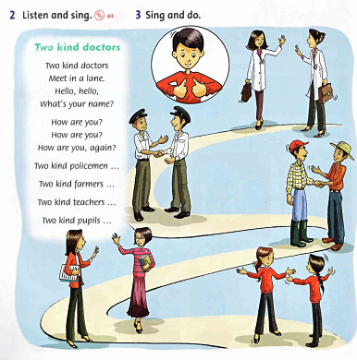

Teacher: Today I’m going to present you a new material. If we speak about a man’s profession, we use the expression HE’S and when we speak about a woman’s job we use SHE’S. For example,

HE’S SHE’S

Listening
Teacher: Watch the video, listen to the sentences, and repeat the sentences.
Tapescript
He is a cook. She is a student. He is a fisherman. She is a dentist. He is a doctor.
He is a fire fighter. He is a pilot. She is a bus driver. She is a nurse.
He is a police officer. He is a farmer. She is a teacher.
Writing
Teacher: Next task is to fill in the gaps with the words HE’S or SHE’S
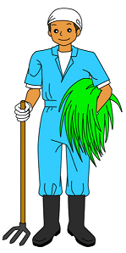


_______a chef. _________a doctor. ______a farmer.

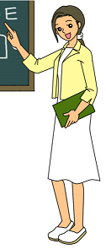


_______a policeman. __________a teacher. _________a singer.


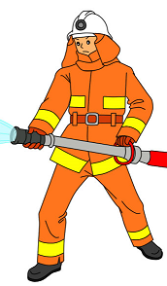

________a fireman. ________a pilot.
Exercises
Teacher: I see that you are very tired, so you need some exercises, so let’s move and read the alphabet rap .
A, B, C, D, E-
Here’s a rap for you and me!
F, G, H, I, J-
English lessons are OK!
K, L, M, N,O
Nice to meet you! Hi! Hello!
P, Q, R, S, T-
Count the students-1, 2, 3!
U, V, W- shout and clap!
X, Y, Z- do the rap!
Reading
Teacher:. And now open the book and read the text.
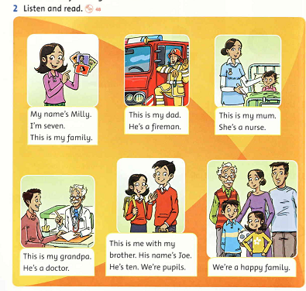
After-reading activity.
Pair Work

Speaking
Project
Teacher: You read about Milly’s family and now I want you to draw your family and tell us about your family jobs.
MY FAMILY
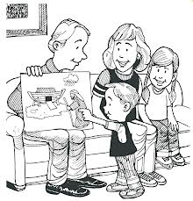

E.g. Pupil 1: My name is Sophiyka. This is my mum. She’s a teacher. This is my dad. He’s a builder. This is my sister. She’s a pupil.
III. CONCLUSION
Evaluation
Teacher: You worked well. Thank you very much. You marks are…..
Homework
Today everybody will have an individual homework. Come to the board and take the picture with the task.
Answer: What is our dad? What is your mum? What is your sister? What is your brother?
Translate: вчитель, офіціантка, фермер, художник, медсестра
Translate:
Він є фермер. Вона є кухар. Він є шофер.

Answer: What is your grandma? What is your grandpa? What is your mum?
Correct: polisman, fermer, draiver, pupel, haveswife.
Translate:
Він є льотчик. Вона є медсестра. Він є учень. Вона є шофер

Put the letters in order:1. mailopnec 2.ernamif 3. iwesuohef
Put the words in the order: 1. is, he,doctor,is. 2. a, nurse, she,is.

Correct the mistakes:
He’s doctor. This a nurse. I’m a weitriss.

