КОНСПЕКТ УРОКУ
з англійської мови
у 6 класі
на тему
« HOMES IN BRITAIN»
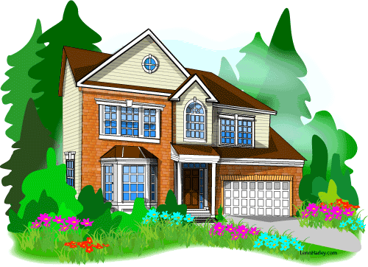
Підготувала
вчитель англійської мови
Теребовлянської СШ № 3 з ПВІМ
ЯМЕЛИНЕЦЬ Л.В.

Objectives:
- to extend pupil's knowledge about homes in Britain, its traditions and customs;
- to activate pupils speaking habits;
- to develop listening skills and understanding of English;
- to develop reading activities;
- to develop pupils writing habits and skills;
- to reinforce grammar skills through using in their speech the Present ContinuousTense;
- to encourage students to lead discussion;
Equipment: a laptop, a projector, a screen, English plus i-tools, pictures with types of houses, individual tasks for children.
PROCEDURE:
- INTRODUCTION
Greeting chant
- Good morning students. How are you?
- Good morning. We’re fine, thank you.
- Are you ready?
- Yes, we are.
- Are the boys present?
- Yes, we are.
- Are the girls present?
- Yes, we are.
- So, let’s start.
- OK.
Motivation
Students pass each other a box with tennis balls as soon as the music plays. When the music stops a student takes a tennis ball from the box, reads the task, which is written on the ball and does the task.
TASKS:
Name 10 types of houses
Name 10 furniture items
Name 10 household chores
Checking the homework
Students present their projects about unusual homes in Ukraine
- MAIN PART
Teacher: The topic of the lesson is “HOMES IN BRITAIN” By the end of the lesson you will learn about some types of houses in Great Britain, to watch some video, to compare British homes to your homes, to discuss advantages and disadvantages of living in some types of homes.
First of all we’re having an activity K-W-L. We have to write what we know about homes in Britain and what we want to know.
K-W- L chart
What we know | What we want to know | What we ‘ve learnt
Watching the video
Pre-watching task
Teacher: Answer the questions, please
- Have you ever been to Great Britain?
- Have you got relatives or friends in Britain?
- How do you imagine homes in Britain?
While- watching task.
Teacher: While watching the video you have to remember what types of homes are mentioned in the video.
Transcript
Over sixty million people live in the United Kingdom and there are over twenty-five million homes.
There are a lot of different kinds of homes. There are cottages, terraced houses, semi-detached houses, detached houses, old flats and new flats in the UK. All these homes are very different inside.
Lauren and her friend Brian are walking home from school. Lauren lives with her mum in a terraced house in Cambridge, in the south-east of England. The kitchen in Lauren’s house is small, but it’s nice. Lauren is making a cup of tea for Brian. They’re talking about their day. Lauren and Brian are deciding what to watch on TV. In Lauren’s living room, there’s a small sofa, a big TV and a table. There’s a rug under the table.
Terraced houses are usually quite small, like Lauren’s house. But some terraced houses are very large and beautiful. This is the famous Royal Crescent in the city of Bath, in the south-west of England. There are thirty houses in the Royal Crescent. The buildings are over two hundred years old. Today, a lot of these buildings are flats, offices, or expensive hotels. The homes haven’t got big gardens, but there’s
a great park in front of the Royal Crescent. Today, it isn’t raining. The sun is shining and it’s very hot! People are sitting in the park and playing games.
There are other unusual homes in the UK. Some people live on a boat on the canals. It’s never boring – the view is always changing! And a few families live in very old stately homes, like Broughton Castle.
This building is about seven hundred years old and it’s very large. It’s the home of Lord and Lady Saye and Sele, but they don’t use all the rooms. Part of the house is a museum. In one of the living rooms, there are sofas, chairs and tables, but there are some unusual things too. There’s a great view of the garden from the windows upstairs.
There’s a moat around the house. It’s full of water. There’s a tower and a church here too. There are a lot of beautiful flowers growing in the garden. Broughton Castle is quite famous. Because it’s very pretty, people sometimes make films and TV shows here. People aren’t filming at Broughton at the moment, so it’s very peaceful. It’s an interesting place to visit and it’s an amazing place to live.
After-watching activity
Teacher: Choose the correct answer:
- How many people live in the UK?
a over 60,000 b over 16,000,000 c over 60,000,000
- Where is Royal Crescent?
a Bath b Broughton c Cambridge
- What do people make at Broughton Castle?
a radio programs b TV shows c nature documentaries

Speaking
Discussion
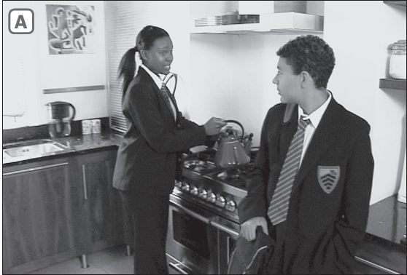

-Where are Lauren and Brian?
-Describe the room.
-How is it different from your kitchen?
-What are Lauren and Brian doing in the kitchen?
-What do you do in the kitchen?

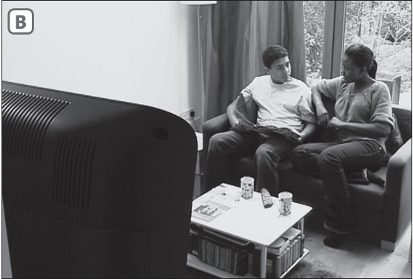
-Where are Lauren and Brian?
-Describe the room.
-How is it different from your living room?
-What are Lauren and Brian doing in the living room?
-What do you do in your living room?
Writing
Pair Work
Teacher: You have to take a piece of paper and find your partner .
detached house
House boat
sky scraper
semi detached

Terraced House
Cara van

Teacher: One of the partners has to go to the blackboard, take one envelope of any color. There is a picture of one house. You have to write advantages and disadvantages of living in this type of house.


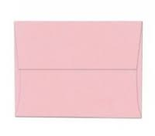

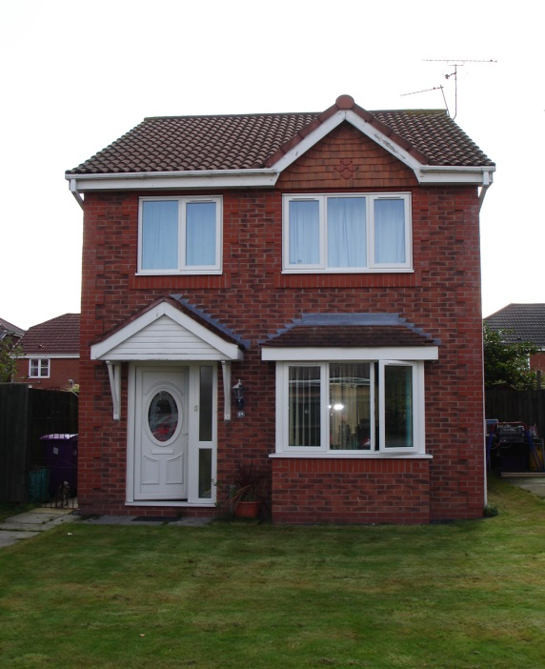
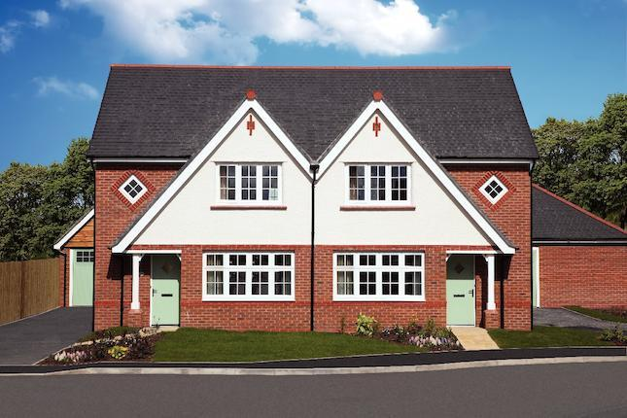

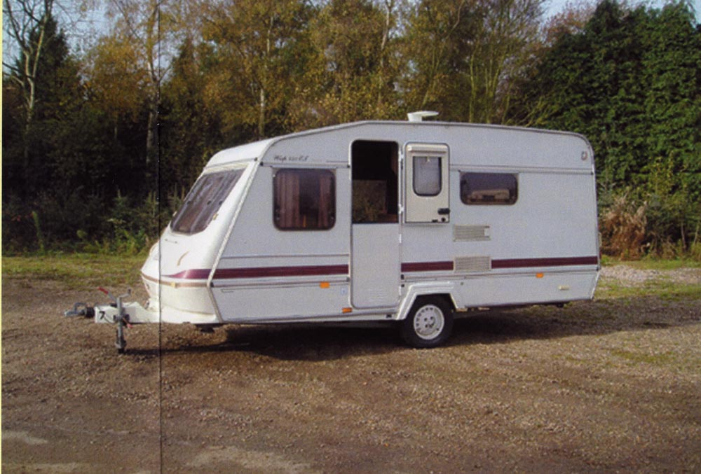

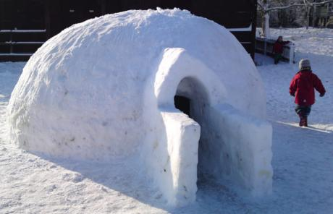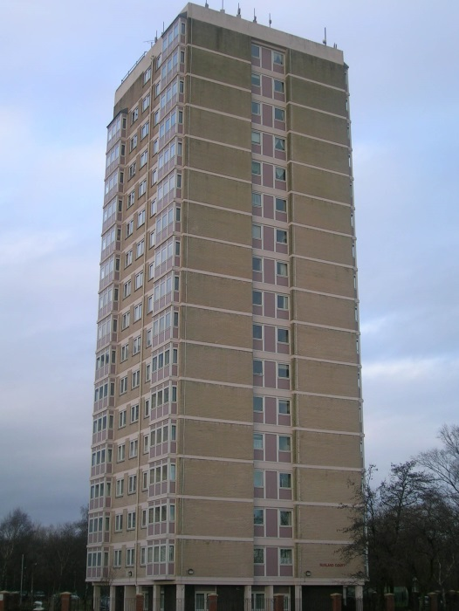

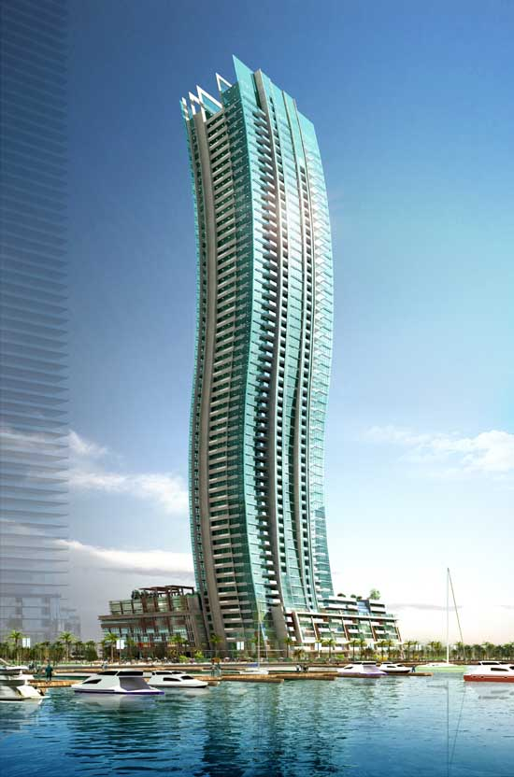

- CONCLUSION
Evaluation
Hometask
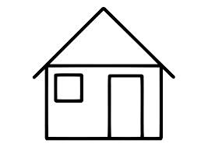
There are 12 houses on the blackboard. The individual task is written on each house. Each student takes any house and does the task.

