Конспект уроку
у 5 класі
на тему
«CHRISTMAS IN UKRAINE»
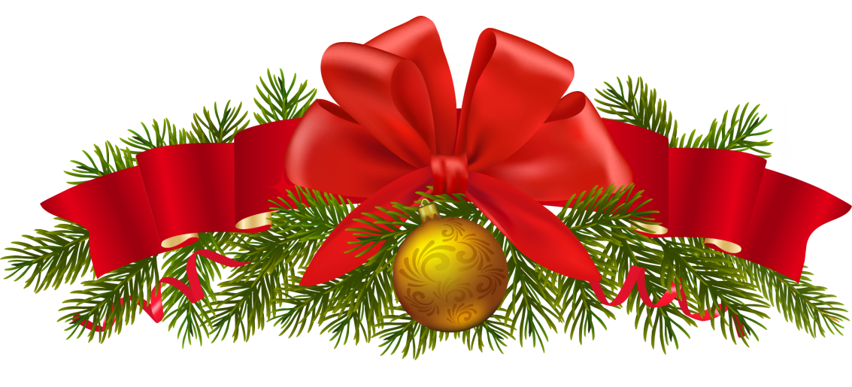

Підготувала
вчитель англійської мови
Ямелинець Л.В.

TOPIC: CHRISTMAS AROUND THE WORLD.
SUBJECT MATTER: Christmas in Ukraine
OBJECTIVES:
By the end of the lesson the students will be able to:
-practice word order in Wh- questions;
-- read a piece of information about Christmas in Ukraine;
-compare Christmas traditions in Ukraine and Great Britain;
- encourage students to work in pairs and in groups;
Equipment: a box with tennis balls, envelopes with paper strips, handouts.
PROCEDURE:
I. Introduction
- Greeting
-Motivation
THE GAME “HOLIDAY BOX”
The teacher prepares a colorful box with tennis balls. A holiday greeting is written on each ball. A student takes a ball without watching, reads the greeting and guesses the holiday
  - Christ is born! ( Christmas)
  - Happy New Year! (New Year)
  - Be my Valentine! (Valentine’s Day)
  - Christ is risen! (Easter)
  - Christ is being christened! (Epiphany)
  - Many happy returns! ( Birthday)
II.Main Part
SPEAKING

Group Work
The students are divided into groups of three. Each group gets an envelope in which they can find words on paper strips. Their task is to make up sentences. Then the teacher names the color, the students read the question of this color and answer.

Ukraine?
Group 1
When
celebrated
Christmas
is
in

Group 2
the
What
main
is
dish?
Christmas

Christmas
call
special
songs?
How
Group 3
do
we

Group 4
are
on
there
many
How
supper?
holy
the
dishes
Group 5
What
do
you
Christmas
know?
symbols
Ukrainian

READING
Pair work
The students put the sentences in order to have a story about Christmas in Ukraine
Christmas in Ukraine is celebrated on the 7th of January.
The evening before Ukrainian people have the Holy Supper.
It begins when the first star appears in the evening sky.
Then the head of the family brings in didukh (a sheaf of wheat) and puts it in the corner of the room.
The hostess puts kolach ( sweet Christmas bread) and 12 dishes on the table.
The main dish is kutia . It is made of boiled wheat grains, poppy seeds, raisins, nuts, honey.
The dinner starts with the prayer.
At the end of the holy supper the family sings koliadky (Christmas carols).
Young people organize vertep (Christmas play).
They go from house to house and show the scenes of Jesus Christ’s birth.
After-reading activity
The students can see Venn diagram on the board and with the help of the teacher they write similar and different features of Christmas in these two countries.

Ukraine
Great Britain

WRITING
The students fill in the gaps in the letters with given words. Then they read and check the answers.
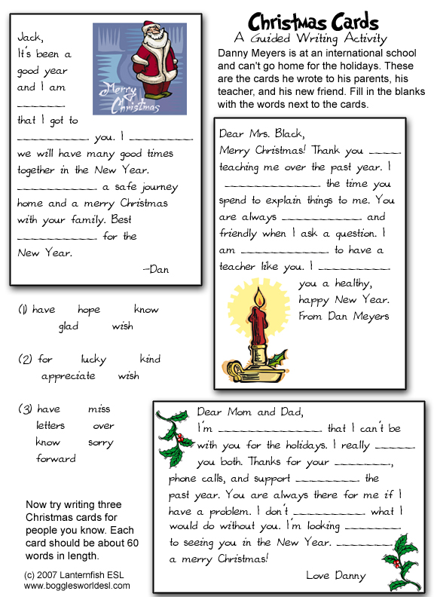

III. Conclusion
-Evaluation
-Home task
Make three Christmas cards to people you love. Each card should be about 60 words in length.

