**Look at the picture of Agatha Christie and try to characterise her.**

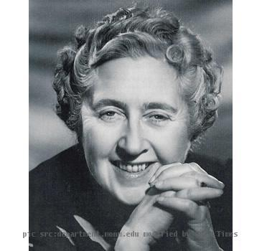

***Listen to Christie’s biography and do the following task in groups.***

***Post-listening tasks***

***I.*** Group work. Jumbled sentences.

T. Each group will get two sentences. They are jumbled. Make up  
sentences from the words given there. Mind the word order.

*Group 1*

1. was / Agatha / and / mother / in / American / Christie / English / 1890 / of / Devon / an / father / born / in.

2. have / than / of / London / 30 / Some / continuously / her / years / run / more / works / for.

*Group 2*

1. 80 / novelist / produced / The / century / made / the / more / famous / than / of / detective / books / her / she / most / the.

2. also / 6 / plays / self — / Christie / and / Agatha / novels / por-  
traits / several / wrote / 2.

*Group 3*

1. classic / ingenuity / Agatha / exclusively / books / of / almost / tantalizing / Christie's / concentrate / on / plot.

2. but / her / form / undistinguished / slight / style / sufficient / is / of / and / exigencies / Her / the / characterization / the / for.

*Keys:*  
Group 1

1. Agatha Christie was born in 1890 in Devon of an American father and English mother.

2. Some of her works have run continuously in London for more than 30 years.

Group 2

1. More than 80 books she produced made her the most famous detective novelist of the century.

2. Agatha Christie also wrote 6 novels, 2 self-portraits and several plays.

Group 3

1. Agatha Christie's classic books concentrate almost exclusively on tantalizing ingenuity of plot.

2. Her style is undistinguished and her characterization slight, but sufficient for the exigencies of the form.

***II. You are going to read the extract. Some words are missing from the text. Choose the most appropriate answer from the options (A, B, C, D) for each gap (1-7) in the extract. Write the letter of the appropriate answer in the white boxes below.***"I (1) ... know what to think", said Mrs. Ackroyd tearfully. "It's all very upsetting. What (2)... happen to the estate, I wonder, if Ralph were very guilty?"

Raymond (3) ... his chair away from the table violently. Major Blunt remained very quiet, (4) ... thoughtfully at her. "Like shellshock, you know", said Mrs. Ackroyd obstinately, "and I dare say Roger kept him (5)... money — with the best intentions, of course. I can see you are all against me, but I do think it is very odd that Ralph (6) ... forward, and I must say I am thankful Flora's engagement was never announced formally.

"It will be tomorrow", said Flora in a (7) ...voice.

|  |  |  |  |  |
| --- | --- | --- | --- | --- |
| 1 | A don't | B am not | C was | D will |
| 2 | A are | B will be | C would | D were |
| 3 | A put | B took | C threw | D pushed |
| 4 | A looking | B staring | C watching | D gazing |
| 5 | A short with | B short of | C short at | D short |
| 6 | A did not come | B has not come | C will not come | D are not coming |
| 7 | A bright | B fine | C clear | D distinct |

Keys: 1 A; 2 C; 3 D; 4 A; 5 B; 6 B; 7 C.

**You are working in the local newspaper. Your task is to write down an article about Ralph.**