1.Lead-in

a )Is health one of the main values?
b )Do you often get ill?
c )What must one do to keep fit?

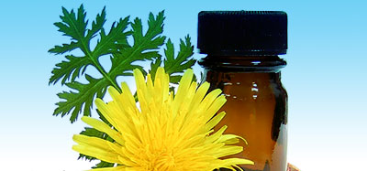
2.Read the text and mark the statements (1-10) as T (true) or F (false) according to the text.

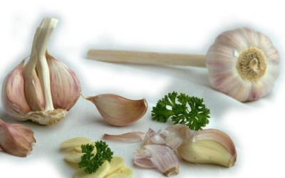
Ukrainian remedies

Definitely nothing has done more for the comfort and happiness of mankind than the advance of medical knowledge! Millions of people have benefited from the common aspirin! How many lives have antibiotics and tranquilizers saved? But drugs can sometimes have “side effects”. That`s why we can`t ignore natural healing to prevent the disease. We should strengthen the body`s immune system through natural means, reduce stress, improve our diet and lead a healthy way of life. Some people use both: the best technological medical care and the tested herbal remedies to cure different diseases. Here are some traditional Ukrainian remedies for flu:
- boil a glass of milk, add one ground onion. Mix everything well. After the milk has cooled a bit, filter the liquid and drink it slowly before going to bed. You must repeat this in the morning.
- chop 150grams of garlic and 2 lemons, add 1,5litre of boiled and cooled water to the mixture and place it into the fridge for 24 hours. Take a spoonful of this substance before breakfast and going to bed for several days. You can drink it as a preventive remedy as well.

- take 5 tablespoons of dried hips of dog-rose, add 1litre of cold water and boil it for 10 minutes. Cover the mixture and let it draw for 8-9 hours. After that filter it and drink the glass of the liquid every 2-3 hours for a week. You can add honey if you like.

- Prepare a mixture of 1,5kilograms of chopped onions, 1,5litre of boiled water, two glasses of sugar and 3-4 spoonfuls of honey. Boil everything for 3 hours with a cover. Drink warm 3-6 tablespoons per day.
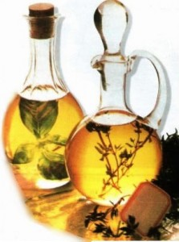
Don`t forget to consult a doctor before trying any home remedies!

- The advance of medical knowledge is the least helpful to mankind.
- The common aspirin has failed to be of great benefit for millions of people.
- Drugs can be both useful and harmful.
- Natural healing must be taken into consideration.
- Good mood makes one’s immune system stronger.
- Diets never influence our health.
- Nobody combines traditional medicine with approved herbal remedies.
- The text presents all traditional Ukrainian remedies.
- The mixture of milk and onion must be drunk quickly before going to bed and in the morning.
- The last remedy described in the text takes more than an hour to be prepared.

3.Speaking:
a) Do you trust traditional medicine? Explain your answer.
b) What do you know about remedies?
c) Remedies have become more and more popular lately. Do you think them to be as useful as they are being proved now?

