1.Lead-in

a) Do you think it would it be cool to take part in a Beauty competition?
b) What is your favourite kind of music? Have you ever been to the Opera house?
c) Who is your best sportsman?

2.Read the text and answer the questions using not more than five words.

Young, beautiful and popular.
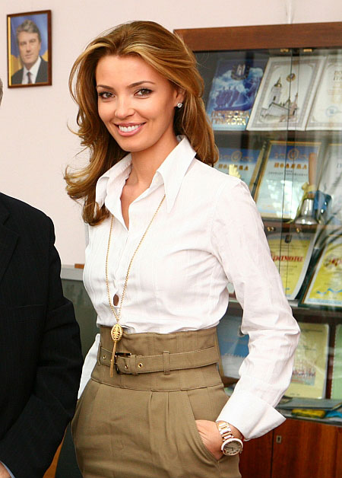
Oleksandra Nikolayenko, 24; 88-60-92, is a top model of Savrox Models Agency, Odesa. . She took part in thirteen contests and 16 titles won including Miss Tourism World. She also won the Audience Sympathy prize, the title of Miss Negombo at the contest held there and the title of Miss Hotel at the resort of Kandy. She was awarded the crown decorated with Sri Lankan precious stones.
But being beautiful is not easy. She thinks sixty percent of her beauty is what God and her parents have given her, twenty percent is keeping what has been given in a top condition. The rest includes the conditions she grew up in and her feeling of taste and style.
Her motto is ` Keep trying and never give up! `
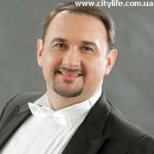
Life and Art
Volodymyr Hryshko is an opera singer, a tenor of world fame. He performed in operas staged in the theatres of many foreign countries. The singer has performed parts in more than 30 operas; he regularly takes part in international classical music festivals. Mr Hryshko performed on stage together with many great singers, Luciano Pavarotti and Montserrat Caballe included. He is the owner of many prizes and awards and the winner of the Ukrainian national contest Lyudyna Roky (Man of the Year) 2005 in the nomination Opera Singer of the Year.
But one of the performances was particularly special for him. On the day when his daughter was born, he had to sing Puccini’s Le Boheme at the Metropolitan Opera in New York. In the evening at the Metropolitan he sang particularly well. Incidentally, they played the anthem of Ukraine — in honour of the soloist who had a newborn daughter that day. And it was a real inspiration for the singer. He felt that it was the greatest achievement in his life!
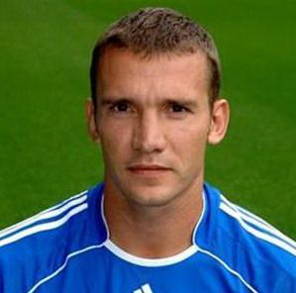
Football Star
Andrij Shevchenko is a Ukrainian football player, the captain of National Team Ukraine. He is very famous and admired by fans all over Europe. He is often called Sheva (the shortened form of his surname). When he was nine he joined the football club and started his career in the Dynamo team in Kyiv. In 1999 he was transferred to AC Milan, Italy. He scored 24 goals in 32 football matches during the first year as a striker of the team. In 2003 Shevchenko’s team won the Champions’ League. Next year he was awarded the Golden Ball prize as the best footballer of Europe. In 2006 he moved to England as a player of Chealsea. Nevertheless he remains a striker of Team Ukraine. In the words of his team mate Serhiy Rebrov, he is the only player for whom the place on Team Ukraine is always guaranteed.
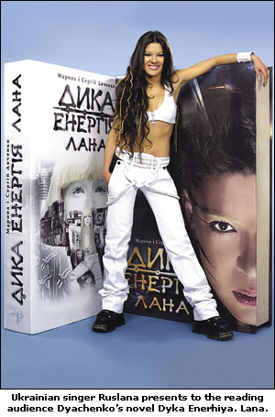
Born to be wild
.
Ruslana Lyzhychko, the Ukrainian pop singer who won the Eurovision Song Contest in 2004 with her Wild Dances. She is never at rest; she is always on the move, meeting people, while she moves from place to place. This energetic woman of a small stature with a sunny smile welcomes people, makes new friends, and signs autographs, all at the same time. Above all she is the Deputy of Ukraine and Ambassador of Good Will in UNESCO.
Ruslana has become quite well-known in many countries. In Turkey they gave her the Person of the Year Award which is usually given only to the Turks. In Israel, Greece, and Cyprus she was given a very warm reception, and in Germany, Sweden and Belgium there are many Ruslana fan clubs. She was given presents and received invitations.
Ruslana is a very sociable person, but for her music always will be on the first place with its wild character and sound. She says” I think the spirit of Wild Dances, the spirit of freedom and naturalness will stay with me forever”.

- Where did Nikolaenko win the title of Miss Hotel?
- What was the crown decorated with?
- How many operas has the singer performed in?
- What nomination did Mr. Hryshko win in the Ukrainian national competition in?
- Why did they play the national anthem of Ukraine?
- What team does Shevchenko lead?
- When was Shevchenko awarded the Golden Ball prize?
- Who told about Shevchenko’s membership in Team Ukraine?
- Who is supposed to have been born to be wild?
- What Ruslana’s feature of character is mentioned in the article?

3.Speaking:

a )Do you consider Beauty competitions to be necessary? Why?
b )What must one do to become a winner of such contests?
c) Must a participant of such competitions be intelligent and perfectly educated?

