1.Lead-in

a) Are there any interesting periodicals for teenagers in Ukraine?
b) Do you prescribe any newspapers or magazines?
c )Would you like to read more about Ukrainian youngsters?

Teen magazines in Ukraine
Read the students’ opinions and mark the statements (1-10) below the text as T (true) or F (false).

We asked some students to prepare short presentations about their favourite Ukrainian teen magazines and explain their choice. Here are their opinions.
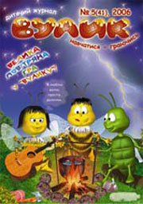
Sergij, 13.
“Vulyk” is a great magazine for teens. The main hero is a Bee which is the symbol of a very active and curious child. In this magazine one can find a lot of interesting information about the world and celebrities, many fairy tales, poems, puzzles and riddles. The legends of our country are told in the way of a game that helps to know more about Ukrainian history. “Academy of magic” is the page for children who like to amuse others with special tricks. Each edition also has an envelope where you can put your letter and send it to the Bee, get the answer and even win the prize!
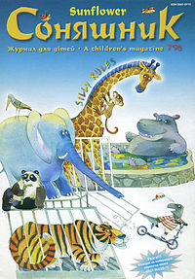
Nastia, 12
“Sunflower” is my favourite magazine. It was established in 1991, the year of the Independence of Ukraine. There are many smart crosswords and quizzes, articles about nature and the problem page. Young readers are told about the culture and traditions of different countries and native land, about old and modern authors and their books. You can send your drawings, photos, poems or stories which are published in the magazine in a way of a literary competition or exhibition. Everyone is encouraged to creativity and I think it’s amazing!
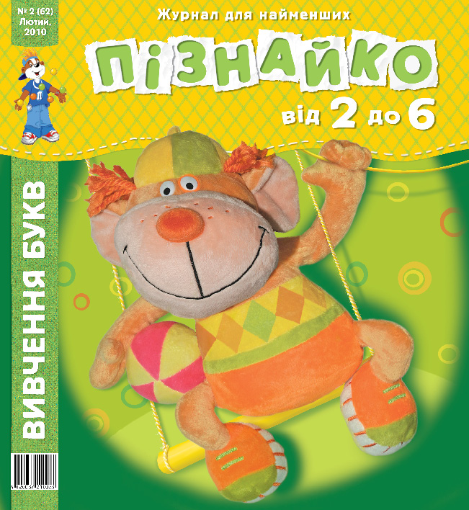
Pavlo, 12
I am fond of reading and find it very useful, especially for teens. The magazine I like the best is “Posnayko”. It is published once a month in three languages: Ukrainian, Russian and English, which helps a lot in studying. Its motto is “Learn English by playing” and it works with me. This magazine is for modern schoolchildren who want to know more and surprise everybody. There you can read about famous people, popular gadgets, interesting news, also find comics, table games and logical puzzles. Every time I read “Posnayko” is like opening the magical doors to the Kingdom of Knowledge where everyone cares about you.

- “Bee” is the symbol of a very active child.
- You can’t take part in different contents arranged by “Vulyk”.
- “Academy of Magic” is the page for children who are fond of being surprised.
- You don’t have to buy an envelope to send a letter to the Bee.
- “Sunflower” has been published for 20 years.
- You can send letters to “Sunflower” and win lots of money.
- If you know Russian or English, “Poznaiko”is for you!
- “Poznaiko” tells about celebrities.
- These three magazines can satisfy modern children’s tastes.
- “Poznaiko”is especially useful for children of all ages.

3. Speaking:

a) Are you sure there are enough teen magazines in Ukraine?
b) Do you read all of them and why?
c) What articles are the most interesting for you? Explain your choice.

