1.Lead-in
a) Have you got a hobby?
b) Are you an active person?
c ) Would you like to start training in the sport club?

2.Read the following advertisements. Match questions (1-8) with the advertisements (A-E). There is one extra question that has no answer in the advertisements.

Recently we were the guests of Ternopil school, we met with fine sociable students and visited some after-school clubs for teens there. They gamely shared with us about their hobbies and activities Ukrainian children like the best. Take a good look and choose one for yourself!

A.
COMPUTER CLUB
Is your dream to become a computer genius?
Our club is the one you need!
• Improve your skills or practice new ones
• Professional smart tutors really help
• Learn about new programmes and how to work with them
• Make use of your knowledge in the future
• Meet new people with the close interests to share
The club meets every Wednesday in computer classroom at 3 o’clock.

B.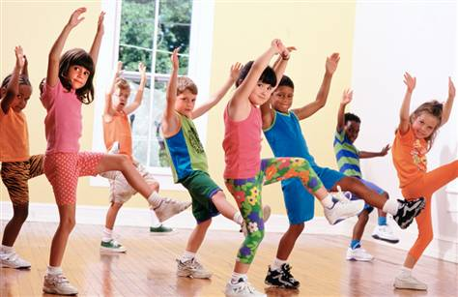
AEROBICS
Shape your body, make it perfect!
Goddess Venice would envy! It’s not only sport, it’s art!
• Girls’ and mixed groups
• Regular trainings
• Skilled instructors
• Good music
• Modern types of dancing
Special sportswear is needed.
Your positive mood is our care, just come and tries from Monday to Friday at 4 or 5 in the Athletics Centre.

C.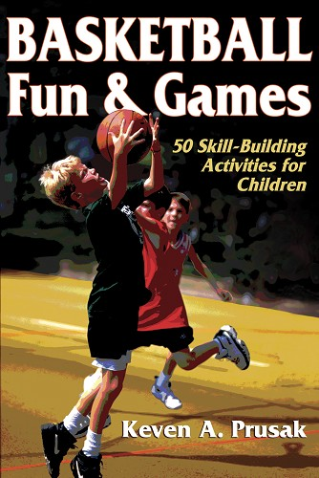
BASKETBALL CLUB
Our club for sure suits your sporty lifestyle!
• Boys and girls come and try playing
• Learn new or special basketball tricks from experienced coaches
• This is a real team game
The club welcomes on Tuesday and Friday in the school gym.
D.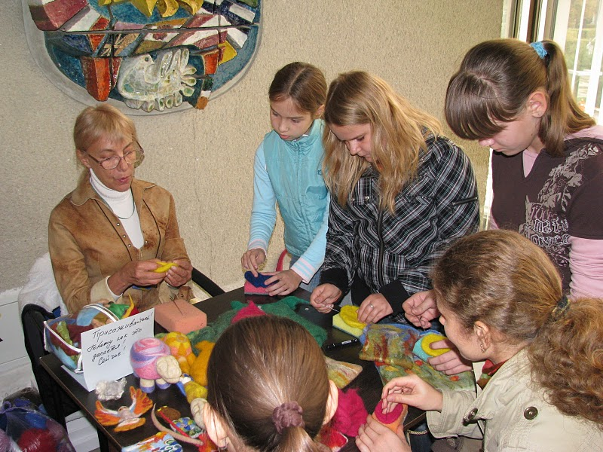
HANDICRAFT AND HANDIWORK CLUB
Make good use of your hands!
Join us and you won’t have to buy presents – you can make them yourself!
• Learn how to create beautiful out of simple
• Work with different materials like wood, clay, fabrics
• Enlarge your creativity to impress somebody with your unique creation
Come to us on Thursday from 3 to 5 in the Art School
E.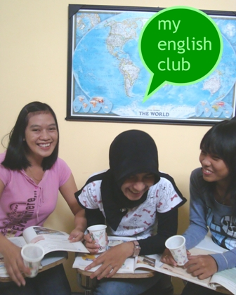
ENGLISH LANGUAGE CLUB
Do you want to improve your knowledge of English?
Do you need some practice speaking it?
• Come and communicate in our English Club
• Meet many interesting people and share the atmosphere of a good company
• Learn how to speak and use English in different life situations
• Get new experience out of talking with the foreigners and native speakers
• Play games and watch movies in the original
You are welcome on Friday at 3 in the English classroom.

Which advertisement

- speaks about the atmosphere members are surrounded? _______
- attracts attention to the future career prospects? _________
- points to the importance of developing your mastery? _____
- has information about your chance to save some money? ______
- draws attention to possibility to work together? _______
- speaks about wearing uniform? ______
- mentions their teachers’ experience? _______
- attracts attention to your appearance? _______

3. Speaking:

a Are you interested in different activities?
b What most popular hobbies do Ukrainian youngsters have?
c Why do young Ukrainians tend to prefer doing sports rather than surfing the Internet?

