1.Lead-in
a) Do you enjoy reading?
b)Do you prefer reading to watching films?
c ) Is it interesting to write books?
2.Read the text and fill in the blanks.
Serhiy and Marina Dyachenko, Ukrainian fantasy writers.
Serhiy and Marina Dyachenko is a literary couple, both of them are sci-fi writers. In 1996, at the European Forum of sci-fi and fantasy writers, EUROCON-96, 1)….as “the best debut.” In 2005, at EUROCON-2005, they were nominated as the best writers in their genre in Europe. When, in April 2006, the 28th Convention of Science Fiction EUROCON-2006 was held in Kyiv, the Dyachenkos 2)….
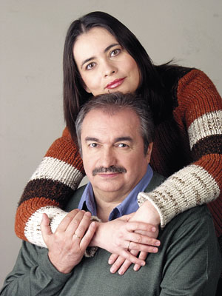
I have bad nightmares and in the morning when I wake up, the hurricane strikes.
I cannot leave the house because of the wind which bends the trees to the ground. Some of the roofs get ripped off. A terrible rain crashes down on the villagers 3)…. the roofs, gates and whatever else is 4)….
I am horrified, I feel a disaster coming. I do not know for sure what will happen but when I think about it my hair stands on end.
At noon the fierce wind calms down a little and I feel I should go out. I wrap 5)…. around my head and shoulders and walk to the central square of the village where there is a bell. Once I get there I begin to ring the bell sending the alarm to all the villagers. I do it for the first time since I’ve become Queen Mother.
The tolling sounds are very sad and scary. People rush out of the their homes and run to the square gathered by the bell. Children cry and weep. I look at the people 6)….. The rain lashes at their faces and bodies.
“It’s coming, it’s coming!” I shout in a loud voice.
The silence falls, the only sound being the falling rain. Even the children stop crying.
“We’ll fight it! We, all of us, together!”
My tongue does not obey me quite well.
Yary [Lana’s boyfriend] pushes his way through the crowd, rushes towards me and grabs me by the hand. I feel 7)….. I know that we have a chance. We’ll come out against it — we’ll win over it! Probably.
[the hurricane is evidently produced by The Plant, a mysterious source of evil, situated somewhere in the mountains].
***
I feel cold and wet. I hear the voices 8)….. I see a big hole in the ground some distance away — it’s the place where the wind touched the ground for the last time. Uprooted trees all around.
There are many injured people but no one has been killed. The injured, some of whom are trapped under the fallen trees, call out for help.
“Queen Mother! Help!”
I do not know how to heal wounds… The old women who know 9)….will help. But I know how to relieve the pain. I put my hand on the forehead of a wounded man and 10)….. He smiles at me.

- fight his pain
- I’m ready for action
- the secrets of healing
D. who are in the square
E. who try to fix
- their novel was recognized
- guests of honour
- calling to each other
I . wrap a piece of cloth

3. Speaking:
a )What Ukrainian authors do you know?
b) What genres of stories do you prefer? Give reasons.
c) Do you agree with the statement that books are our best friends?

