1. Lead-in

**a) Do you enjoy sightseeing?**

**b) Have you seen any Ukrainian places of interest? Do they differ from those abroad?**

1. Pre-reading task

Read the text and match the headings (A-G) to the paragraphs (1-6). There is one extra paragraph you don’t need.

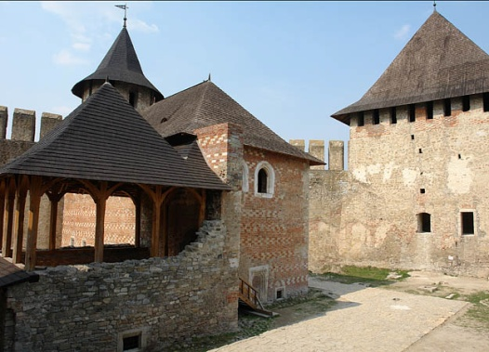

1.In childhood, a castle is a place where a beautiful princess is waiting for a prince to come on a white horse to take her away to another castle where they will live happily ever after...

In Ukraine you can admire a great number of castles beauty and historical value.

In the land of Podillya, two most attractive places worth paying a visit to are Kamyanets-Podilsky, a fortified town, and the fortress of Khotyn.

2.The fortress of Kamyanets-Podilsky stands at the top of a cliff on the bank of the river Smotrych which runs through a scenic canyon. There is no other fortress like it to be found in the mountains of Eastern Europe. Its walls are cut out of solid rock. It is known that the fortress was founded in the twelfth century and then grew over the centuries into the art of fortification.

“A stone flower on the rock” — that is how Ukrainian poet Lesya Ukrayinka called Kamyanets-Podilsky.

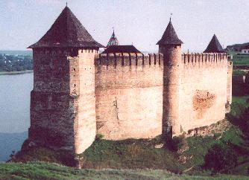

3. Only 25 kilometres away from Kamyanets-Podilsky we find the fortress of Khotyn The fortress was founded at least a thousand years ago and sat at the crossroads of the trade routes. Though there are no romantic ghosts walking around and sighing at night, the place still has an impressive look; besides, treasure hunters keep digging for the coins of the past in many hiding places of the castle.

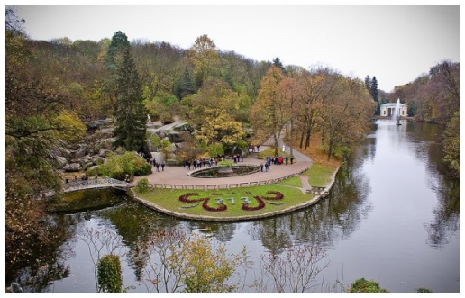

4.Sofiyivka in Uman is a beautiful park named after a beautiful woman, Sophie Potocka. It dates back to the end of the eighteenth century.

The park is designed in such a way that it uplifts your spirits and fills you with

emotions. There are but few other parks in the world that can rival Sofiyivka in the harmony of nature and design. A walk through the park opens new views and new wonders almost at every step you take. Statues, ponds, columns, islands, exotic plants, wonderful alleys amaze and fascinate you by the artistic and natural beauty.

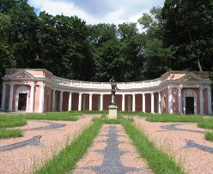

5.The old park, Oleksandriya, in the town of Bila Tserkva is situated only 80 kilometres from the city of Kyiv. The park was founded by Duchess Oleksandra in 1797.

Emperors paid visits to the park. So did poets. The park was visited by Mickiewicz, Pushkin

and Taras Shevchenko. Poets and prose writers come here for inspiration, others — to enjoy the beauty of the park. The park has many ponds and bridges.

It attracts a lot of tourists every year.

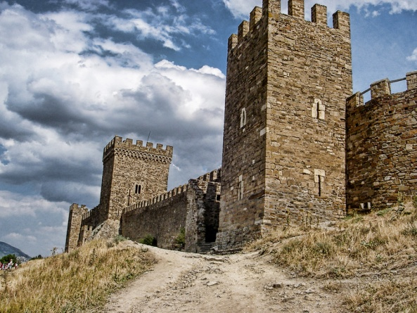

6.If you are in the Crimea, go to Sudak, a resort town on the eastern side of the peninsula, but not only to sunbathe or swim in the sea but to have a good look at the ancient fortress there.

The Genoese fortress in Sudak is situated on Kriposna (Fortress) Mount in the western part of the town.

According to some archeologists it must have been a fortified place back in the 6th–8th centuries when it was an outpost of the Byzantine Empire.

Probably like any other ancient city, Sudak has a lot of colourful stories and legends that have come down to us through generations from the distant past. According to the most interesting one the fortress is called the Girl`s Tower, because of the girl kept locked in a tower…

But this is the only one of the great number of legends about the fortress. Don`t miss your chance to visit this remarkable place!

1. Speaking:

**a) What do you know about the most interesting sights of Ukraine?**

**b )Do you know how and when they appeared?**

**c )What can these places of interest tell about Ukrainian history?**