Заліщицька державна гімназія

Конспект уроку
з англійської мови
у 10 класі
на тему «The Hryvnia»

Підготувала учитель
Стрельбіцька О.П.

Заліщики, 2016
Topic: The Hryvnia

SWBA:
- to read and understand a text about Ukraine’s currency
- to learn the new vocabulary
- to translate into Ukrainian and English
- to watch and understand a clip about the way people donate money and work as volunteers
- to describe some examples of Ukrainian bank notes

MATERIALS:
song “Money, money, money…”
A video clip

I. INTRODUCTION. SONG “MONEY, MONEY, MONEY…”
Dear students! It’s easy to guess that today we are going to read and to speak about money
There are some proverbs on the board
Will you translate them into Ukrainian
1). Money never comes out of season.
Грошей не буває забагато.
Гроші не приходять невчасно
2). Moneyhasnosmell.
Де гроші люблять,там совість гублять.
3). Moneyhaswings.
Гроші як вода крізь пальці протікають.
You can use the proverbs when having discussion or writing essays.
You may use the proverbs in your essays.
Making up a mind map.
Now I suggest you the following task.
Will you draw a mind map with the word money in the centre and as many as you know verbs around it?
So if you have or don’t have money, what can you do with it ?
Money:

- spend;
- have
- find
- donate
- pay, pay back
- win (as a prize)
- give
- use
- earn
- to invest, to put into
- raise
- put in the bank
- change, exchange
- steal
- lose
- waste
- throw away
- fritter away
- keep
- set aside, save up
- lend
- borrow
- get
- withdraw

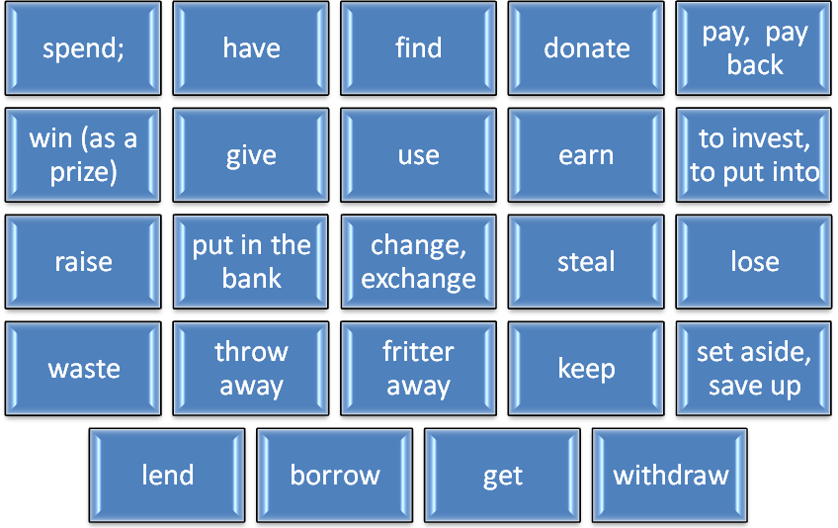

ІІ. COMBINING THE WORD «MONEY » AND A VERB YOU WILL BE ABLE TO MAKE UP YOUR SENTENCES.
1) I have been saving up money for a new laptop.
2) Can you get money from a cash point
3)If you waste money, do you use it well?
4)They have got to pay back a lot of money.
5)She has borrowed some money from her friend.

III. LET US REVIEW –3– GRAMMAR RULES. CONDITIONALS.
Translate the sentences into English.
1.Де ти зберігаєш гроші? Я зберігаю їх у банку. Where do you keep your money? I keep it in a bank.
2. Якщо матиму гроші, я потрачу їх на велосипед. If I have money, I'll spend it on a bike.
3. Якщо б я мав гроші,я б поїхав у Норвегію. If I had money, I'd go to Norway.
4. Якщо б я виграв багато грошей , я би віддав половину на благодійність . If I won a fortune, I'd give half of it away to charity.
5. Вони б купили яхту минулого літа,якщо б вони не тринькали гроші на машини та азартні ігри. They'd have bought a yacht last summer if they hadn't frittered away a fortune on fast cars and gambling.

IV. NOW WE ARE WORKING WITH OUR WORKBOOKS.
Exercise 1. Match the people and the places. Which bank note do they appear on?
Exer1
LesiaUkrainkaVolodymyr the Great Ivan Mazepa
HryhoriiSkovoroda IvanFrankoYaroslav the Wise
TarasShevchenko BohdanKhmelnytskyi
MykhailoHrushhevskyi
Kyiv PecherskLavra cathedral TsentralnaRada
Kyiv MohylaAcademy Lutsk Castle Lviv Opera
Kyiv Saint Sophia cathedral church in Subotiv
Volodymyr the Great’s fortress in Kyiv
The Chernecha landscape

People |  | Places | Bank noels
LesiaUkrainka |  | Lutsk castle | 200 hryvnias
Volodymyr the Great |  | Volodymyr the Great`s fortress min Kyiv | 1 hryvnia
HryhoriiSkovoroda |  | Kyiv Mohyla Academy | 500 hryvnias
Ivan Mazepa |  | Kyiv Pechersk  Lawra cathedral | 10 hryvnias
Ivan Franko |  | Lviv Opera | 10 hryvnias
Yaroslav the Wise |  | Kyiv PecherskLawra cathedral | 2 hryvnias
Taras Shevchenko |  | The Chernecha Landscape | 100 hryvnias
BohdanKhmelnutskyi |  | Church in Subotiv | 5 hryvnias
MukhailoHrushevskyi |  | TsentralnaRada | 50 hryvnias

A where the word hryvnia comes from
B how the currency was reintroduced after independence
C what the symbol for the currency is
D what values of notes exist
E souvenir coins for special occasions
F some of the things that make the notes difficult to copy
G what pictures you can see on some of the notes
Read the text again and choose the correct answer.
1 When was money called hryvnia first used?
A 1000s B 1100s C 1200s
2 What does the original word hryvnia mean?
A the long hair around creatures” heads
B a gold or silver necklace
C gold or silver hair
3 When were hryvnias reintroduced?
A 1990 B 1992 C 1996
4 How long did it take to replace most Karbovanets?
Aa week B two weeks C a month
5 Why do the notes have a lot of characters which are difficult to see?
A to make them difficult to count
B to make them more attractive
C to make them hard to copy
Match the highlighted words in the text with the meanings below.
1 movement (especially of money, blood and traffic)_________
2 parallel to the surface___________
3 two or more things put together ___________
4 illegally copied_______________
5 put inside something_______________
6 cannot be seen______________
7 the money of a country____________
8 the liquid you write and print with________________

THE HRYVNIA
Although the hryvnia has only been around since 1996 in its current form, its history is much longer. Hryvnias were used in the eleventh century in an area know as Kyiv Rus (land which included parts of present day Ukraine, Belarus and Russia). The word may come from the Slavic word griva, meaning mane. A mane is the long hair around an animal’s face or neck, for example on a horse or a male lion. So it is possible that hryvnias were something originally worn around people’s necks, maybe in gold or silver.
Following Ukrainian independence, official decided in the early 1190th to create a currency called the hryvna. The first notes for 1, 2, 5, 10 and 20 hryvnias were printed in 1992, but the currency wasn’t introduced until 1996. the government delayed the transition because of very high inflation. Prices were rising fast and there was a fear that bringing in a new currency would have made situation worse.
Higher denominations were added in 1994, 2001 and 2006. So, now there are also notes for 50, 100, 200 and 500 hryvnias, plus coins for 1 hryvnia.
It is not easy to replace a currency with a new one because there are so many pieces of the old in circulation. The way it was done in Ukraine was to have the old currency (Karbovanets) side be side with the new currency (hryvnia) for a time. This meant people could pay for things in Karbovanets, but they would receive hryvnia as change. After a fortnight, 97 per cent of Karbovanets had been taken out of circulation. The small remaining proportion of old notes and coins were then exchanged by banks.
The symbol used to represent the hryvnia is the first letter of this name, in this case, the Ukrainian letter. The two horizontal lines across it symbolize stability.
With any currency,it is very important that it cannot be forged easily. Apart from using special inks and papers hryvnias also have many other security features. For example there is a polymer thread embedded in the notes which you can see hen it is held up to the light. In addition there are magnetic codes and sections in the notes. Not only that, but there are specific characters and features which can only be seen under a microscope or under certain lights. Some elements of the design become florescent in ultraviolet light while others become visible or invisible under infra-red light.
The artwork on the notes also adds complexity. On one side of the notes are the heads of famous Ukrainians like Volodymyr the 1 hryvnia and the young Taras Shevchenko on the 100 hryvnias. On the other side there are places. These places have changed with each new issue and checking the right combination for the right year is another way of knowing you have a genuine note.

A short clip will tell you about people’s donations and volunteering work.

SUMMARY. In the lesson you’ve worked hard. Nice of you! You’ve received and shared useful information about home currency, its history and design.

YOUR HOMEWORK IS EXERCISE «CHALLENGE»! ON P.82
Write about the Ukrainian bank note you like the most and explain why. Describe it and provide some history about the person and place on it.

The 200 Hryvnias
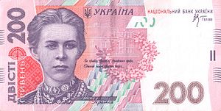The most appealing Ukrainian bank note is the 200 hryvnias. It’s a light pink color and all the pictures are fascinating.
The front side presents a portrait of Lesia Ukrainka. To the right there is a caption with the dates of her birth and death and the words Lesia Ukrainka.
The young woman dressed in a national costume is beautiful. She is wearing a nice necklace. The prominent poetress glorified the country. The poetry she created as well as her progressive democratic ideas contributed much to the development of Ukrainian literature, culture, and history. This quotation from Lesia’s poem expresses her love and devotion to Ukraine;
“Let’s get together, my dear fellows,
As we’ve got the only right way”.
In the background you can recognize Lesia’s small white house, where she spent her childhood and adulthood. These days it’s a museum and you can see there Lesia’s personal belongings among which her best friend the gandpiano.
Next to the portrait you can observe something that looks like a small slide or hill covered with some green, dark blue and purple tracks and small triangles. Frankly speaking, it’s difficult to guess the meaning of this hill and some other signs too.
Above this slide there’s another symbol of Ukrainian culture. It’s a flower wreath. The wreath is partly embracing the small white house. To the left of the portrait an intricate pattern draws your attention, on top of which you can notice something that looks like an opened peacock’s tail. This sign is really amazing.
The Trident, which stands for our national symbol, the words ‘Ukraine’ and ‘the National Bank of Ukraine’, and some other weird signs complete the front image of this side.
The back (the reverse side) of the bank note is as attractive as the front; complete with a white stork flying top to the left and the Entrance Tower of Lutsk castle in the background. This historical monument and the city itself are also connected with Lesia Ukrainka’s life.
A small water lily placed between two numbers 200 and 200 on the right side of the note adds another nice feature to this artwork.
To sum up, I enjoy all pictures and all small details or signs which create the whole design of this bank note. They are all full of artistic beauty and elegance, historical and cultural importance.

