Відділ освіти
Теребовлянської райдержадміністрації

ПОЗАКЛАСНИЙ ЗАХІД
для 1 класу на тему:
Merry ABC ( a contest party )

Підготувала:
Коцур Світлана Тарасівна
вчитель англійської мови
Теребовлянської №1
ЗОШ І-ІІІ ст.

2015 р.

Merry ABC ( a contest party )
The Procedure of the Party.
Compere 1: Good afternoon, dear boys and girls, parents and teachers. We are very glad to see you and we hope that you will enjoy our party.
Compere 2: Dear children! Today we are going to have an interesting contest party dedicated to the ABC. These are our judges. They will give marks for every task. Your answers should be right, loud, expressive, artistic. Good luck!
Compere 1: You may sit down, children! Now I'd like to see if all the letters of the English alphabet are here. You are welcome, letters!
Compere 2: Here they are our letters, the ABC brothers and sisters.
(Children appear on the stage holding letters of the English alphabet. Each pupil tells about his / her letter. )
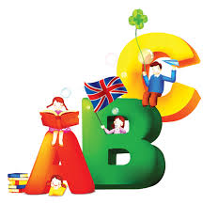
All the letters sing a song:
Good morning to you!(Twice)
We’re all in our places
With sunshiny faces.
Good morning to you!(Twice)
Compere 1: If you know the ABC, you can read books, write letters , sing English songs and recite poems in English.
1. A A is for Apples and Apple-trees
You can see apples on apple-trees.
2. B B is for Books and for Bookcase.
I have many books in my bookcase.
3. C C is for Cat. My cat is grey,
And with me it likes to play.
4. D D is for Dog and for Doggy.
I have a dog, not a doggy.
5. E E is for Eight and for Eleven.
How much is eight and eleven?
6. F F is for Flowers: red and blue,
White and yellow and rosy, too.
7. G G is for Girl, and also for Garden.
I see a girl going to the garden.
8. H H is for Hand. I have two hands.
This is the way I clap my hands.
9. I I is for I. I'm a boy, and I'm ten.
I like to play with my brother Ben.
10.J J is for Jam. This is apple jam.
Jimmy likes it, and so does Sam.
11.K K is for Kite. Kate has a kite.
It is little, and it is white.
12.L L is for Letter. This letter is for me.
It is from my sister, as you can see.
13.M M is for May and for May Day
For March and for Mother's day.
14.N N is for Nine, Ninety and Ninety-Nine.
Children, how much is Ninety and nine?
15.O O is for One. One and two is three.
Three little cats are in a tree.
16.P P is for Pencils. With them I draw:
A red pen, a green tree and a blue door.
17.Q Q is for Questions: How are you?
How old are you? How do you do?
18.R R is for Red. Many things are red.
What can be red? Do you know, Fred?
19.S S is for Street. This is my street.
I have many trees in my street.
20.T T is for Tick and for Tock.
"Tick-tock", - says the clock.
21.U U is for Under, but not for At.
"I'm under the tree", says Pat.
22.V V is in five and also in seven.
It is in twelve and eleven.
23.W W is for Winter, when it is cold.
But I like winter and I like cold.
24.X X is in Six. Let's count up to six!
One, two, three, four, five, six!
25.Y Y is for Yard where children play.
They play in the yard every day.
26.Z Z is for the Zoo. Let's go to the Zoo.
I like go to the Zoo. And you?
Compere 2: And if you know English alphabet very well, let's sing the song "The ABC"
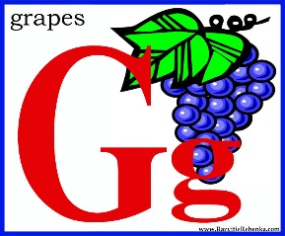
Children:
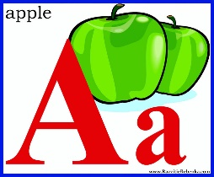
A B C D E F G
H I G K L M N O P
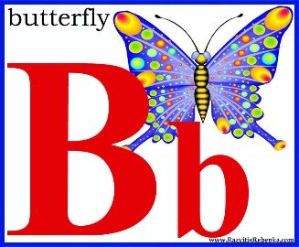
Q R S T U V W
Q R S T U V W
X Y Z X Y Z
Now I know my ABC.
Next time won’t you sing with me?
Now we know our ABC.
We’re so glad you sang with me!
(The class is split into teams and pupils are given cards. There are 3 contests. )
Compere 2: Please, sit down and let me see if you know the ABC.
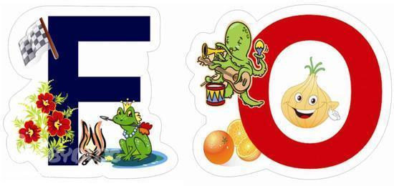
- Look at this ABC and say what letters are missing.
V A Z P N U
W Q I C F L Y K D
T G J E M B S O (Key: H, R, X)
Compere 2: Thank you. Judges, will you show your marks, please?
2. Put these words in the ABC order! (name, red, apple, cat, street, big, tree, white, lamp, green) (marks)
3. Please, write letters missing one! (2 children: 1 - A, C, E...; 2 - B, D, F:) (marks)
Compere 2: - Good, I see you know the ABC and now let's play the game "Taking steps"
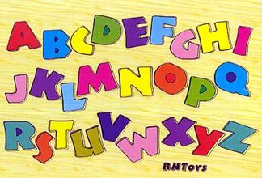
(One pupil from each team stands in line. There are 10 lines for one step. Ps are to spell the words on the cards ”Spell the word, please.” If a pupil is right, he steps forward.)

І | ІІ
NAME | FACE
BIG | SIX
NINE | FIVE
HAND | BLACK
STREET | TREE
PEN | BED
ROSE | NOSE
DOG | BOX
BUS | CUP
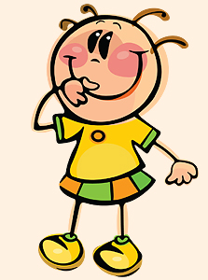
Compere 1: Well done. You know how to spell. But can you read? We"ll see it in a moment. Please, solve puzzles and read your sentences.
M | D | G | S | L | C
Y | O | I | B | A | K
(marks)
Compere 2: I see that you can read, but can you answer my questions?
Children: Yes, we can.
Compere 1: You have to answer my questions: Is it a cat? - Yes, it is./ - No, it isn't.
What is it? - It's a horse.
(There are 6 pictures for each team.)
Compere 2: That's good. Now I'd like to know how you remember words.
(Ps have to find 10 animal words in a box of letters)

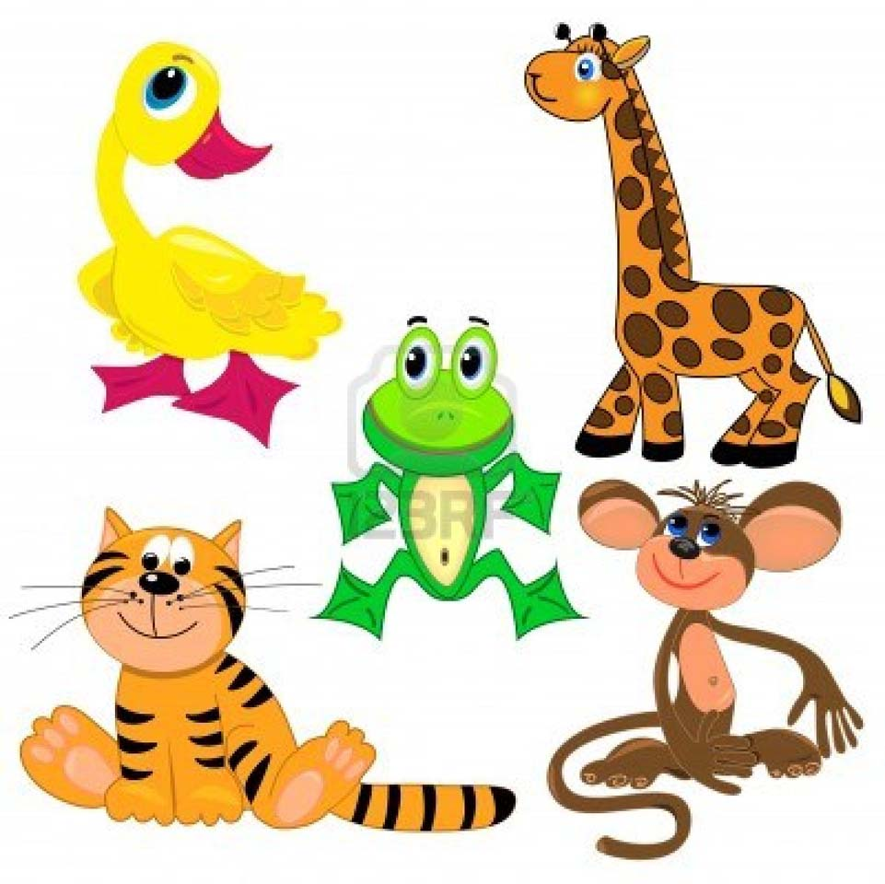
P | E | T | D | E | S | R | O | H
V | B | X | V | F | H | K | L | S
F | H | J | M | D | G | T | R | A
A | E | V | W | O | S | A | R | M
W | E | F | I | G | I | C | D | C
W | A | O | K | T | U | L | P | O
P | E | X | C | T | P | S | S | Q
E | L | T | I | A | I | K | C | A
E | A | I | H | F | G | K | O | S
H | A | G | C | N | E | H | C | D
S | Y | U | D | X | V | B | K | F

( Marks)
Teacher: - Well, children. I see you know the ABC very well. Good for you!
Compere 1: We are happy to sing, play and speak English here
Compere 2: Now let’s say “good-bye” to the ABC.
(Children sing «The Merry Song» waving goodbye to guests. )

If you're happy and you know it, clap your hands.
If you're happy and you know it, clap your hands.
If you're happy and you know it,
And you really want to show it,
If you're happy and you know it, clap your hands.

If you're happy and you know it, stomp your feet.
If you're happy and you know it, stomp your feet.
If you're happy and you know it,
And you really want to show it,
If you're happy and you know it, stomp your feet.
If you're happy and you know it, nod your head.
If you're happy and you know it, nod your head.
If you're happy and you know it,
And you really want to show it,
If you're happy and you know it, nod your head.

If you're happy and you know it, turn around.
If you're happy and you know it, turn around.
If you're happy and you know it,
And you really want to show it,
If you're happy and you know it, turn around.

If you're happy and you know it, say we are, we are.
If you're happy and you know it, say we are, we are.
If you're happy and you know it,
And you really want to show it,
If you're happy and you know it, say we are, we are.

