Відділ освіти
Теребовлянської райдержадміністрації

КОНСПЕКТ УРОКУ
для 7 класу на тему:
«Famous people»

Підготувала:
Коцур Світлана Тарасівна
вчитель англійської мови
Теребовлянської №1
ЗОШ І-ІІІ ст.

2015 р.
Subject Matter: Famous people
Past Simple
Objectives:
- to develop Ss speaking, listening, writing, reading skills;
- to incorporate Ss team, independent & group work;
- to involve Ss in the process of Eng. communication ;
- to practice Ss coherent speech, enrich their active vocabulary;
- to rain force Ss grammar skills through using dialogues & monologues;
- to develop Ss socio-cultural competence & cultural awareness.
Procedure
- Introduction.
T: Good morning, dear Ss! How are you today? You look great. I hope you’re in a good mood. So, we are ready to start our lesson.

- Warming-up.
T: Today we’re going to continue speaking about famous people of the world. We’ll review lexical & grammar material, practice speaking in dialogues, monologues, pair & group work and I’ve prepared an interesting presentation of one of the most famous Ukrainian actresses. But it’ll be a bit later. So, right now we’ll have a great number of activities.

- Main Part.
Spider gram
T: Look at our topic & make a spider gram. What words are associated with our topic? Please, name words which refer to “Famous People”, find them on the pieces of paper on my table & put them on the blackboard around the topic.

- Revising Vocabulary.
T: You can see some familiar photos of prominent people you’ve learnt about. Complete them with people’s occupation, countries they are from & their nationalities.

- Making groups.
T: I guess you know some information about your favorite person. Let everyone listen to your heroes. What’s your favorite outstanding person, Tania? (Ss are to develop their monological skills)
T: Let’s split into 4 groups. I give red squares to the group of actors, orange circles to the group of singers, yellow rectangles-to statesmen & blue triangles-to painters.

- Project works(in groups).
T: Our next activity is to make groups project works. Each team has to get the name to your project, stick photos you were supposed to prepare for today,& present your project(or a class poster)

- Role-play.
T: Imagine you are a famous person. Your classmates have to ask yes/no questions to guess the person.
Ss: Are you a woman? – No, I’m not.
Are you American? - Yes, I am.
Are you a scientist?
Do you live in Germany?
Do you appear on TV/in films?
Do you play a sport?
Do you write books/music?

- Grammar Revising.
T: And now a bit of grammar. Let’s make sketching grammar rules of Past Simple
Eng. grammar has got many irregular verbs. Let’s recollect them, playing a game “Who knows IV better”.

- Writing skills (Independent Activity)
T: Please, do ex. 7 p. 71 (SB) on Past Simple. Listen to a piece of music, while doing exercise about Mozart, a famous composer.

- Reading Skills
T: Let’s check the exercise about Mozart, answering my questions:
- Where is Mozart from?(Austria)
- Where & when was he born? (Salzburg, 1756)
- Was he a violin player? (No, pianist)
- Who taught him music? (His father)
- When did he give his first concert? (at the age of 10)
- How old was Mozart when he wrote his first piece of music?(just 4)
- What countries did he travel? (Italy, France, England)
- When did he die? (fin 1791/at the age of 35)
- How many pieces of music did he compose? (over 600)
- Which piece of music remained unfinished? (Requiem)

- Strip dialogue (group work)
T: I’d like you to talk about the last weekend. But first you’ll get the lines from dialogue but they’ve mired up. Try to order them so that the dialogues make sense.

- Acting out (pair work)
T: I wonder what happened to you or your friends at the weekend. Please, make up your own dialogue and act in out with your partner.

- Teacher’s Presentation ( Olha Sumska)
(Ss watch the presentation about Olha Sumska & listen to her biography)
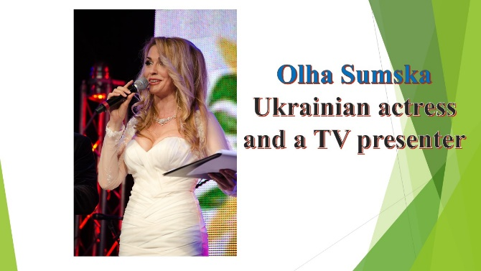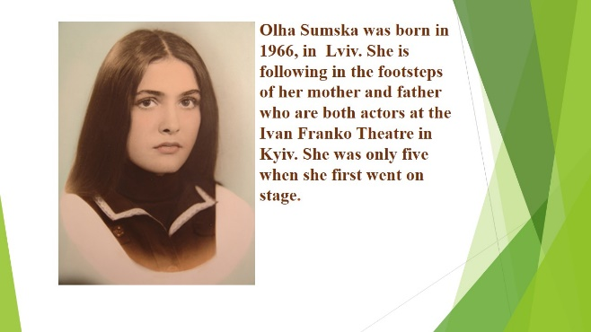
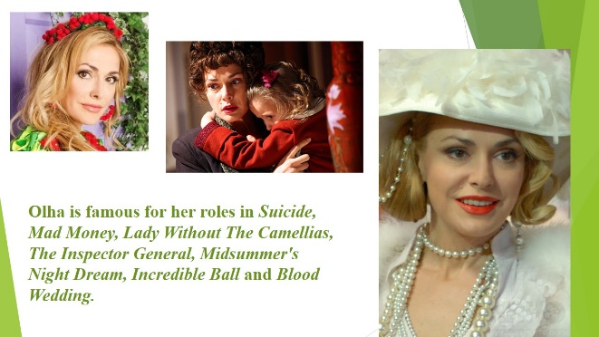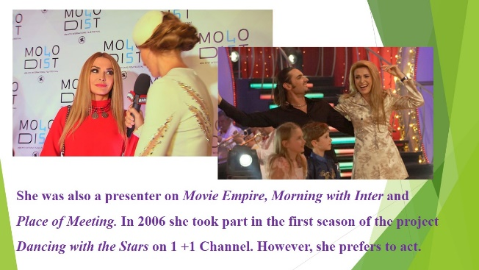

- Multiple Choice Test (on O. Sumska biography)
- Quiz (on Famous people)
T: And now it’s high time to do the Quiz. I’ll read a sentence about biography &you should guess the famous person.
- He hated school but he loved science. (Albert Einstein)
- He was deaf from the age of 40. ( L. van Beethoven)
- He spoke 5 languages! (N. Copernicus)
- He didn’t paint pictures of real life. ( S. Dali)
- She discovered many comets and a galaxy. ( Caroline Herschel)
- She fought for the rights of black people. (Rosa Parks)
- She studied secretly in Warsaw. (M. Sklodowska-Curie)
- She started a hospital in London. (Florence Nightingale)
- He used shapes & lots of colours. (P. Picasso)
- He wasn’t famous when he was alive. (Van Gogh)
- He became President of South Africa in 1994. (Nelson Mandela)
- People remember her for the role as “Roksolana”. (O.Sumska)

- Summing up. Evaluation. Hometask.
T: I guess there is nobody who lost because we all love English. And now it’s high time to put marks.
(Ss get ‘smileys’ onto their evaluation sheets)
T: Your hometask is to write a short biography to a school magazine about one of the most important people in history of Ukraine.
Our lesson is coming to an end. I want to thank all of you for a great job at the lesson. I’d love to finish our lesson with the words of Henry Ford:
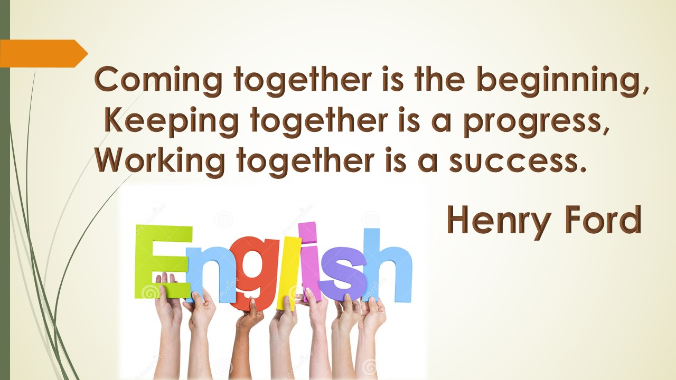

I wish all of you be successful in learning English. Good luck!

