Відділ освіти
Теребовлянської райдержадміністрації

КОНСПЕКТ УРОКУ
ДЛЯ 3 КЛАСУ НА ТЕМУ:

«The Animal Kingdom »

Підготувала:
Коцур Світлана Тарасівна
вчитель англійської мови
Теребовлянської №1
ЗОШ І-ІІІ ст.

2015 р.

Subject matter: The Animal Kingdom
Aims and objectives:
- to develop pupils’ speaking, listening, reading skills;
- to bring up pupils as kind and positive persons.
- to practice the usage of different grammar structures;
- to develop pupils’ curiosity and interest to English language;
- to form pupils’ ability to use their imagination;
- to develop pupils’ power to learn and understand
Equipments: copy-books, cards, maps, blackboard, Smart Board, cards with tasks for pair and group activities, pictures and photos of animals.
The Procedure of the lesson:

I. Greeting
T:Good morning, children. I’m glad to see you. How are you? Sit down, please. P:Good morning. We are glad to see you too.

2.Introduction to the lesson
T:Today we are going to speak about animals. We’ll revise the words on the topic. We’ll remember the names of pets and wild animals. We’ll read a text about a parrot. We’ll make a dialogue about your favourite pets. Then you’ll listen to a fairy-tail about an old dog and you’ll answer some question about it. And at the end of the lesson you’ll try to tell us about your pet.

3. Warming-up

- What animals do you know?
- What animal is brown (green, black, grey, white)?
- What animal has got a long tail (big ears, fins, wings, four paws)?
- What can a fox (a dolphin, a parrot, a dog) do? 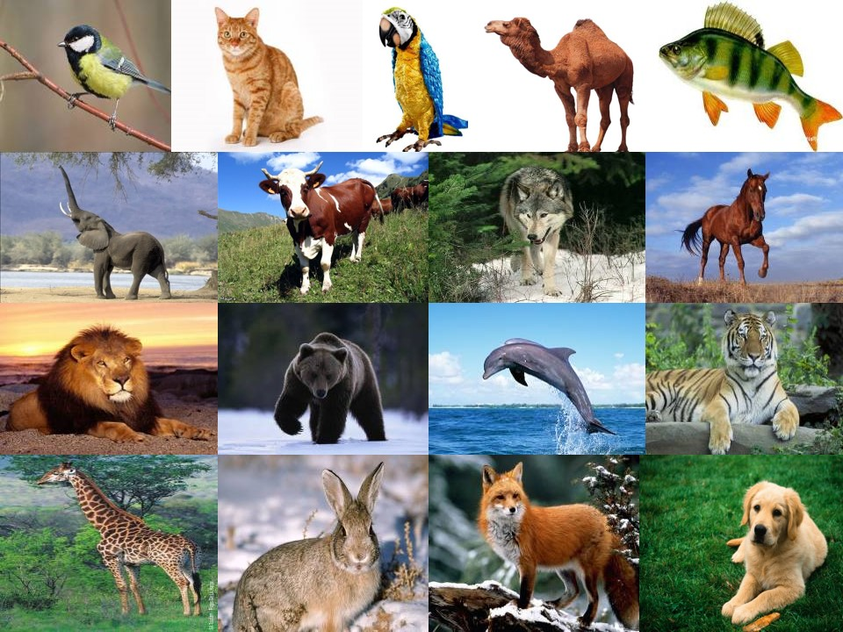

4. Lexical drill
T:On the blackboard there are cards with the names of animals Put them into two columns (pets and wild animals).
For example:
A dog is a pet. A fox is a wild animal.

fox | cat | dog | cow | pig | zebra | bear | tiger | lion | wolf | parrot

5. Checking homework.
Open your books. Let’s read your hometask.
II.The main part of the lesson

6. Writing drills
T:Now you must write true or false .
- Mike has got three pets: a cat, a dog and a parrot. (true)
- The parrot’s name is Tom. (false)
- The parrot is blue, green and yellow. (true)
- Mike doesn’t teach him to talk. (false)
- Mike likes to play with his parrot. (true)
- The parrot can play hide-and-seek. (true)
Pupils exchange cards with their answers checking each other.
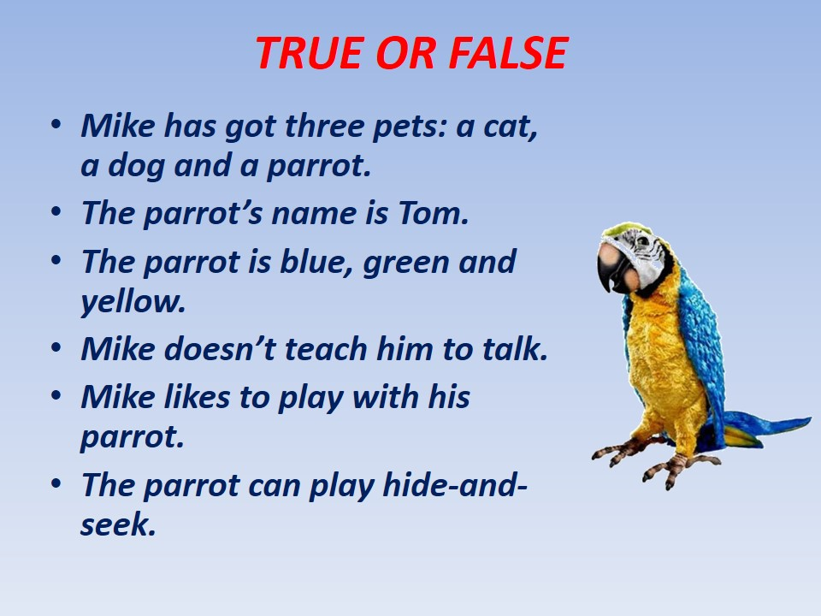

7.Making up dialogues and acting them out
T:Children, have you got pets? I’d like you to ask each other questions about your pets.
Hi ________ Do you have a pet?
Yes _________, I have a _____________.
What is its name?
Its name is _____________.
What color is your __________________?
It is ____________. And you? Do you have a pet?
Of course. I have a ________. Its name is ______. It is ___________.
_________? How boring! It can only ___________.
My cat isn't boring. He is a lot of fun.
Really? What can it do?
It can ______________________________. It is very sweet.

8. Singing a movement song
Head and shoulders, knees and toes, knees and toes.
Head and shoulders, knees and toes, knees and toes.
Eyes and ears and mouth and nose.
Head and shoulders, knees and toes, knees and toes.

Up – down, up – down.
What is the way to London – town?
Where? Where? Up in the air.
Close your eyes and you are there.

9. Listening-comprehension
T:Now, children, you’ll listen to a fairy-tail and get ready to answer the speaker’s questions./recording/

10. Monological drill
T:Now, children, I’d like you to speak about your pets. You’ll get cards with a plan of your answer. I’ll give you two minutes to think and then you’ll tell us about your favourite pet.

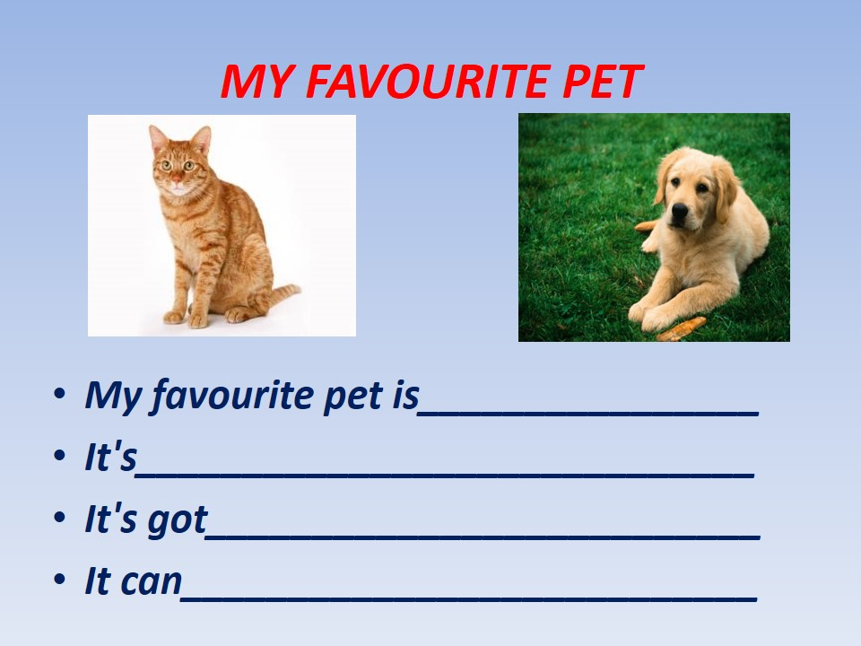

11. A quiz “Guess the Animal”

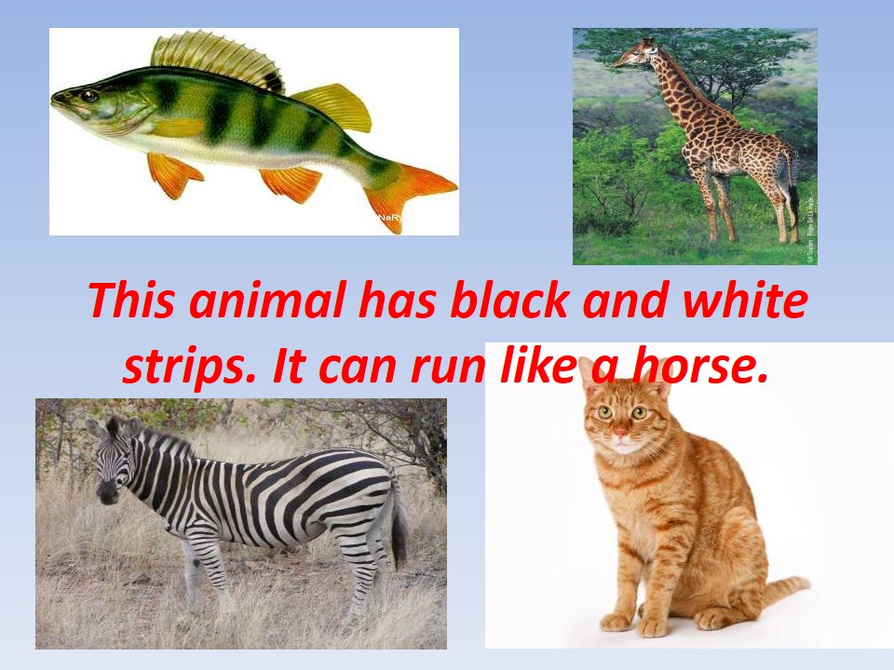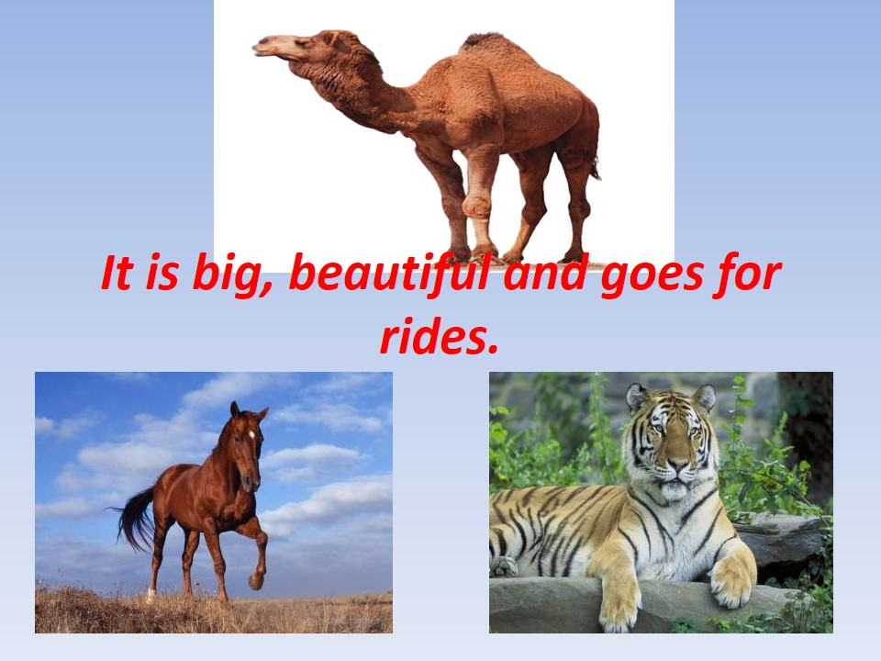
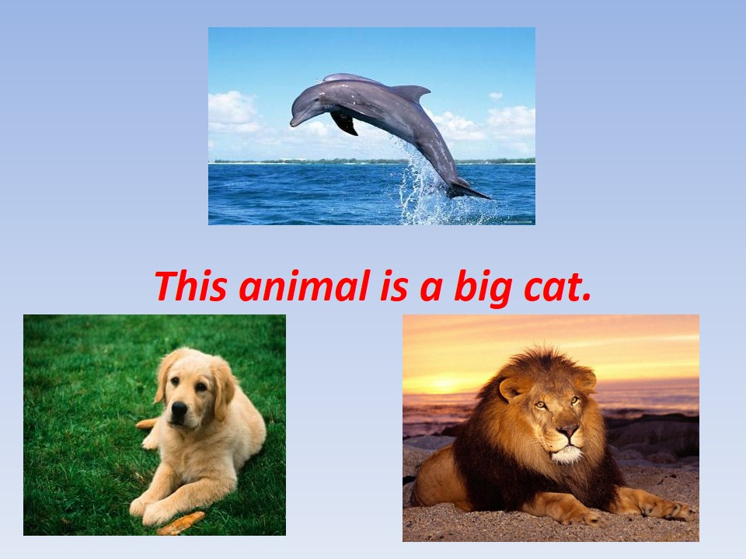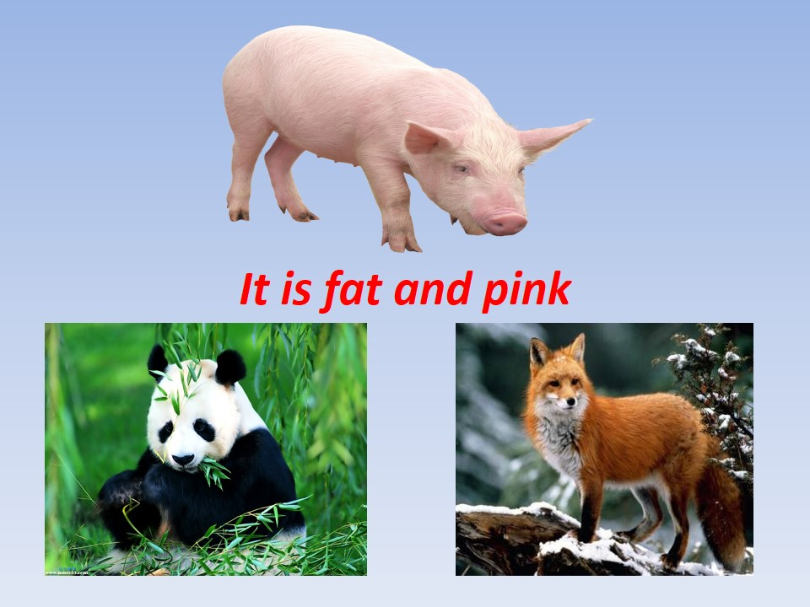

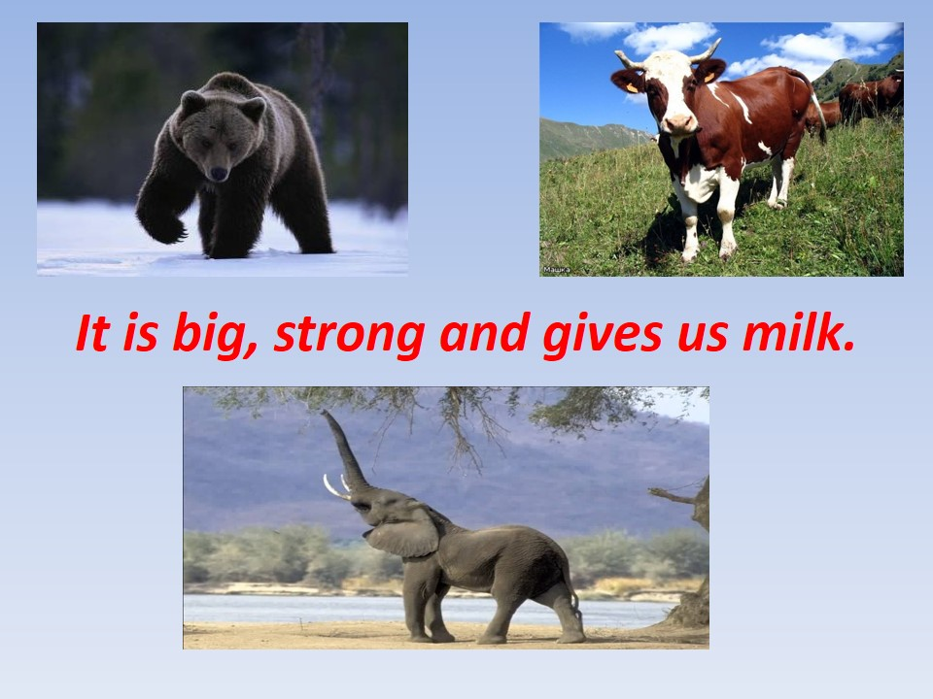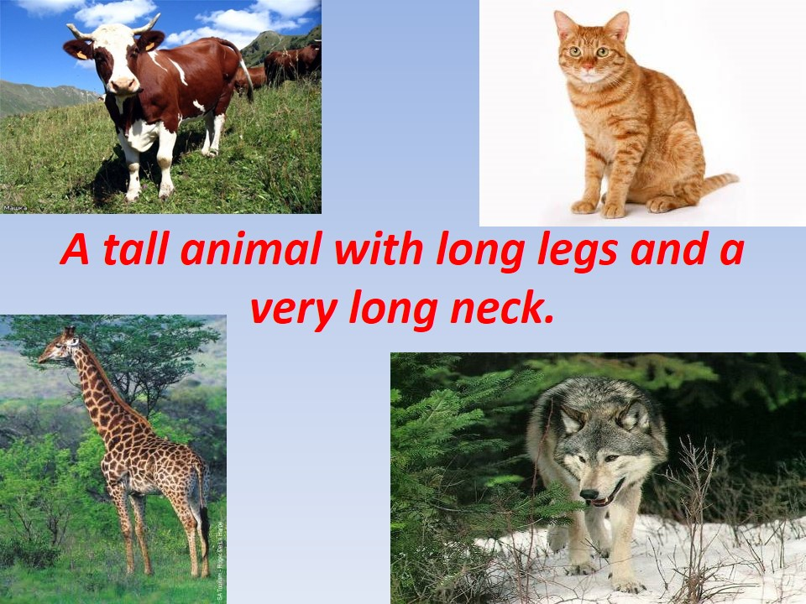

III. The Concluding Part of the Lesson.
12. Summarising
T:Children, did you like our lesson? What did you like most of all? Your marks for the lesson are….
13. Hometask
T: Make a poster about your favourite animal (in groups or pairs).
