Відділ освіти
Теребовлянської райдержадміністрації

КОНСПЕКТ УРОКУ
для 9 класу на тему:
« Art in our life »

Підготувала:
Коцур Світлана Тарасівна
вчитель англійської мови
Теребовлянської №1
ЗОШ І-ІІІ ст.

2015 р.
Subject matter: Art in our life
Objectives: to revise the vocabulary on the topic, to develop Ss grammar skills
( Past Perfect /Past Perfect Continuous);to encourage Ss thinking, imagination and creativity; to widen Ss outlook giving additional information; to encourage Ss to work in groups and pairs; to develop Ss acting abilities through role-play.

Equipment: posters, pictures of famous art galleries, Smart Board, flashcards with tasks for pair and group activities, course books.

Procedure
- Warming up
- Do you often go to museums?
- When did you go to a museum or gallery last?
- What famous painters do you know?
- Who is your favorite painter?
  - Checking the homework
Match the words with their definitions.
1 | a painting | A | is a painting or other artistic representation of the sea
2 | a landscape | В | is a picture on a wall or ceiling
3 | a seascape | C | this word is used as a general term meaning 'work', 'picture'
4 | a portrait | D | is a person (subject, model) who is having his portrait painted
5 | a sitter | E | is a picture, a canvas
6 | a still life | F | this word is used in expressions: city scene, country scene, historical scene, street scene, battle scene
7 | a fresco | G | is a picture representing a scenery of nature or countryside
8 | a scene | H | is a painting of such unanimated subjects as fruit, flowers or other decorative things
9 | a piece | I | is a painting, picture or representation of a person, especially of a face generally drawn from life

III. Grammar Point
Look at the screen and remember about using of Past Perfect Tense.
The Perfect Tense is used to show a past action that happened before another action in the past.
Examples:
Bill had just finished the test when the bell rang. After I had finished the text I left.
The Past Perfect Tense is often used with the following words and phrases: by, by the time, before, after, just, when.
Examples:
By the time I got to class, the lesson had started. Mike had already eaten his pizza before I got home.
Now open your books and do ex. 1.
Complete the sentences by changing the form of the verb in brackets info the Past Perfect.
The Past Perfect Continuous Tense is used to show an action that was in progress in the past before another action (Past Simple) happened or interrupted it.

Examples:
We had a break because we had been working so hard. He had been training for three years when he painted this masterpiece.
The Past Perfect Continuous
is often used with the following words and phrases: for, since, before, all day / night.
Examples:
Meg had been studying all day. He had been reading the book since yesterday evening.
Do ex.2 Complete the sentences using the prompts is brackets and putting the verbs info the Past Perfect Continuous.
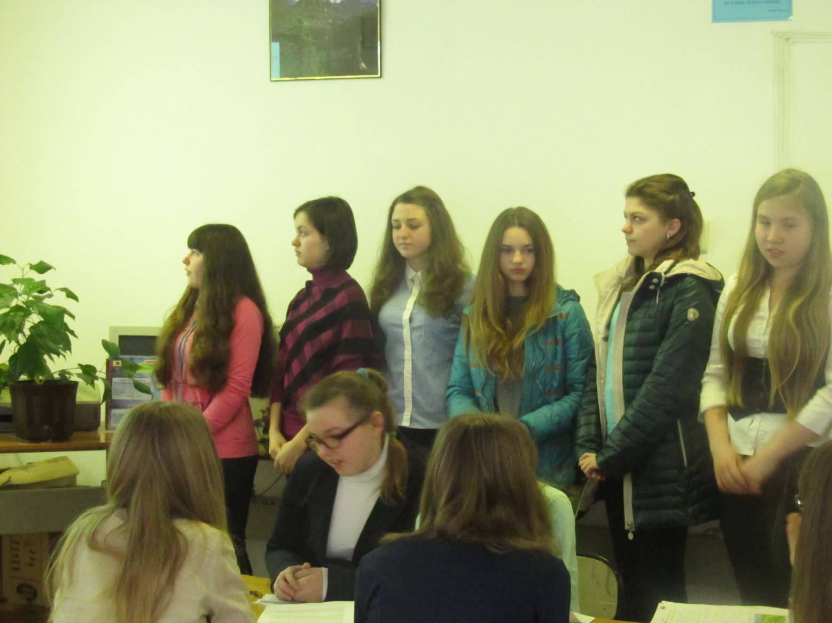
IV. Listening
Listen to the story. Read the statements and say if they are true and false.
Read and put 'T' if the statement is true, and 'F' if it is false.
- You can see everything in a day in the Louvre if you try.
- A handy map highlights the main attractions of the Louvre.
- The beauty of any museum or gallery is personal discovery.
- There are no reasonably priced cafes around the Louvre.
- Photography is forbidden in the Louvre.
- Audio guide is free in the Louvre.
- You have to leave a document to get an audio guide.
- Each wing of the Louvre has got its audio guide.
- If you tike long queues enter the Louvre from the street.
Listen to the story again and answer the questions.
- Do you need to buy a map?
- What should you visit first?
- When should you see the galleries that most interest you? Why?
- Where can you have lunch?
- What should you do in the afternoon?
- Can you take photographs?
- Do you have to pay for audio guides?
- What do you have to remember if you borrow one? Why?
V. Reading and speaking
Ask and answer the questions to learn some information about a famous artist.

Reading and speaking
Ask and answer the questions to learn some information about a famous
artist.

Student A
Van Gogh was born in Holland in 1853. He worked at many jobs, such as at an art gallery, a school, a bookstore, as a preacher, and at last, he became an artist. He didn't have a very happy life. He painted sad paintings with poor people in them. His paintings were always very dark until he saw some colorful Japanese paintings. Then Van Gogh started painting happier paintings. Most of his work was in the Postimpressionist style.
One day, he moved to live with his brother because he was unhappy where he lived and he wanted to find someone to paint with. When he finally found someone, he wished he hadn't. Van Gogh and the other artist did not get along. After this, Van Gogh became so sad that he cut part of his ear off!
After these things happened, he painted one more gloomy painting. It was called Wheatfield with Crows. After he finished it, he shot himself. His famous works are The Starry Night, Wheatfield with Crows, Sunflowers and, of course, Self portrait.
- When was Claude Monet born?
- Where was he born?
- Where did he study art?
- Was he married?
- What style did he represent?
- What are his famous works?
Student B
Claude Monet was born in 1840 on November 14 in Paris. He grew up in Le Haver, near the sea. Even when he was young he was a very good artist. His pictures were so good that an art supply store let him hang his pictures in their window.
Monet's parents did not want him to become an artist because they thought he would not make a good living. That did not stop him though. When he was 20, he studied art at an inexpensive art school in Paris.
Monet often went on trips around France to paint. Sometimes, his friend Camille came along. Camille later became Monet's wife. They had two sons, Jean and Michel. In 1878, Camille got sick and died. A few years later, Monet got married again to a woman named Alice.
Later, Monet and his family moved to Giverny, a small town near Paris. This is where he painted his Impressionist wheatstack and cathedral Daintings that became very famous. Their house also had a wonderful garden with a lily pond that had a Japanese bridge across it. These were his favorite things to paint.
Monet died in 1926 in Giverny. Many people came to his funeral. Unlike many artists, he was famous even before he died. Now his house in Giverny is a museum that is visited by many people. His famous works are Morning Haze, Poppies Blooming, Lily Pond
- When was Van Gogh born?
- Where was he born?
- Was he married?
- What were his paintings like?
- What style did he represent?
- What are his famous works?
Cut out and shuffle the parts of the two biographies. Students in pairs have to sort out the cards to make the biographies complete.
Salvador Dali was born in Spain in 1904, When he was a child, he showed strange behavior and often interrupted his class in school. As he got older, he started to paint pictures that came from his dreams. His dreams and his paintings were scary and unreal. Dali went to art school in Madrid, Spain. He got kicked out, and never finished. He even spent time in jail. However, he continued to paint, and his art style became known as Surrealism. Salvador Dali drew everyday items, but changed them in odd ways. For example, one of his paintings is of melting clocks. Before he died
at the age of 85 in 1989, Dali had created works in film, ballet, opera, fashion, jewelry, and advertising illustrations.

In 1452, Leonardo Da Vinci was born in an Italian town called Vinci. He lived in a time period called the Renaissance, when everyone was interested in art. Even though Da Vinci was a great artist, he became famous because of all the other things he could do. He was a sculptor, a scientist, an inventor, an architect, a musician, and a mathematician. When he was twenty, he helped his teacher finish a painting called The Baptism of Christ. When he was thirty, he moved to Milan. That is where he painted most of his pictures. Da Vinci's paintings were done in the Realist style.
VI. Speaking (Ss project works)

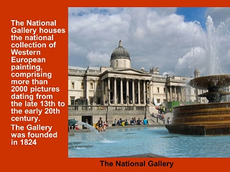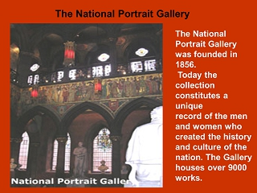
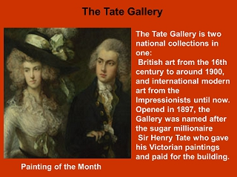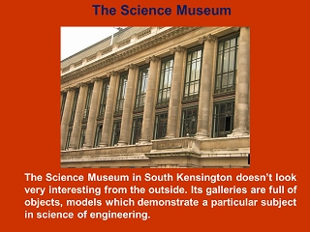
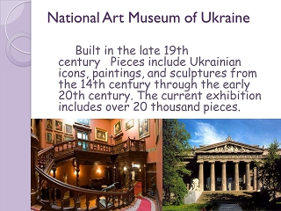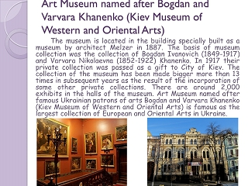
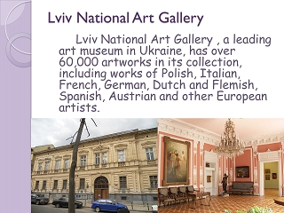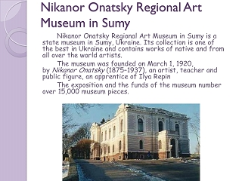
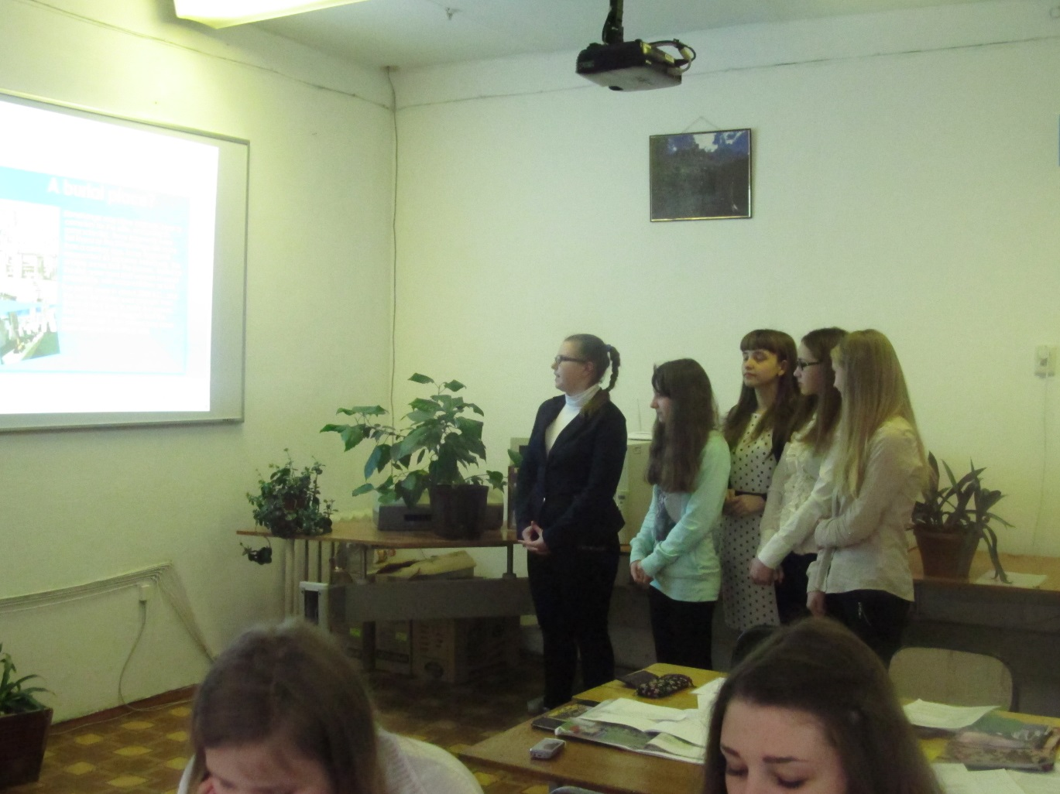
Work in pairs. Complete the dialogue with the sentences and dramatise it.
- Yulia:...
Misha: I'm going to Lviv to visit some of the museums of the city.
- Yulia: ...
Misha: What interesting exhibits do they display?
- Yulia:...
Misha: Is there a picture gallery in the city?
- Yulia:...
Misha: It's good you've shared your impressions with me.
I'm impatient to see it all with my own eyes.
  - Yulia...
Misha: Thanks, Yulia, bye.
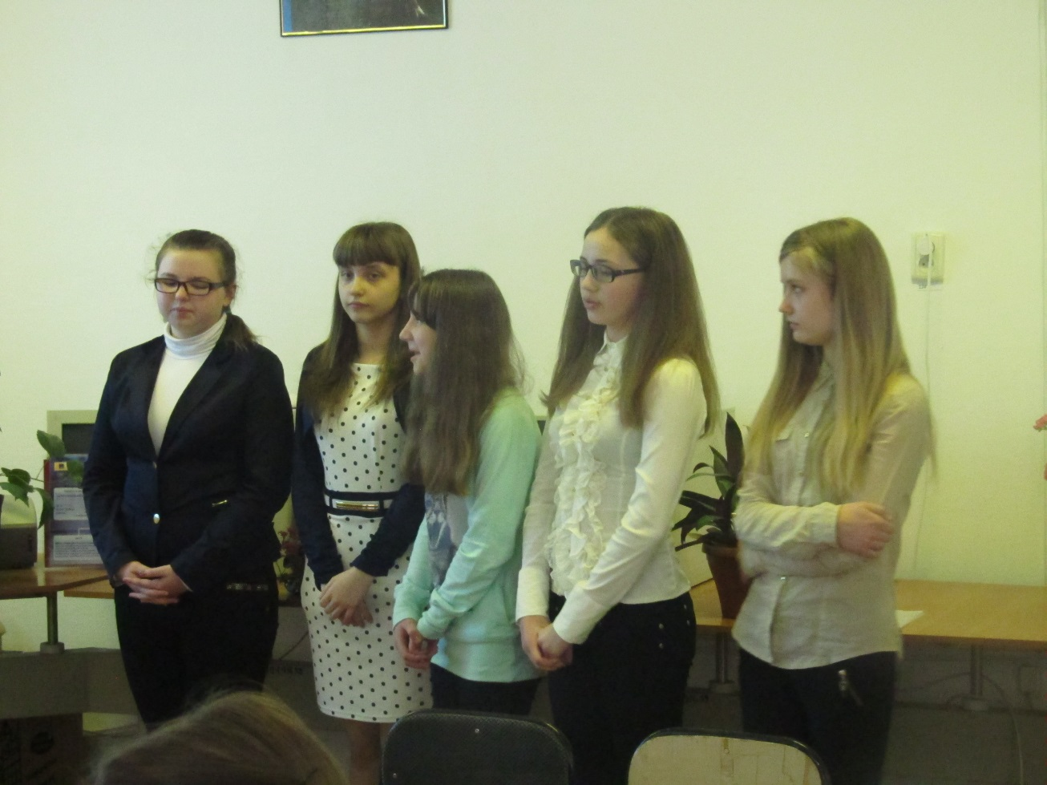
A Well, there are many things dating back to ancient times: national embroidery, collections of coins, glassware, alt kinds of weapons, articles made of bone, stone, iron or silver and different manuscripts.
B Have a nice journey.
C I say, Misha, what are you doing on Sunday?
D Oh, yes, and by the way, it's very rich. It's named after Vasyl Stefanyk, a well- known Ukrainian writer. It has beautiful collections of pictures, portraits, landscapes, seascapes and still life. They mostly belong to Ukrainian artists.
E Oh; that's wonderful. I've been at the historical museum in Lviv. It's really worth visiting.
Work in pairs. Complete the dialogue with the sentences and dramatize it.
A: Can I help you? I see you are in a difficulty.
B:
A: Oh, I am sure you will enjoy seeing our collections. Only one visit here is not enough. You will have to come here again and again to get a full impression of the museum.
B:
A: What is it you would like to see today?
B:
A: Yes, we have a fine collection of their paintings on the second floor. Just go up this staircase, then walk along the corridor and cross the hall of the 19th century masters.
B:
- Yes, thank you. You see, this is my first visit to this gallery.
- Of course, I understand that. I know that this gallery is one of the richest art galleries of the world, and I cannot hope to see everything in one day.
- Do you have paintings by Renaissance masters?
- Thank you very much.
VII. Summary
1) What museum is home to the Mona Lisa?
- The Metropolitan Museum of Art in New York City
- The National Gallery in London
- The Louvre in Paris
- The Uffizi in Florence
2).Who painted the Mona Lisa?
- Leonardo da Vinci
- Raphael
- Rembrandt
- Michelangelo
3).Claude Monet was a founder of what school of painting?
- Expressionism
- Cubism
- Romanticism
- Impressionism
4).What artist painted 'The Night Watch'?
- Rubens
- Rembrandt
- Gainsborough
- Van Dyck
5).What is Pablo Picasso's style of artwork called?
- Realism
- Cubism
- Abstract
- Romanticism

6).How many paintings did Van Gogh sell in his lifetime?
- One hundred
- Fifty-four
- Sixteen
- One
7).How long did Leonardo da Vinci spend painting the Mona Lisa's lips?
- 8 months
- 12 years
- 10 weeks
- 2 years
8)What is Da Vinci’s style of art work called?
- Realism
- Cubism
- Abstract
- Romanticism
9).When did Leonardo Da Vinci move to Milan?
- In 1582
- In 1482
- In 1472
- In 149
10)When was Salvador Dali born?
- In 1804
- In 1904
- In 1914
- In 1814

11).What is Dali’s style of art work called?
- Cubism
- Realism
- Surrealism
- Romanticism
12).Who studied art at an inexpensive art school in Paris?
- Van Gogh
- Salvador Dali
- Leonardo Da Vinci
- Claude Monet
VIII. Homework
Prepare a short report about your favorite painter.

