Відділ освіти
Теребовлянської райдержадміністрації

КОНСПЕКТ УРОКУ
для 1 класу на тему:
«TOYS»

Підготувала:
Коцур Світлана Тарасівна
вчитель англійської мови
Теребовлянської №1
ЗОШ І-ІІІ ст.

2015 р.
Subject matter: Toys
Aims: to introduce new lexical material to the topic; to work on the correct pronunciation; to practice the usage of the structure "Is it a... ? - Yes, it is. / No, it isn't."; to develop listening, speaking skills; to bring up pupils as kind and positive persons.
Materials: toy flashcards, handouts, pictures, a computer, the recording of the songs.
The Procedure of the lesson:
I. Introduction
1.1 Greeting
Teacher: Good morning, pupils!
Pupils: Good morning, dear teacher!
Good morning, good morning,
Good morning to you.
Good morning, good morning,
I'm glad to see you!
Teacher: I'm glad to see you too. Sit down, please.
1.2. Warm up
Teacher: What's your name? How are you today? How old are you?
Pupils: I'm ... ; I'm ( fine, thank you ). I'm ( six ).
Teacher: Let's sing the song "Hello, hello!"
Hello, hello.
What's your name?
I'm Rosy. I'm Rosy.
Hello, hello.
Hello, hello.
What's your name?
I'm Tim. I'm Tim.
Hello, hello.
Hello, hello.
What's your name?
ga ga, ga ga
Hello, hello.
Goodbye, goodbye.
Goodbye to you.
Rosy, Tim and Billy.
Goodbye, goodbye.
II. The Main Part of the lesson
Teacher: The topic of our lesson today is "Toys." And today we are going to work on the words of the topic, to play lexical games, we'll talk about your toys. We'll recite rhymes, sing songs and will do different activities to develop your listening and speaking skills. So, let's start!

2.1 Match
Teacher: Look at the desks. You see different letters (Aa, Bb, Cc, Dd, Ee, Ff). You need to match them with the pictures on the board.

Aa Bb Cc Dd Ee Ff
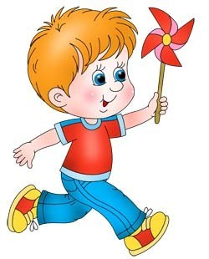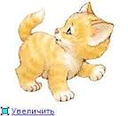

2.2 Speaking
Working on the Topical Vocabulary. The pupils answer the teacher's questions. Teacher: What's this?
Pupils: It's a balloon. (plane, teddy, puppet, robot).
Then, the teacher asks some of the pupils to repeat the words individually.
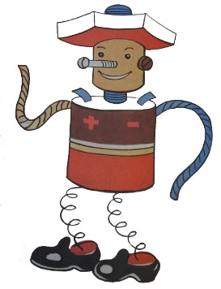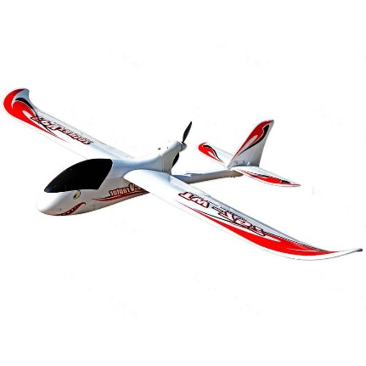
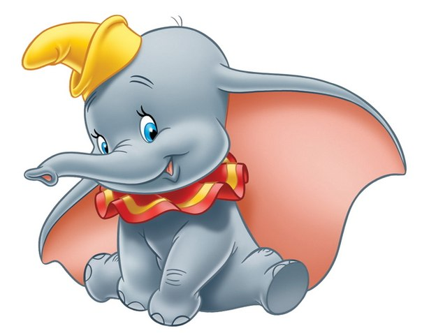
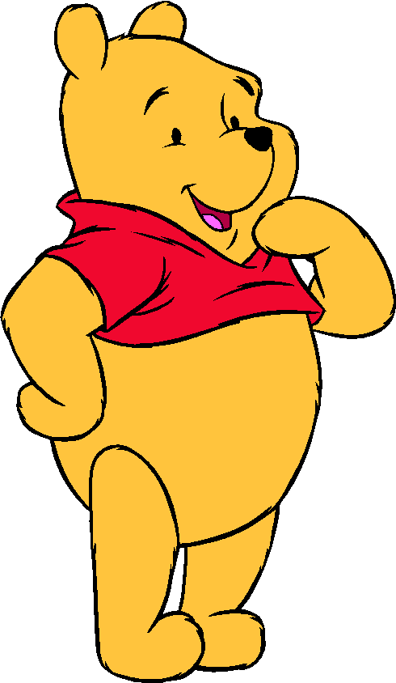

2.3 Lexical Drills.
Teacher: Look at these toys. Match the pictures with the colours and name them.

2.4 Relaxation
Teacher: Let's have some rest! Stand up!
Clap your hands
Clap your hands, clap your hands,
listen to the music and clap your hands.
Stamp your feet, stamp your feet,
listen to the music and stamp your feet.
Turn around, turn around,
listen to the music and turn around.
Jump up high, jump up high,
Listen to the music and jump up high.
2.5. Working on the structure " Is it a ...? - Yes, it is. / No, it isn't.
Teacher: Is it a plane (a puppet, a teddy, a robot, a balloon)?
Pupils: Yes, it is. / No, it isn't.
Teacher: Now, you need to guess what toy it is.
Then, pupils make dialogues about their toys.
Pupil 1: Is it a ...?
Pupil 2: Yes, it is. (No, it isn't). Is it a ... ?
Teacher: Thank you very much! Now, let's get down to the next task.
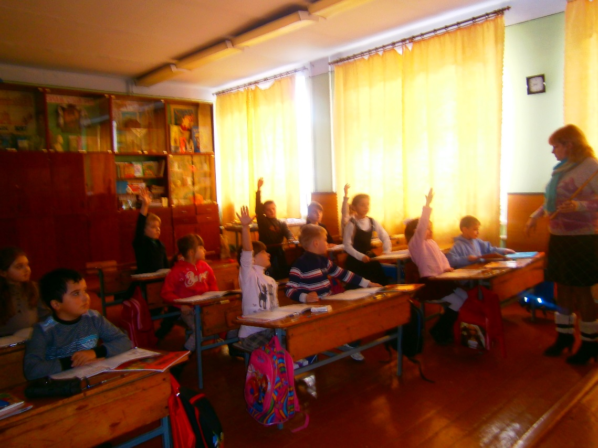
2.6. Listening
Teacher: We'll listen and tick or cross.
Typescript:
1. Is it a balloon ? Yes, it is.
2. Is it a plane? No, it isn't.
3. Is it a teddy ? Yes, it is.
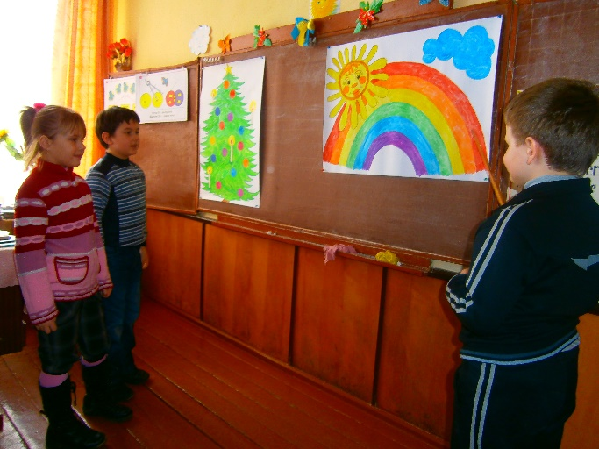
4. Is it a puppet? No, it isn't.
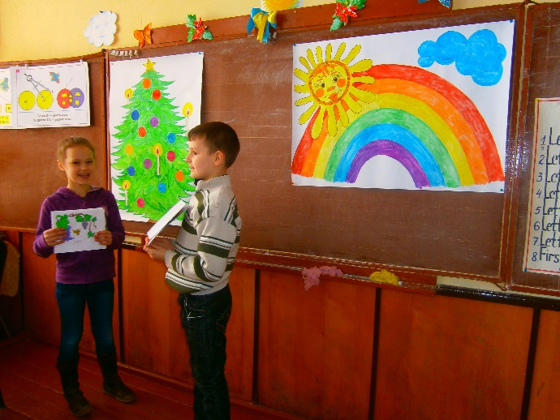

2.7 Workbook
Teacher: Open your workbooks on page 23. You need to complete the pictures.
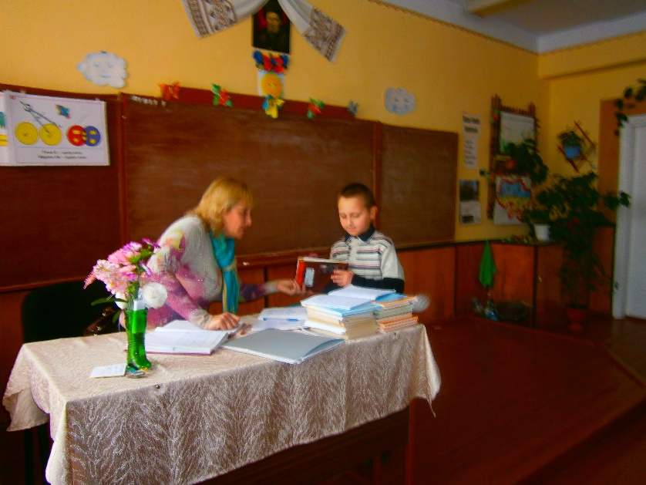
2.8 Singing the song. Having a Break.
Teacher: Now, it's high time to sing a song.
Is it a plane?
Is it a plane?
Yes, it is.
It's a plane.
(woosh, woosh, woosh, woosh)
Is it a robot?
Is it a robot?
No, it isn't.
It's a car.
(broom, broom, broom, broom)

2.9 Game: "Santa's Stocking"
Teacher: Look at the blackboard, please.
It's a Santa Claus.
Let's recite a poem about Santa Claus!
Santa Claus, Santa Claus,
Santa Claus is here.
Bringing toys,
For girls and boys,
And lots of Christmas cheer.
Teacher: And now tell that poem individually.
OK. Let's play a game. This is a Santa's Stocking. You need to come up and pull out something. Then, answer the questions.
Teacher: Is it a ( plane )?
Pupil: Yes, it is. / No, it isn't.
Teacher: What color is the ( plane )?
Pupil: It's ( red ).
III. The Concluding Part of the Lesson.
Teacher: Our lesson is over. Goodbye!
Oral evaluation of pupils.

