Відділ освіти
Теребовлянської райдержадміністрації

КОНСПЕКТ УРОКУ
для 4 класу на тему:
Weekends Around the World
Present Simple Tense

Підготувала:
Коцур Світлана Тарасівна
вчитель англійської мови
Теребовлянської №1
ЗОШ І-ІІІ ст.

2015 р.

Subject matter: Weekends around the world
Present Simple Tense
Objectives:
- to revise the vocabulary on the topic;
- to improve Ss listening, reading, writing and speaking skills;
- to motivate Ss in using Present Simple in different communicative situations;
- to encourage Ss to work in groups and pairs;
- to widen Ss outlook giving additional information;
- to develop Ss creative imagination and free expression of ideas:
Equipment: posters, pictures of Ss leisure time, Smart Board, card with tasks for pair and group activities, course books.

Procedure
І. Introduction
Language is a city to the building of which every human being brought a stone.
R.W.Emerson

T. Good morning , dear Ss! How are you today? You look great. Look at each other! Smile at each other! A warm smile will encourage our work.
ІІ.Warming up
T. Today is a big day for us. We are going to do some exercises, work in groups and pairs, play and sing, and watch a video about... But it’ll be a surprise for you, if you work hard. So, lets start

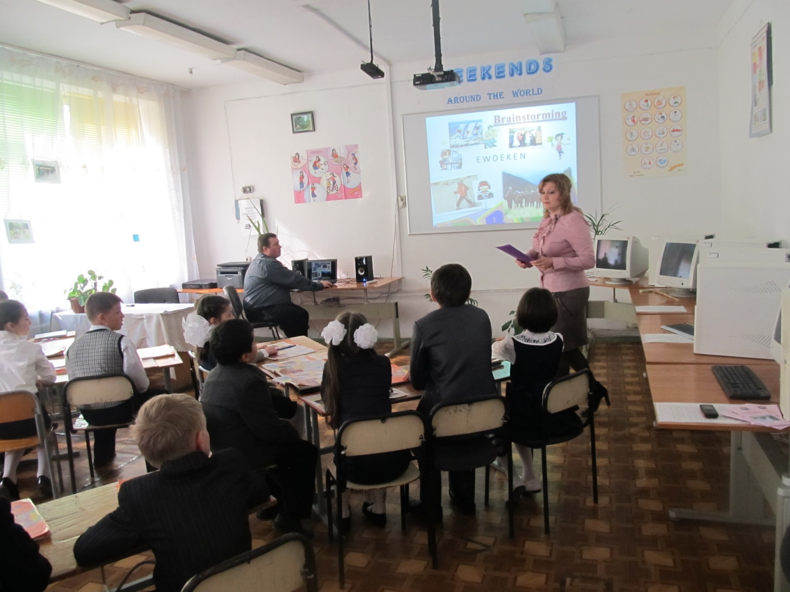
III. Main Part

Brainstorming.
T. Our computer will help us to make an exciting trip. Look at the monitor. There are pictures and letters in disorder. Will you help me? Make a word by changing the order of the letters. Then you know what our topic is about. What other words are similar to the word “weekend”?
IV. Mind Map.
T: Let’s make a mind map about various activities you usually do in your free time.
V. Revising Vocabulary
T: Join the correct word pairs in a diagram. Make as many word combinations as possible.(1-2min)
VI. Discussion (Free Expression of ideas)
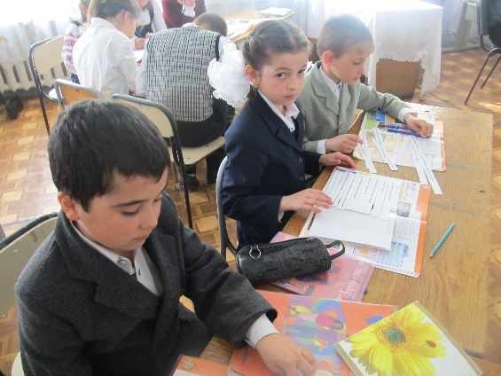
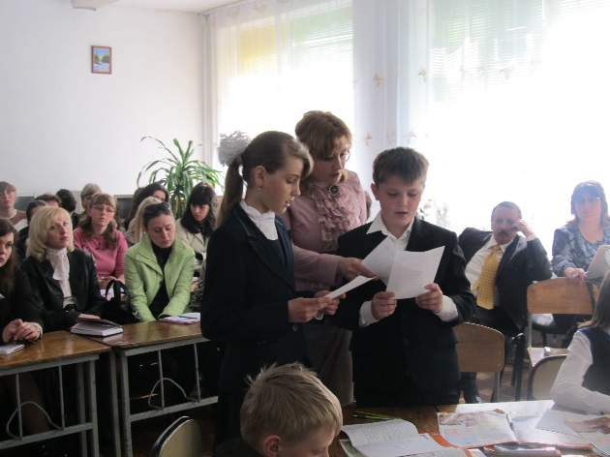

T: Let’s share your own experience: What do you usually do at weekends? Use positive sentences in Present Simple.
What don’t you do in your pastime? Use negative sentences in Present Simple.
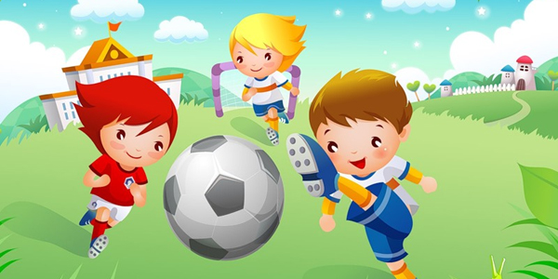
VII. Music Break

T: I see you’re tired a little, so let’s relax a bit and sing a song “After school”

VIII. Project Work (Groups' Presentation)

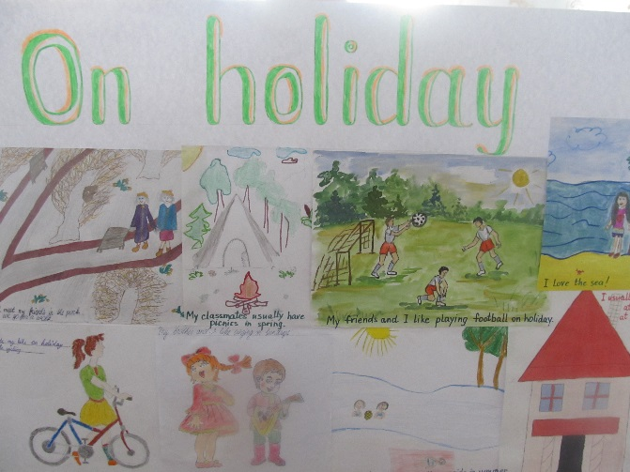
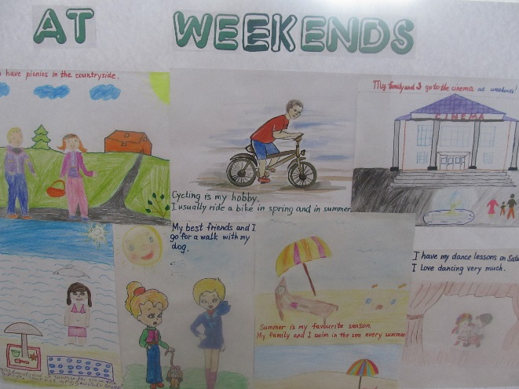
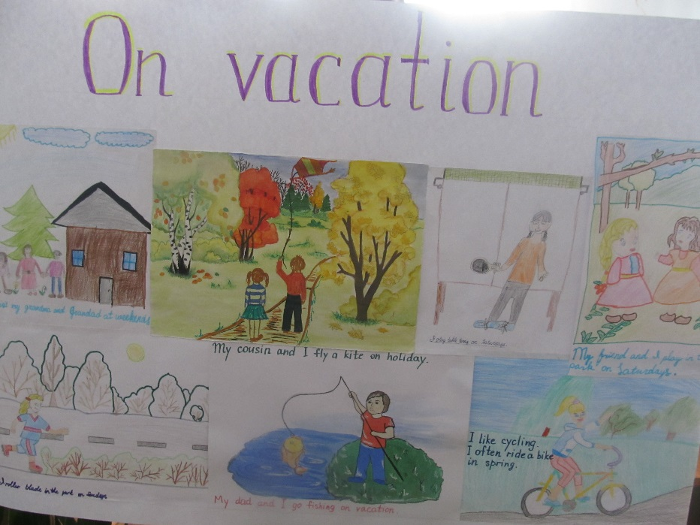

T: You were split into 3 groups and your home task was to make up projects in pictures and present them. Make picture diaries about the rest in our country and stick them on a poster in the classroom
So the 1st team is invited to start with their presentation

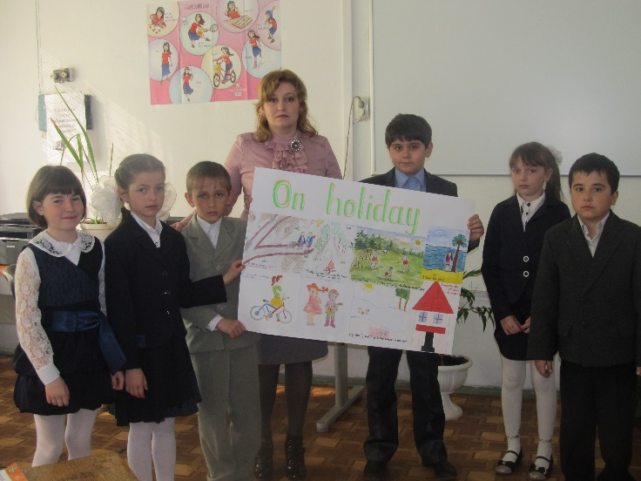
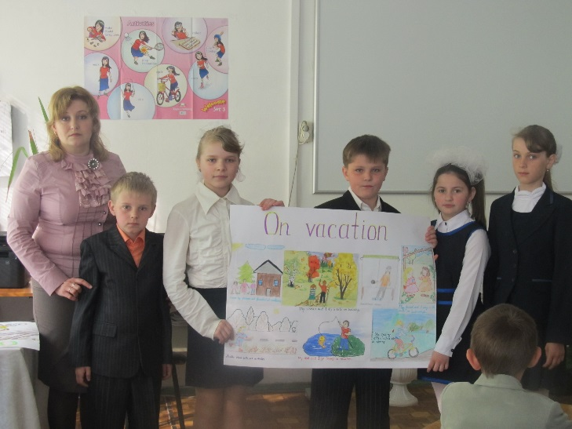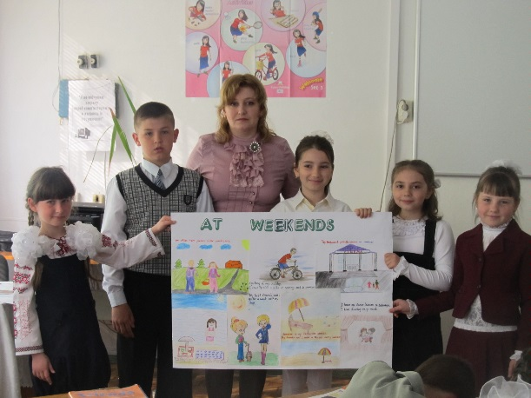
IX. Speaking ( Monological Skills)
T: Look at the screen. Do you remember the photos from your Ss books? On previous lesson we read and learnt some information about spending free time in different countries. Could you speak about activities the children from other countries like to do? But first remember the stories and answer the questions to the pictures
X. Listening Comprehension
1. Pre - listening task
Teacher’s Questions round the photos
- -Whom can you see in the photos?
- -Where is a boy from ?
- -Is he a student?
- -Is he Ukrainian?
- -How old is he?
Give Ss time to look at the days before playing the recording.
2.While-listening task. Match the days with the pictures.
3.Post-listening task
Ss work individually writing sentences about Ramesh
XI. Watching a Video (Discussion)
XII. Fun Time
T: I think you’ve worked hard, so it’s high time for relaxation. I invite everybody to make some movements. Listen and act.
XIII. Group and Pair Work
Ss are given different tasks for each team
(a Strip Dialogue, Snake Questions, My Partner’s Rest) 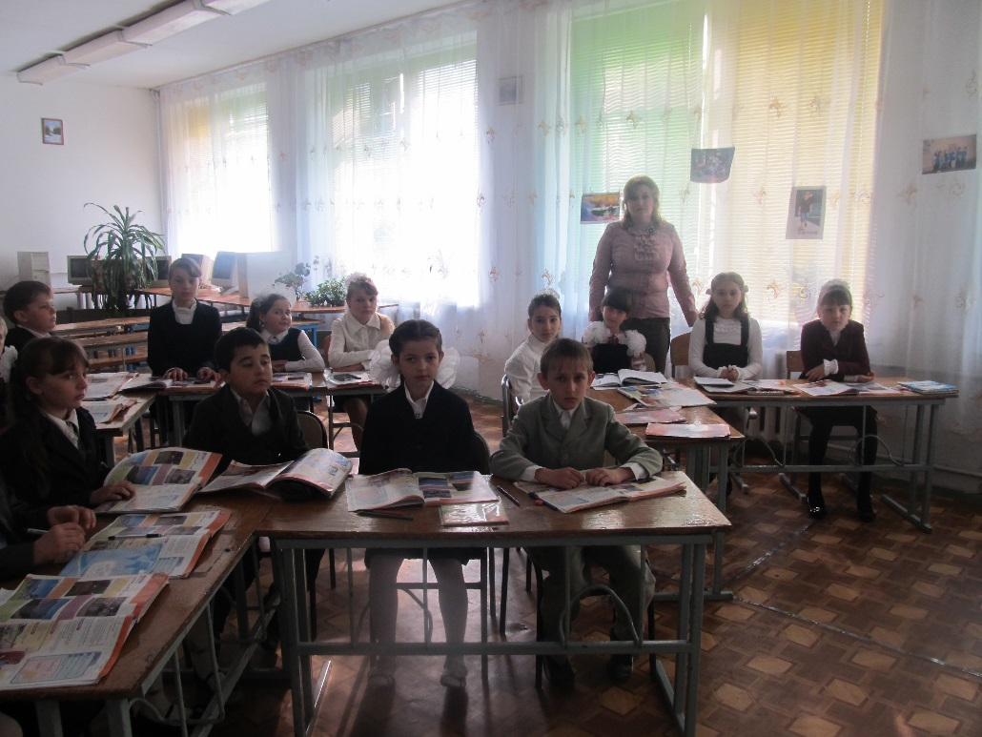

XIV. Playing a game (Sweet Quiz).
T: Do you like sweets?
Do you love fruit?
What about presents before Easter?
XV. Summing up
T: You’ve done a great job. In our today’s lesson we were doing a lot of activities...
- Home assignment.
Make up a dialogue about Ramesh. You’re an interviewer. Make questions about his family, his school and friends.
- Closure. Evaluation. Comments.
T: Our lesson is coming to an end. I’d like to thank everyone for good work in the lesson.
I prepared some special words for you:
‘Be happy, you’re special!’
‘I’m glad you’re my students!’
‘It’s nice to work with you!’
‘Keep smiling, you’re special’

Now it’s time to say good-bye. Look at each other! Smile at each other! Have a nice weekend!
