Відділ освіти
Теребовлянської райдержадміністрації

КОНСПЕКТ УРОКУ
для 8 класу на тему:

«Canada—the land of dreams»

Підготувала:
Коцур Світлана Тарасівна
вчитель англійської мови
Теребовлянської №1
ЗОШ І-ІІІ ст.

2015 р.

Subject matter: Canada—the land of dreams
Level – pre-intermediate
Aims and objectives:
- to develop students’ speaking skills;
- to enrich students’ vocabulary ;
- to teach students’ to respect other cultures ;
- to widen students’ knowledge about English – speaking ;
- to encourage students’ independent thinking and creative imagination.
Equipments: copy-books, cards, maps, blackboard, students’ presentations on Canada, Smart Board, cards with tasks for pair and group activities.
PROCEDURE

I . Introduction
1. Greeting.
T. Good morning, friends!
I’m glad to greet you in a cheerful and merry mood.
Can you guess what we are going to speak about today ?
2. Warming-up
Can you see those decorations? How do you think we are going today?
Ask students to write down ten answers to questions about their imaginary journey (homework). After writing down the answers, they have to form pairs or small groups and try to find out what the questions are.
Example: answer — By car — How did you travel last year?
- The Carpathians — Where did you go?
- White bears — What did you see?
You can stop at three guesses if you want, or keep going until someone in the class can guess the question.

II. Main part.
2. Aims. Method “Microphone”
1) Why do people travel?
2) Do you like travelling?
3) What kind of traveling do you know?
4) Why do people travel by plane?
5) Do you want to travel to English-speaking countries?
Look at the screen. Be attentive!
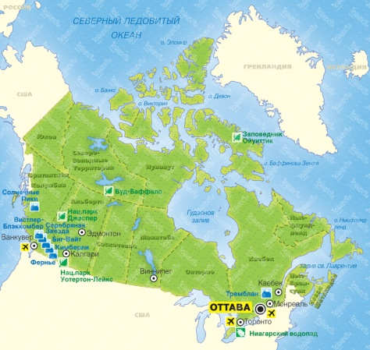
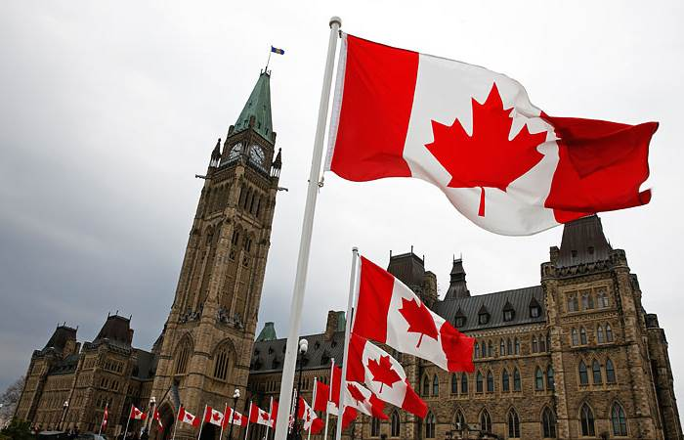

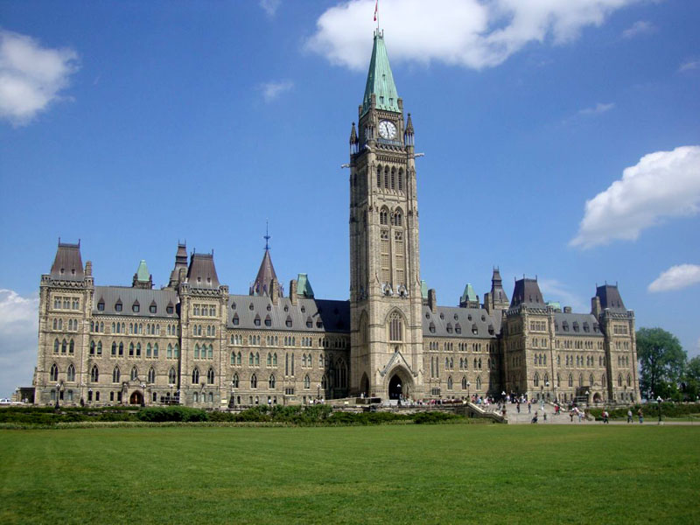

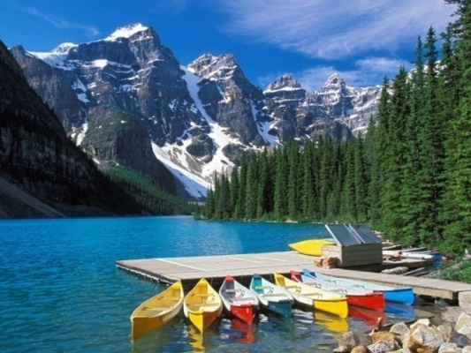
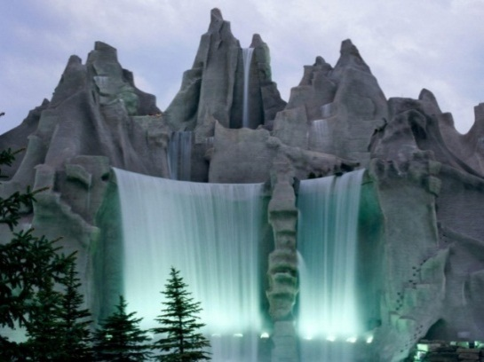
How do you think what is the topic of our today’s lesson? What will you do during today’s lesson? Where can you use this knowledge? What are you expecting from today’s lesson?

3. New Vocabulary. Work with dictionary.
- An immigrant – іммігрант
- The United Kingdom – Об'єднане Королівство (Великобританії)
- Original – початковий, первісний
- To cover – покривати, обкладинка, займати

- make up sentences with new words (2 minutes)
My father is an immigrant.
There are many immigrants in the Canada.
My house covers 12 square kilometers.
I shall travel to the United Kingdom of Great Britain.

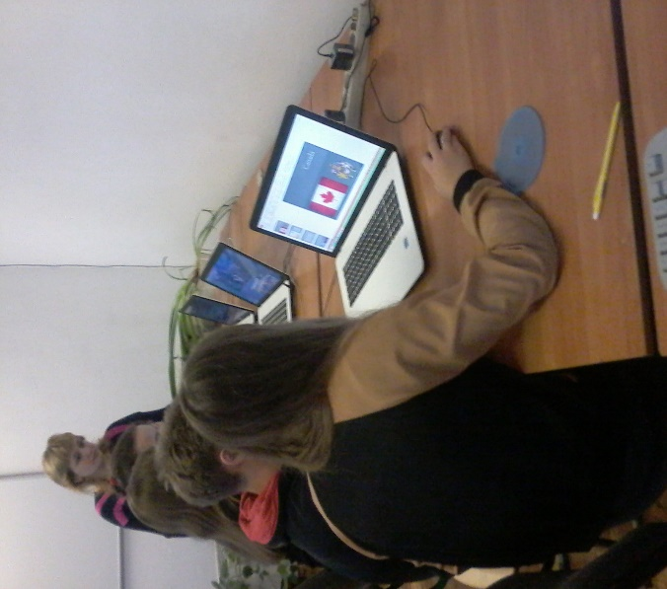
4. Pair Work. Cards.
Find right translation . (2 minutes)
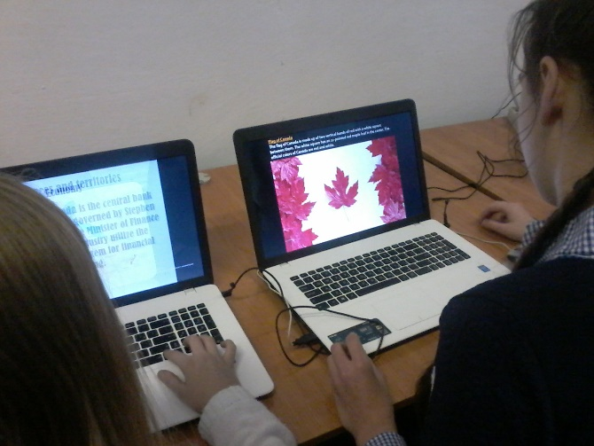
1) wonder | a) | отримувати
2) ancient times | b) | незалежний
3) receive | c) | площа
4) introduce | d) | коріння
5) cover | e) | давні часи
6) area | f) | населення
7) population | g) | корінний, справжній
8) root | h) | іммігрант
9) immigrant | i) | знайомити, рекомендувати
10) original | j) | диво
11)independent | k) | займати, покривати

4. Reading .
DIFFERENT COUNTRIES, DIFFERENT PLACES
Our world has many faces. It is different in its beauty. There are lots of wonders in the world. Since ancient times men have travelled to different countries and continents and have sailed across different seas and oceans. People have always wanted to know the world better. The "English Bridge" group has received many letters from different countries. The Canadian School Magazine "The Winni Peggies" is our new friend. The Canadian friends introduce their country here.
Meet Canada! It is the second largest country in the world. It covers 9,976,185 square kilometres. This area is as big as the whole Europe. The population is 27 million people. It is less than half the population of Britain.
Most of the Canadians have their roots in families of immigrants from European countries: the United Kingdom and Ireland, France and Germany. Today a lot of immigrants come from Asia. The original population were the Eskimos and the Indians. Most of them live in the north of Canada.
In winter Canada is very cold and has a lot of snow. Winter sports are very popular here.
For many years Britain and France fought for Canada. It is an independent country now. But the British Queen is still the head of the state. Most of the population speak English, but about 6 million Canadians speak French.
This is the CN Tower in Toronto. Toronto is the largest city in Canada. Other big cities are Montreal, Vancouver and Calgary. We live in Winnipeg. The capital is Ottawa. It is not very big but comfortable.

5. Speaking. Pair work.
Is Canada a large country?
Are the winters cold there?
What is the largest city in Canada?
Is Ottawa a small city?
What languages do they speak in Canada?
What is the population of the country?
What is Canada today?

6. Physical Activity .
Do these exercises with music.
Jump, sleep, hands up, smile, dance, clap your hands….
7. Listening. Travelling on foot. Hiking
Before listening.
New words
- Hike – пішохідна екскурсія
- Walk – прогулянка
- Especially – особливо
- Bank of the river - на березі річки
- rucksack – рюкзак
- Tent - намет
- Competitions – змагання
- Campfire- вогнище

- Listen to the text
Traveling on foot. Hiking
A long walk in the country is very interesting. Such a walk is called a hike. And when you go for a walk in the country, you say that you are going on a hike.
Why is hiking such a nice thing for many people, especially for schoolchildren and students?
Well, a hike is a walk for pleasure in the open air. You don't need to think about tickets, timetables and other things like these. Usually a hike is a good time for friends to spend some days or even a day together in the forest, on a bank of the river or in the countryside. What you need is a rucksack with all the things you will use on a hike and a group of your best friends or classmates.
It has become a very good tradition for the pupils of some schools to go hiking. At the beginning of the school year when the classmates meet again after their summer holidays, they go on a hike. They take some tents, rucksacks and a guitar with them and go somewhere to the forest not far from the town. They have a very good time together: walk in the forest, have sport competitions. In the evening they sit round the camp fire, sing favourite songs and speak about their last summer holidays.

- Writing skills
I. Complete the sentences.
- A hike is a walk for pleasure in the…
- They have a very…
- In the evening they sit round…
- Only thing you need is…
II. Multiple choice questions
1. Hiking is very popular among…
- old people
- young people
- little children
2. On a hike you take…
- a suitcase
- a school bag
- a rucksack
3, On a hike you don't need…
a) to take food
b) to buy tickets
c) to put on comfortable shoes
4. Hiking is…
- a long walk in the country
- riding a bike
- driving a car
III. Answer the questions.
- Do you need to think about tickets?
- How do we call the long walk in the country?
- Where do the children go for hiking?
- When do they sing songs?

8. Quiz. “What do you know about Canada?”
1) Canada is…
- the largest country in the world
- the second largest country in the world
- third largest country in the world
2) The capital of Canada is …
- Montreal
- Toronto
- Ottawa
3) Canada has two official languages. They are…
- English and German
- English and French
- English and Canadian
4) The official colours of Canada are…
- red and blue
- white and red
- red and gold
5) Canada national sport is…
- baseball
- football
- ice hockey
6) The Canadian head of state is…
- the Queen
- the President
- the Prime Minister
7) A snow house built by the Inuit (Eskimos) is called…
- an igloo
- a cabin
- a hut
8) The world famous waterfall situated in Canada is…
- Victoria
- Niagara
- Sutherland
9) Canadians have a special celebration in honour of this sweet drink.
What is it?
- Cola
- lemonade
- maple syrup
Key: 1 b, 2 c, 3 b, 4 b, 5 c, 6 a, 7 a, 8 b, 9 c.

9. Students’ Presentations about Canada (on Smart Board)

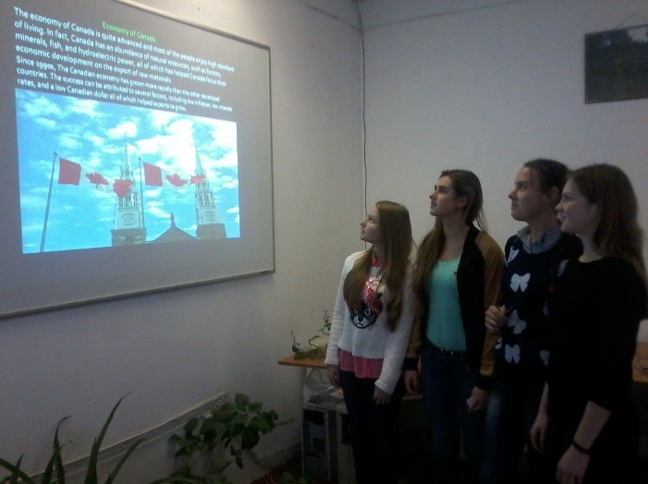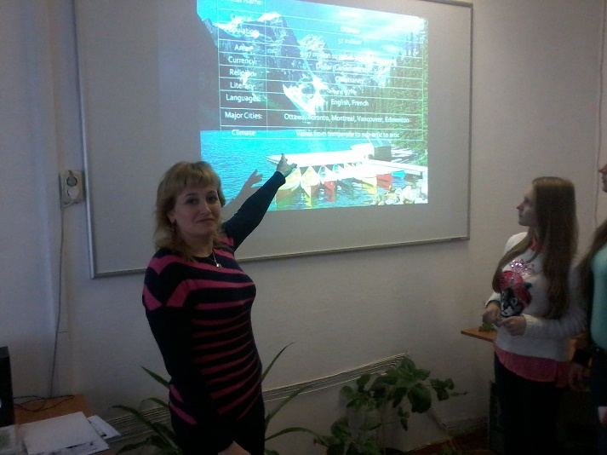

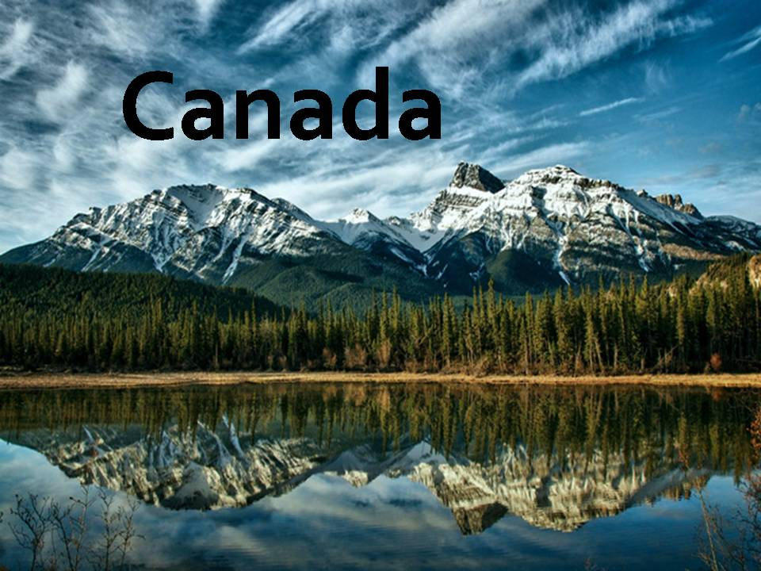
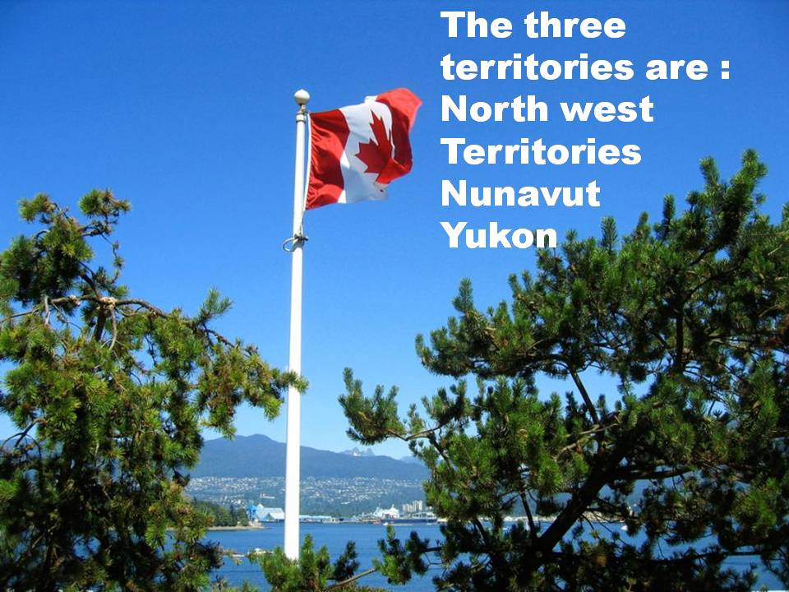

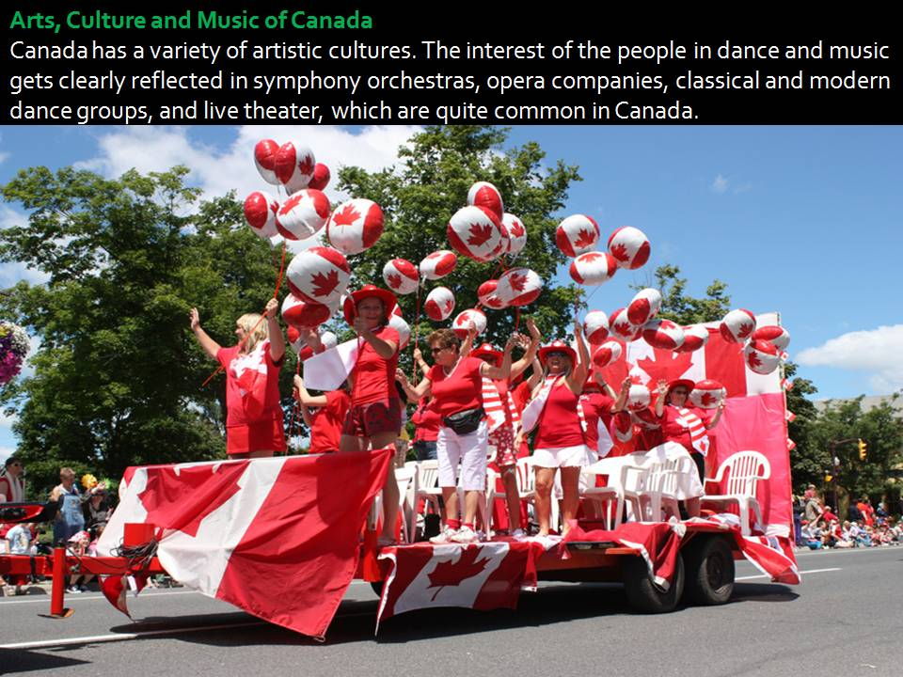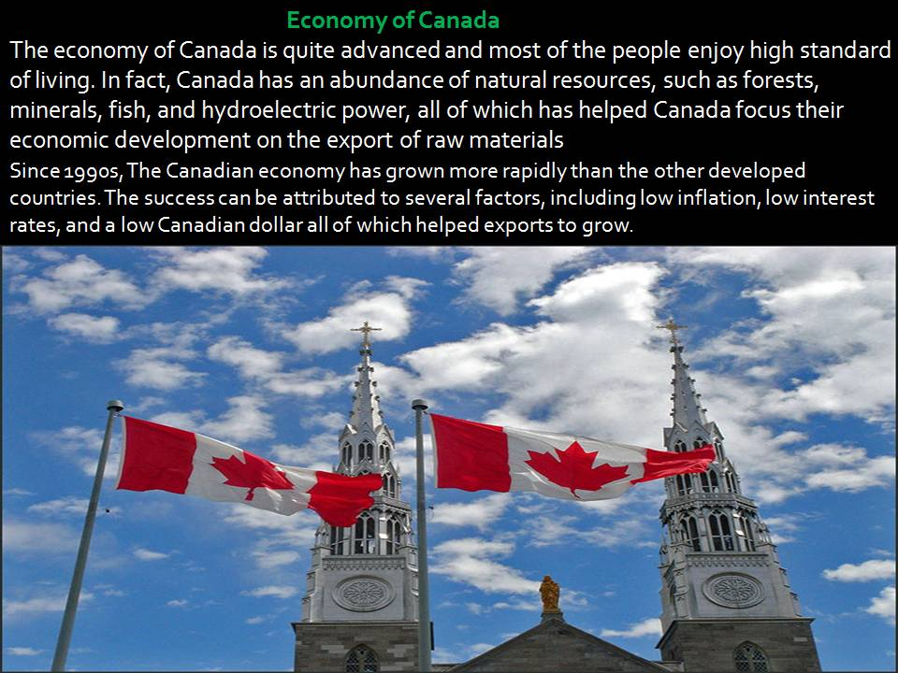

III. Summary. Evaluation.
What did you do during today’s lesson?
Did you like today’s lesson?
What new did you know from today’s lesson?
What did you learn on today’s lesson?
Did your expecting come true? Your marks are…..
10. Hometask
T. Our lesson is coming to the end. Did you like today’s lesson? What task did you like best of all? Your hometask will be to write a letter to your pen – friend in Canada about our country Ukraine.
See you soon. Thank you for the lesson. Good bye.

