Заліщицька державна гімназія

Урок - екскурсія

«WELCOME TO GREAT BRITAIN»
8 клас

Підготувала і провела
вчитель
англійської мови
Савчинська М.В.

2011 р.
Урок - екскурсія
«Welcome to Great Britain»
Мета: активізувати навики монологічного і діалогічного мовлення учнів; автоматизувати навики і вміння групової роботи; розвивати навики самостійної роботи; виховати навики правильної поведінки під час подорожі; розширити кругозір про країну, мова якої вивчається.

Обладнання: тематичні картинки, карта Великої Британії, комп’ютер, картки з тестовими завданнями.

Хід уроку
І Організаційний момент. Розмова учителя з класом.
T: Good morning, children. I am glad to see you again. The weather is fine today, the sun is shining brightly in the blue sky, it is warm, the birds are twittering, the air is full of freshness and aroma of flowers. The warmth brings new hopes and joy. I think, you are in good spirit, good health. Tell me, please, how you are.
P1: I am fine, thank you.
T: How is your mother?
P1: Okay. Thanks a lot.
T: How is your brother, Ilona ?
P2: He is not well. He feels bad because he has a sharp toothache.
T: Oh, it’s a pity. How is your brother, Nastya?
P3: He is down with flue. He has a high temperature, a headache and a cough.
T: Oh. I am very sorry indeed.

II Вступне слово учителя.
Dear children. Today we have an unusual lesson. We are going to pay a friendly visit to Great Britain and its capital London. As you know, the official name of the country is the United Kingdom of Great Britain and Northern Ireland. It consists of 4 countries: England, Wales, Scotland and Northern Ireland. It is washed by the Atlantic Ocean and the Irish Sea, the English Channel and Irish Sea. Great Britain is a highly developed industrial country with the population of about 56 mln people. The main branches of British industry are machine - building, ship - building, electronics, metallurgy, textile industry; Agriculture is still one of its most important industries.
London is the capital of Great Britain. It is one of the largest cities in the world. It consists of 4 parts: the City, the West End, the East End and Westminster. There are a lot of sightseeing in London. But before travelling let’s listen to the weather forecast, because the weather in London is often changeable and we must know what things to take with us. Turn on your TV set, please and listen to the weather commentator.

Weather commentator (повідомлення з телемакета)
P: Good morning. Let me introduce myself. I am Robert Redford. I am a weather commentator. I want to inform you about the weather forecast for tomorrow. It’s winter now. Frost is expected at night. But as you know the Atlantic Ocean, influences the climate of Europe, that’s why tomorrow they are expecting a windy day, rain and fog. Temperature will rise from -4+5С°. I advise you to take your umbrellas and put on rain-coats. Thank you. Good bye.
T: So, we see that according to the weather forecast they are expecting rain. Let’s remind a poem “Rain”.
It was raining (3p) hard.
It was falling on my head.
It was falling on my stars.
It was falling on the sun

It was falling on my shoes.
I got soaking wet (2p).

But I stayed outside (2p).
The rain was sweet,
The rain was warm
The rain was soft
It reminded me of home.
III Основна частина уроку. Починається подорож Великою Британією і Лондоном. Діти діляться на 2 групи: туристи з України та англійці. На дошці зображення Лондона, карта Великої Британії.
P1: Welcome to Great Britain. We are glad to meet a delegation of Ukrainian pupils in our country. First of all I’ll tell you some words about the United Kingdom, its geographical position and then answer all your questions. I’d like to start with a part of Rudyard Kipling’s poem.
The Glory of the Garden
Our England is a garden that is full of stately views,
Of borders, beds and shrubberies and lawns and avenues,
With statues on the terraces and peacocks strutting by;
But the Glory of the Garden lies in more than meets the eye…
Our England is a garden, and such gardens are not made
By singing:”Oh, how beautiful!” and sitting in the shade,
While better men than we out and start their working lives
At grubbing weeds from gravel-paths with broken dinner-knives…
Do you like this poem? I hope you do because it’s a beautiful description of Motherland.
T: So, United Kingdom is a sovereign island country located off the north-western coast of continental Europe. The United Kingdom includes the island of Great Britain and many small isles. The largest island Great Britain is linked to France by the Channel Tunnel. The United Kingdom is governed by a parliamentary system: a seat of government in London and a constitutional monarchy with Queen Elizabeth II, as the head of state. The flag of the United Kingdom is the Union Jack. The national anthem of the United Kingdom is “God Save the King”. Have you questions?
P1: I don’t like your weather. It’s the end of winter, but it’s rather cold. It was raining the whole day yesterday and we got wet to the skin and bones. What can you say about the climate of Great Britain?
P2: The United Kingdom has a temperate climate with plentiful rainfall all year round. The temperature varies with the seasons but seldom drops below - 10C° or rises above 35C°. The prevailing wind is from the southwest, bearing frequent spells of mild and wet weather from the Atlantic Ocean. Snowfall can occur in winter and early spring. But the weather changes very often. That’s why England people are constantly talking about the weather.
P3: I want to know more about London and its sightseeing. What are the most wonderful places of interest in the capital? (Slide show. Supplement 1)
P1: London is one of the largest cities in the world. It’s more than 2 thousand years old. London’s most famous sights are Tower Bridge, Big Ben and the Houses of Parliament, Trafalgar Square, St. Paul’s Cathedral. We start from Trafalgar Square. On the column in the center there is a statue of Admiral Nelson. To the left you can see the National Gallery. It has a fine collection of European paintings. Piccadilly Circus is the meeting point of six streets.
Buckingham Palace is the home of the Queen. On the left you’ll see St. Jame’s Park. Here you can see pelicans and ducks. There are a lot of parks and gardens in London. Hyde Park is a very democratic park. Here anyone can stand up and say what he wants. In Regent’s Park there is the London zoo.
The Houses of Parliament is the seat of the British government. Big Ben is one of the most famous clocks in the world. Westminster abbey is a royal church. Here you can see the tombs of many British kings and queens From Tower Bridge you can see the Tower of London. It was a fortress a royal palace and later a prison. It is a museum now.
P4: Are there any famous museums or galleries in London?
P1: Of course, there are many of them. You may visit the British museum. It’s one of the biggest. It was built in 1852. There is a big collection of Egyptian, Greek and Roman arts. The collections are arranged with great care, so everything is clear for the visitor. The library of the museum is also very big. There is a manuscript room in the library. Here you can see the Magna Charta and other important documents.
The National Gallery is situated in the centre of the city, in Trafalgar Square. It’s one of the best picture collections in the world. You can see paintings from almost all over the world. Works by Rubens, Goya, and Leonardo da Vinci are represented here.
The Science Museum has national collections of science, industry and medicine. There are also many interesting museums in other cities and towns in Great Britain.
P5: I am very fond of music. I like your rock group “The Beatles”. Their music contained a new sense of melody. The lyrics of their songs were more imaginative and meaningful.
P1: I agree with you. I am crazy about their songs too. If you don’t mind, let’s listen to one of my favourite songs “Imagine” by J.Lennon. (звучить пісня)
The Ukrainian delegates: Thank you very much for your interesting information, kindness, hospitality, warmth. We have learned a lot about your country. Next year we’ll expect you in Ukraine. Welcome to our native land.
P2: Thank you very much for your invitation. We’ll visit Ukraine by all means.
T: Students, I am sure you like the excursion about Gr.Br. and London. But it seems to me you are tired. Let’s relax and enjoy aerobics.
(Фізкультхвилина)
T: Listen and try enjoy aerobics.
1. Stretch your hands, move them up and down.
2. Make a circle with your hands, strech them.
3. Move your arms up and forward, to the sides and down.
4. Cross your arms and move them up and down.
5. Let’s stretch our shoulders, move them for ward one by one, slowly and now faster.
6. Cross your shoulders and sit down 1, 2 stand up!
7. And now step right and clap, 3 steps left and clap, 3 steps forward and clap, 3 steps back and clap.
8. 3 steps right and clap, 3 steps left and clap, 3 steps forward and clap, 3 steps back and clap.
9. Let’s jog.
T: So, after a short rest we’ll continue our work.

Group work (клас ділиться на групи і кожна група одержує завдання)

I group: make up short dialogues

By Plane

P1: Good afternoon!
P2: Good afternoon! Can I help you?
P1: I would like a ticket on a plane to London, please IV - 105.
P2: All right. Do you want one ticket?
P1: Yes, please. Is this a direct flight?
P2: No, it isn’t. It makes some stops over. And in Manchester you must change for another plane.
P2: It costs 500$.
P1: Thank you. Good bye.
P2: Good bye. Here is your ticket.
P1: Thank you.

How can I get to…?
P1: Excuse me, sir.
P2: Yes?
P1: How can I get to the tourist information office?
P2: Go along the Queen Street. Turn right. And you will see the tourist information office.
P1: Thank you.
P2: Don’t mention it.

In the Information Office
P1: Hello! Could you give us some information about London sightseeing?
P2: What have you already seen in London?
P1: We haven’t seen anything yet. We have just come.
P2: Have a look at the leaflets over there and take what you like.
P1: Let’s start with a London sight-seeing tour on a bus.
P2: OK. Let’s go to Trafalgar Square. The tour starts from here.

II group: fill in the gaps
1) Great Britain consists of (Scotland, Wales, and England).
2) (The English Channel) separates Great Britain from the continent.
3) London is (the capital) of England.
4) The City is (the business) part of the capital.
5) (The climate) is temperate with plentiful rainfall.
6) The National Gallery is situated in the centre of the city, in (Trafalgar Square).
7) The Houses of Parliament is the seat of (the British government).
8) (Buckingham Palace) is the home of the Queen.

III group: Choose the correct variant
1) Great Britain is a highly developed agricultural/industrial country.
2) Manchester is the centre of metallurgical/cotton industry.
3) The West End/the City is the richest part of London.
4) In the British Museum you can see the Magna Charta/national collections of Science.
5) Westminster Abbey/Buckingham Palace is the residence of the Royal Family.
6) Piccadilly Circus is the meeting point of six streets/2 streets.
7) The population of Great Britain is 56/52 mln people.
IV. Підсумки уроку.
Dear children! Today we have travelled all over Great Britain and its capital London. I’d like to say it was interesting and unforgettable. You worked hard and I’m satisfied with your answers. I am going to give you only excellent and good marks. During our lesson we were developing your listening, speaking and writing skills. I advise you to pay attention to the word order of the English sentences, the correct using of articles and the verb to be. Thank you very much.
V. Домашнє завдання.
T: Surf the Internet or use reference books. Find interesting stories about famous Englishmen. Share your ideas with your classmates. Choose the most interesting story in the class. The lesson is over. See you later.

Додаток 1.
London Sightseeing
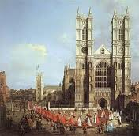 Westminster Abbey

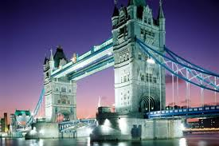 Tower Bridge

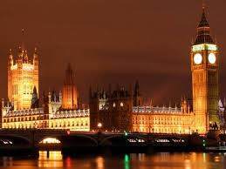 Big Ben
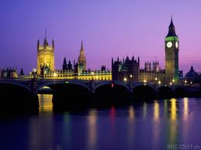 River Thames

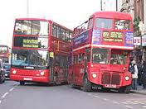 London Buses

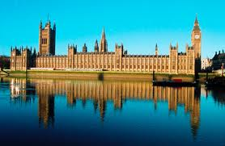 The Houses of Parliament

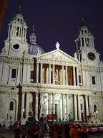 St. Paul’s Cathedral
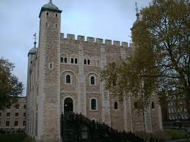 The Tower of London
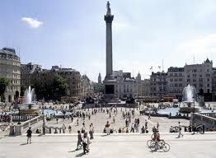 Trafalgar Square
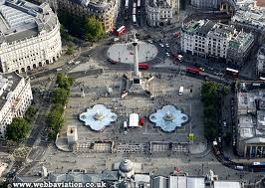

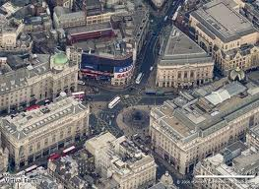 Piccadilly Circus

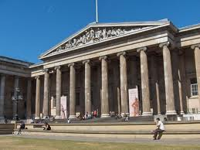 The British Museum

Додаток 2.
The map of Great Britain

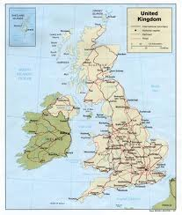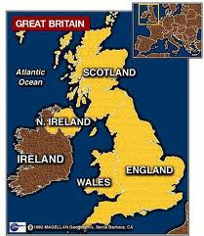

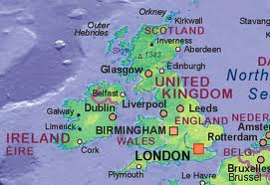

Додаток 3.

Imagine (by John Lennon)
Imagine there's no heaven
It's easy if you try
No hell below us
Above us only sky
Imagine all the people
Living for today...
Imagine there's no countries
It isn't hard to do
Nothing to kill or die for
And no religion too
Imagine all the people
Living life in peace...
You may say I'm a dreamer
But I'm not the only one
I hope someday you'll join us
And the world will be as one
Imagine no possessions
I wonder if you can
No need for greed or hunger
A brotherhood of man
Imagine all the people
Sharing all the world...
You may say I'm a dreamer
But I'm not the only one
I hope someday you'll join us
And the world will live as one

