Заліщицька державна гімназія

Комбінований урок

“Hobbies and Interests”

5 клас

Підготувала і провела
вчитель
англійської мови
Савчинська М.В.

2015 р.

Тема уроку: Хобі та інтереси

Мета: навчити учнів висловлювати думку щодо власних захоплень та інтересів своїх друзів; тренувати учнів у засвоєнні тематичної лексики; розвивати вміння діалогічного та монологічного висловлювання з теми, аудіювання; виховувати почуття поваги до інтересів та захоплень інших людей.

Тип уроку: комбінований

Обладнання та матеріали: інтерактивна дошка, аудіодиск, картки з малюнками.

Хід уроку

І. Організаційний момент.
1. Привітання. Введення в іншомовну атмосферу.
T: Good morning, dear children. Glad to see you. How are you?
P: Fine, thanks.
T: How is your mother?
P: She’s OK. Thank you.
T: How is your granny, Pavlo?
P: Thanks, she’s fine.
2. Мовна зарядка.
T: It’s a lovely day today, isn’t it? Do you like today’s weather?
P: Yes, I do. The weather is fine today. It’s frosty, but the sun is shining, the sky is blue. The air is so fresh.
P: And I don’t like such weather. It is winter but there is no snow in the yard. We can’t sledge, ski and play snowballs. I like winter and I like snow.
T: Do you know any poems about winter?
P: Yes, we do.
Winter time is full of light,
Winter time is big and bright,
Winter time is full of fun,
Winter time has lots of sun.
T: You are right. We can have a lot of fun in winter and in each season.
II. Основна частина уроку.
- Повідомлення теми та мети уроку.
T: Today we are going to speak about our hobbies and interests. You will learn how to speak about your hobbies and your friends’ hobbies, practise the new vocabulary; you will make dialogues and play games.
2. Перевірка домашнього завдання.
T: But first of all let’s check your hometask. Last time we spoke about our likes and dislikes. You had to make up some dialogues. Let’s act them out.
Dialogue 1.
P1: Do you like watching TV?
P2: Yes, I do. And you?
P1: Yes, I like watching TV.
P2: How often do you watch TV.
P1: Often.
Dialogue 2.
P3: Hello.
P4: Hello.
P3: Do you like listening to classical music?
P4: No, I don’t. Do you like listening to pop music?
P3: Yes, I do.
P4: How often do you listen to pop music?
P3: Sometimes.
Dialogue 3.
P5: Do you like pizza?
P6: Yes, I do.
P5: How often do you eat pizza?
P6: Sometimes.
Dialogue 4.
P7: Do you like playing football?
P8: Yes, I do.
P7: How often do you play this game?
P8: Often.
T: Very good.
3. Активізація лексики до теми.
T: Now look at the board. You see the words and word-expressions. Listen and repeat.
Watching TV
Reading
Playing computer games
Going out with friends
Listening to pop music
Going to the cinema
Playing chess
Collecting badges
Playing with cars
Making models
Drawing and painting
Playing the guitar
T: Ihor, read the words.
Pupils read the word-expressions.
4. Розвиток навиків діалогічного мовлення.
T: Look at the board. You see some questions on it. Let’s make dialogues with these questions.
T: What are your hobbies?
P: My hobbies are drawing, playing tennis and watching TV.
T: What is your favourite hobby?
P: My favourite hobby is playing tennis.
T: Do you like listening to music?
P: Yes, I do.
T: Do you like reading?
P: Yes, I do.
T: Do you like going to the cinema?
P: Yes, I do.
Pupils act out the dialogues.
5. Розвиток навиків аудіювання.
T: Do you want to know what hobbies the children from English-speaking countries have? You are going to listen to four children talking about their hobbies and interests. Look at the pictures. What are the children’ names?
P: Meg, Freddy, Layla and Tim.
T: So, listen to the children and then write their favourite hobbies or interests in the table.
Pupils listen and write the hobbies on the board.
T: Well done, children. But you must be tired. Let’s do some exercises.
Фізкультхвилинка. Виконання спортивних вправ під сучасну музику.
Hands up! Hands down! And jump, jump, jump!
Turn left! Turn right! And jump, jump, jump!
Put your hands into the air! And dance, dance, dance!
6. Закріплення вивченого матеріалу.
T: Now let’s play a little. You are going to see some pictures on the board. You have to write the appropriate word near each picture.
Pupils go to the board one by one and write the words and word-expressions on the board.
7. Давайте пограємо.
T: Look at me, children. I have a bag in my hands. There are some objects in the bag concerning our topic. Take one object from the bag and ask your partner if he or she likes doing this or that. For example, you take a pencil and ask: Do you like drawing? Your partner answers the question.
III. Підведення підсумків уроку.
T: You have worked a lot today. You can already speak on the topic “Hobbies and interests”. You learned a lot of words on this topic. You can ask questions about the hobbies of your friends and answer them. You’ve got the marks today.
IV. Домашнє завдання.
T: Your hometask for the next time is to do Exercises 1,2,3 on page 28 in the Workbook. You have to write answers to the questions in ex. 1, write which hobbies you like and which hobbies you don’t like in ex.2 and write true sentences about you and your interests in ex. 3.

Додаток 1.
A list of the questions to the topic “Hobbies and Interests”
- What are your hobbies?
- What’s your favourite hobby?
- Do you like listening to music?
- Do you like reading?
- Do you like going to the cinema?
- Do you like going out with the friends?
- Do you like playing with cars?
- Do you like drawing and painting?
- Do you like playing the guitar?
- Do you like playing computer games?
- Do you like watching TV?

Додаток 2.
Tapescript.
Meg: Hello! My name’s Meg. I’m ten and I live in London, in England. Well, I have a lot of hobbies. I like making models and playing the guitar, but my favourite is drawing. I like drawing very much.
Freddy: Hi! Freddy here, from Toronto, in Canada. I love going to the cinema, and reading, er but my favourite hobby is playing computer games. I’ve got a great computer at home.
Layla: Hi! I’m Layla. I’m from New York City, in the USA. Well, some of my friends like reading and painting. Not me. My favourite hobby is shopping! I love shopping malls, ohh, they’re terrific. Here in the States…
Tim: Hello. My name’s Tim. I’m eleven and I’m from Wellington, New Zealand. My favourite hobby is going to the cinema. I love action films. My favourite actor is Stallone – I go to see all his films.

Додаток 3.
Pictures and word-expressions.
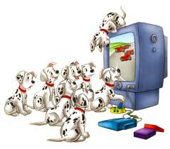watching TV

reading
playing computer games
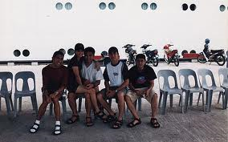going out with friends
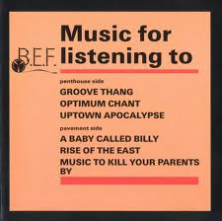listening to pop music
going to the cinema
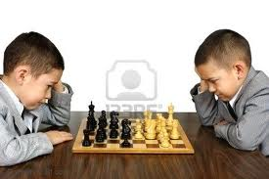playing chess
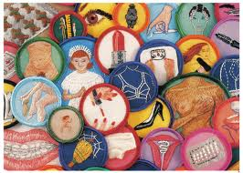collecting badges
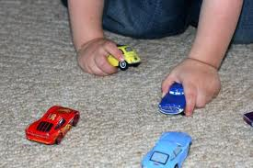playing with cars
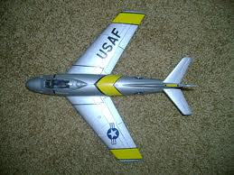 making models
drawing and painting
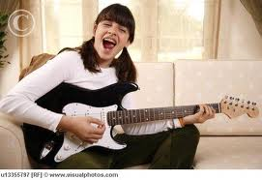 playing the guitar

