Заліщицька державна гімназія

План-конспект уроку

“The Food We Eat”

5 клас

Підготувала і провела
вчитель
англійської мови
Савчинська М.В.

2011 р.

Тема уроку: The Food We Eat

Мета: закріпити знання учнів лексики до теми «Їжа і напої»; перевірити засвоєння вивченого матеріалу; тренувати учнів у використанні засвоєної тематичної лексики; розвивати вміння діалогічного та монологічного висловлювання з теми, читання, аудіювання; виховувати правила поведінки в магазині та за столом.

Тип уроку: Урок узагальнення і систематизації знань

Обладнання та матеріали: інтерактивна дошка, аудіодиск, картки з малюнками.

Хід уроку

І. Організаційний момент.
1. Привітання.
T: Good morning, children. I’m glad to see you. We have a lovely day today. The winter has come at last. It is snowing. The sun is shining and it is frosty. I’m sure, you are good today, aren’t you?
Ps: Yes, we are.
P1: I’m so happy today. My mom has birthday today and we can go skating and making snowman in the yard.
T: Do you like winter?
P2: Yes, I do. I like winter very much. We can sledge, ski, skate in winter.
P3: We can play snowballs with our friends.
P4: The nature is beautiful in winter, everything is like in a fairy-tale.
T: Very good, children. You are right, winter is a wonderful season.
2. Введення в іншомовну атмосферу.
T: You know that our topic is Food, and at the beginning of our lesson I want you to do such a task. Look at the board. You see different products which you have bought in the market and a shopping list. Read the shopping list and say what you forgot to buy and what you have extra.
I have extra… I forgot to buy…
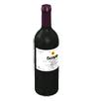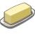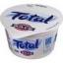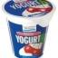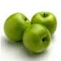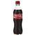

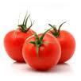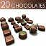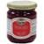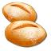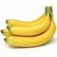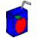

- eggs
- honey
- bread
- cherry yogurt
- a bottle of wine
- butter
- jam
- coffee
- cheese
- a pack of rice
- 4 apples

P1: I have extra: yogurt, a bottle of cola, three tomatoes and chocolate.
T: Good. What else do you have extra?
P2: I have bananas and juice. And I had to buy one loaf of bread, but I bought two.
T: Well done. What did you forget to buy?
P3: I forgot to buy eggs, honey, coffee, cheese and rice.
II. Основна частина уроку.
1. Повідомлення теми і мети уроку.
T: Today we are going to speak about the food we like. You will talk about what you like to eat and drink and what you don’t like to eat and drink. We’ll review the vocabulary and grammar material. You will read and listen to children talking about the food.
2. Перевірка домашнього завдання.
T: Your homework for today was to write and talk about what you like to eat and drink and what you don’t like to eat and drink. There is a writing guide in your textbooks to help you. I want to hear your compositions.
P1: I like potatoes and pasta. I often eat eggs too. I always drink fruit juice. I don’t like rice or cola. I never eat fish and never drink milk. My favourite food is pizza with chicken and my favourite drink is apple juice.
Pupils retell their compositions about food and drink.
3. Повторення і закріплення граматичного матеріалу.
T: In this unit we spoke about countable and uncountable nouns and the use of some/any, how much/how many. Let’s review the material. Look at the board. You have to complete the dialogues using some/any, how much/how many.
Some/any
Boy: Let’s make some chocolate cake.
Girl: OK. Good idea! Is there _______ flour?
Boy: Yes, there’s _________ in the cupboard.
Girl: Is there ________ sugar?
Boy: No, there isn’t _______ sugar.
Girl: But there’s ________ honey.
Are there ________ eggs?
Boy: No, there aren’t ________ eggs.
But there are _______ chocolate chips and there’s ________ butter.
Girl: Well, let’s make ________ biscuits!
How much/how many
A: ________ sugar do you need?
B: 3 kilos.
A: ________ water would you like?
B: 1 bottle.
A: ________ apples does your child eat a day?
B: 3 apples.
A: ________ beer do you want to buy?
B: 6 cans.
A: ________ eggs do you need to make a cake?
B: 10 eggs.
T: Go to the board one by one and complete the dialogues correctly.
4. Повторення лексичного матеріалу.
T: Dear children, we have learned a lot of new words on the topic Food and Drink. I’d like to know if you’ve remembered them. We shall read a text with some images instead of the words. You have to change them into words.
My favourite food is 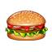 and 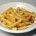 . But on Sundays my mother cooks 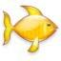 for lunch. We eat it with 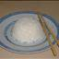 and 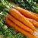. Then we usually have

some 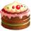. Sometimes we eat or for dinner. And we often eat
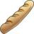 and 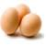 for breakfast. I eat a lot of 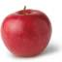 but I don’t like 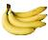.

T: Well done, children. I see you know the vocabulary and you can use it in your speaking. But now we must have a rest. Let’s do some exercises.
Фізкультхвилинка.
Hands up! Hands down! And jump, jump, jump!
Turn left! Turn right! And jump, jump, jump!
Put your hands into the air! And dance, dance, dance!
5. Розвиток навиків аудіювання.
T: And now, children, you are going to listen to two children talking about food. Look at the picture. What are the names of the children? (Helen and Paul). You have to listen and complete the notes on the board. Let’s read the notes first of all.
- Paul hates bananas.
- Paul never eats hamburgers.
- Helen loves chicken.
- Paul eats a lot of chocolate.
- Paul and Helen love biscuits.
- Paul’s favourite food is pasta.
- Helen’s favourite drink is orange juice.
6. Розвиток навиків діалогічного мовлення.
T: We shall speak now a little. I have some cards with the pictures of food and drinks on them. You are going to choose a card and ask your partner if s/he likes eating or drinking that and how often they eat that food or drink those drinks.
P1: Do you like fish?
P2: Yes, I do. I love it.
P1: How often do you have fish?
P2: I eat fish once a week.
7. Song “Tropical paradise”
T: You’ve worked well today and I’ve prepared a song for you. You are going to listen to it and complete it using the words in the box.
III. Заключна частина уроку.
1. Підведення підсумків.
T: You were very good today. You worked a lot. You were speaking, reading, listening, writing. I am sure you’ve remembered the vocabulary on the topic The Food We Eat and you are able to use it in real life. You have got such marks today.
2. Homework.
T: Your homework for the next time is to be ready for the test. Review grammar material: countable/uncountable nouns – Ex.1, p.44 in Workbook; some/any, much/many – Ex. 3, 4, p.44 in Workbook; Vocabulary – Ex. 5, p. 44 in Workbook.

Додаток 1
Tapescript
Helen Mm. They look good. Do you like bananas, Paul?
Paul Bananas? No, ugh. I hate them. They’re horrible.
[PAUSE]
Helen I like hamburgers. Do you eat hamburgers, Paul? I often eat them.
Paul Oh, no, I never eat hamburgers. I don’t like them.
[PAUSE]
Helen What about chicken? I love chicken.
Paul Mm, I sometimes eat chicken.
[PAUSE]
Helen Mm. Chocolate. Do you like chocolate?
Paul Oh, it’s great. I eat a lot of chocolate. It’s fabulous. I like chocolate milk, chocolate cake, chocolate sweets, chocolate…
[PAUSE]
Helen They look great. I love biscuits.
Paul Mm, I love biscuits too! I want some now!
[PAUSE]
Helen What’s your favourite food? My favourite food is fish.
Paul Fish? Oh no! My favourite food is pasta. It’s great. I love spaghetti.
Helen Pasta? I think it’s horrible!
[PAUSE]
Paul What’s your favourite drink, Helen?
Helen Orange juice. What’s your favourite?
Paul Milk.
Helen Oh, Paul! It’s horrible!

Додаток 2.
Cards with food and drinks

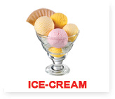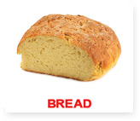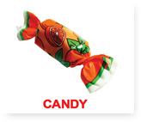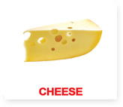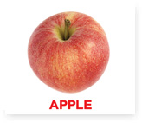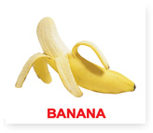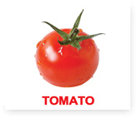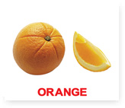
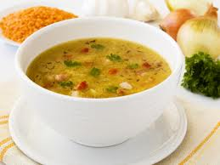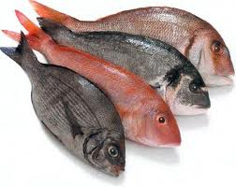
Soup fish
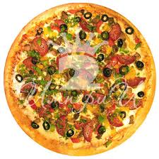pizza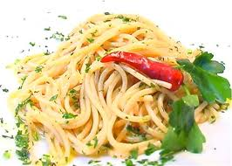spaghetti
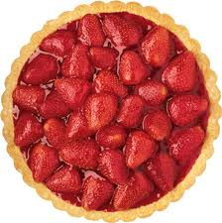pie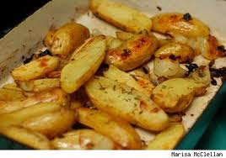potato
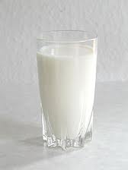milk 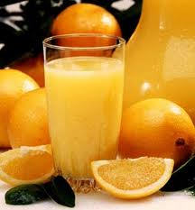 orange juice
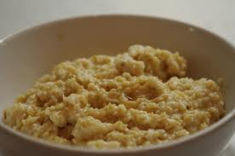porridge

Додаток 3.
Song Tropical paradise
There are coconuts and mangoes.
There is every kind of spice.
There are pineapples and bananas
In our tropical paradise.
There are red peppers and chicken.
There is fresh fish and rice.
There are barbecues beside the sea
In our tropical paradise.
Is there any cool water?
Are there any drinks with ice?
Yes, there is everything
In our tropical paradise.

