Заліщицька державна гімназія

Комбінований урок

“Clothes. What do I wear?”

5 клас

Підготувала і провела
вчитель
англійської мови
Савчинська М.В.

2013 р.

Тема уроку: Одяг. Що я люблю одягати?

Мета: розширити словниковий запас на тему «Одяг»; навчати розповідати про те, у що одягнені люди, про свій улюблений одяг; розвивати навички діалогічного і монологічного мовлення, аудіювання, читання, письма; виховувати естетичні смаки в одязі.

Тип уроку: комбінований

Обладнання та матеріали: інтерактивна дошка, аудіодиск, картки з малюнками, Cambridge I-Dictionary.

Vocabulary: trainers, skirt, coat, tie, jeans, shoes, hat, gloves, sweatshirt, trousers, jacket, blouse.

Хід уроку

І. Організаційний момент.
Warming-up
Привітання. Введення в іншомовну атмосферу.
T: Good morning, dear children. Glad to see you. How are you?
P: Fine, thanks.
T: How is your mother?
P: She’s OK. Thank you.
T: How is your granny, Nastya?
P: Thanks, she’s fine.
2. Мовна зарядка. Активізація лексики (кольори)
T: Do you remember the words denoting colours? Can you answer my questions?
What colour is your book?
P: It’s blue.
T: What colour is your bag?
P: It’s green and blue.
T: What colour are the walls in the classroom?
P: They are yellow.
T: What colour is the door?
P: It’s white.
T: Very well. Look at the board. There’s a chant there. Let’s say it together. Say it and show the things of this or that colour.
Chant:
Show me something red, red!
Here is something red, red!
Show me something blue, blue!
Here is something blue, blue!
Show me something green, green!
Here is something green, green!
Show me something yellow too!
Here is something yellow too!

II. Основна частина уроку.
- Повідомлення теми та мети уроку.
T: We’re going to talk about clothes today. Our topic is “The clothes I like”. You will learn more words on this topic. We’ll describe people’s clothes. Besides, you will talk about the clothes you like to wear at home and at school, about your favourite colours. So, you will speak, read, listen and write today.
2. Активізація лексики до теми.
T: At home you had to do exercise 1 on page 64. You had to match the clothes with the words in the box. So, let’s check. Listen, check and repeat the words.
Tie
Trousers
Shoes
Coat
Blouse
Skirt
Hat
Sweatshirt
Trainers
Jacket
Gloves
Jeans
Read out the words.
T: Well done, children. Let’s work with the pictures now. Look at the picture of Nina Clark, her parents and brother in your books. I will show you a picture with ah item of clothing, and your task is to say who’s wearing it:
e.g. hat: Nina’s wearing a hat.
tie: Mr Clark’s wearing a tie.
coat: Mrs Clark is wearing a coat.
3. Розвиток навиків діалогічного мовлення.
T: Usually when we talk about clothes we say the colour, and to give more details about colours we use the words light and dark. For example, look at the pictures on the board and read the sentences:
Emma’s trousers are dark blue.
David’s trousers are light blue.
Let’s ask and answer about the clothes in the picture. Tell me please:
What colour is Mr Clark’s tie? – It’s red.
What colour are his shoes? – They’re black.
Work in pairs. Ask and answer with your partner about the colour of the people’s clothes.
T: Look at the board you can see some statements on it. All of them are false. You have to correct them as in the example.
Pupils correct the statements.
1. Nina is wearing a green sweatshirt.
2. Nina and Matt are wearing white trainers.
3. Mrs Clark is wearing a black skirt.
4. Mr and Mrs Clark are wearing black shoes.
5. Matt is wearing a grey jacket.
6. Nina is wearing a purple hat.
4. Game “Help a mouse”.
We’re going to play now. You will see some funny mice on the board. They need your help. You have to give them the clothes they need. Are you ready to help them? Let’s do it. (Cambridge I-Dictionary)
5. Розвиток навиків читання
I think each of us has his or her favourite clothes. Am I right? E.g. My favourite clothes are trousers, sweatshirts and trainers. Look at the picture of the boy on the board. His name is Martin. What do you think: What clothes does he like wearing? (T-shirts, sweatshirts, jeans). OK. We’re going to read a text about his clothes. But you task is not only to read but to change the pictures into the words.
My Clothes
I like 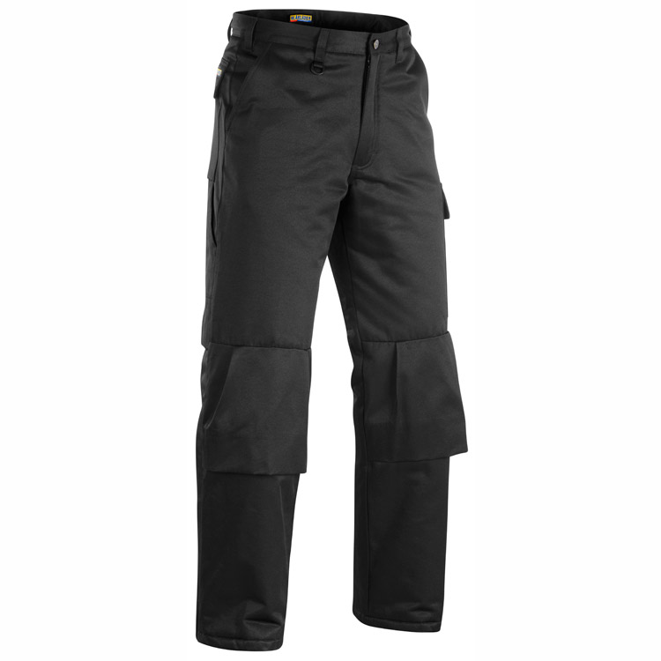 and 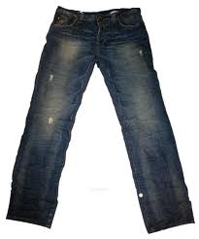 . I don’t like shirts,
but I like T-shirts and 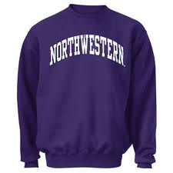 .
I also like baseball caps. My favourite colours are blue and red. At school I usually wear my black or blue ,
and a 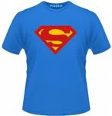 or sweatshirt.
At the moment I’m wearing blue , and a red and blue .
T: Well done, children. So, which clothe does he like?
P: He likes trousers and jeans. He likes T-shirts and sweatshirts.
T: Which clothes doesn’t he like?
P: He doesn’t like shirts. He doesn’t like his black shoes.
T: What is he wearing now?
P: He’s wearing blue jeans, a red and blue sweatshirt and trainers.
Physical exercises.
You are working a lot today and you must be tired already. Let’s move a little. Listen to the song, look at the funny mice and repeat their movements.
6. Розвиток навиків аудіювання.
T: So, you know which clothes Martin likes. Now you’re going to listen to four speakers talking about their favourite clothes. Your task is to match the speakers with the sentences A-D. Let’s read the sentences first.
A: This person loves wearing jeans.
B: This person likes trainers.
C: This person doesn’t like hats.
D: This person doesn’t like blouses.
Answers: A-3, B-4, C-2, D-1.
6. Розвиток навиків діалогічного мовлення і письма.
T: Very well. So, you know which clothes those children like. And which clothes do you like? Which clothes don’t you like. Let’s talk about your favourite clothes.
- Do you like blouses?
- Yes, I do. / No, I don’t.
- Which clothes do you like?
- I like jeans, trousers and t-shirts.
- Which clothes don’t you like?
- I don’t like shirts and ties.
- What are your favourite colours?
- My favourite colours are blue and white.
T: So, you task is to make up dialogues, write them down in your copy-books and then act them out. Start working. Raise your hands when you’re ready.
III. Підведення підсумків уроку.
T: You have worked a lot today. You can already speak on the topic “Clothes”. You learned a lot of words on this topic. You can ask questions about the clothes of your friends and answer their questions. You’ve got good marks today.
IV. Домашнє завдання.
T: Your homework for the next time is to do Exercises 6 on page 66 in the Student’s Book. You have to write about your clothes using the writing guide to help you.

Додаток 1.
Tapescript.
Speaker 1.
Julie: Blouses? Ugh! I don’t like blouses. I never wear them. They’re horrible. But sweatshirts are OK. I like sweatshirts. And I always wear T-shirts. T-shirts are cool!
Speaker 2.
Marco: Well, I like clothes! I really like baseball caps. They’re really, really good. But I don’t like hats. Hats are so boring.
Speaker 3.
Mandy: Mm, yes, well. My friend loves skirts, but I don’t like them. I really love jeans. They’re great. Skirts, ugh! No thanks. But jeans are brilliant.
Speaker 4.
Neil: I like trainers. I always wear trainers. But I hate shoes. They’re awful, No shoes! Not for me!

Додаток 2.
Pictures: The clothes I like.
