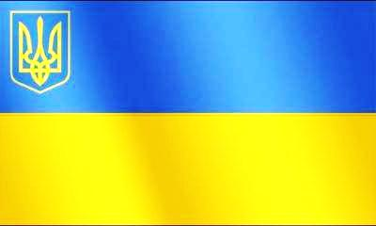
Poems about our native land “ Ukraine”.
P1: Blue sky and yellow field of grain
Is on the flag of my Ukraine.
It’s emblem speaks to all the world
With Freedom – such a lovely word.
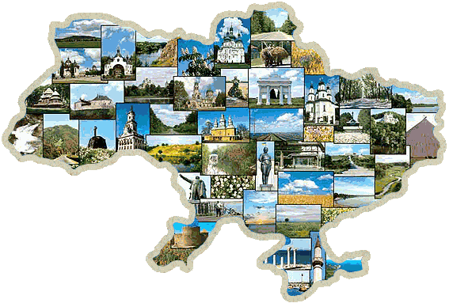
P2: Bread-salt will give to a friendly guest
Ukrainian people without request.
They work and sing the song of praise
To God who’s able from ash to raise.
P3: Ukraine rejoices in the Lord
Reviving from His mighty
Word Forever lives who’s born again.
Lord live and pray, my land Ukraine!
P4: “Love Ukraine, like sun that you love
Like wind, like grass, and like water,
Whenever you're happy, in moments of gladness,
At times of trouble, do love.
P5: “Love Ukraine, like sun that you love
Like wind, like grass, and like water,
Whenever you're happy, in moments of gladness,
At times of trouble, do love.
P6: My native land, the land of wonders,
Of autumn rains, and summer thunders.
The greenest hills and magic lakes,
The tender breeze, romantic land.
Amazing land – my dear Ukraine.

Imagine our country being a sunflower. What will be the petals ?
Holidays
Ukraine
People
Language
Symbols

History
Cities
Customs

Now let’s stop at each petal and describe it.

Vocabulary
a) Fill in the correct word from the box
countries, borders, washed by, flat, mild

1) Ukraine is one of the largest ___ of Eastern Europe.
2) Ukraine ___ on Russia, Belorus, Moldova, Poland, Slovakia, Hungary, Romania.
3) It is ___ the Black Sea and the Sea of Azov.
4) The major part of Ukraine is ___ .
5) The climate is ___ and soft.
b) Fill in the words from the box and make up sentences with them.
cover, whole, mountainous, variety, animal, main, flora, inhabit

1) to ___ an area
2) the ___ territory
3) ___ areas
4) ___ of plant species
5) ___ life
6) ___ river
7) ___ of Ukraine
8) to ___ our country

Post-listening. Multiple Choice Questions.
1.Cossacks were … .
a) dependent people
b) Free people
2. The main idea of Zaporizhian Cossacks was … .
a) to be independent
b) to work for their masters
3. Cossacks called their leader … .
a) tsar
b) koshovyi otaman
4. Ivan Sirko … .
a) broke up Zaporizhian Sich
b) won many victories
5. Cossacks fought for … .
a) independence of their native land
b) Russian Empress
6. Cossacks were men who loved … .
a) freedom and independence
b) their masters

Kyiv- the capital of Ukraine

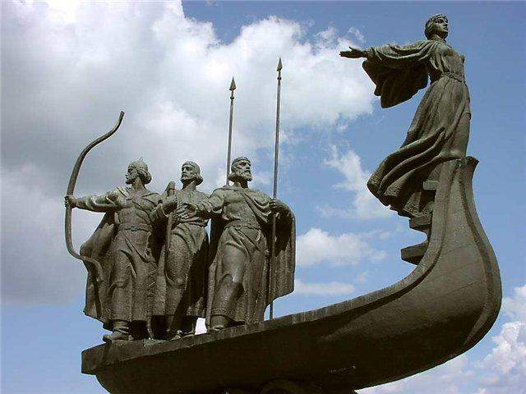
Read the text. Match the titles with the passages.

1. The historical monuments of Kyiv.

2. The geographical position.

3. Kyiv is the centre of education and culture.

4. The foundation of the capital.

5. The central street of the city.

A. Kyiv is the capital of Ukraine. It is one of the most beautiful and oldest cities in
Europe. The city is situated on the picturesque banks of the Dnipro river.
Kyiv is a large political , industrial, scientific and cultural centre.
Its population is about three million people.
B. There is a legend about its founding. Once there were three brothers named
Kyi, Shchek and Khoryv, and they had a young sister named Lybid. Kyiv was
named after the eldest brother Kyi, two hills were named Shchekavytsa and
Khorevytsa after the other two brothers – Shchek and Khoryv. A narrow river
was named Lybid after the sister. In the 11th century, Kyiv became the capital
of a strong Slavonic State – Kyivan Rus .
C. Kyiv is about 1,500 years old. Today it is one of the greatest ancient European
cities, rich with the monuments of art and architecture. Among them are the
Kyivo-Pecherska Lavra, the Golden Gate, St. Sophia’s Cathedral and the
monuments to Prince Volodymyr, Bohdan Khmelnytskyi and T. Shevchenko.
D. Khreshchatyk is the central street of the capital. It is one of the finest streets of the
city. The traffic is very heavy in it. A constant stream of buses and cars runs along the
main street of the city.
E. There are many research institutes in Kyiv and the Academy of Sciences is located
there. There are a lot of libraries in our capital. They have millions of books,
magazines and newspapers. The museums and art galleries make our capital a
world cultural centre. The famous T. Shevchenko Opera and Ballet Theatre and the I.
Franko Ukrainian Drama Theatre are visited by many residents and guests of
Kyiv.

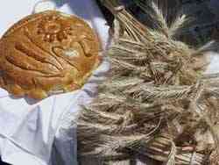
Ukraine is a wonderful country with rich culture and interesting traditions. Ukrainians pay great attention to observing holidays. They try to keep all traditions and customs. Ukrainian people are kind, hospitable and friendly. They respect old people, love children, nature and animals. Home is a real wonder for them. Ukrainians are musical, artistic and wonderful craftsmen. They are hard-working.
Ukrainians respect bread. They meet their guests with bread and salt on the embroidered towel. Bread is one of the holiest foods. Ukrainian people celebrate Christmas, Easter, New Year, Ivana Kupala, St. Nicholas Day. They like to go to the church.
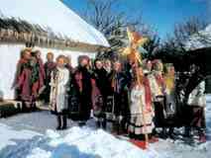
Our traditional symbols are straw didukh, decorated pysanka, holy water, and traditional dishes like kutia, paskha, varenyky, borsch and pampushky. Our people are famous for their folk dances, carols, fortune telling and blessing with water.
Numerous folk songs (schedrivky, kolyadky, vesnyanky) accompanied by the charming music of national instruments (bandura, sopilka, tsymbala, buben) and folk dances (hopak, kozachok) are an integral part of family and folk holidays.
Ukrainian people keep their customs and traditions and are proud of them.

1.Answer the questions:
1. What kind of country is Ukraine?
2. What kind of people are Ukrainians?
3. Do they respect bread?
4. What holidays do we celebrate?
5. What are traditional symbols of Ukrainian people?
6. Are Ukrainian people famous for their songs and dances?
7. Ukrainian people keep their customs and traditions, don’t they?

