Environmental Protection
The Objectives.

Practical: - to extend and refresh students’ knowledge of the vocabulary on the
topic “ Environmental Protection”;
- to develop speaking skills, practising the material of the lesson in
the natural way;
- to improve listening and reading skills.

Developing: - to develop students’ attention, memory and criticalthinking;
- to promote students’ curiosity; to develop creative skills;
- to motivate students’ spontaneous speech.

Upbringing: - to widen the pupils’ knowledge about ecological situation on the

Earth in Ukraine and in the native village;

- to cultivate in pupils a sense of responsibility for their actions,

adherence to an active civic position;

- to educate a good attitude towards the nature.

Equipment and visual aids.
- pictures of nature;
- the map of the World;
- a tape-recorder, a computer;
- pupils’ projects, the globe.
Lesson Plan

I. Introduction
1. Greeting . Prayer for Earth (1 min)
2. Poem ( 2 min)
2. Warming-up (2 min)
II. The main part of the lesson
1. Vocabulary(4 min)
2. Listening (3 min)
3. Speaking. Brainstorming (3min)
4. Watching the video “Types of Pollution” (2 min)
5. Spider map (1 min)
6. Group work(3 min)
7. Relaxation period : Quiz “Are you a nature-lover?” (2 min)
8. Project work (6 min)
9.Pupils’ interview ( “Microphone”)

III. The end of the lesson

1. Home task (1 min)
2. Evaluation (1min)
3. Summing up (2 min)

Procedure
I. Introduction.
1. Prayer. . (1 min)
Our Father, who art in heaven, hallowed be Thy name. Thy kingdom come. Thy will be done on earth as it is heaven. Give us this day our daily bread; and forgive us our trespasses as we forgive those who trespass against us. And lead us not into temptation, but deliver us from evil.
2. Poem (1 min)
“What have they done to the world?”
T: What have they done to the seas, my friends?
What have they done to the seas?
What have they done to the rivers, my friends?
What have they done to the trees?
What have they done to our land, my friends?
This land which is ours from our birth.
What have they done to our forests, my friends?
What have they done to the Earth?
What have they done to the skies, my friends?
Skies that are blue and so clear.
What have they done to the skies, my friends?
What have they done to the air?
Good morning, dear pupils,! I am very glad to see you. Welcome to our home, Planet Earth! As you can guess,the topic of our lesson is “Environmental protection”. Today we’ll speak about the ecological problems out Planet faces, the main factors of the pollution, about the ways of solving these problems. We’ll widen our knowledge about ecological situation in Ukraine and in our native village. You know if we are active participants in the protection of our environment, we’ll help our Planet survive and keep it healthy for future generations. Today you’ll present your own projects on the topic. We’ll work together at our lesson and I’m sure that our work will be interesting and fruitful.
3. Warming up. (2 min)
T. Dear pupils! I would like to sound the motto of our lesson: “Our world is a nice place and it’s worth fighting for”. I like these words of the great English writer Ernest Hemingway. They are so urgent nowadays. How do you understand this phrase? (Pupils give their own explanations.)
P1. Our Planet is our home and we must take care of it. We must help our Planet Earth survive.
P2. We must save our Planet for all people, for all leaving creatures, for future generations.
P3. We, young people, understand our great role in solving ecological problems because everybody wants to see our Planet clean and beautiful.
P4. Our Planet Earth is only a tiny part of the universe, but nowadays it’s the only place we can live.
T: What state document reminds us about environmental protection?
P1. It’s article 67 of our Constitution. It reads: “Citizens of Ukraine are obliged to protect nature and conserve its riches”.
P2. New laws and decisions are adopted every year. Their aim is to protect the atmosphere from pollution, protect the country’s land resources, control the use of water resources, save plants, animals and birds.
T: Children! You know April 22 is a special day around the world. On this day all people of our planet celebrate Earth Day. It’s a time when people show that they take care of our planet. It’s a day for people to learn what they can do to preserve the Earth. Can you tell me what you do on this day?
(Pupils tell about their activities on this day.)
P1. We work on our school plots digging the soil
P2. We rake the leaves and hang bird-houses.
P3. We plant new trees and bushes.
T. Good for you, my dear children. I really see that you take care of our environment.
II. The main part of the lesson
1. Vocabulary (4 min)
Let’s see what words we shall use during the lesson. Some of them are known for you and some are not.
Pollution – the contamination of the environment by substances harmful to living creations.
Recycle – make new things from different kinds of litter.
Litter, trash, waste, rubbish, garbage - things that you throw away, such as empty bottles, used papers, food that has gone bad etc.
Rainforest – rich woodland which occurs in warm climate and high rainfalls regions. Destroy - to damage something so badly that it no longer exists or cannot be used or repaired.
Poacher – a man who kills animals illegally.
Distress - a situation when smth is in danger and needs help.
Deforestation- the cutting or burning down of all the trees in an area.
T.Do you know the difference? In pairs match the word with its definition:
1) Garbage | a) Something in a crumbled or broken condition
2) Litter | b) An unwanted by-product of a manufacturing process
3) Rubbish | c) Food waste, discarded or useless material
4) Trash | d) An untidy accumulation of objects lying about
5) Waste | e) Useless or rejected matter

Key: 1 c, 2 d, 3 e, 4 a, 5 b.
T.Choose one word to best complete the sentences.
1) I don’t like their house — it’s always full of __ (Rubbish)
2) The main problem of ecology today is thousands of tons of industrial __ (Waste)
3) She always leaves a lot of __ in the kitchen. (Garbage)
4) In Singapore a person throwing __ on the road may be put to prison. (Litter)
5) Sometimes it seems that __ accumulates itself. (Trash)
2.Listening(2 min)
T.: -Students , representatives of Greenpeace have brought a message from the Earth. Listen to it, please.
"Dear boys and girls,
Take care of me. I'm ill. My water is polluted. The air is dirty. Don't cut down the forests . Plant a tree a year. Don't kill animals and birds.
They may all disappear.
Never throw or break glass bottles. You pollute the land. Take what you need from me. You are my parts.
So, keep me clean and healthy for future generations,
Love, your Earth".
After listening activities.
T.: - Children, please, mark what should and what shouldn't we do about the Earth.
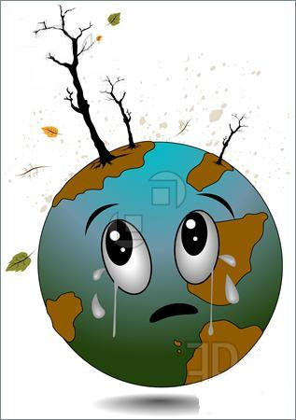

should shouldn't
1) Cut down the forests.
2) Plant a tree a year.
3) Throw or break glass bottles.
4) Pollute the land.
5) Kill animals and birds.
6) Keep the Earth clean and healthy.
3.Speaking. Brainstorming(2 min)
Teacher: From this letter we see that our Earth has a lot of problems.
Teacher: With the development of the civilization man's interference in nature began to increase and now our planet is in danger. What problems do we have now? Can you prompt me?
P1 - Air pollution
P2 - Water pollution
P3 - Global warming
P4 - Trash (garbage)
P5 - Cruelty to animals
P6 - Nuclear pollution
P7 - Smoking
P8 - Unhealthy food
P9 - Wars
P10 - Cutting down the trees
(Pupils name ecological problems and stick pieces of paper with these problems on the globe.)
4. Watching the video “Types of pollution”(2 min)
5. Spider map (1 min)
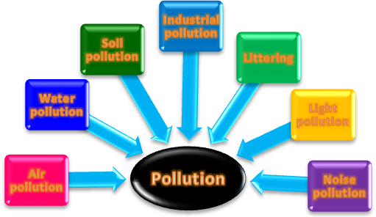
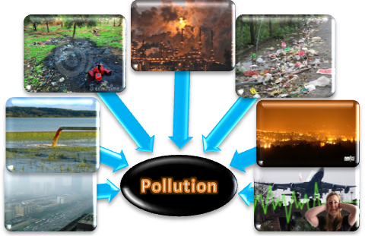
T: Pollution is one of the most serious problems of our environment. Our planet suffers from different kinds of pollutions. After watching the video look at the screen and name some of them.
Use pictures to activate your brain. (Pupils name kinds of pollution according to the pictures .
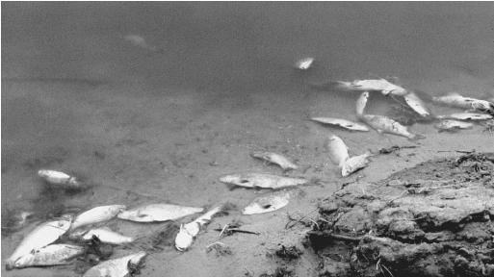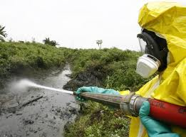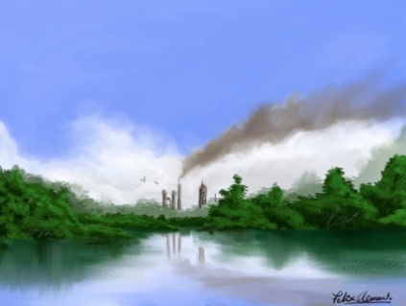
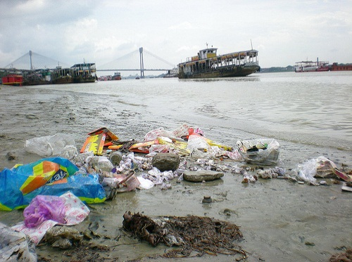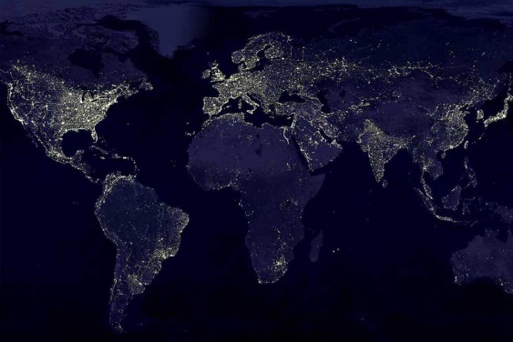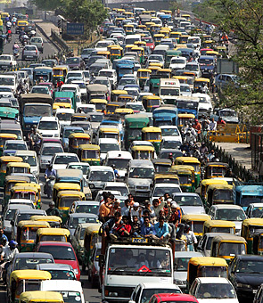
6. Group work(3 min)

T:Put the activities below into the appropriate pollution groups.
Air pollution —
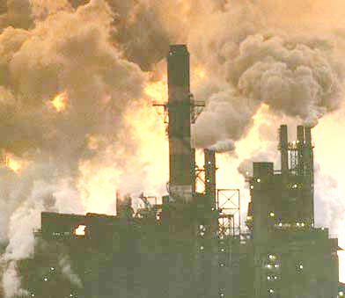
Water pollution —
Soil pollution —
Noise pollution —

• burying waste or household trash
• cutting forests
• rock concerts
• car exhaust fumes
• hyperactive fishing
• oil spilt in oceans
• headphones
• no change footwear in schools
• poaching
• airport noise
• smoking
• burning leaves in spring and autumn
• littering and spitting in the schools, streets, and woods
The groups inform the results.
T. Children! What causes these problems? Please, tell me.The first group ,you are welcome.
(Pupils give their own answers.)
P1. It’s a scientific and technological progress.
P2. If we speak about Ukraine, it’s Chernobyl explosion, of course.
P3. To my mind, it’s nuclear waste.
P4. Unfortunately, these are chemical weapons.
P5. It’s a waste of minerals.
P6. Cars, of course.
P7. I think these are deforestations.
T: Can you tell me what they result in? The floor is given to the second group .
(Pupils answer.)
P1. People’s health is damaged.
P2. We can observe great changes in weather patterns (global warming).
P3. As a result, we have annihilation of plants, animals and birds.
T: It’s a pity that we have such problems. We must solve them.All these problems are the result of man's careless treatment of nature, aren't they? There are many places on our planet which need immediate help and of course people must do everything possible to save our planet.
Now we shall do the quiz: “Are you a nature-lover?”
7. Relaxation(2 min)
“Are you a nature-lover?”
Read the questions and mark the answer that is close to you.
1) If someone asks you to plant a tree in your schoolyard or in front of your house, do you agree to do it?
a) With pleasure. Trees make our streets more beautiful.
b) I’m not sure that I can do it on my own, but I’m ready to help.
c) Sorry, but I’m too young for it.
2) When you go for a walk to the forest or to the park, do you pick up flowers?
a) I ask grown-ups if I may do it.
b) Yes, I do, but not many — three or five.
c) Yes, I always pick up flowers. Anyway, new ones will grow up.
3) What do you do with a candy / ice-cream wrapper?
a) I always throw it in the litter-bin. If I don’t see it around, I put it in my bag.
b) I always try to find a litter-bin. But if there isn’t one around, I just throw it on the ground.
c) I just drop it anywhere. What are yard-keepers for then?
4) Do you throw away your old exercise-books if there are blank pages left?
a) No, I don’t throw them away but use them for my notes or drawings.
b) It depends on how many pages are left.
c) Yes, the greatest pleasure is to start writing in a new exercise book.
Add up you’re A, D and C scores.
If you get mostly:
As - The Green Peace will send you a thank-you letter.
Bs - You have to take more care of nature. We all are parts of it.
Cs - Such people destroy nature, don’t they?
8. Checking up homework. Presentation and defence of pupils’ project works
(6 min)
T: You had a task in groups to watch and find out the sources of water and air pollution in Probizhna. Please, be active. Who wants to be the first?
Pupil 1: Our group worked at the problem of air pollution. We have taken some photos. Now let's look at them.As you see, many people dump waste into the atmosphere along the roads. They pollute the air we breath.
Pupil 2: Cars and buses put a lot of smoke into the air. There are too many cars nowadays.They do a lot of harm to our village atmosphere and ruin the beauty of the countryside.
Pupil 3: I'd like to add the railways are also one of the sources of pollution, especially locomotives. One locomotive exausts as much harmful waste into the air as 40 or 50 cars.
Pupil 4: You know that railway transport throws out into the atmosphere 300 kinds of harmful substances which change the structure of air. It's very dangerous for the health of people.
Pupil 5: Some people's activities do a lot of harm to forests and trees. They are cut down. Their disappearance upsets the oxygen balance. As a result some rare species of animals , birds and plants disappear forever.
Pupil 6: But trees disappear not only because of it. Every day we waste tons of paper made from wood.
Pupil 7: One more source of air pollution. We produce carbon dioxide when we burn things. Trees take this gas from the air and produce oxygen. There are fewer trees and of course, more dioxide.
Teacher: Thank you. Now let's listen to the second group.
Pupil 1: Our group has worked at the problem of water pollution. As you know, there is a nice pond and the tributary of the river Nichlava in our village. But they are dirty. People use them as a dump. There are a lot of different rubbish in the pond such as plastic and glass bottles, paper etc. Fish isn't eatable in them. Sometimes people can't even swim there.
Pupil 2: Many times I saw that people washed their cars near a river or in a pond.
Pupil 3: Pesticides from fields get into river and poison it.
Teacher:Thank you. The floor is given to the third group. Read your letter to the chairman of the village rada.
Dear Nazar Zenovijovych,
We are concerned about air and water pollution in our village. Air and water pollution are the most serious ecological problems in Probizhna. We would like to tell you about air pollution. Many people burn rubbish or autumn leaves. It pollutes air. Most of the pollution comes from cars, buses, and motor cycles.. The forests help to control the world’s weather and to produce much of the oxygen in the air. But people cut a lot of trees.
Another serious environmental problem in our village is water pollution. People pollute water. They wash their bicycles and cars in our river. They pollute water when they wash carpets in river.. It poisons and kills fish. We want to keep our river clean; we want to swim in it!
If we want to survive we must solve these problems quickly! Please help us to keep air and water clean. We ask you to make laws to keep our nature clean.
Yours faithfully,
Pupils of the 11th form
School of Probizhna
T: Thank you very much indeed.
9.Pupils’ interview ( “Microphone”)
T. Children! I’d like to sum up again how we can save our planet.
1. What must we do to stop acid rains?
2. How can we save seas, rivers and lakes?
3. How can we stop greenhouse effect?
4. In what way can people reserve rainforests?
P1. To stop acid rains we need to make factories and power stations cleaner.
P2. To save seas, rivers and lakes clean it’s necessary to stop polluting them.
P3. To stop pollution we need to:
buy products with as little packing as possible;
use and throw away fewer carrier bags;
waste less paper;
turn rubbish into energy;
use rubbish after recycling;
throw bottles, broken glasses, gum, candy, icecream wrappers into big rubbish bins.
P4. To avoid chemicals in food we need to use fewer chemicals in food production.
P5. We can stop greenhouse effect by:
conserving rainforests;
using natural energy;
stopping to use chloro-fluoro-carbon gases that are in refrigerators and plastic boxes for hamburgers and pizzas.
P6. People can reserve rainforests making them national parks.
T: So, we know how to solve some ecological problems. But what can we do to live healthy?
(Pupils give their own answers.)
P1. We must buy fresh food that doesn’t need much packing.
P2. We must buy fruit and vegetables from farmers who don’t use chemicals.
P3. We must save as much water as possible.
P4. We must save paper and wood.
P5. We must use bicycles as often as we can.
P6. We must use batteries as little as possible. It takes 50 times more energy to make them than they produce.

T: Children! Let’s hope that our mankind will cope with all ecological problems and preserve our Planet for future generations. Fortunately, it’s not too late to solve these problems. We have enough time, money, technologies and a great desire to make our Planet a better, cleaner and safer place.
(Pupils take away the pieces of paper with ecological problems written on them from the globe to show that they are ready to help our Planet.)
Ps (together). Let our Planet Earth live long!
P1. Blue and wonderful!
P2. Green and sunny!
P3. Friendly and beautiful!

III. The end of the lesson
1. Home task (1 min)
T. Pupils! At home you will write your suggestions on the environmental protection to the newspaper “Our Planet- the Earth”.
2. Evaluation (1min)
T. Children! All of you took an active part in our lesson and tried to do your best. I’m satisfied with your project works. They are wonderful. Thank you very much for your work.
3. Summing up (2 min)
I'm sure that you are real friends of our fragile planet. The Earth is our home. We must take care of it.
I want you to sing the song which sounds as a call to the people of the whole world to save the Earth
Kids for Saving Earth Promise Song.
The Earth is my home
I promise to keep it healthy and beautiful.
I will love the land, the air, the water
And all living creatures.
I will be a defender of my planet,
United with friends.
I will save the Earth.
United with friends, I promise to keep it.
United with friends, I will love the land.
United with friends, I'll be a defender,
I will save the Earth.

T: Earth is our home. You must take care of it!
Pupils:(in chain)WE PROMISE
- The birds will sing if we don’t cut the trees.
- The flowers will be in blossom if we don’t build cities everywhere.
- The trees will grow if we stop all the fires.
- The animals will live in the forests, if we do not touch their homes.
- The water and the air will be pure, if we don’t pollute them.
- The climate will be good for us, if we don’t build factories and plants.
- The Earth will be a green planet if we take care of it.
- The children will live in peace if we stop all the wars.
- The people will be kind and happy, if they take care of each other.
- We will live, if we pay attention to the world around us.

Literature
1. Любченко О. С. / Усі уроки англійської мови. — Х. : Вид.група«Основа», 2009. — 288 c. — (Серія «12-річна школа»).
2. Карп’юк О. Д. Англійська мова: Підручник для 11 класу загальноосвітніх навчальних закладів. Рівень стандарту. — Тернопіль : Астон, 2011. — 296 с.
3. Полупан В. Л. Ukraine. A cultural reader / В. Л. Полупан, А. П. Полупан, В. В. Махова. — Х. : Гімназія, К Каталог журналів | Англійська мова та література | № 9 (451)
4.Балкашина О.Ю. English. Англійська мова. 9 клас. : Навчально-методичний посібник. – Харків: ФОП Співак В.Л. , 2010. – 192 с. 5
5. Сайти: uk.wikipedia.org; photoukraine.com; kulturologia.ru; ian.umces.edu; pages.drexel.edu; soundingoffonpollution.yolasite.com
6. zw.ciit.zp.ua/.../План-конспект_уроку_%22Environmental_Protection%22

