Environment. Pollution
Put the activities below into the appropriate pollution groups.
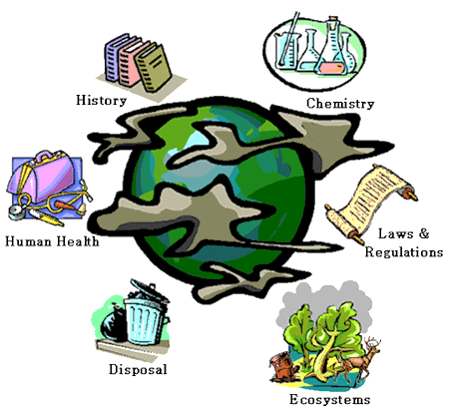
Air pollution —
Water pollution —
Soil pollution —
Noise pollution —

• burying waste or household trash
• cutting forests
• rock concerts
• car exhaust fumes
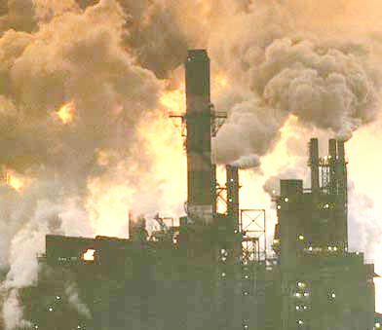
• hyperactive fishing
• oil spilt in oceans
• headphones
• no change footwear in schools
• poaching
• airport noise
• smoking
• burning leaves in spring and autumn
• littering and spitting in the schools, streets, and woods
Match the problem and the authority to handle it. Sometimes there may be more than one choice.
Global authorities —
Local authorities —
I could do it myself —

