Environmental Protection
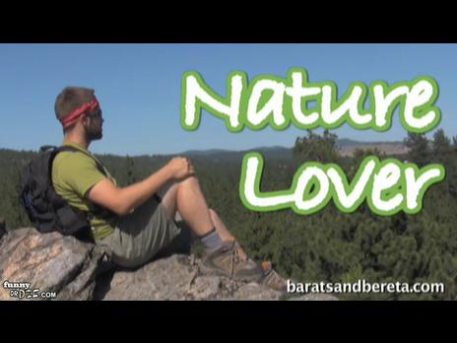
Quiz “Are you a nature-lover?”
Read the questions and mark the answer that is close to you.
1) If someone asks you to plant a tree in your schoolyard or in front of your house, do you agree to do it?
a) With pleasure. Trees make our streets more beautiful.
b) I’m not sure that I can do it on my own, but I’m ready to help.
c) Sorry, but I’m too young for it.
2) When you go for a walk to the forest or to the park, do you pick up flowers?
a) I ask grown-ups if I may do it.
b) Yes, I do, but not many — three or five.
c) Yes, I always pick up flowers. Anyway, new ones will grow up.
3) What do you do with a candy / ice-cream wrapper?
a) I always throw it in the litter-bin. If I don’t see it around, I put it in my bag.
b) I always try to find a litter-bin. But if there isn’t one around, I just throw it on the ground.
c) I just drop it anywhere. What are yard-keepers for then?
4) Do you throw away your old exercise-books if there are blank pages left?
a) No, I don’t throw them away but use them for my notes or drawings.
b) It depends on how many pages are left.
c) Yes, the greatest pleasure is to start writing in a new exercise book.

Add up you’re A, D and C scores.
If you get mostly:
As - The Green Peace will send you a thank-you letter.
Bs - You have to take more care of nature. We all are parts of it.
Cs - Such people destroy nature, don’t they?
Earth is our home. You must take care of it!

