Resources

LOVE
FRIENDSHIP
HEALTH
FAMILY
HOME
NATIVE LAND
KINDNESS
PEACE
VALUES
OF LIFE

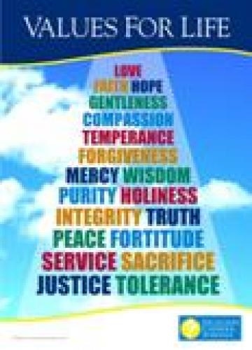

Vocabulary (writing)
- Find extra word:
  - article, chapter, act, economy;
  - right, duty, test, freedom;
  - to adopt, to secure, to watch, to establish.
2.Match the two columns:
to adopt power
to exercise Constitution
to defend the laws
to observe native land

3.Fill in the gaps: (proclaim, symbolize, fundamental, adopted, right)
  - The Constitution of Ukraine is a ________ Law of our State.
  - It was ______ on the 28th of June 1996.
  - The Constitution _______ real rights and duties.
  - The colours of the flag ________ colour of the sun, wheat, sky, water.
4. Complete the sentences:
a) Our Constitution consist of … (Chapters and articles ).
b) The people of Ukraine have the rights to … (rest, work, education, medical treatment).
c) Our sovereign state has its own symbols … (Emblem, flag, anthem).

Work in groups
Task: What would you do if you were the president of Ukraine.
Use the following phrases:
If I were the president of Ukraine I would:
- do everything possible in order to make the life of the people better;
- ensure timely payment;
- increase the wages, pensions;
- make state power honest, responsible, just;
- secure reliable medical treatment and education free of charge;
- protect people by fair law;
- follow the God’s commandments;
- observe the law myself and try to be a person of high moral values;
- take care of nature.

Didactic play
“Agree or disagree. Prove”
The variants of answers are:
- I agree with you
- You are quite right.
- My opinion is just the same.
- I disagree with you
- I am of different opinion.

