**Козівська ЗОШ І-ІІІ ст. №1**

**Тема уроку:**

***Problems of Our Planet***

***and Ways to Their Solutions***

**9 клас**

**Вчитель вищої категорії**

**Гарасівка Галина Іванівна**

**2014**

***Slide 1 I don't understand why when we destroy something created by man,we call it"vandalism"but when we destroy something created by nature,we call it progress..﻿***

**Objectives:**

* to practice extended use of active vocabulary on the topic;
* to develop students reading , listening and speaking skills;
* to introduce some information about recycling;
* to teach students’ responsibility for keeping the environment clean;
* to develop student’s socio-linguistic competence.

**Equipment needed:** a computer, multimedia projector.

**Material needed:** a video “Save the Planet”; Quiz “Are you environmentally friendly?” Survey “Energy conservation at school”.

**Procedure**

1. **Introducing the topic of the lesson**

Teacher: Today we’re going to continue our work on the topic “The Problems of Our Planet and Ways to Their Solutions”. Our lesson is devoted to the issue of Environmental protection. We’re going to raise the most vital environmental problems, find solutions to them and state the results.

At this lesson you will practice extended use of active vocabulary on the topic, develop your speaking and communication skills, increase your awareness of the environmental issue, develop your socio-linguistic competence, and raise your responsibility for keeping the environment clean.

1. **Warm up activity.**

Teacher: Students, you can see three laws of nature suggested by *Barry Commoner,* a biologist, in his book “Making peace with the Planet”.

*“Everything is connected to everything else”*

*“Everything has to go somewhere”*

*“Let nature take its course”*

*Barry Commoner*

I’d like you to read the quotations and discuss them in three groups. What does the quotation mean to you? Do you agree or disagree with the author? (3 minutes).

*Students share their ideas.*

**3. Before watching the video about the problems our planet students discuss these questions.**

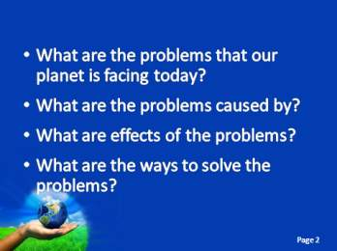***Slide 2***

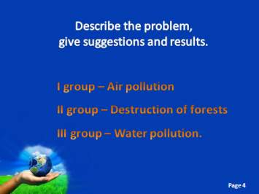**3. Watching the video about the problems our planet is facing today (*Slide 3*). Students get ready to identify the problems, give suggestions and state the results. Students work in groups (3 minutes). They present their ideas.**

***Slide 4***

**4. Imagine that you are at the conference devoted to the topic “Global Litter. Ways to Reduce Global Litter”.**

**4.1. The questions to discuss:**

- Why is litter an ongoing concern which many nations have to deal with? *(Students share their ideas)*

- Are there any possible solutions which could lead to the permanent reduction in the waste that has mounted up in the countries in the world? *(Students share their ideas)*

*(-Use biodegradable packing*

*- Save scrap metal*

*- Educate people to recycle*

*- Organize paper saving projects*

*- Educate to conserve natural resources an energy)*

**4.2. Match suggestions and results. Each student receives a strip of paper with a suggestion or result written on it. Students should find their partners to make up a sentence using linking words and present the sentence.**

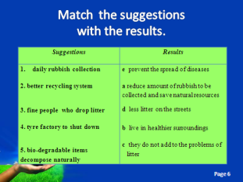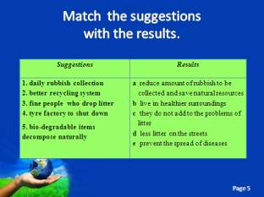***Slide 5***

|  |  |
| --- | --- |
| ***Suggestions*** | ***Results*** |
| **1.** daily rubbish collection  **2.** better recycling system  **3.** fine people who drop litter  **4.** force factory to shut down  5. bio-degradable items decompose naturally | **a**  reduce amount of rubbish to be collected and save natural resources  **b** live in healthier surroundings  **c** they do not add to the problems of litter  **d**  less litter on the streets  **e** prevent the spread of diseases |

**1 – e 2 – a 3 – d 4 - b 5 - c**

**5. Watching the video and writing 10 steps to save energy. Work in pairs (3 minutes). (*Slide 7. Video ) ***

*Students present their ideas.*

**6. Discussion.**

Teacher: Do you take part in any recycling programs or have you ever participated in such activities? Discuss it in pairs and report about your classmate’s contribution to recycling.

Students should create a poster to encourage schoolmates to recycle (3 minutes). They present their posters.

**7. Energy conservation at school (a survey, conducted by students)** (appendix 2)

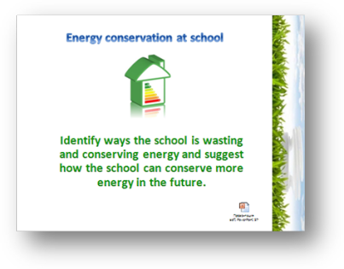***Slide 8***

*Students present the results of their survey.*

**8. Quiz “Are you environmentally friendly?”** (appendix 3)

Teacher: To sum up what you have discussed, I want you to present the results of the quiz in order to see if you are environmentally friendly. Compare your score with your classmates’, think of how you could increase your awareness of these problems and get ready to give a feedback.

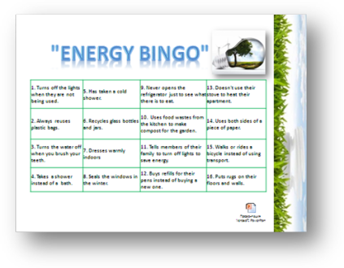***Slide 9***

*Students present the results of their survey.*

**9. Poetry and Environment.**

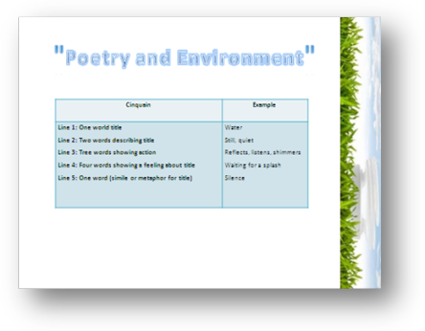***Slide 10***

|  |  |
| --- | --- |
| ***Cinquain*** | ***Example*** |
| Line 1: One world title  Line 2: Two words describing title  Line 3: Tree words showing action  Line 4: Four words showing a feeling about title  Line 5: One word (simile or metaphor for title) | Water  Still, quiet  Reflects, listens, shimmers  Waiting for a splash  Silence |

Students work in small groups to create a poem (3minutes).They present their poems.

1. **Summing up.**

***Slide 11***

Teacher: Environmental problems are of great concern to us. Solutions to ecological problems require the cooperation of all nations. By working together, we can really make a difference to our planet but don’t forget, we can make a difference as individuals, too.

We all live in such a beautiful world, and humans really are beautiful souls with such great potential, we just have to reawaken to who we are, ridding ourselves of ignorance. The more truth we see, the more we can do to change our ways into more productive habits. And it really all does begin with caring about ourselves, other people, and the world. Even though we cannot take on the responsibility for the entire earth, we can take personal responsibility; pledge to our Earth, and everything on it.

Now we have come to the end of the lesson. Your homework for the next lesson is to write an article for our school magazine entitled “How can we make our town a better place to live in”. I appreciate your hard work at the lesson today. Your marks are…

**Appendix 1**

1. daily rubbish collection

2. better recycling system

3. fine people who drop litter

4. tyre factory to shut down

5. bio-degradable items decompose naturally

a) reduce amount of rubbish to be collected and save natural resources

b) live in healthier surroundings

c) they do not add to the problems of litter

d) less litter on the streets

e) prevent the spread of diseases

**Appendix 2**

|  |  |  |  |  |  |
| --- | --- | --- | --- | --- | --- |
| **Is Energy conserved or wasted in your school?**   |  | | --- | |  | |  |  |  |  |

Tour your school building to look for ways energy is conserved or wasted. There are eight things to observe as you walk through the building. If you think energy is being conserved write "conservation" in the blank next to the "C" blank. If you think energy is being wasted, write "waste" next to the "W" blank. Each is worth one point. Repeat this process in every room you chek. When you finish your tour, count the points for each thing. Does your school save energy or waste energy?

|  |  |
| --- | --- |
| **WINDOWS** | **CEILING HEIGHT** |
| (Check for drafts and for number of windows) | (Very high ceilings waste energy) |
| C: ___________________________ | C: ___________________________ |
| W:___________________________ | W:___________________________ |
|  |  |
| **LIGHTING** | **CLASSROOM RADIATORS** |
| (Unnecessary lights should be turned off) | (Placement in room affects conservation) |
| C: ___________________________ | C: ___________________________ |
| W:___________________________ | W:___________________________ |
|  |  |
| **FURNITURE PLACEMENT** | **EXTERIOR DOORWAYS** |
| (Furniture should not block heating devices) | (Door should be kept closed when heat is on) |
| C: ___________________________ | C: ___________________________ |
| W:___________________________ | W:___________________________ |
|  |  |
| **THERMOSTAT** | **EXTERIOR DOORWAYS** |
| (Should be located on inside walls and set at 20 in winter or 25 in summer) | (Carpeting helps keep rooms more comfortable) |
| C: ___________________________ | C: ___________________________ |
| W:___________________________ | W:___________________________ |
|  |  |

Total points: Conservation:__________________

Waste: ____________________________________

**Appendix 3**

1. Give each student a copy of the Energy Bingo sheet. Students will walk around the room or area and find a classmate who can answer "yes" to questions on the bingo sheet, and write their name in the box of the question they answered. Students can only write their name in one box for each bingo card.

2. After a student yells "BINGO" have everyone sit back down.

3. Ask the student with "bingo" to tell the class the number of the square and the name of the student who answered the question. If student confirm that they do these energy saving actions then you have a winner. Ask students how and why they save energy as they answer. If there is a problem, then play the game until there is another "bingo".

4. Discuss with the class the ways of saving energy listed on the bingo sheet. Can everyone in the class do these things? What difference would it make if everyone did these things?

|  |  |  |  |
| --- | --- | --- | --- |
| **1. Turns off the lights when they are not being used.** | **5. Has taken a cold shower.** | **9. Never opens the refrigerator just to see what there is to eat.** | **13. Doesn't use their stove to heat their apartment.** |
| **2. Always reuses plastic bags.** | **6. Recycles glass bottles and jars.** | **10. Uses food wastes from the kitchen to make compost for the garden.** | **14. Uses both sides of a piece of paper.** |
| **3. Turns the water off when you brush your teeth.** | **7. Dresses warmly indoors** | **11. Tells members of their family to turn off lights to save energy.** | **15. Walks or rides a bicycle instead of using transport.** |
| **4. Takes a shower instead of a bath.** | **8. Seals the windows in the winter.** | **12. Buys refills for their pens instead of buying a new one.** | **16. Puts rugs on their floors and walls.** |